TNDY 430
Transdisciplinary Changemakers
Justice-Centered Frameworks for Education

Assignment Textbook

Fall 2023

Shamini Dias & Shelby Lamar
with Jonathan Aragon and Jessi Knippel

Course Overview 4
Chapter 1: Transdisciplinary Pedagogy: Principles and Mindsets 9
Wicked Problems: The Starting Point for Transdisciplinary Work 10
Foundations for Transdisciplinary (TD) Pedagogy 11
Framework: Transdisciplinary Mindsets for Ethical Education 15
Framework: From Transmission Education to Empowerment 16
Framework: Reflexivity for Transformative Practice 17
Framework: Double loop thinking. A Process for Reflexive Practice 19
Extracts on the WHY Of Teaching: What it means to educate. 21
Chapter 2: Systems. Difference & Power. Legacy Education 22
Systems Thinking. A Complexity Orientation 24
Systems and The Primacy of Difference 27
Change Tool: Plural thinking as resistance to hegemonic stories. 32
The Legacy Education System 34
Application: Mapping Education as a System 39
Chapter 3: The Paradox of Change. Tools for Changemaking 43
Paradigms and Paradigm Shift Overview 44
Resistance to Paradigm Shift 48
Change Tool 1: Cartography and Counter Mapping 52
Change Tool 2: Cynefin Multi-Ontology Sense-Making and Reflexivity 57
Chapter 4: Change Tool: Design Thinking to Center Learners and Identities 68
Complex Intersectional Identities 69
Socio-Ecological Determinants of Learning: Integrating Bronfenbrenner’s Theory 71
Mapping Your Complex Intersectional Identity 74
Teachers’ Complex Intersectional Identities 76
Justice: Integrating Diversity, Inclusion, and Equity 77
Design Thinking for Ethical Education 82
Chapter 5: Learning and Teaching as a Complex Adaptive Process. 88
Overview: Learning as a Complex Adaptive Process 89
Explore Learning and Motivation Theories 90
Learning Science and Learning Cultures 102
Chapter 6: Designing the Future: Culturally Sustaining Pedagogies 107
Review Frameworks & Tools 107
Culturally Sustaining Pedagogy: Shifting the Mission 108
Culturally Sustaining Pedagogies as a Gathering of Liberatory Pedagogies. 110
Counter Mapping Tool: Metaphorical Thinking 118
Transforming Metaphors in Re-Imagining Teaching and Learning 123
From Metaphor to Teaching Philosophy and Mission 126
Re-Imagining Education 127
Chapter 7: Transformation 1 – Reframing Outcomes 129
Bloom’s Taxonomies 130
Fink’s Taxonomy of Significant Learning 133
Essential Learning Outcomes (ELOs) 135
Backwards Design: Starting with All Learners and Future in Mind 137
Outcomes as a Transformative Move 140
Chapter 8: Transformation 2 – Inclusive Active Learning 143
Actively Learning About Active Learning 143
Active Learning for a Future-Focused Education 149
How to Design Active Learning Facilitation 151
Inclusive Active Learning: Digital Tools for Analog Spaces 164
Chapter 9: Transformation 3. Relationality & Community in Classrooms 165
Aspects of Community 166
Classroom Community 168
Managing or leading classrooms? 170
Transforming policies for mattering and belonging 173
Chapter 10: Transformation 4. Assessments at the Heart of Learning 179
Review: Learning and Assessment as a Creative Adaptive Process 180
Examining the Foundations of “Assessment” 182
Assessment as Visible Learning 187
Reframing Learning: Productive Struggle 189
Formative Processes = Productive Struggle in Assessment 193
Assessment Patterns in Course Design 197
Designing Transparent Assignments for Equity 198
Chapter 11: Transformation 5. Feedback and Grading 204
Exploring Feedback 205
Pathways for Feedback: Self-Assessment and Peer Review 209
Grading 212
The Rubric as a Compass for Success 216
Chapter 12: Transformation 6. Modalities. UDL and Multiliteracies 221
Universal Design (UD) 222
UDL in Education 223
Multiliteracies 224
UDL & Multiliteracies - From Disabilities to Full Inclusion 226
Digital Tools in Teaching and Learning 232
Chapter 13: Transformation 7. Expanding the Disciplinary Canon 239
Open Educational Resources (OER) to Reimagine Course Content 241
Integrating UDL and Multiliteracies and Open Access 243
Expanding and Transforming Your Course Content 244
References and Further Exploration 245

Course Overview
What is our learning journey? What will I achieve in this course?

This course will help you become a future-focused justice-oriented changemaker.
DEFINITION: Someone whose values and purpose are grounded in an inclusive holistic vision of flourishing for all. Embodying this in thought and action, they work intentionally to address marginalization, oppression, and erasure of human and planetary voices and well-being in order to amplify joy and justice in future-positive outcomes.

Here is a poetic aspiration of a changemaker (I invite you to write your own version)
How do I move?

Marginalization. Oppression. Erasure. Pain. Rage. Despair that comes
When we say, “you are less than me”.
When we are blind to our place in a woven tapestry of humanity. When we brutalize human birthrights to flourishing and peace.
When we say, “the earth is less than human”.
When we are blind to our place in a complex entanglement of people and planet. When we brutalize ecosystems in the name of progress.

When I know these things are said and done
When I know nightmares that waken loudly in broad daylight
How do I move?

Knowing these things
Not knowing all the answers.
I still move
Dance through entanglements
Imagine new futures
Find friends – make friends with foes
Learn the art and science of changemaking

I dance with change
To move
Something. Where I am and the people that I’m with.
Something. A transgression to transcend – transform.
Something. A pebble in a pond rippling out into flowing futures.
Something. A catalyst that pushes me-you-them-us to see differently.
I move for humanity and the future.

Course Structure
Phase 1: Foundations for developing philosophy and approach. (Sessions 1 – 6)
Phase 2: Transformation tools and strategies in teaching and learning. (Sessions 7 – 16)
FOCUS. We focus on changemaking using culturally sustaining pedagogies that humanize teaching and learning as meaningful relational processes of joy and mattering. We focus on learners and learning, centering inclusion and equity-minded teaching and learning for justice. Through this process, we empower all learners to flourish in classrooms and beyond.
OUR APPROACH. You will use Journaling and build a Learning Portfolio to connect transdisciplinary pedagogy with who you are as a teacher-scholar. These critical processes are part of your formative learning and self-assessment to curate and demonstrate learning as well as serve as resources into the future. This process will help you develop and strengthen transdisciplinary habits of mind to unpack and address the systemic and hegemonic colonizing effect of legacy education.
OUR LEARNING JOURNEY. This is a journey of discovery and co-creation – not just a class:
- Inner journey – values, beliefs, and purpose that form your WHY and underpin your practice.
- Outer journey - build a toolkit of frameworks, principles, and strategies that address HOW we can bring positive change to teaching and learning.
These interconnected journeys help you integrate a teacher-scholar and leader identity with your strategies for thought and action. The end result – our collective destination - is a formation of an explicit and living changemaker philosophy and approach, your evolving practice as a transformative educator. Like all good adventures, I hope you arrive at other destinations you are drawn to. This is not a linear, tour bus journey; rather I hope it will be a true exploration and journey of discovery.

REASONS. Why – you might ask – do we need both journeys? When you integrate your identity – who you are, your vision and goals for education – with knowledge and strategies for practice, you ground your leadership in an authentic sense of self:
- Purposeful Adaptivity. Integration gives you a compass to guide you in adapting to new situations you cannot predict today, while sustaining a commitment to ethical education.
- Effective Advocacy. Integrating knowledge and critique of education, principles from learning science, and your values and purpose helps you better explain and advocate for change and innovation in teaching and learning with your students, colleagues, administrators, parents, etc.
Connecting identity with knowledge and strategy is part of your development of transdisciplinary habits of mind and tools that enrich your grounding for a lifetime of development.
TASK: View this Video: Inner Development Goals (IDG). [5:19 mins].
This video is from the IDG Institute, Stockholm. The ideas presented connect with transdisciplinary skills and mindsets. Their research focuses on the importance of an internal development of human capacities as the foundation for changing the world for the better.

Visual Map of Transdisciplinary Pedagogy
Visual map of the landscape for our journey:

This overview map shows you spaces for exploration to develop a living philosophy and habits of mind that integrate informed vision, purpose, and methods for ethical education.

Transdisciplinary Pedagogy: Learner-Centered • Future-Focused • Justice-Seeking • Transformative
Making learning matter by making learning meaningful for every learner
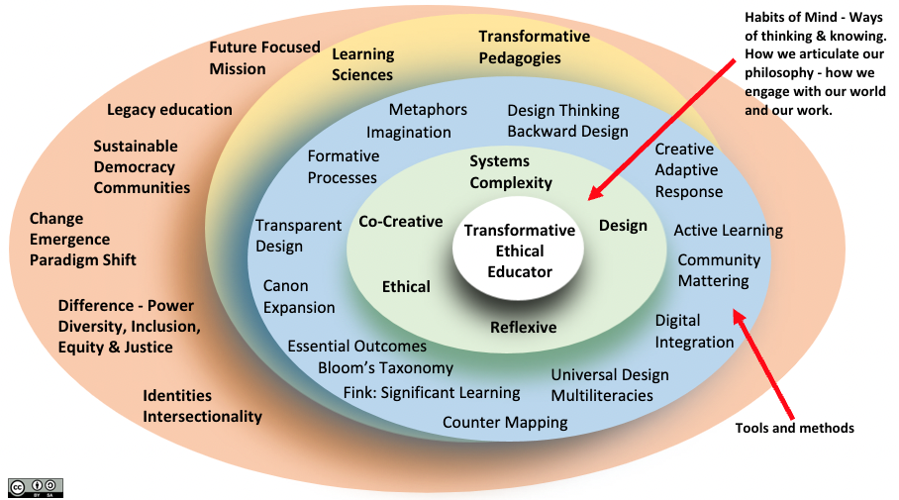
Image Source: Shamini Dias

Transdisciplinary Pedagogy integrates transformations within the teacher as scholar and leader to build inner capacities and skills for engaging in transdisciplinary work – to transgress harmful legacy structures and assumptions, to transcend and remove barriers, thus, ultimately to transform teaching and learning so that all learners are invited into a journey of flourishing into their futures in a complex world.
- The two outer dimensions - large global shifts and contexts, legacy systems, understanding differences and identities etc., inform how we make sense of teaching and learning for the current and emerging world.

- The blue central dimension - tools and methods that help us develop justice-oriented transformations and meaningful approaches to help people engage with learning and flourish in their futures.

- The inner green dimension - five habits of mind or mindsets within which are values, purpose, and inner capacities support our practice as responsive, ethical teacher-scholars and leaders. You will apply these mindsets as part of transdisciplinary pedagogy that helps you to transgress and transcend legacy ontologies and epistemologies to transform teaching and learning toward inclusion, meaningfulness, and justice.

How to use this coursebook to optimize your learning

I could spend the rest of my life reading, just satisfying my curiosity – Malcolm X. Autobiography (1965)

Classes will NOT be lecture based. Each session runs like a workshop within which we might have mini-lectures that actively engage you - solo, in pairs, small groups, and with your course team - to explore, synthesize, apply ideas, and build your toolkit together. The coursebook presents materials to help you prepare for collaborative work in class, and to guide you in critical reflection and curation of ideas for your philosophy and portfolio.
Please do the following:
- Explore material assigned for each class session – integrated notes, short readings, images, videos, podcasts etc., that bring key ideas and questions together. Hyperlinks within the notes are there to point you to sources and further exploration – you are NOT required to read/view those (but I encourage you to explore if you can). Some pages have boxes labelled RESOURCE that you can come back to so you can easily find them in designing your own teaching.

- Do the TASKS and PAUSE TO REFLECT that are presented in boxes within each chapter. These ensure active integration of what is presented with your lived experiences in learning and teaching, your life-worlds and identities, and your evolving values and goals as an educator.
  - The tasks and reflections will also help you do your assignments, especially in developing your teaching philosophy and diversity statement worksheets.
  - Sometimes, you will be asked to submit a task in Canvas. This is not an assignment - it helps me organize everyone’s responses ahead of time to use in class. We co-create our work.
  - In responding to the tasks and reflections, make notes in your Journal so that all your thinking and ideas are gathered in one place. This will make it easy to search and organize related ideas and strategies in doing your assignments.
- Use Your Journal – for everything: Tasks and Reflections in reading the course book, for in-class work, notes, ideas, thoughts. You will submit portions of it as an assignment.
  - Do not fuss over mechanics like spelling or grammar. It’s the thinking that matters.
  - Bullet points are fine.
  - Be playful and creative – use doodles, mind maps, drawings, pasted in images, embedded audio and video. Engage in different modalities to push your thinking.
Journaling will enhance your class engagement and contributions. AND you’ll be able to use your ideas in many assignments. See the Assignment Book for detailed guidelines and what you will submit from your Journal at the end of the course.
The more that you read
The more things you will know.
The more that you learn,
The more places you’ll go
Dr. Seuss. I can read with my eyes shut (1978)

TASK: Explore your Changemaker purposes and goals.
Make notes in response to the questions below. You will share this with your peers and use your ideas in class. Remember – bullet points are fine, and do not worry about grammar and spelling.

- Your “why” as you begin. As you enter this learning journey to become an educator who is a justice-seeking changemaker, list 3 purposes/goals for yourself as a teacher-scholar and leader beyond this course.

- Co-create community in our class. List 2-3 commitments you can make that will help us all co-create a joyful and trusting classroom community.

- Clarify the journey. What questions do you have about the course - Syllabus, Canvas, coursebook, assignment book, our process? I encourage you to share your questions in our question forum or in class. Any question you have is likely to be shared by others and will help us all work effectively together.

Chapter 1: Transdisciplinary Pedagogy: Principles and Mindsets

TASK: Pre-Exploration Priming
Pedagogy Note: Structuring active, focused thinking when providing class preparation primes the brain for stronger and more meaningful engagement with the exploration to follow

Before you read further, think about how you define TRANSDISCIPLINARY.
What have you read or heard about transdisciplinarity, and in what contexts? Have you seen it in your disciplinary scholarship or professional practice?

Here is a definition of transdisciplinarity from CGU’s Transdisciplinary Studies website. How does this definition resonate with your ideas of scholarship, teaching, leadership, and learning?
Transdisciplinarity: Working across knowledge and stakeholder boundaries to facilitate a systemic way of solving complex, wicked, real-world problems.
Expanding on this, transdisciplinarity is a collaborative effort to do the following:
- Address a complex problem that is important to society.
- Seek justice-oriented solutions and pathways for holistic social and future good.
- Collaborate with diverse actors and stakeholders to unpack and reframe problems and approaches to problem-solving.
- Cross disciplinary boundaries, including between academic and non-academic ways of knowing and being to seek divergent and holistic insights and solutions.
- Practice epistemic humility - listen radically, practice intentional openness and flexibility.
Engage in disciplinary and personal reflexivity to explore and address assumptions, values, and beliefs that shape our thought-action frameworks and mindsets.

TASK: View this Video. The Transdisciplinary Approach [3:50 mins]
This video brings together the voices of people from different countries sharing their perspectives on Transdisciplinary research and practice. Their contexts are in sustainable development. However, as you listen, what connections do you see that apply to the world of education and leadership?

In the rest of this chapter, you will read about:
- Wicked Problems: The Starting Point for Transdisciplinary Work
- Foundational Perspectives and Principles for Transdisciplinary Pedagogy
- Framework: Transdisciplinary Habits of Mind and Action
- Framework: From Transmission to Empowerment
- Framework: Reflexivity for Transformative Practice
- Extracts on the WHY of Teaching

Wicked Problems: The Starting Point for Transdisciplinary Work

What’s a Wicked Problem?

TASK: View these two videos:
- Austin Center for Design. Video Defining Wicked Problem [1:45 mins] with a good website.
- Systems Innovation. Video – slides with concise text set to music [3:52 mins]

“Wicked problems are highly complex problems. They are unstructured, open-ended, multi-dimensional, systemic, have no known solution. Examples include inequality, terrorism, environmental degradation or multicultural integration." ­Systems Innovation

Wicked Problems is a recognition of systems and complexity, uncertainty, and emergence that futures-design and leadership describe as the VUCA world (Volatile, Uncertain, Complex, and Ambiguous).

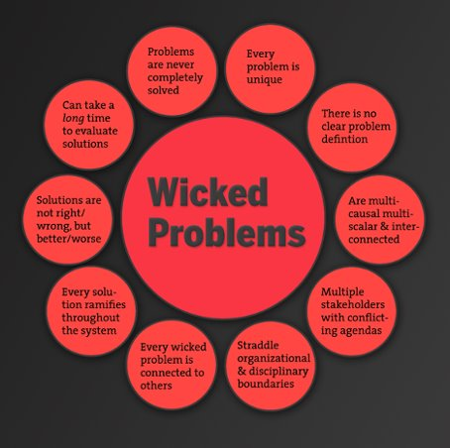
Education is a wicked problem as a system that affects and is affected by multiple other co-embedded systems and shares the following characteristics:
- Every problem is unique.
- There is no clear problem definition.
- They are multicausal, multi-scalar, interconnected.
- Multiple stakeholders with conflicting agendas
- Straddles organizational and disciplinary boundaries.
- Every wicked problem is connected to others.
- Every solution ramifies throughout the system.
- It can take a long time to evaluate solution-impact.
- Solutions are not right or wrong but better or worse.
- Problems are never completely solved.

PAUSE TO REFLECT:
Which of the above elements of a wicked problem do you see in issues of equity and inclusion that come up in education?

Foundations for Transdisciplinary (TD) Pedagogy
A philosophy and practice of transformation for justice

Transdisciplinary pedagogy is liberatory in being transgressive, transcendent, and transformative.
“The discourse of transgression was forged in critique of the existing system of knowledge and education. TD became aligned with imperatives of cultural critique, sociopolitical movements, and conceptions of post-normal science and wicked problems that break free of reductionist and mechanistic approaches.” – Julia Klein, 2004.

“[T]ransdisciplinary praxis … has been argued as manifest at the juncture of humility and complexity. The nexus, formed as one opens heart and mind to radical listening, is derived by neither prescribed goals nor deductive reasoning; rather, it is a transformative movement toward a peace-building potential, a mutuality embedded in participatory relationships with young people and community.” Shannon Moore, 2018. p. 485.

“[T]ransdisciplinarity presupposes an individual ethics, as desire to improve society and to contribute the advancement of the common good” (Tanya Augsburg, 2014, p. 233)

“Problem-posing education affirms men and women as beings in the process of becoming.”(Paulo Friere, Pedagogy of the Oppressed, 2000; p.84. Freire Institute)
“Education either functions as an instrument which is used to facilitate integration of the younger generation into the logic of the present system and bring about conformity or it becomes the practice of freedom, the means by which men and women deal critically and creatively with reality and discover how to participate in the transformation of their world.” — Richard Shaull. Foreword to Pedagogy of the Oppressed by Paulo Freire.

Transgressive. TD work is transgressive in being “forged in critique of the existing system of knowledge and education” (Klein, 2014; p. 68). In creating futures, we take a skeptical stance grounded in an ethical quest (Sardar, 2010). Transgression is crossing disciplinary boundaries and tightly privileged knowledge, knowledge experts, knowledge production, and discourses that marginalize other ways of knowing and being. Klein (2014) describes transgression as “entwined with democratic participation in problem solving” (p. 72). In TD pedagogy, we take a transgressive futures-oriented stance to question and surface assumptions in education, revealing misalignments with the complex diversity of identities, perspectives, and emerging futures.
Transcendent. Transdisciplinarity transcends a search for unity to embrace complexity based on epistemological and ontological relativity. TD pedagogy seeks justice by transcending paradigms of singular “normative” narratives to integrate complex interconnected multiplicities (identities, bodies, knowledges, languages, cultures, histories, and life-worlds). Hence, we reject paradigms that otherize differences and exclude the whole self. At the same time, transcendence rejects fragmentation, seeking integration of plurality as part of boundary crossing in developing perspectives and solutions.

Transformative. TD pedagogy is transformative in justice-oriented re-imagination to shape new goals and designs teaching and learning that move away from reductionist, single-narrative or one-size-fits-all approaches toward nuanced and responsive approaches that humanize education. In this process, both teacher and learners are also transformed to recognize and celebrate their capacity to flourish through authentic, reciprocal relationships (Freire’s notion of “reconciliation” - Freire, 1970/2000; p. 72) and work that it meaningful and expansive.
Transdisciplinary (TD) pedagogy arises from the following perspectives for thought and action.

Our world and who we are in it are part of and shaped by multiple complex systems.
We embrace the vast diversities, complexities, and emergent qualities of teaching and learning.
- We work with highly diverse, interconnected, and dynamically interacting and changing systems (natural, technological, and social). There are multiple levels - from microsystems of our intersectional identities and positionalities to the meso-system of the classroom as learning environment, to larger systems of institutions, and the world beyond.
- There isn’t a single center of control or linear hierarchy as all the elements are co-dependent and co-evolving. We are embedded in and shaped by systems with which we work. We are entangled with multiple issues, life-worlds, and experiences.
- Change is a natural process in complex systems as new interconnections and patterns emerge.
- We embrace “knowledges” – scientific, artistic, spiritual, place-based knowledges. Therefore there are multiple perspectives and ways of knowing, being, and responding to the world.

Knowing and learning is a complex and reflexive embodied process.
We embody complexities and bring who we are to scholarship, teaching, and learning.
- We are each a microsystem of ideas, beliefs, assumptions, motivations, fears, and dreams. These are shaped by our socio-political identities, disciplines, histories, bodies, and lived experiences. Therefore, we each bring a different narrative or story to anything.
- We cannot take the subject – the person – out of the process. We are embedded in the system, trained into disciplinary and socio-political ways of seeing and constructing knowledge that we might be unconscious of, and hence complicit with the system. As embodied minds, we can only explore and build knowledge through the filters of an embodied subject or self.
- THEREFORE: Positionality is critical, and we engage in reflexive work – to surface, examine, and modify our personal and disciplinary assumptions, values, beliefs that shape how we think and act. This means seeking multiple divergent perspectives, listening radically to engage rather than deny, and fostering an intellectual or epistemic humility that understands the complexity of inter-perspectivity. TD pedagogy requires curiosity, openness, and flexibility.

We seek transformations focused on justice-and future-orientation for positive futures.
We envision a co-creative process that centers equity-minded, meaningful, and joyful learning.
- We reject the hegemonic and colonizing legacy systems whose power dynamics block, suppress, oppress, and erase our human birthright to learning as a joyful, self-actualizing process.
- We reject the industrial transmission model of linear, binary, hierarchical, and transactional processes that puts learners in passive roles in one-size-fits-all methods that block learning.
- We center empowerment through meaningfulness, joy, and relevance in learning through co-creation, cultural responsiveness, and multiple ways of knowing and expressing knowledge.
- We take a contexts-and future-focused approach through intentional design that helps all learners succeed in the present and into future lives, careers, and positive global citizenship.

Transdisciplinary Habits of Mind and Action

Based on the above perspectives, TD pedagogy fosters complexity-based habits of mind and action in educators and learners.
REFLECT AS YOU READ – invite your imagination – what do these principles look like in practice - in classrooms and other learning spaces? How do these principles work in scholarship and leadership?

PRINCIPLE 1. Begin with critical justice-oriented questions not subject matter.
Why – why not – what if? • Imagine beyond legacy and tight paradigms.
No matter what we teach, rather than begin with a singular knowledge base and method, TD pedagogy begins with questions about purpose, practice, and people that address inequities. This speaks to Freire’s (2000) idea of “problem posing”. We first ask – in teaching this subject, what are we transforming and why? Who are the marginalized, overlooked, ignored, or oppressed, who are not represented or invited, and whose presence and voices have been erased? These questions help us reveal and address barriers and inequities in legacy education systems and our discipline specifically. Starting with critical questions is the first step in transgression, transcendence, and transformation toward a more inclusive and just education into the future.

PRINCIPLE 2. Cross boundaries. Embrace plurality and multidimensionality. Reframe. Reimagine.
Reject the single story or narrative • Integrate multiple ways of seeing, thinking, and learning.
TD pedagogy rejects the imposition of a single perspective or story especially through legacy systems that work for a dominant group while marginalizing others through an exclusionary power dynamic.
Instead, it understands and welcomes multiple stories and counter-stories because different perspectives, knowledges, ways of knowing and communicating, and lived experiences are part of our life-worlds. TD pedagogy thus transforms and expands paradigms of subject matter and method by crossing disciplinary, methodological, and discourse boundaries to create meaningful learning environments that engage life-worlds beyond classrooms. Imagination and boundary crossing skills - curiosity beyond our paradigms and a desire to seek connections - are essential for this.

PRINCIPLE 3. Intentionally design for diverse humanity - with learners and learning at the core.
Reject assumptions of homogeneity and linearity • Center relationality and learning complexity.
In taking a systems- and complexity-oriented approach, TD pedagogy rejects legacy instrumentalist ideas of 1-1 causality, linearity, hierarchy, and a one-size-fits-all approach that presupposes a homogenous student body and an unchanged and unchanging context. Teaching is not using method X to get result Y each time. Nor is learning a process of doing X to learn Y.
In intentional design that locates learners and learning at the core, we recognize teaching and learning as complex emergent processes embedded in multiple contexts and identities that have historically denied plurality and equity in learning. In countering this, we integrate a diversity of learners, forms of knowledge, and ways of knowing. We use open, non-linear, non-binary processes to design inclusive, equity-minded teaching and learning to support deep learning and flourishing into the future.

PRINCIPLE 4. Work responsively and adaptively. Embrace liminality and uncertainty.
Transformation is a creative adaptive response • Embrace emergence, uncertainty, and change
TD pedagogy works with the idea of fluid futures, change, and emergence. It recognizes the dynamically interconnected global system within which we live and learn and accepts change and emergence as natural processes. It also recognizes that learning and teaching are embodied complex adaptive processes of discovery and emergence, moving from what we know to building knowledge, skills, and capacities. In response, TD pedagogy integrates flexibility and responsiveness in designing purpose, contents, and methods, while remaining focused on centering learners, learning, and contexts of engagement.

PRINCIPLE 5. Integrate reflexivity and build metacognition.
Surface and question assumptions • Practice epistemic humility.
Reflexivity or critical introspection is necessary for transformative, ethical decision making. Reflexivity is a process of critically examining our status quo - (legacy) systems and practices to reveal underlying beliefs and assumptions. Reflexive practice helps develop metacognition of our positionality and complicity (conscious and unconscious) at multiple levels as the first step in working for change and demands epistemic humility, or the idea that we do not and cannot have full certainty and knowledge.
This metacognitive awareness and humility are essential to transformative work helping us to remain open to differences, divergences, and emergences that are part of the process of innovation, discovering both known and unknown unknowns in problem solving. It is critically important when we work to transcend legacy systems and our own positionality in order to make intentional and future-focused, ethical decisions and to avoid working unconsciously in the system.

PRINCIPLE 6. Connect and co-create generously.
Listen radically • Invite all voices to collaborate for justice.
Transdisciplinary thinking embraces the power of multiple stakeholders who bring diverse stories that together through mutual learning can lead us to larger ideas and new perspectives that can address issues in the world. This means connecting with others empathetically and engaging with radical listening, compassion, and generosity. In working for justice, we focus especially on inviting voices that are traditionally absent or erased.
TD pedagogy brings in co-creation in multiple ways. We co-create with other educators to build collective awareness, intentionality, support, and energy, in addition to sharing resources for change. We co-create with our students, inviting them as partners with us and each other in navigating learning. In both these actions, we embrace Open Access in knowledge sharing and Open Pedagogy, where students co-create information rather than simply consume it. Working co-creatively also builds a sense of meaningful and shared effort that develops resilience and persistence for transformation.

Note: Developing these principles for TD pedagogy is a creative and embodied process rather than acquiring a finite set of strategies. This is where connecting your internal explorations of purpose and values with external development of frameworks and tools will help you build habits of mind and skills for changemaking in your own practice. This will also enable you to work adaptively and keep expanding your capacities as you move ahead in your work.

Framework: Transdisciplinary Mindsets for Ethical Education
Developing transdisciplinary mindsets – or complexity-oriented habits of thought and action – is essential in engaging with and adopting the principles above. These mindsets help you to integrate the WHY of ethical education and the methods (HOW) in a living philosophy and practice. You likely embody these mindsets to some extent, or some might be new ideas to you. You might think of them in different terms, or you might not be consciously aware of them.
Your goal is to explicitly understand and cultivate them as part of the work you do in this course.
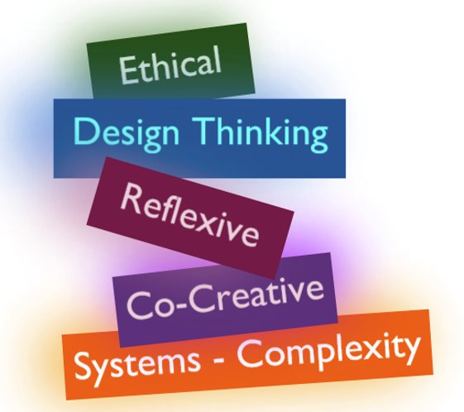
Image Source: Shamini Dias
Ethical. A deep yearning for justice in education and awareness of legacy schooling structures and practices that perpetuate inequities and barriers to learning and flourishing. In response, we design teaching and learning to remove barriers and ensure all learners are engaged and supported in preparing to flourish in their future.
Design. A humanizing and context-focused intentional approach. We always start with a focus on learners and their current and future contexts, the removal of barriers to success, integrating evidence-based teaching and learning strategies and environments, and making learning joyful. Therefore, we take a flexible, adaptive approach that is responsive to emerging information and opportunities.

Reflexive. Critical introspection as an on-going practice helps us to examine assumptions, build self-knowledge, and work with a coherent, explicit value set. Critical introspection from a systems and disciplinary perspective helps us examine legacy assumptions and biases that are harmful or misaligned to students’ future flourishing. We create a living philosophy and become lifelong learners.
Co-Creative. Collaboration for growth. We listen with openness and curiosity to new and different ideas, to invite and engage feedback toward growth. We develop teaching and learning as co-creative, collaborative processes with learners, other educators, and communities.

Systems and Complexity. Embracing plurality. We work with interconnected, non-binary, non-linear, and emergent aspects of teaching and learning. We engage complex adaptive thinking in questioning the status quo to stay open, imaginative, and creative in responding to emerging situations.

PAUSE TO REFLECT.
Do you embody any of these mindsets – in what contexts have you applied them? Which ones do you feel you need to develop or strengthen? Why are they important for educators?

Framework: From Transmission Education to Empowerment

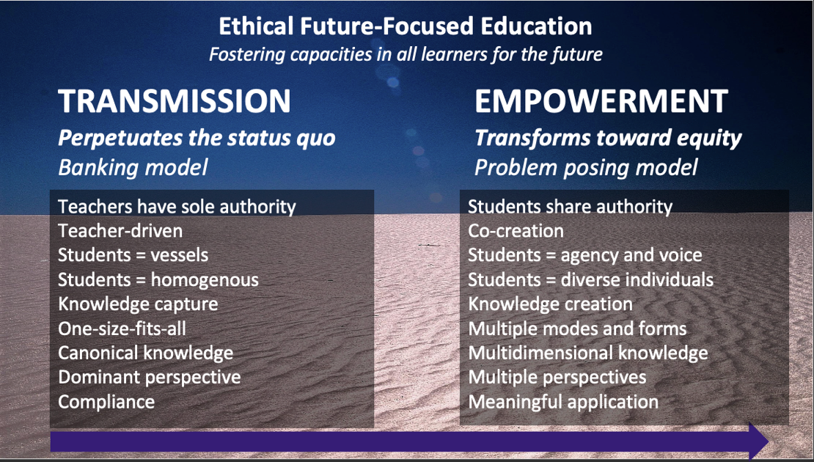
Image source: Shamini Dias
This is one of our key frameworks for building an integrated TD pedagogy philosophy and approach.
The goal in transforming education is to move away from the legacy Transmission approach that perpetuates a status quo, blocking access to learning and marginalizing and oppressing many learners. Freire (2000) refers to the legacy system of education as “banking” education characterized by an overarching and singular narrative based on power, compliance, and homogeneity in education. In this model, teachers and students interact in a linear, a top-down hierarchy of student compliance and teacher as sole expert. This comes from an assumption of learning as a one-way process of information transmission from teacher to students in the acquisition and demonstration of a canonical body of knowledge that presents a singular dominant perspective. In this model, the wholeness of students and the rich complexities of diverse identities and multiple perspectives of deep learning are absent.

The goal in transforming education is to move toward an Empowerment approach to education and leadership. This model engages a rich centering perspective of a diversity of learners, learning processes, knowledges, and contexts. Students have agency, and are invited to bring their full selves and life-worlds into the learning process. Together, teachers and learners become a community engaged in co-creating learning and growth. While teachers have knowledge authority, they are not authoritarian; they engage in a reciprocal relationship so that they learn as they teach, inviting their students to teach as they learn. They are aware of and integrate students’ lived experiences, knowledge, cultures, and perspectives in designing and facilitating learning. The learning environment is expansive, connective, and joyful in integrating multiple ways of knowing, representing, and expressing knowledge so that learning is meaningful. Each person matters deeply in the process.

PAUSE TO REFLECT: In your schooling experiences – looking back from early childhood through college – when and in what kinds of schooling contexts did you experience the Transmission and the Empowerment model of education? Which was more prevalent in your schooling?

Framework: Reflexivity for Transformative Practice
"... seldom if ever do we ask the 'who' question - who is the self that teaches? How does the quality of my selfhood form - or deform - the way I relate to my students, my subject, my colleagues, my world?” – Parker Palmer. The courage to teach. P.4
“I use the term wide-awakeness .… Without the ability to think about yourself, to reflect on your life, there’s really no awareness, no consciousness. Consciousness doesn’t come automatically; it comes through being alive, awake, curious, and often furious.” - Maxine Greene

Defining Reflexivity: Critical introspection for transformation.
Reflexivity enables us to pause, get outside ourselves, and take a critical, fresh look. And grow.

Image generated by Dall-E2

Reflexivity is unpacking, unraveling, and questioning prior knowledge, assumptions, values, beliefs, motivations that condition and shape our thoughts and actions. It helps us make intentional choices to change or discard incongruent beliefs and assumptions, and to amplify and articulate those that support our explicit mission. Reflexive thinking enters many aspects of our lives. While it is a specific way of thinking, a habit of mind, it is not a specialized activity limited to just some areas of life. It comes into play in our personal lives, at workplaces, in scholarship, as leaders – and as transformative teachers. Reflexivity grounded in values for positive futures helps us work transformatively as ethical educators.

Reflexivity in Scholarship
“Examination of one’s own beliefs, judgments, and practices during the research process and how these may have influenced the research. If positionality refers to what we know and believe, then reflexivity is about what we do with this knowledge. Reflexivity involves questioning one’s own taken for granted assumptions. Essentially, it involves drawing attention to the researcher as opposed to ‘brushing her or him under the carpet’ and pretending that she or he did not have an impact or influence. It requires openness and an acceptance that the researcher is part of the research (Finlay 1998) – from Warwick University. Education Studies.

Reflexivity in Teaching
“Reflexivity is an act of self-conscious consideration that can lead people to a deepened understanding of themselves and others, not in the abstract, but in relation to specific social environments... [and] foster a more profound awareness . . . of how social contexts influence who people are and how they behave... It involves a person’s active analysis of past situations, events, and products, with the inherent goals of critique and revision for the explicit purpose of achieving an understanding that can lead to change in thought or behavior. pp. 155-156 (Danielewicz, J. (2001). – from Transformative Inquiry

Reflexivity: A Process to Examine Assumptions
Have you heard statements like these – or maybe thought them yourself? What do these statements assume? Why, where, and for whom might they not be true or applicable?

- Australians love rugby.
- It’s polite to offer to shake hands when you meet someone.
- Kids love pizza.
- Cats are not people friendly.
- Boys are better at mathematics than girls.

Image source

Assumptions
As the metaphorical figure below shows, assumptions, beliefs, values, and expectations are shaped through lived experiences. These form the ground from which grow mindsets, perspectives, theories, and philosophies that we embody, often in tacit and unconscious ways. These govern thoughts, responses, actions, and our interactions.
Assumptions are not all bad. They help us move through the world. We assume laws of physics, of social interaction. We do not need to puzzle everything out and can work on auto or reflex. In scholarship, disciplinary training builds assumptions and norms that we assume as valid.
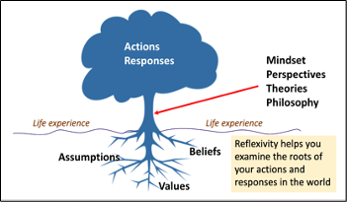
Image source: Shamini Dias

When situations shift away from the familiar, we might see clearly that what we assume is in fact not necessarily a given truth. For example: Travel – experiencing cultures and environments very different to our normal experiences, we find that some of our assumptions no longer hold, a simple instance being the discovery that in another country, people drive on the opposite side of the road! A larger scale example: When manufacturing because highly automated, many assumptions about how we work were disrupted. In science, deep beliefs that the sun moved around the Earth or that the Earth was flat were disproved, upsetting a great many people. In Mathematics, assumptions of linear order were disrupted by explorations in Chaos theory; Einstein’s work disrupted assumptions of force and movement in Newtonian physics. Assumption disruption and revision is a natural outcome of discover and learning.

Framework: Double loop thinking. A Process for Reflexive Practice

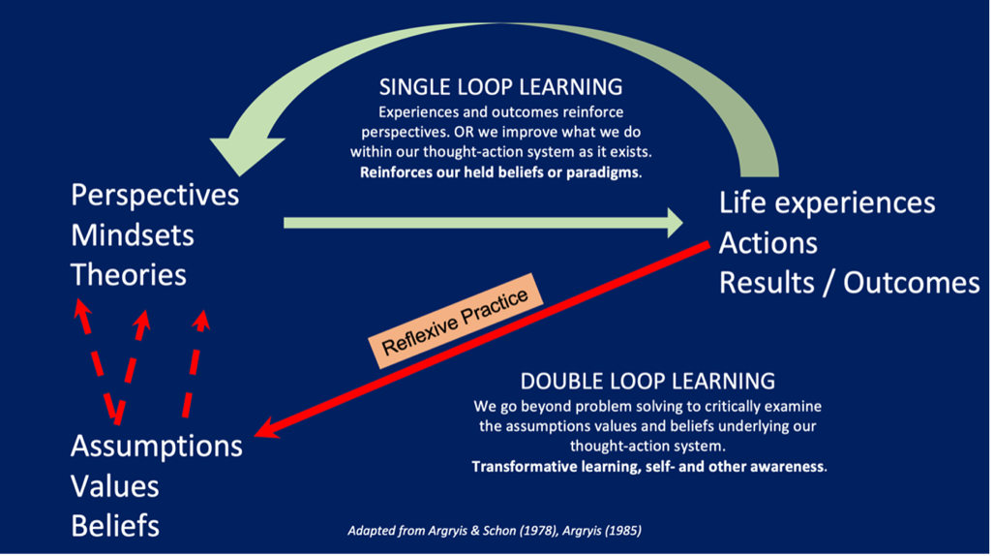
Image source: Shamini Dias

This figure shows double loop learning – a way of understanding how reflexive practice works.
Single Loop Learning. We work in a single thought-action cycle. Our perspectives – grounded in deep assumptions, values, and beliefs (often unconscious) shape how we experience life and the outcomes of how we act and respond. These in turn reinforce our perspectives. When things go awry, we problem solve within our existing thought-action system, focusing on addressing elements outside of ourselves.

Double-Loop Learning. We work in a reflexive thought-action cycle. While we engage in single loop thinking looking at external factors, we also critically examine internal assumptions, values, and beliefs – both personal and disciplinary - to discover possible biases and blind spots. This leads to perspective shifts and to expanded theories or worldviews that can reframe and reshape how we respond and act in the world.

Double loop learning is a critical reflexive process for transformative work. This is because in doing transformative work, we cross boundaries, connect with ideas and people in ways we have not previously done. We have to be aware of the ways in which our perspectives contain blind spots, misassumptions, and biases. How are they limiting our thought and action? For example:
- Unconscious assumptions, values, and beliefs about clothing can cause a negative response to women in hijab. Reflexive awareness can help us intentionally empathize and connect to understand and accept their choice of clothing.
- Disciplinary training can cause blind spots leading us to design marketing approaches that fail in a foreign country. Reflexive awareness through double loop learning helps us check our assumptions about how markets work and be open to intentionally exploring new ideas.
- Educators bring legacy shaped assumptions, values, and beliefs in designing tests and assignments. Reflexive awareness can alert us to assumptions about learning and testing that shape our actions but are incongruent to our students’ current realities and learning science.

The examples below show the need for reflexive practice. Can you think of areas in your life – personal and professional - where reflexive practice through double-loop thinking is important?
- Scholarship – assumptions of method and context shape scholarship but can also block expansion of knowledge and method. For example, the assumption that teachers are the classroom experts miss the potential of students as experts of their own learning and we do not include them as study participants; assumptions of binary genders in math education research misses the potential of designing from the perspective of intersectionality and plurality of genders and sexuality; the assumption that only quantitative data is valid, misses critical information found in thick qualitative data. (Literature reviews can be framed as a reflexive process that can help us examine and question research assumptions).
- Parenting – social, cultural, and historical assumptions shape how we think about parenting. For example, assumptions that good parenting is being strict or good parenting is letting children learn the hard way; women should prioritize being mothers and homemakers over their career, and conversely, a woman who is very career-oriented is not a good parent; without a good education, one cannot effectively support a child’s education. Pausing to question assumptions in our actions or judgments of parenting can help us address specific context-related needs of our families.
- Teaching – assumptions of method and mission that shape how we teach. For example, the assumption that the teacher is the expert, and the student receives information and have nothing to contribute; that unless we give grades to everything, students will not be motivated to do the work; that learning is taking in pieces of knowledge given by the teacher and committing them to memory; that the student who does not speak up in class is not engaged.

Positive Outcomes of Reflexive Practice
- Plural thinking and humility in knowledge and knowing. We recognize that perspectives are not absolute nor stable. And therefore, we are more open, better able to consider, embrace, and integrate different beliefs, values, and perspectives. This supports perspective taking and empathy. We develop a more open, curious mind.
- Change and learning. We are not stuck in unquestioned assumptions and unconscious bias. We are not tightly bound by our contexts and can take a step outside of ourselves to see with new perspectives. Therefore, we can change how we approach and align with shifting contexts.
- Creative thinking. We can think out of the box of our preset assumptions and beliefs and find new ways of knowing and creating. For example, artists question the assumptions of what makes good Art – and innovate new forms; scientists question the assumptions of a human-centered world and develop theories and actions based on an ecosystem with the planet at the center.

CAN YOU THINK OF A FEW MORE POSITIVE OUTCOMES?

Optional Article: Tagg, J. (2010). The learning-paradigm campus: From single- to double-loop learning. New Directions for Teaching & Learning, 2010(123), 51–61.

Extracts on the WHY Of Teaching: What it means to educate.
These short extracts speak to the authors’ philosophies – their deep beliefs and visions of education in which they ground their work, and from which they derive energy and focus to sustain their practice. As you discover and develop your teaching philosophy and approach, you will articulate who you are as a teacher-scholar and leader, and the beliefs, values, and goals that shape your mission and practice.

Bettina Love - We want to do more than survive. "Education reformers take up space in urban schools offering nothing more than survival tactics to children of color in the form of test-taking skills, acronyms, grit labs, and character education. The barriers of racism, discrimination, concentrated poverty, and access to college - persistent, structural barriers - cannot be eradicated by tweaking the system or making adjustments. We must struggle together not only to reimagine schools, but to build new schools that we are taught to believe are impossible: schools based on intersectional justice, antiracism, love, healing, and joy" - p. 11 Claremont Colleges Lib e-book

bell hooks. Teaching to transgress. "To educate as the practice of freedom is a way of teaching that anyone can learn. That learning process comes easiest to those of us who teach who also believe that there is an aspect of our vocation that is sacred, who believe that our work is not merely to share information but to share in the intellectual and spiritual growth of our students. To teach in a manner that respects and cares for the souls of our students is essential if we are to provide the necessary conditions where learning can most deeply and intimately begin”. - p. 13. Book summary. bell hooks’ website • Claremont Colleges Lib e-book
Parker Palmer - The courage to teach. Parker Palmer goes beyond the WHY to ask - WHO? "... seldom if ever do we ask the 'who' question - who is the self that teaches? How does the quality of my selfhood form - or deform - the way I relate to my students, my subject, my colleagues, my world? [p. 4] ... 'When I forget my own inner multiplicity and my own long and continuing journey toward selfhood, my expectations of my students become excessive and unreal. If I can remember the inner pluralism of my own soul and the slow pace of my own self-emergence, I will be better able to serve the pluralism of my own students at the pace of their young lives. By remembering our mentors, we remember ourselves - and by remembering ourselves, we remember our students" [p. 25]. Claremont Colleges Lib e-book
Paulo Freire - Pedagogy of Freedom. Ethics, Democracy, and Civic Courage connects teaching and learning. "There is, in fact, no teaching without learning. One requires the other. And the subject of each, despite their obvious differences cannot be educated to the status of object. Whoever teaches, learns in the act of teaching, and whoever learns teaches in the act of learning. ...the process of learning, through which historically we have discovered that teaching is a task not only inherent to the learning process but is characterized by it, can set off i the learner an ever-increasing creative curiosity." p 31-32. Claremont Colleges Lib e-book

PAUSE TO REFLECT. Consider what resonates with you and why. What questions arise? What connections do you see between these extracts and TD pedagogy and mindsets, and to the Transmission and Empowerment model of education?

Chapter 2: Systems. Difference & Power. Legacy Education
Starting with Problem Exploration

In this Chapter you will explore:
- Systems thinking. A complexity orientation
- The primacy of difference. 3 responses to difference.
- Difference as a tool for reflexive reframing
- Negating difference. The danger of a single story. Human history of power and privilege.
- Legacy Education. Misalignments.
- Application of systems thinking – Mapping systems.

“Life can only be understood backwards; but it must be lived forwards.”
― Søren Kierkegaard

Systems thinking helps us get a sense of the big picture to understand the current system of education in relation to its past and future. Understanding the legacy system within which we practice is important in ethical work as educators so that we can connect our inner journey of self-awareness with intentionality in transforming education for the future. This helps us better identify and explain inequities and work strategically to transgress, transcend, and humanize our classrooms and other learning spaces in inclusive, joyful, and equity-minded ways.

TASK: Pre-Exploration Priming
Pedagogical note: A priming task makes space for learners’ knowledge and ideas. The process of guessing in pre-reading anticipates key ideas in the reading, making them more “sticky” in the actual reading process.

Answer these questions before moving on to the next page so you can see what you bring to this chapter from your prior knowledge and experiences. It’s much more revealing! So, no peeking!
What do you know about systems thinking? Write a short definition.

- List some "systems" - think of Natural and Human systems.

- What do you think makes them systems?

- What have you heard about "systems thinking"? Why is this important - and growing in importance? (think back to the principles of transdisciplinarity and wicked problems)

TASK – continuation…
Compare the examples you brainstormed with these images of systems:

Human-made systems


Nature-Made Systems
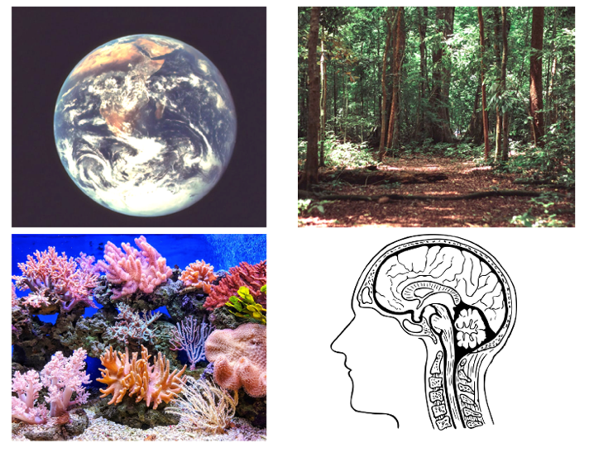
Image sources: Marketplace • Astronaut • Factory • Social Media • Earth • Forest • Brain • Coral Reef

What makes all of these examples - and your examples - systems? How would you now define systems and their characteristics and explain why systems thinking is important?

Systems Thinking. A Complexity Orientation

Image Source: Nathan Dumlao

Systems Thinking reveals larger - and complex - pictures of our lives at large and micro scales. Our planet is affected by elements of the Solar System (and other systems beyond). Within this, we are part of Earth’s environmental systems. As human beings, we live in multiple interconnected social systems spanning the globe or that are local to our communities. As individuals, we are a microsystem of many embodied systems - physiological, neurological, cultural, historical etc. Each system can be regarded as a paradigm or set of interacting norms within which we live.

TASK: VIEW THIS VIDEO. What is Systems Thinking? Peter Senge [1:08 mins]
Peter Senge, author of The Fifth Discipline: The Art and Practice of the Learning Organization (1990), defines systems thinking. He focuses on developing learning organizations applying this into the field of education. As you watch, ask yourself how you are a systems thinker. Listen for these key ideas:
- “consequences of my own actions”
- “the web of interconnectedness within which we always live and act”
- “the connections in any situation”
- “how things unfold over time”
Where in your life do you see this happening? Where in education and in classroom teaching can you see these characteristics of a living system?

Systems thinking is a more natural and common way to think than we might assume.
“On the one hand, we have been taught to analyze, to use our rational ability, to trace direct paths from cause and effect, to look at things in small and understandable pieces, to solve problems by acting on or controlling the world around us … On the other hand, long before we were educated in rational analysis, we all dealt with complex systems. We are complex systems — our own bodies are magnificent examples of integrated, interconnected, self-maintaining complexity. Every person we encounter, every organization, every animal, garden, tree, and forest is a complex system. We have built up intuitively, without analysis, often without words, a practical understanding of how these systems work, and how to work with them."
Donella Meadows (2008). Thinking in Systems.

The complex nature of systems
“Let’s face it. The universe is messy. It is non-linear, turbulent, and dynamic. It spends its time in transient behavior on its way to somewhere else, not in mathematically neat equilibria. It self-organizes and evolves. It creates diversity and uniformity. That’s what makes the world interesting, that’s what makes it beautiful, and that’s what makes it work.” - Donella Meadows. Thinking in Systems. 2008

“It is a very hard thing to turn off once you learn how to think in systems. … I never look at something in an isolated way anymore and I always try to understand why something might be the way that it is”
Roison Dillon. Map the System finalist 2020.
TASK. READ Systems Thinking for Social Change. Introduction and Chapter 1 -2 [25 pages]
E-book available at Claremont Colleges Library

Key Characteristics of Systems
- Diverse. Systems have a complex diversity – there are multiple elements.
- Plural and Non-Hierarchical. Systems reveal complexity and beauty of multiple perspectives.
  - There is no center. What we think of as the center is subjective i.e., defined by the perceiver’s point of view. Different people will see different patterns and connections.
  - Changing what we put at the center, and looking at the system at different levels gives us different information and understanding.
- Messy fluid interactions. The elements are interconnected in relationships of causality, co-existence, contradiction, and continuity:
  - Each element can be connected to more than one other element, and many elements can connect to a single element.
  - The elements are in dynamic flow - in constant interactions of causality, contradiction, amplification, dampening.
  - Interactions or flow are non-linear and non-sequential. Feedback loops can amplify or dampen elements and situations or maintain balance. There can be multiple outcomes from one source and multiple sources leading to single outcomes.
- Purposeful. There is an overarching organization or function, inherent in the system (natural systems) or intentionally designed for the system (human-made systems). A natural system like a forest is organized in order to keep adapting to perpetuate itself. The neurophysiological system of our body functions to keep mind and body connected and working. A digital system, like a computer, functions to enable users to engage in knowledge work.
- Emergent and adaptive. Systems have emergent properties; new interaction patterns and relationships arise as the system functions and adapts to its own dynamic interactions and especially with interactions with other systems and factors.
- Embeddedness. Systems themselves are not singular or isolated; all systems are part of other systems and have systems embedded within them.

Systems Thinking Across Disciplines. Transdisciplinary Boundary Crossing
Systems thinking helps us span different domains and epistemologies. It bridges science and art, qualitative and quantitative methods, and especially, it brings in and integrates subjectivity, embodied knowledge, and plural ways of knowing. It is both new and ancient; the discoveries of neuroscience and atomic physicists reflect the wisdom of ancient thought about reality and being. Here are 3 scientists connecting physics and mathematical theory with Eastern philosophy:
“The general notions about human understanding ... which are illustrated by discoveries in atomic physics are not in the nature of things wholly unfamiliar, wholly unheard of, or new. Even in our own culture they have a history, and in Buddhist and Hindu thought a more considerable and central place". -J Robert Oppenheimer, 1954
"For a parallel to the lesson on atomic theory ... [we must turn] to those kinds of epistemological problems with which already thinkers like the Buddha and Lao Tzu have been confronted". - Neils Bohr 1958
"The great scientific contribution in theoretical physics that has come from Japan since the last war may be an indication of a certain relationship between philosophical ideas in the tradition of the Far East and the philosophical substance of quantum theory". - Werner Heisenberg 1958

Systems thinking and complexity-mindsets are part of many fields.
Evaluation Science: “A complex system is characterized by a large number of interacting and interdependent elements in which there is no central control. Patterns of change emerge from rapid, real-time interactions that generate learning, evolution, and development – if one is paying attention and knows how to observe and capture the important and emergent patterns. Complex environments for social interventions and innovations are those in which what to do to solve problems is uncertain and key stakeholders are in conflict about how to proceed." - Michael Quinn Patton. Developmental Evaluation. 2010

Philosophy and Complexity: “Organization gives constructive coherence, order, regulation, structure, etc., to the interactions. In fact, the notion of system comprises three different concepts:
- system (which expresses the complex unity and phenomenal character of the whole, as well as the complex of relations between the whole and the parts);
- interaction (which expresses the set of interwoven relations, actions, and reactions which collectively create a system);
- and organization (which expresses the constitutive character of these interactions as forming, maintaining, protecting, regulating, governing, and regenerating the system-in short, the thing that gives the idea of system its conceptual backbone).
These three terms are indissoluble; each one implies the other two, and the absence of any one seriously mutilates the macroconcept of system. The idea of a system without the notion of organization is just as defective as the notion of organization without the idea of system. We are dealing with a macroconcept.” Edgar Morin. From the Concept of System to the Paradigm of Complexity. 1992. p.376.

Poetry – Contemplative Practice: “No man is an island entire of itself; every man is a piece of the continent, a part of the main; if a clod be washed away by the sea, Europe is the less, as well as if a promontory were, as well as any manner of thy friends or of thine own were; any man's death diminishes me, because I am involved in mankind” - John Donne. Meditation XVII. 1624

Systems and The Primacy of Difference

Diversity – plurality – multiplicity – variation – divergence …
DIFFERENCE is a primary defining characteristic of systems – and of the nature of our world. Even a monoculture forest will have variation in the age of trees and ecosystem of animals, land, water, and air that comprises variation. In understanding how human systems work and how we respond unconsciously and intentionally within our systems, let’s take a look at how “difference” plays out in human consciousness and interactions.

Priming TASK: Explore the idea of “Different”
Does the word “different” evoke negative or positive impulses in you?
Do your responses vary in different contexts? Here are some synonyms for the word “different” arranged alphabetically. Which of these seem negative and which seem positive? Do they change in value (positive/negative) in different contexts?
Aberrant
Alien
Contrasting
Deviant
Dissimilar
Extraordinary
Foreign
New
Novel
Odd
Other
Strange
Unalike
Variant
Weird

Human Perceptions of “Difference”
When things are the same, there is no power dynamic at play; we have a flat equilibrium.
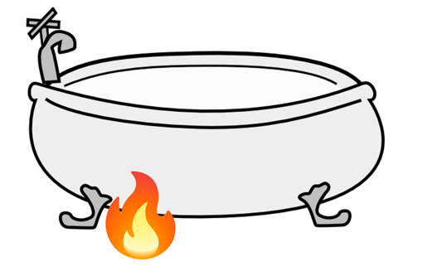
A simple natural system shows this. For example, a tub of water at the same temperature is at equilibrium; nothing happens. But, if one side is heated the equilibrium is affected and a water current is created as one side gets hotter than the other. Hot – Cold differences are not values. They are natural phenomena.
But if we ask what the difference means: is "Hot" better than "Cold?”, then we enter into perception and preference.

Here are 3 perceptions of “difference” that have impacted the course of human history. Consider where you have experienced them – in yourself, as expressed by others, or in social systems.

Difference as Threat
Many are wary or afraid of the concept of “different”. Different – means unknown, not like us, not like the life or ideas or practices we know. Different – means things might be changing and destabilizing us. I am “different” means I am an Outsider. Alien. Less Than. Unaccepted. Suspect. Awkward. I feel “different” and work hard to “fit in”. Or it can mean “I am Superior. Better. They are less than me. They must fit in with me”.

Difference as Richness
And yet, “different” is also wonderful and positive, the yet undiscovered, beckoning discovery. A new story. Different is – uniqueness, innovation, creativity. To be different is to bring new ideas and perspectives. Cultural and scientific innovations have come from people who dared to think and explore in the realm of difference. Divergent perspectives are critical for problem-solving and avoiding group-think. Differences mean variety, richness, many possibilities, and potential. We revel in the richness of art and language and color and stories, in faces, and dances, and songs, and ideas. Without differences we’re bored. We also die without difference – it is critical to life – the diversity of eco-systems is essential for planetary sustainability against the threat of monocultures; the diversity of humanity is essential against a monoculture of ideas.

Difference as Reframing and Connection
Sometimes, encountering something different stops us in our tracks and disrupts our autopilot thinking and response. This pause – even momentary – creates a focused moment of attention where we see from a different perspective and reflect on assumptions. For example, seeing PhD holders teaching kindergarten in Finland disrupts assumptions that teaching children is “child’s play”; seeing child soldiers and hearing their stories of violence they have to commit shocks us into awareness of the impact of war and the loss of childhood; seeing a statistics course using storytelling in analyzing data from a local community shifts many assumptions about teaching seemingly abstract subjects. Social revolutions for justice arise from embracing and supporting differences. Peace – at personal, community, and global scales - happens when we reconcile and integrate differences. Deep personal growth comes when we are able to see differences with curiosity, openness, and generosity.

Negating Difference: Human History of Power and Privilege
Oppression and domination of others and negation of difference came from people who saw differences as threats to power or for whom differences signified an Other, less than human who could be oppressed and erased without conscience. Difference lies at the heart of racism and subjugation of others and is a fundamental structuring principle at the root of systemic inequities.
Human cultures have developed in waves of interactions rooted in perceived differences. As people come into contact with another group, differences set up a binary structure (US-THEM) articulated in power dynamics. Those who are not like us are Other, and sadly often, less than us. Waves of conquest and subjugating of the Other are millennia old and part of our global cultural history. In the modern world, the pattern has been White European subjugation of many others. This map shows colonization in modern times through the 20th century. Only the 5 indicated countries were never colonized or significantly influenced by White European power. Think of the magnitude of this impact!
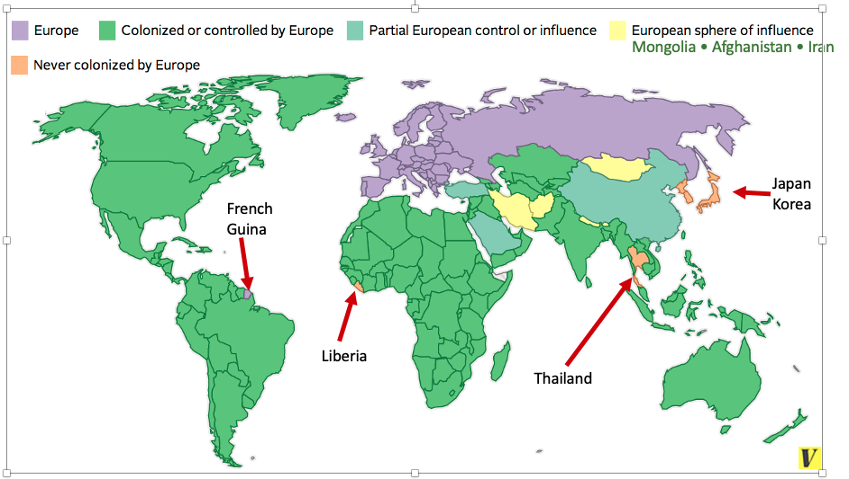Map Source

The legacy world. Imposition of a Eurocentric worldview or story.
The legacy of a racial colonizing history is inherent systemic oppression in the social fabric of how we experience the binary distinctions of who is empowered and privileged (has something seen as “better” “more valuable”) and who is disempowered and disenfranchised (marginalized, oppressed, erased).
The dominant metanarrative of “progress” is rooted in European developments of science and technology from the Enlightenment, the Western industrial revolution, and the political-economic expansion of European empires to colonize territories and people. This single story or metanarrative defined and continues to define global social systems and landscapes, the production economy, and globalized development (e.g., urban design, supply chain processes). Current world norms are based on Eurocentric perspectives and European exceptionalism – the idea that European definitions of progress, scholarship, knowledge, science, industry, and the arts are singular truths and hallmarks of human achievement.
This single narrative does not represent the plural world.
The Eurocentric narrative of modernity disregards the rich civilizations, technological and scientific contributions, and social systems of the global East and South.
Early innovations from multiple civilizations seeded much of the world’s collective knowledge and wisdom. Here are a few other examples from non-European parts of our world – What can you add?
- China (paper, printing, compass …)
- India (medicine, the concept of zero, astronomy …)
- African nations (metallurgy, medicine, mathematics …)
- Middle East (glass, philosophy, music, the first university …).
- South Americas, (astronomy, calendars, architecture …)
- Indigenous cultures around the world (medicine, astronomy, farming and land management)

And yet, much of this is absent in narratives of science and innovation that we read in school.
There is a telling irony in understanding that the European Crusades between the 11th and 13th centuries created contact, exchange, and trade with non-European civilizations that expanded European knowledge and technology development. This was instrumental for the European Renaissance, the flowering of arts, culture, and science that eventually led to European exceptionalism and its rapacious and oppressive colonizing impacts on these same cultures.
The legacy of a racial colonizing history is inherent systemic oppression in the social fabric of how we experience the binary distinctions of who is empowered and privileged (has something seen as “better” “more valuable”) and who is disempowered and disenfranchised (marginalized, oppressed, erased). The dominant map of human civilization has been a cartography based on European epistemology and ontology. The model of the “modern” world of science and progress rooted in concepts of European industrial exceptionalism sets up binaries of perception and power (civilized vs. primitive, developed vs. undeveloped, industrial technological vs. backward). This creates privileged bodies and power for some (social status and perceptions, cultural capital, and many degrees of freedom), while marginalizing, oppressing, and erasing erase black and other non-white cultures, and indigenous people. This narrative created the notion of the “Third World” a derogatory concept that views some nations as “less than” the European “First World or developed” nations measured by western currency, culture, technology, and industrial infrastructure. These frameworks ignore the highly developed richness of cultures, histories, and non-European modes of living, knowing, and being that might actually have less negative impacts on human and planetary well-being. It might be more accurate to think of these countries not as “under-developed” but as “over-exploited”.

PAUSE TO REFLECT: What do you think are the results of these dominant narratives in the contents and methods of scholarship and teaching in your discipline? Which groups of people or knowledge bases have shaped your disciplinary canon and methodologies?

What Happens When We Negate Difference? The Danger of a Single Story

TASK: View this video: The Danger of a Single Story [19:16 mins]
In this video of her TED talk, author Chimamanda Ngozi Adichie speaks about the importance of many stories rather than one singular narrative.
"Stories matter. Many stories matter. Stories have been used to dispossess and malign. But stories can also be used to empower and humanize. Stories can break the dignity of a people. But stories can also repair that broken dignity. When we reject the single story, when we realize there is never a single story about any place, we regain a kind of paradise."

Stories are constructed and plural.
We “story” our world; our governing patterns of thought shape how we sense-make and act. While the world is objective, the reality we perceive is not. Stories - narratives – perspectives – worldviews - theories (they are called different things in different disciplines) are based on phenomenological ontologies and epistemologies, our embodied lived experiences. And it is not just cognitive - it’s an outcome of our physical, social, emotional, and cognitive dimensions (Chandler, 2007). This implies the existence of a multiplicity of perspectives shaped by who we are and that shape us in turn (Beaumont, P., & Coning, C. de., 2022; Escobar, 2021; Tummons, 2021).

Stories take different forms.
They are not always narrative texts. Socio-cultural stories come in images and metaphors, explicit laws and policies, tacit norms of behavior, themes in cultural texts such as books, films, artwork. Architecture is a "text" and story - e.g., the symmetry and size of imposing Roman columns in European buildings for centuries tell a story of heritage and power. Open plan, glass clad homes tell a different story of lifestyle and values compared with cottage style houses with small windows and multiple rooms.

Hegemonic stories are destructive.
There are many entangled stories of power and privilege beyond race – gender, sexuality, religion, age, citizenship, appearance, ability. The resulting dynamics shape how our social systems work. Different levels of access, information, choice, and power shape responses to shifting contexts and differences in situations or people. We can accept or reject refugees, legislate to ban books that we do not like, create housing programs etc. We can allow unhealthy feedback loops to amplify injustices for some because it sustains power and privilege for others. With long-perpetuated systems, we often do not even realize the imbalances for some people if we ourselves do not experience the negative outcomes.
Chimamanda Adichie describes how dominant stories shape minds and constrain norms for human interaction. Historically rooted in power dynamics of difference, a dominant system of power imposes a hegemonic stories that devalue, marginalize, silence, and erase other stories. We see this in metanarrative critique of legacy systems in liberatory pedagogies, post-colonial literature, feminist theory, and critical theory that reveals how dominant stories maintain embedded, systemic power and privileges. Hegemonic domination is more than the destructive, tangible occupations and oppressions of territory, people, and social structures. It also colonizes minds and hearts, imposing ways of thinking that erase sense of self, agency, and imagination. The latter colonizing effect can be far more poisonous to human flourishing and a deeper barrier to transformations for justice.

Change Tool: Plural thinking as resistance to hegemonic stories.
“Each one of us has within him a whole world of things, each man of us his own special world. And how can we ever come to an understanding if I put in the words I utter the sense and value of things as I see them; while you who listen to me must inevitably translate them according to the conception of things each one of you has within himself. We think we understand each other, but we never really do.”
– Luigi Pirendello. Six Characters in Search of a Play

Our first step in disrupting these erasing narratives is to become aware of them, adopting systems-oriented multi-ontology thinking. This is the ability to engage on ontological pluralism or the ability to see and embrace multiple different perspectives rather than cling to one way of seeing and doing things. This is admittedly hard to do as it means cultivating epistemic humility “the ability to embrace the fallibility of one’s knowledge, and more broadly, one’s ways of thinking (in) the world, in light of an encounter with difference” (Vizcaino, 2021; p. 7).
This idea of a plurality of stories challenges Eurocentric metanarratives rooted in ideas of the centrality of man, European exceptionalism, western science, and western industrial development. Jean-Francois Lyotard (1984) described this as "an incredulity toward metanarratives”, a sense that a singular view of anything is not the only truth and could not possibly represent the shifting, changing, complex reality where multiple stories jostle together.
The gift of ontological pluralism and epistemic humility is being cognitively and emotionally open and nimble in engaging in radical listening, empathy, and inter-perspectivity. These capacities are enhanced through reflexive thinking that helps us shift perspectives to connect with others, see alternative ways to think about things, to question how our own minds might have become habituated or conditioned, so that we can be creative, connective, adaptive, and responsive to circumstances.
This part of systems thinking involves our personal capacity for radical change.

PAUSE TO REFLECT
In integrating this idea of the danger of a single story and systems thinking, what connections can you trace to the key principles of transdisciplinary pedagogy that you read in Chapter 1?

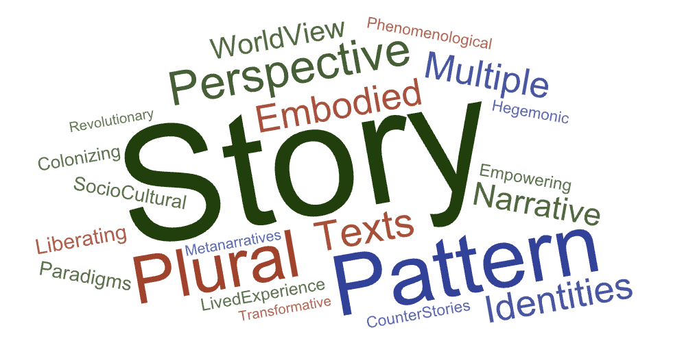

Difference as a Reflexive Tool: Intentional Reframing and Rethinking
Artists use difference - defamiliarization or making strange – to amplify multiple stories and possibilities in order to disrupt habituated thinking and expectations. This process creates a heightened state of perception, attention, and thought in their audience, surfacing conditioned thinking and assumptions, and making us pause to question things, i.e., creating a reflexive moment and taking audiences into double loop thinking). This disruption is the first step toward creating awareness and action for change.
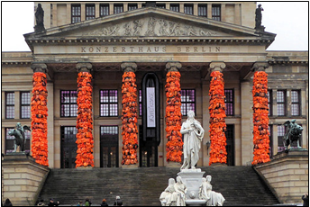
Image Credit: Gertrud K. Berlin
How does Ai Wei Wei’s installation (2017) of refugee lifejackets on a classical European building use defamiliarization to disrupt and heighten awareness and perspectives on current affairs?


Image Credit: Jaana Eleftheriou, Houston

What are your responses to the strangeness of blue trees (2011 – 2018) by Konstantin Dimopoulos? What might this difference be disrupting and calling into focus?

What might be some similar transgressions/disruptions we have experienced or observed in other social spaces as part of shifting social perspectives about something?

The Legacy Education System

TASK: Connect with Paulo Freire
- READ FREIRE CHAPTER 1 AND 2 Pedagogy of the Oppressed. (33 pages).
Link to e-Book at Claremont Colleges Library
- Select an extract (sentences, a short paragraph) to share with your peers. Be prepared to share why this extract is important for educators. Why does this stand out for you - does it connect to your lived experiences as a learner, an educator, a parent? How does it connect to the ideas about systems perspectives, difference, power, hegemonic stories, legacy education, and the transmission to empowerment model? Does it connect to some aspect of your own discipline and scholarship? Does it speak to some aspect of how humanity prepares itself for the emerging future? Consider what you find mind-blowing, puzzling, frustrating, revealing etc. What thoughts or questions does it evoke for you about teaching and learning in classrooms today?
Context
Paulo Freire was a Brazilian philosopher and educator. His Pedagogy of the Oppressed (1968) strongly influenced movements in critical and liberatory pedagogy development around the world. Following Frantz Fanon’s (1961) The Wretched of the Earth with its call for an education beyond the cultures of colonization, Freire analyzed colonization through education. He proposed an education that developed a self- and other-awareness – conscientization. This includes a critical understanding of self and social realities through the integration of reflection, recognition or awareness, and action. Chapter 1 presents many of Freire’s key themes about freedom and education. Chapter 2 presents his concepts of “banking” and “problem posing” models of education and outlines key elements of his pedagogy. Look out for his concept of revolution as a “dialogical” process central to problem-posing education. Consider connections to elements of transdisciplinary principles of multiple perspectives and plural thinking, co-creation, and reflexivity.

On humanization. “While the problem of humanization has always, from an axiological point of view, been humankind's central problem, it now takes on the character of an inescapable concern. Concern for humanization leads at once to the recognition of dehumanization, not only as an ontological possibility but as an historical reality. And as an individual perceives the extent of dehumanization, he or she may ask if humanization is a viable possibility. Within history, in concrete, objective contexts, both humanization and dehumanization are possibilities for a person as an uncompleted being conscious of their incompletion. But while both humanization and dehumanization are real alternatives, only the first is the people's vocation. This vocation is constantly negated, yet it is affirmed by that very negation. It is thwarted by injustice, exploitation, oppression, and the violence of the oppressors; it is affirmed by the yearning of the oppressed for freedom and justice, and by their struggle to recover their lost humanity.” (p.43)

Transformations for the future. “Problem-posing education is revolutionary futurity. Hence it is prophetic (and, as such, hopeful). Hence, it corresponds to the historical nature of humankind. Hence, it affirms women and men as beings who transcend themselves, who move forward and look ahead, for whom immobility represents a fatal threat, for whom looking at the past must only be a means of understanding more clearly what and who they are so that they can more wisely build the future” (p.86).

Legacy Education as a Single Story Locked in Time: Broken Connections
The legacy system of education is a product of the singular colonizing metanarrative explained above in its articulation of the contents of learning, scholars represented, ontological and epistemological assumptions, methods, practices, and policies. Unlike some other social systems, legacy education has shown immense inertia, resisting change to align with a changing world. It is ironic that the academy, a place where scholars push boundaries to expand and reframe knowledge resists change in teaching and learning. Instead, academia has long perpetuated and reproduced assumptions, practices, and biases that leave us with a long legacy of social inequities. Taking a systems view of education is the first step toward intentional transgression to disrupt and dismantle oppressive and outdated practices (the Transmission model), and to transcend and transform by re-imagining and creating equity-minded pedagogies that honor all learners and support them in flourishing (the Empowerment model).

Here are some of the key misalignments between legacy education and our current-future world.
- Broken connections with current college populations. Legacy education was designed to reflect and perpetuate social, political, and economic power structures of European life-worlds. College education was designed for White, wealthy, able-bodied, Protestant, and cis-gendered males, with a common lived experience and social aspirations¹. This one-size-fits-all design of legacy education is wildly out of alignment with college populations today that brings together a rich diversity identities, ages, social roles, lived experiences, dreams, goals, and needs.
- Broken connections with a plural knowledge era. Disciplines have inherited knowledge and curricula based on European and Eurocentric knowledge and scholarship. Different ways of knowing especially indigenous knowledge are excluded. This is challenged by scholars from different disciplines such as Helga Nowotny, Peter Scott, and Michael Gibbons (frameworks of Mode 2 or context-embedded knowledge production); Tyson Yunkaporta, Marie Battiste, James Henderson, and Gregory Cajate (indigenous modes of knowing); Dolores Bernal and Ruth Galvan (critical race-gender and feminist epistemologies) among others.
- Broken connections with the emerging future. Legacy education was created for a world that no longer exists. Today, we prepare students to enter a radically different VUCA future (volatile, uncertain, complex, and ambiguous).
- Broken connections with learning sciences. Legacy pedagogy is based on misassumptions about intelligence, learning, and motivation based on racist and gendered frameworks and research. Current research in learning sciences contradicts many legacy beliefs and practices in teaching and learning.

Legacy Education: A Story About the Inertia of Systems
“Even as all this change occurs, there are those who argue that the core concept and method of universities will not radically change. They argue that mostly unfulfilled predictions of significant improvement in the effectiveness and wider distribution of education accompany every major new communication technology. In the early days of their evolution, radio, television, personal computers—and even the telephone—were all predicted to be likely to revolutionize formal education. Nevertheless, the standardized knowledge-transmission model is primarily the same today as it was when students started gathering at the University of Bologna in 1088.”
Anderson, J., Boyles, J. L., & Rainie, L. (2012, July 27). The future of higher education.

STORY: Here is a story about change and the misalignment of education with current times. This story is from Professor Alan Luke, from Queensland University Australia who told it at the International Reading Conference in 2001.

Image Source

Imagine a time traveler, plucked out of the 1650s and thrown in an instant into the middle of Times Square, New York City. Looking through their eyes and mind, nothing is at all familiar; the city sounds of traffic, smells of automobiles, the pace of movement, the materials in steel and glass clad buildings, the colors and textures of people's clothes, the shapes of bags, strange metallic objects that people speak into, frightening vehicles moving at what will seem like dizzying speed. Even the gaze and faces of people will seem otherworldly.

This person could very easily go instantly, screamingly, mind-crushingly insane.

BUT …. What if this time traveler - by chance - happened to be flung into a classroom in the Bronx?
The clothes would still be different, and maybe there is a woman instead of a man up front. But there would be enough there to recognize and bridge the gap between the old world and the new; tables and chairs in rows, authority figure up front (must be teacher), people in the seats facing forward (must be students) … I’m in a school room!


The world has changed radically in 300+ years, but schooling … not so much!!

Higher education works strongly within the status quo of legacy education when it comes to fundamental assumptions of teaching and learning. Even as many elements change – architecture, technologies, new services, policies etc., these fundamentals do not easily shift.

Why is this? Why is there such a resistant force in education? What would it take to change fundamental assumptions, values, and beliefs?

Consolidation: Systems Thinking for Transformation and Innovation
In the above section, you explored systems thinking and the impact of difference in shaping global human systems of power and exclusion. Systems thinking reveals the complexities inherent in any context or issue and prevents us from over-simplifying with linear, sequential thinking. We are better able to work with the “messiness” of complex situations.
Here are a few examples of how systems thinking helps us work transformatively (how many more can you think of?
- Ecology. In becoming conscious of human impact on natural planetary systems, we make a choice to work for sustainable human systems of commerce, industry, and living.
- Racism. In learning about systemic racism and oppression, we choose to understand and take action as allies, advocates, and activists in our own spheres of influence however modest.
- Women’s rights. In becoming conscious of systems of subjugation of women in patriarchal societies, we make a choice for equitable inclusion of women in all aspects of life.
- Political revolution. In becoming conscious of political corruption and hegemonic rule as domination systems, we make a choice for revolution and new government.
- Medicine. In becoming conscious of the interconnections between radiation and social impacts in multiple sectors, we make a choice to explore and create technologies to counter it.
- Education. In becoming conscious of the inequities and oppressions and the misalignment of the legacy system to current world needs, we make a choice to transform teaching and learning.

For ethical educators, systems thinking reveals patterns of inequity in the legacy educational system. Together with ethical, reflexive thinking, and evidence-based pedagogy, systems thinking – understanding our mutual interconnectedness informs our professional and scholarly practice. It is the first step toward making intentional choices to change teaching and learning toward equitable and just outcomes for all. We become nimble, responsive future-focused, and ethical educators.

“I am cognizant of the interrelatedness of all communities and states. I cannot sit idly by in Atlanta and not be concerned about what happens in Birmingham. Injustice anywhere is a threat to justice everywhere. We are caught in an inescapable network of mutuality, tied in a single garment of destiny. Whatever affects one directly affects all indirectly. Never again can we afford to live with the narrow, provincial “outside agitator” idea. Anyone who lives inside the United States can never be considered an outsider anywhere in this country”.
Rev. Dr. Martin Luther King, Jr., Letter from Birmingham Jail, 1963

PAUSE TO REFLECT: Using Systems Thinking in Your Scholarship and Practice
- In what ways are you already of systems thinker – how aware have you been of the large patterns outlined above?
- As a scholar, professional, and educator, why is it important to understand systems as dynamically interconnected, shaped strongly by power dynamics and interpretation?

Application: Mapping Education as a System
“A system isn’t just any old collection of things. A system is an interconnected set of elements that is coherently organized in a way that achieves something. If you look at that definition closely for a minute, you can see that a system must consist of three kinds of things: elements, interconnections, and a function or purpose.”
Donella Meadows (2008) Thinking in Systems

Systems thinking does not make the solution easier (in fact it reveals complexities). However, it is a great tool for problem-finding; it reveals interconnections, assumptions, feedback loops, and unintended consequences (purposes) that help surface systemic inequities, as well as unconscious and deeply conditioned assumptions. This first step of explicit awareness and understanding helps us to begin dismantling inequitable practices and to build equity-minded transformations.
In this section, you will apply your understanding of systems to unpack and analyze legacy education.

TASK: Visual storytelling: Represent the elements in a system.
Here is an abstract sketch of a system. Use this as a representation of the system of education. Label the parts (the dots and lines) and the whit e space.

Begin by naming the central large dot. Remember that there is no actual center in systems, except in the eye of the perceiver and the focal point they select. In this map, you define what you as perceiver would put in the center.
Name all the other elements – what are the smaller dots? What do the lines mean? What about the white space between the lines? For this task, do not add or remove anything from the abstract framework you have been given; use it as is.

TASK 2. Visual storytelling: Map and analyze the education system.
As a systems thinker, analyze the parts of the education system to understand it as a whole and to analyze where the barriers are for different populations of learners.

ELEMENTS - the things or "stock" in a system. These comprise objects, living beings (people, animals, plants), spaces, ideas (law, policies, social norm), practices etc.
- Make a list of the elements in the system of education at college level.
INTERCONNECTIONS - the ideas, relationships, rules, norms of how things work that link elements to each other. In a system, everything is fluidly connected to many other things in relationships – causal, to block, amplify, enable etc.; often through feedback loops. These relationships among the elements cause a "flow" or reaction among the elements, which creates further shifts and adjustments. Larger and smaller reverberations travel through the whole system.
- Connect all the elements (or as many as you can) by building a mind map (check out the resources below) showing interconnections between the elements in the college education system.
- Trace how they affect each other - what positive and negative outcomes happen – what feedback loops can you see - can you see how interactions of different elements cause barriers and inequities for some students? What does the map NOT show? Whose stories and contexts are not present?
EMERGENT PURPOSE.
"As important as purpose and goals are, we almost always take them for granted. When you change them, systems fundamentally change."- Andrew Hening. Systems Thinking Part 1. The Medium.
Each system has a purpose, often to seek equilibrium and sustain itself. Natural ecosystems respond to change to rebalance and find new equilibrium. In human social systems, purpose is less obvious. We make a distinction between desired purpose (a conscious goal we might have) and the emergent systemic purpose and unintended outcomes. The two can contradict each other, for example, a desired purpose to provide temporary shelter to help homeless populations actually exacerbates and reinforces homelessness (Stroh, 2015).
- What is the mission of college level education – and for whom? Remember that different stakeholders might have different missions that do not align with each other.
- Consider aspirational missions (what you think it ought to be) and the actual mission or emergent purpose the legacy system seems to have. In what ways does the legacy system’s emergent purpose block your aspirational mission? What elements of deep conditioning or assumptions drive the system? What is missing or must change to transform higher education’s mission to be more aligned to your ideas for a reimagined educational process?

RESOURCE: System Mapping Tools
“A system is never the sum of its parts. It’s the product of their interaction.”
Russell Ackoff 2003

Here are some useful resources to help you explore methods and tools for exploring the elements and interconnections in any system.

About systems mapping. Leyla Acaroglu is a systems thinker and teacher of systems thinking. This webpage on Medium has some very useful tips and approaches to drawing a systems map.

Drawing Systems Maps. Open University. These video tutorials explains how to draw spray diagrams (like mind maps) to explore ideas. This webpage also has a list of other short videos on systems thinking and mapping.

Mind Mapping Tools.
There are some excellent mind mapping tools our there … many free! A good one to use is GitMind.
- This article on Medium reviews some other tools and presents what they do, and their pros and cons. The author looks at iMindQ, Coggle, Mindomo, Mind42, Bubbl, Mindmeister.

- Low-Tech. The paper-technology approach. Mind mapping is essentially putting elements of a system into a space, finding categories and patterns, and connecting them to show how they interact – cause-effect and causal feedback loops. You can just as easily do this on a large sheet of paper or a whiteboard and then take a photo to share. The only downside to this is ease of making changes and working collaboratively with people who are not physically present. For this, the digital tools are a real boon.

Oxford University Map the System! Competition. A very cool and powerful application of systems
This is an initiative at Oxford University and a global competition in partnership with other institutions around the world. The goal is to change conversation and strategy in social impact education toward a co-creative understanding of complex problems as part of transformative change. In this competition, participants from multiple disciplines use systems thinking to explore a complex issue in the world and share their findings in a meaningful way. The website has a video of the final presentations where participants share their maps and discuss what they learned.
You might be interested to apply to participate with your research.

Images of systems thinking maps

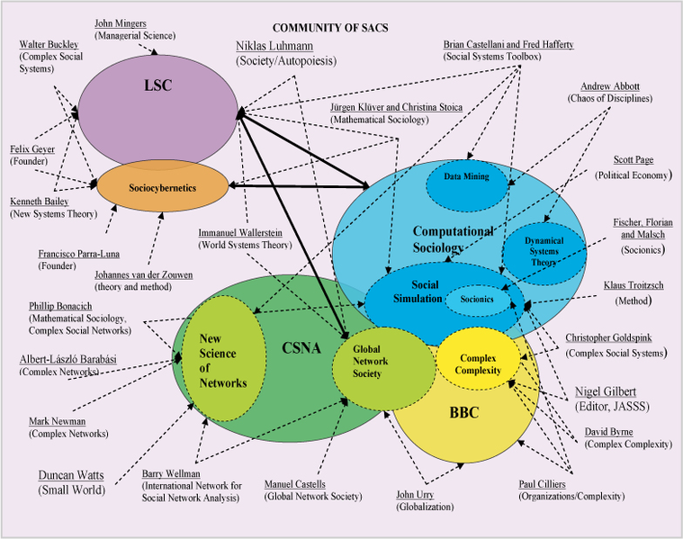
Image source. A systems map showing the landscape of sociology.

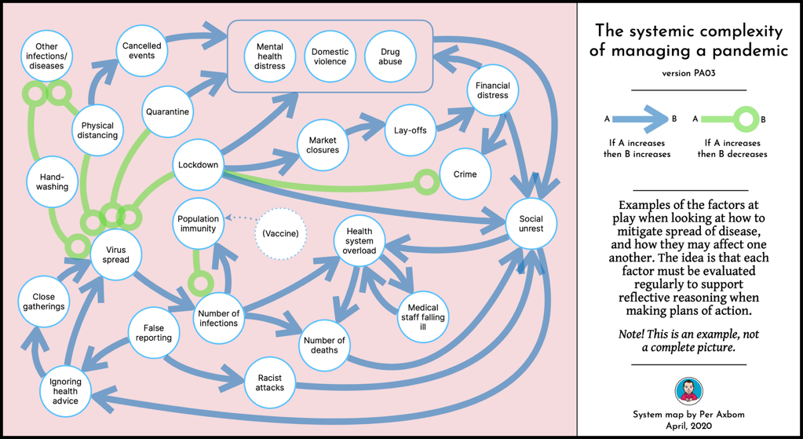
Image source. A systems map showing the partial complexity of managing a pandemic.
The map shows both amplifying (Increase in A causes increase in B) and dampening feedback loops (increase in A causes decrease in B).

Imagine visualizing a literature review!

Chapter 3: The Paradox of Change. Tools for Changemaking

In the earlier chapters you explored the big systems picture – basic principles of transdisciplinary pedagogy, the complex, interconnected nature of human systems, especially with the insertion of consciousness and volition into systems dynamics. You looked at how human responses to difference created systems of domination and power that perpetuate colonizing narratives that marginalize, oppress, and erase people and ideas. We explored the importance of countering this single hegemonic narrative through the empowerment of plurality – multiple narratives and stories.
In education, the dominant colonizing world view created a legacy system misaligned in many ways to current and future learners and contexts. As ethical educators and changemakers, our next move is toward transformation using a justice-oriented lens to examine entrenched perspectives and deep conditioning that has shaped the practice of education. In this chapter, we explore the nature of change and why people resist it. In connection with that we will learn critical frameworks for change making that will enable you to analyze issues and situations to understand how and where transformative change can happen, and conditions that support effective change.

An essential question in this quest: Why is it that people fear change and want to persist with the status quo they know?

We will explore:
  - Paradigm shift and change dynamics. Resistance to change.
  - Change Tool: Counter mapping
  - Change Tool: Contextualizing. Multi-ontology decision making. The Cynefin framework (pronounced KE-NE-FIN)

Paradigms and Paradigm Shift Overview

Your paradigm is so intrinsic to your mental process that you are hardly aware of its existence, until you try to communicate with someone with a different paradigm. - Donella Meadows

“Paradigm” comes from Greek paradeigma – meaning pattern, model, or precedent.
A paradigm is a deep perspective, a way of thinking, or lens through which we view the world and that affects our responses and actions. Our paradigms are systems of patterns (conscious and unconscious) that govern our sense-making, decision-making, and how we respond to the world. It is therefore a thought-action system.

Characteristics of paradigms:
- Bounded and Socially Constructed. Our paradigms comprise established and bounded knowledge and sets of rules or norms that we learn through explicit instruction and/or lived experiences. Scientific paradigms are learned through instruction within a bounded set of ontological-epistemological principles. The paradigm of positivism is grounded in an ontological-epistemological position of a single objective reality that can be measured, while constructivism comes from an ontological-epistemological position that there are multiple realities that must be interpreted. Socio-cultural paradigms shape our social roles and norms for example the paradigms of parenting, or practices surrounding birth and death, or determinations of what is Literary or Artistic.
- Stability Through Gatekeepers. Paradigms have a gatekeeping process that perpetuates it and keeps it stable. These can be formal disciplinary experts or informal social opinion and actions. Experts validate approved methods, research studies, and ideas through formal structures such as journals and conferences, doctoral programs, and scholarly or expert positions. Informal gatekeeping comes from cultural and social opinions of social leaders like fashion and music experts, media influencers, public opinion, and institutionalized cultural structures such as religious institutions, museums, and cultural rituals. This gatekeeping is also responsible for the perpetuation of dominant paradigms such as the legacy education system, or paradigms of what constitutes “good” art, or “proper” language.

Examples of Paradigms
- Scientific methodologies.
- The geocentric view – the earth is in the middle of planets, the sun, and other stars.
- The heliocentric view – the sun is in the middle; planets revolve around the sun.
- Political systems – democracy, socialism, communism.
- The canon of good literary works (Shakespeare is literary, Harry Potter is not).
- What constitutes good Art.

Paradigm Shift and Transformation
A paradigm shift is the best a scientist can hope for. Whenever I smell an opportunity like that, I go after it. You have a new discovery that something's working in a different way than you thought. E. O. Wilson

Thomas Kuhn, physicist and philosopher, presented the concept of paradigm shift in his 1962 work The Structure of Scientific Revolutions. Paradigms while bounded and governed by a system of gatekeepers are not fully stable; paradigms can change. For Kuhn, science proceeded through exemplars within the established paradigm until challenged – entering “revolution” that yields a new paradigm.

According to Kuhn, there are 3 phases.
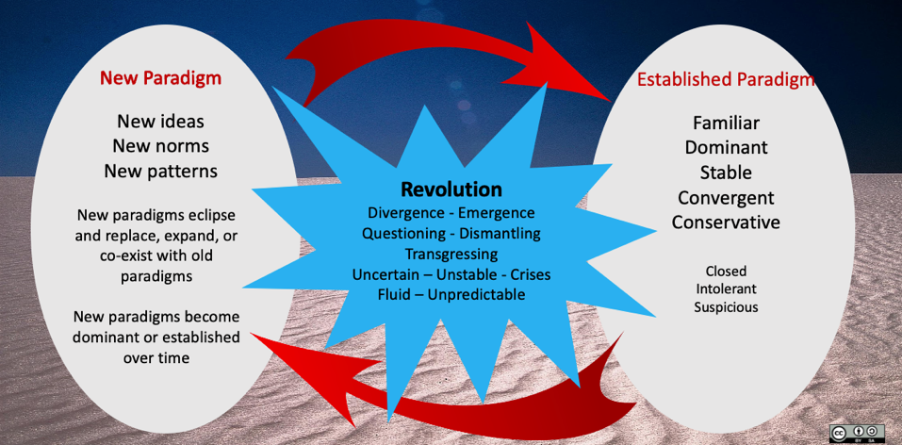Image Source: Shamini Dias

PHASE 1: A dominant and established paradigm or “normal” phase.
- In the “normal” paradigm, we work within established and bounded norms without questioning assumptions of practice as many of these are unconscious or learned as correct in our socialization and formal schooling. We go by “how it’s always done”, “what the experts say”. Normal paradigms are the dominant story, legacy narrative, or status quo. We learn and use research methods, medical treatment, and social practices without too much questioning.
- Gatekeepers maintain the dominant paradigm – experts, those in authority and positions of power, those with social influence. These gatekeepers in positions of authority establish rules, norms, and processes within which we live and work. There is a kind of orthodoxy whose assumptions and methods resist contradiction.

PHASE 2: Revolution
Paradigms can be destabilized and shift if something significantly alters or dismantles the major ideas and assumptions of the paradigm. We then get the tension of dominant narrative against difference.
- Paradigm shifts can emerge from cataclysmic events (natural disasters, wars, pandemics etc.); scientific, artistic, and technological developments (discovery of quantum reality, nanotechnology, artificial intelligence, new art and theatre); and social issues (antiracism and other human rights, new modes of government, responses to environmental sustainability).
- These new elements call prevailing perspectives and methods into question. For example, Copernicus challenged the geocentric perspective in the 16th century, quantum physics problematized assumptions about space-time and matter, the Civil Rights movement disrupted deep social and political assumptions about race and human rights, Gandhi resisted colonization, Van Gogh and other Impressionists questioned the paradigm of Realist art.
- As we saw in Chapter 2, differences are often seen as a threat, especially in contrast to a dominant narrative. This leads to an intensification of gatekeeping, where established narratives or paradigms are defended by those in power, while new contradictory ideas are rejected as abnormal, aberrant, anomalous, or just wrong. We have a long history of rejecting new ideas.

“[p]eace that was based on oppression was defended as neutral and natural, and the disruption that was based on justice seeking was seen as the problem” - Kimberle Crenshaw. 2021 ACLU Interview.

PHASE 3. New Normal. Emergence.
However, if the challenges and counter stories persist and grow, the paradigm reaches a sufficient level of destabilization or fluidity that allows new ideas or methods to take root. A new paradigm then replaces the old one, expands it to integrate the new ideas, or co-exists with the old paradigm.
- The geocentric paradigm of the solar system was replaced by the heliocentric paradigm.
- Newtonian physics was expanded by Einsteinian physics.
- Impressionist art became an accepted paradigm co-existing with Realism.
It’s not always so neat and it can be dangerous and violent.
- Galileo was persecuted by the Church for heresy.
- The Civil Rights movement gave rise to a new paradigm for human equity and equality that continues in tension with old paradigms of difference and power.
- Gandhi and Martin Luther King were assassinated.
- Paradigms of women’s roles and rights are in continuous tension in different spaces – e.g., while women in some nations walk easily into education, Malala Yousafzai was shot in the head just trying to go to school in Afghanistan.

Typically, a paradigm holds steady for a long period of time with short bursts of crises and revolution, e.g., natural disasters and human wars, or long extended periods of very gradual change, e.g., geological ages or cultural development through extended contact. We can see this as complex adaptive systems change. However, as a result of technology, knowledge access, innovations, and sharp planetary impact, paradigm shift is accelerating, with extended periods of time spent in crisis or revolution phases. This explains the VUCA world of social and global uncertainties, volatility, and significant shifts in how we live and interact with others.

Systems view of change and paradigm shift
Emergence and change are outcomes of dynamic interactions of elements in a system and between systems. Systems shift and emerge into new patterns as elements interact or new elements enter –
- In nature - a new creature enters the ecosystem causing a different interaction of flora and fauna, or an earthquake happens and shifts the flow of a river system.
- In social systems – new technologies for communication, new fashion trends, war and refugees, new laws, parents deciding to homeschool.
- In interactions between nature and humans – overfishing of salmon in Alaska, a new virus creating a global pandemic, wildfires destroying forest and property.
As new elements bring new interactions and connections, new contiguities and interactions, the overall system patterns shift - or re-equilibrate - to maintain the fundamental purpose for the system as a whole to survive. We see this at the macro level of social systems when crisis-based elements come in (a pandemic, social unrest, political strife, a natural disaster). We also see it in the normal ebb and flow of social microsystems - think of fashion elements entering in and disrupting how we think about clothes, for example the radical entry of trousers for women, or the stopping of foot binding in China etc.

CASE EXAMPLE: Paradigm shift and entering “new normal”.
The 2020 COVID pandemic caused radical shifts in life. We adapted. Typical of paradigm shift, many innovations, while addressing immediate problems, also raised new and hidden issues that point to deep assumptions in our pre-pandemic life paradigms.

Work and Home Life
- Paradigm shift: Remote work, worker autonomy, home delivery, curbside pick-up.
- Positive Impact: Cost savings, increased effectiveness, improvement in work-life balance and time for wellness, more family time, lower commuting costs, lower commuting impact on the environment, lower space and utilities cost for businesses…
- New issues: virtual meeting fatigue, professional isolation, home-work space availability, privacy, work-life boundaries, technology access and consistency,
- Questioning pre-pandemic practices and assumptions: Definitions of supervision and worker autonomy, efficiency, and effectiveness measures, working hours definitions, expectations of presence at the workplace

Art Galleries and Museums
- Paradigm shift: Artists’ online sales and peer support, online exhibits and artists talks, virtual walk-throughs.
- Positive Impact: Broader viewership and sharing, community formation, cooperatives and collectives, open access - taking away traditional barriers to art
- New issues and questioning assumptions in the process and production of art, audiences, and the role of art. Artists’ workspaces and sustainability of practice, equity - art as an elite practice and industry, definition of art audiences, publicity, and communication methods

Conferences
- Paradigm shift: Virtual conferences
- Positive Impact: Broader access - Lower prices, diverse audiences – from local to national to global - taking away traditional barriers to scholarly exchange.
- New issues and questioning assumptions about scholarly sharing, audiences, cost expectations - Conference industry business loss, loss of informal face to face connections in tension with costs savings and broader access
Education
- Paradigm shift: Online teaching – integrating multimedia that is easy to access.
- Positive Impact: Integrating easy to access digital tools, asynchronous teaching allowing students flexibility in managing workloads, awareness and action for wellness and care
- New issues and questioning assumptions that have shaped legacy education: relevance and injustice of timed and proctored exams, compliance-and contract-oriented design - student motivation through external factors of punishment and rewards, the primary of read/write modes of instruction and learning.

Resistance to Paradigm Shift
The COVID pandemic plunged us first into crisis mode. Many educators adapted effectively. Adaptations came not only from pivoting to online modes, but from the stark visibility that the crisis created of social injustices and how they impacted education. There was a growing recognition of student diversity, life contexts, and home situations. We saw that many digital age norms easily accessed for some are blocked for others. The central importance of social-emotional wellbeing and care for learners and teachers rose to the surface. Teachers and learners innovated by:
- Creating hybrid ways to learn combining asynchronous and synchronous activities to create flexibility for students and teachers to access and engage.
- Integrating digital tools that are easy and free to access and use.
- Rejecting timed and closed books exams to eliminate intrusive online proctoring.
- Using portfolios and project-based learning to work better with asynchronous modes.
- Using multiple modalities and methods to support students to engage and participate at their comfort level and in multiple ways.
- Integrating wellness and care into learning processes and spaces.
- Using Open Educational Resources because they are easier to access online - which therefore also took away expensive textbooks.
- Ending traditional isolation of teachers to collaborate and share ideas for online teaching.
- Ending traditional learning in isolation with groups and sharing through social media.
These innovations led to positive outcomes that also raised questions about legacy practices.
- Positive Impact: increased use of flexible teaching and learning, experiential active learning, workload reframing, ensuring access, awareness and action for wellness and care.
- New issues and questioning assumptions that have shaped legacy education: relevance and injustice of timed and proctored exams, compliance-and contract-oriented design - student motivation through punishment and rewards, the primacy of read/write modes of instruction and learning, the importance of lived experiences and students’ identities and cultures.

However, as with many social paradigm shifts, new stories of teaching and learning while forming a new paradigm, co-exist with the legacy paradigm. Many teachers who had to move to online teaching replicated the same legacy methods, not seeing the transformative potential to change the paradigm:
- Maintaining the time structures of full days of classroom attendance that ignored the critical difference and harm of doing that in constant online video sessions.
- Massive homework loads to “make up” for lost instruction time.
- Maintaining high stakes testing in closed-book timed exams in online spaces using proctoring software that ignored the added layer of digital stress and surveillance.
- Maintaining assumptions and expectations of participation as “speaking up” in class and quiet learners as disengaged.
- Maintaining long lectures with passive listening as the primary mode of teaching.

Connecting to the larger world.
Outside of education, the same tension exists between paradigm shift and resistance to change. Here are some examples. Ask yourself - why do people resist a new normal and cling to life as it used to be?
The planet. Our carbon footprint dropped significantly during the pandemic lockdown with less air travel and use of cars, less use of office and retail space that also reduced energy consumption. People shared pictures of smog-less freeways and cleaner water around the world. But will this last or have we returned significantly to old norms and levels of massive consumption?
Families and communities found ways to connect and interact using virtual apps and innovative use of community spaces. Will we have the imagination to continue this and maintain connectedness and neighborliness even as we return to physical social connections? Will community meetings continue to offer a range of options for those unable to engage in traditional ways?
Business-community interaction. Businesses showed a greater social responsibility in supporting homeless and hungry people during the pandemic. Do they now integrate some of this part of normal business practice moving forward? Or will social responsibility decline post-pandemic?
Social issues. Businesses, governments, and people in communities saw the dark sides of racism and other oppressions revealed through social protests and activism and many joined in solidarity to support a movement for change. The massive crises of conflict and refugees created awareness of forced human mobility that galvanized efforts to help. Will we continue the effort for a new paradigm of social awareness with collective social action without being distracted by a false sense of “return to normal”?

Change Paradox: Opportunities to Transform for Justice.
Indian author, Arundhati Roy, writing about the pandemic and its resulting changes, uses the metaphor of a portal, a threshold through which we walk into a new world:

“Our minds are still racing back and forth, longing for a return to “normality”, trying to stitch our future to our past and refusing to acknowledge the rupture. …But the rupture exists. And in the midst of this terrible despair, it offers us a chance to rethink the doomsday machine we have built for ourselves. Nothing could be worse than a return to normality. Historically, pandemics have forced humans to break with the past and imagine their world anew. This one is no different. It is a portal, a gateway between one world and the next. We can choose to walk through it, dragging the carcasses of our prejudice and hatred, our avarice, our data banks and dead ideas, our dead rivers and smoky skies behind us. Or we can walk through lightly, with little luggage, ready to imagine another world. And ready to fight for it.” – Arundhati Roy. The Pandemic is a Portal

PAUSE TO REFLECT
Why do you think people resist transformations that come with change, even though they can lead to positive social and future good, and instead long to “return to normal”?

For a long time, the world moved slowly moving from Normal to Revolution to New Normal in steady succession. Change took time – centuries where norms could send deep roots into social-political-cultural psyche. Stability and predictability are thus seen as desirable strengths and sought after. We share in a social desire to seek stable lives and to be able to count on predictable ways of doing things. With this comes wariness and fear of change, new ways of thinking and acting in the world.
However, today we live in a world where change is accelerated. Stability and predictability seem for many to be under threat in a VUCA world (Volatile, Uncertain, Complex, and Ambiguous). As the revolution phase of crisis and uncertainty becomes our new normal, many are perplexed and anxious about how to navigate this new normal.
Therefore, a desire to “return to normal” exists in tension with paradigm shift and transformation, as a tension between emergence and change in the Complex domain and habituated automaticity and gatekeeping in Clear and Complicated domains. A phrase that we often hear in a crisis as both hope and desire is “getting back to normal”, a natural and immediate thought as a crisis ebbs away and we emerge from functioning in crisis-mode. We are tired and feel eager to get back to the comfort and stability of how things were, to restore what we had.

Perspectives on Change
In developing a practice of equity-minded education and engaging in transformative approaches in teaching and learning for positive social and future good, we must understand and work with the following key principles about change and human experience.
- CHANGE IS NATURAL - an integral aspect of reality, something we’ve always known as a constant pattern of existence – in Greek metaphysics reflected in Heraclitus’s metaphor of a river and his concept of Panta rhei that everything flows, in Buddhist philosophy in the doctrine of anicca or impermanence and constant change, in complexity science in models of interconnected, dynamic, and constant emergence of complex adaptive systems in nature and human society.
- CHANGE IS PARADOXICAL - and our attraction to and fear of change comes from this:
  - Change can be exciting and exhilarating. It opens new spaces for thinking, new ways to do things, the potential for innovation and growth. It means exploring and discovering, connecting with new things. It invites imagination and creativity. It means opportunities to question legacy system and lead transformative change toward positive, equitable futures. Transformation begins in transgressing and transcending old paradigms or dominant narratives, and then actively, mindfully finding new stories – new visions and metaphors based on perspectives for a positive future - that we can put into action.
  - Change can be discomfiting and frightening. It means uncertainty and instability, the dissonance of letting go old, familiar, tried, and tested things we’ve always done. New ways might be uncomfortable and tiring. It can feel threatening. Change can be a double-edged sword. Many people resist change because it seems to be a threat to certainty and things as they have known them to be.
  - Therefore, in working transformatively, trust and relationality are critical as part of the way in which we scaffold innovations we must scaffold innovations and
- CHANGE LEADS US FORWARD – toward positive good. Resisting change can perpetuate critical issues because in seeking to assuage our anxiety about change and seek short term stability, we can end up ignoring the following:
  - We and our worlds are no longer the same. Crisis is revealing - the pandemic intensified the slow-burning crisis in education, of injustice and misalignment that has been taking place for a long time in ways invisible to many until pandemic adaptations led us to question them. The crisis of climate change is similar; it’s not yesterday’s phenomenon but has been unravelling since the middle of the 19th century.
  - Working WITH change can lead to positive innovation and long-term positive impacts. Innovations in handling crises often reveal questions and actions we did not think of before. We are often led to re-examine how and why we did things in a certain way before. Our imaginations become active and open to new potentialities that benefit all.

TASK: Mindsets for Changemaking
Make a list of values, skills, and mindsets that we need in order to work smartly to create change for positive, justice-oriented futures? Review the Transdisciplinary principles and mindsets in Chapter 1.

In the next 2 sections, you will explore frameworks for transformative thinking and practice.

Change Tool 1: Cartography and Counter Mapping

In Chapter 2, you explored mapping systems in education and read about the danger of single hegemonic stories. This section crosses boundaries into Geography to use mapping and counter-mapping as a tool to reflect dominant and alternative stories as part of transformative work.

Counter-mapping
Maps are stories. Counter-mapping presents alternative perspectives or narratives that disrupt and challenge dominant and hegemonic narratives (single stories) to offer new stories or perspectives.
Counter-mapping comes from Nancy Peluso’s (1995) work in contesting official state maps of forests in Kalimantan in which indigenous people were absent. She presented different cartographies of actual land use and perceptions that centered the lives and needs of indigenous forest users. Counter-mapping can inform policy development and governance perspectives. It is used in fields such as radical geography, ethno-cartography, and critical cartography. It is also part of public-participatory mapping and asset mapping in Asset Based Community Development pedagogies that go beyond land. In Critical Race Theory, counter storytelling is a form of counter-mapping.

Here is a poem that tells the story of the hegemony of maps.

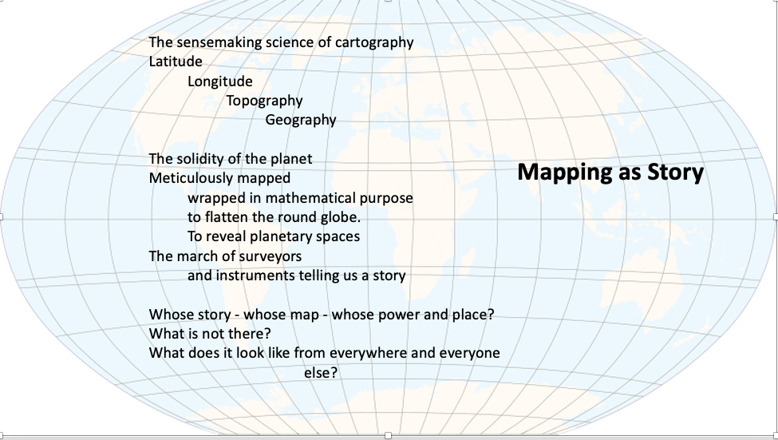 Image Source

Just for Fun …. Images of Literal Maps and Counter Maps
These counter maps offer new perspectives. By changing the map, we point to what was missing, what could be, a different way of seeing; we bring out a new story.
The long-established Mercator map – is this an accurate representation of the world?

Image source

What “story” does this map tell us about land, prominence of nations, and global focus?
Whose story do you think it is?
What does it leave out?

The Autha-Graph map by Hajime Narukawa reframes traditional East-West, North-South views, calling attention to the large bodies of water that define this planet and to issues of climate change.


The Hobo Dyer Equal Area South at Top projection presents accurate land masses and upends the world with the South at the top to question the traditional view that the North is always at the top.
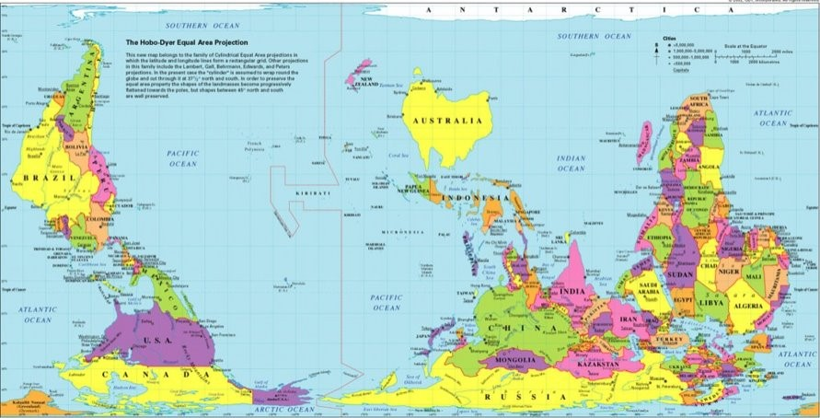
If you want to play with exploring the true size of land masses in the world, check out this website: The True Size Of... created by James Talmage and Damon Maneice. The app allows you to take a country and move it to compare with another country to get a true sense of size.

As you read the following quotes about maps, think about the dominant stories of the education landscape and the potential of counter mapping as a way to re-think, reframe, and reinvent education for greater representation, access, and justice.

“Maps… exert a social influence through their omissions as much as by the features they depict and emphasize”
J. B. Harley, 1992

“... any effort that fundamentally questions the assumptions or biases of cartographic conventions, that challenges predominant power effects of mapping, or that engages in mapping in ways that upset power relations.” This is similar to, but not the same thing as participatory GIS (Elwood 2006).

Counter-mapping appears as a response to the consequences of map-based bureaucratic practices and/or culturally derived cartographic conventions. However, by focusing on the “counter-” this singular definition doesn’t highlight the creative, multitudinal central element of “mapping”: counter-mapping mixes theory and practice to be productive and generative, a way to open, explore, and realize alternatives to the status quo.” Dalton & Stallman, 2018
"...cartography and mapping are uniquely sources of power for the powerful ...However, if maps can be seen as one of many "authoritative resources" that states mobilize to consolidate their own power … then local groups' appropriation of the technology of mapping may help to counterbalance or at least offset the previous monopoly of authoritative resources by the state or capital. This requires understanding the social and political contexts within which maps are used by local groups. Just as inclusion and exclusion are powerful political tools used by states and state-legitimated organizations to control and allocate resource access ... local groups can claim power through mapping by using not only what is on a map, but what is not on it. One effect of having multiple maps of a single forest, for example, could be to challenge the accuracy of a “standard” map used for planning” Nancy Peluso 1995

"Maps themselves are stories: They’re simplifications, distillations, and interpretations of a hugely complex world. Maps provide meaning and context; they reveal patterns and relationships." Allen Carroll ESRI

“For the master’s tools will never dismantle the master’s house. They may allow us to temporarily beat him at his own game, but they will never enable us to bring about genuine change.” Audre Lorde. 1983.

PAUSE TO REFLECT.
Having read about paradigm shift, resistance to change, and counter-mapping, what is your biggest takeaway at this point? What resonated for you? What surprised you, or what was a new thought?
Think of transforming education for equity and justice. What aspect of education would you prioritize for counter mapping and shifting?
Just for fun and to get into counter mapping: Sketch a “map” of a typical classroom. Using systems thinking put in all the elements – objects and people. Draw a sketch or layout of a traditional classroom. Now imagine you have all the power to totally change anything – sketch a counter map of a classroom that presents a very different view of what teaching and learning really means. Feel free to add new elements (people and objects) and take out elements as needed and to configure them in a completely new layout.

Application: Counter Map Binary Thinking

You’ve encountered the idea of Opaque terms, where we automatically make assumptions about their meaning as a result of our deep social conditioning. Another very instinctive human perspective is to think in binaries or dualisms. Some of these are given by our perceptions and experiences of the physical world (although even here, we can expand them):
- Left – Right
- Up – Down
- Inside – Outside
- Dark – Light

This then extends to assumptions and expectations of social interaction and identities:
- Right – Wrong
- True – False
- Success – Failure
- Powerful – Powerless
- Male – Female
- Binary – Dual
- Center – Marginal

TASK: Counter Map Some Binaries
Question each of the binaries above – Look at them from the possibility of more than two polar extremes – what lies between? Is there a landscape of meaning with three or more options?
If you like, draw this out in a mind map to show the plural meanings these pairs can contain.
Reflect: What does this counter-mapping do to social practices and habits of thought and action?

Change Tool 2: Cynefin Multi-Ontology Sense-Making and Reflexivity

In this section, you will explore a framework that explains how legacy systems and deep paradigms of thought work and why we have so much transformative resistance. This framework also clarifies how complex thinking generates innovation and transformation and gives us a powerful tool for reflexive, transformative work that is adaptive and context sensitive.

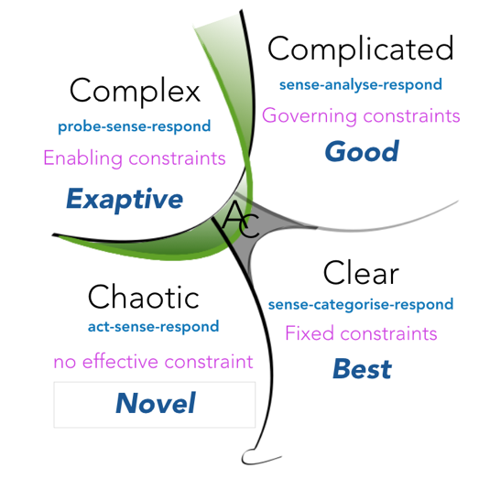
Image source
The framework is called CYNEFIN – a Welsh word that best translates as “habitat” or a ground. It means a place from which we know or “ken” our world. It was developed by Dave Snowden, a change management expert who developed this framework for sense-making and decision making that engages interpretation from multiple perspectives. If you are in evaluation sciences, you might recognize a version of this developed by Michael Quinn Patton in his work with developmental evaluation.

The framework is both ontological and epistemological:
- Ontology – what there is out there in the world.
- Epistemology – how we come to know.

Learn the Cynefin Framework and Apply to Education
TASK. WATCH: An Introduction to Cynefin. [4:07 mins]. Jennifer Garvey Berger explains Cynefin as a framework in decision making. This is a good overview to the fuller explanation in the next video.
TASK. WATCH: Dave Snowden explains Cynefin [12:26 mins]
Note in both these videos, the word “Obvious” is used for one of the domains in Cynefin. Dave Snowden recently changed this to “Clear.” However, the principles remain the same.

Viewing Questions: Look out for and think about the following in response to these videos.
  - Disorder. Snowden describes this as “an unhappy place”. Why do you think this is? And conversely, why might it be important to become comfortable with this state of not knowing?
  - Domains of Order
    - Obvious (Clear) domain. What are some examples of rigid constraints in legacy education? What are habituated ideas and practices that are misaligned with principles of inclusion, the diversity of learners, and the VUCA world into which our students enter?
    - Complicated. What are the traditional roles of students and teachers in this domain? How do governing constraints help teaching and learning, and in what ways do governing constraints of legacy education exclude or harm learners and learning?
    - How do the ordered domains (obvious and complicated) sustain and perpetuate the legacy system of education and transmission models of teaching?
    - Rigid constraints can help some and harm others. How does this domain support learning, and in what situations or for whom might rigid constraints be harmful?
  - Domain of Complexity.
    - How does complex domain sense-making support counter-mapping education to move from a transmission to empowerment model of teaching?
    - What is meant by “the diagnosis is an intervention, and the intervention is a diagnosis”? How is teaching and learning like this?
    - Why is it important to think of errors as “inevitable” and allow room for them?
    - An enabling constraint is a heuristic or flexible principle. How is this useful in developing a transformative and flexible pedagogy? Write 3 heuristics for humanizing teaching that are student-centered, inclusive, and equity minded.
  - Chaotic domain has no constraints, things happen rapidly, we find ourselves overwhelmed and in crisis. There are no patterns. We need to stabilize the situation before we can move the situation forward. Where in teaching and learning does this happen for learners and teachers?

Note that this is a framework – not a model or method. Cynefin helps us recognize that thought and actions – especially in addressing problems - are embedded in and shaped by different ontological and epistemological sense-making filters. We can use the framework to try and understand what kind of domain a situation is in to determine appropriate decisions and actions to apply to the contexts at hand rather than blindly respond in conditioned ways that might be misaligned to the situation.

Cynefin Summary
Use this summary to check your notes from the videos and to review as needed.
There are 3 types of ontological systems: Ordered, Complex, Chaotic. Cynefin splits Ordered systems into Clear (Obvious) and Complicated, and adds a domain called Disorder (Aporia in its latest iteration. Each domain is defined by the level to which it is bounded or constrained, i.e., the level of predictability, cause-effect, and hence how stable they are. We respond to situations in each domain differently.
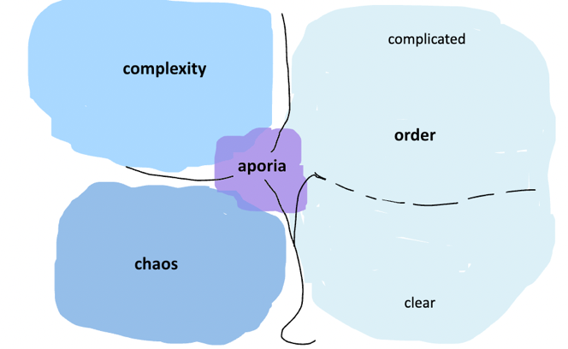
Image source: Shamini Dias

ORDER. Knowledge is established with clearly bounded constraints or rules. Cause and effect is fully or generally predictable; things repeat in the same way. Stability is high. It is easy to set goals with predictable outcomes. There is a conserving logic that resists change. Order is divided into 2 domains:
- Clear (Obvious): Rigid constraints. Fully stable and predictable. We sense-make by categorizing and responding in self-evident ways. Context does not matter; the same rules apply to all.
- Complicated: Governing constraints, i.e., established knowledge and practice guide sense-making and response. Experts and gatekeepers prevail in determining boundaries and decisions.
COMPLEXITY. Enabling Constraints. Things are unknown or emerging. Cause-effect is known retroactively through experience. Things do not repeat in the same way. Hence, there is high uncertainty, low predictability (surprise and the unexpected), and multiple possibilities. . Creativity, change, and learning are processes of this domain. Enabling constraints can be used to explore and discover. Sense-making in the complex domain requires adaptive capacities.
CHAOS. No constraints. Anything can happen – high volatility, unfathomable uncertainty, change with no seeming predictability. In this space of crisis and triage, we have to act immediately and decisively to contain the situation before intentionally moving the situation into the other domains as needed.
APORIA (disorder). Complete unknowing. We do not know what kind of domain we or the situation are in. These is great opaqueness, ambiguity, paradox. Sense-making here is reflexive; we must pause, observe, and especially question assumptions. Radical listening helps us understand where we are. It is a space of cognitive and emotional stillness in learning and leading.

Connecting Cynefin with Adichie’s Danger of the Single Story
Humans are storying beings – we story ourselves and our lives because we naturally seek coherence and meaningfulness. Connecting this to Adichie’s danger of a Single Story, here is a way to look at Cynefin.
- Clear and Complicated modes of thinking court the danger of the single story. Through long years of habituation, we have single stories – assumptions and beliefs deeply embedded in us that rigidly constrain our thoughts and action. Single stories created and determined by experts and gatekeepers in disciplines and social processes are governing constraints within which we think and act. This is helpful and efficient. However, those that fit into these single stories have access and privilege, while those that do not fit are excluded and oppressed. The Single Story demonstrates Clear and Complicated modes of thinking in slavery, colonization, industrialization, exploitation of planetary resources etc.
- Complex modes of thinking seek out multiple stories. This way of thinking sees reality as comprising many truths and perspectives and therefore we must seek out, be open to, and work with multiple stories, as well as with emerging new stories. Complex domain thinking is necessary in contexts of increasing diversity of identities, histories, and experiences, and in contexts defined by constant and rapid change (each change is a new story).
- Those able to engage in Disorder (Aporia) can sit with stories that cause a paradox of multiple truths. This is a powerful ability – to see different stories that are in direct contradiction, i.e., to contemplate multiple truths, not to resolve them by choosing one or the other, but to allow multiple stories/truths to co-exist. From Aporetic modes of thinking, it is easier to move into Complex modes of thinking to then ask questions about the contexts of different stories, how multiple truths can connect and work together, where each is relevant and for whom. Aporetic thinking begins Complex thinking and prevents us falling into Chaotic modes of thinking.
- In Chaotic modes of thinking, there seem to be no stories, or the stories are changing too rapidly in unfathomable ways. Stories do not cohere or make sense … they seem not even to be stories. Too much information is unrecognized or coming too fast. This is crisis, stories are irrelevant, and hence we feel overwhelmed and fall into a fight-flight-freeze response. If we are able to engage in some triage – we act first to contain the situation – we might be able to push into Aporetic and Complex modes of thinking to sit with the information, letting different stories emerge, and then find connections and pathways. A good example of this is when a natural disaster takes place like a hurricane – we deal with the crisis in triage mode. Then we start gathering stories (emerging data from multiple sources) to assess the situation, seek help and find solutions for recovery. Often these actions and solutions are innovative rather than following old ways of doing things.

PAUSE TO REFLECT
Having read thus far, how does the Cynefin framework help us to engage in counter-mapping?

Sense-making is subjective.
The Cynefin framework shows us different ways to make sense of the world and respond, depending on the kind of contexts in which we are doing that sense making:
- The framework reveals the subjective nature of sense-making and action. How we do this depends on which domain we perceive the situation to be in. For example: Two individuals in the same situation can sense-make and respond very differently, depending on the domain they (unconsciously) believe they are in:
  - For person A, moving house is old hat; I’ve done it so many times. This is a clear and highly predictable situation with clear cause-effect. They will approach is with the logic the Clear (obvious) and Complicated domains. They know exactly what needs to happen, in what order, and how things will turn out.
  - Person B, moving for the first time in their life, sees this as a mystery, a massive challenge they have no idea about (Aporia/Disorder). There are many known unknowns (who do I call, what’s the best packing material), and unknown unknowns (they might not realize movers will also pack their stuff). Predictability and certainly ebb low. They might become overwhelmed, into a Chaotic space in a fight-flight-freeze response.
- However, we can also reframe a situation intentionally and respond differently. For example, if Person B had some of the capacities of Complex domain thinking, they will recognize that moving being new and known needs a different approach. They might accept and build time in to explore – do some research, get help, trying a few different things to learn about the world of moving, and being ok with not knowing and mistakes. That is, they can work adaptively. But this only happens with the ability to push the pause button on panic, hang out in Aporia for a while to embrace newness and unfamiliarity, and then intentionally work adaptively to sense-make and take action. It helps of course if there is support from others.

The uses of the Cynefin framework in transdisciplinary pedagogy
Cynefin helps us develop skills in multi-ontology sense-making so we can draw on appropriate ways of making sense situations and respond appropriately. We can use Cynefin for effective counter-mapping to shift the paradigm of education toward a more humanized, learner and learning centered process.
- An analytical tool. Allows us to explicitly recognize and critically question legacy paradigms.
- Reflexive tool. Helps us surface and address habituated or deeply conditioned thinking in ourselves, others, and disciplinary lenses so that we can remain alert to new and emerging situations and in working collaboratively with others.
- Adaptive tool. Operationalizes how to engage in creative adaptive response to work with unknowns and emerging situations and innovate to transform.
- A reframing tool. Explains learning and growth as a complex adaptive process that we can integrate in designing human-centered teaching and learning.
The above skills and mindsets expand our capacity to be leaders of learning in creating empowering pedagogies and facilitation methods in our teaching.

Cynefin Applied to disciplinary cultures and knowledge creation
Disciplines are cultures - with their own philosophical and epistemological lenses, methodologies, bodies of knowledge and skills.
- Disciplinary thinking happens mostly in the Complicated domain - peer review, gatekeeping, experts, professional associations etc. maintain the disciplinary paradigm.
- Disciplines can become siloed - where scholars and leaders become conditioned to their disciplinary paradigms and function on autopilot. In both the above domains of disciplinary thinking and practice, creativity, innovation, and alternative perspectives can easily be rejected by those in authority (e.g., Kepler, Galileo, Van Gogh, the first women comedians).
- The Complex domain is the area of new research and practice - scholarly innovation (e.g., your dissertation research). Research is exploring unknowns and using different lenses. When we do a literature review, we scan established knowledge in the Complicated (and sometimes Clear) domains and find gaps in knowledge and methods. We innovate in research (Complex domain) - experiment, explore, ask, and formulate new questions, find new ways of understanding and acting in the world ... hopefully with responsibility to apply it toward social good.
- New knowledge eventually becomes part of the paradigm (Complicated domain), as it becomes accepted, leading to eclipsing of, modification, or co-existence with an old paradigm. The industrial age paradigm continues in the form of legacy systems as new paradigms emerge shaped by new technologies. Legacy education co-exists and is challenged by new pedagogies and learning science. New knowledge is slowly codified, e.g., acknowledgement of non-binary genders and sexual orientations, definitions of what being “human” means, new trading and business processes. Knowledge production moves from emergence in the Complex domain, to establishment in the Complicated domain. The systems model of creativity by Mike Csikszentmihalyi presents a similar explanation.
- The importance of transdisciplinary thinking - becoming good stewards of a discipline. A critical disciplinary responsibility is balancing gatekeeping with openness. Scholars are stewards of their discipline; they protect and expand the work. They protect the paradigm by scrutinizing new scholarship (the peer review process). Yet, they must also remain open to recognize new perspectives and methods, and integrations from other disciplines and ways of knowing that can enrich the discipline. Hence, they must be transdisciplinary thinkers able to work in both Complicated and Complex domains in moving their discipline forward.
- The importance of transdisciplinary thinking for ethical education – becoming good stewards of the mission for inclusive equitable teaching and learning. As stewards of the mission for ethical education, we observe and understand Complicated domain thinking that perpetuates the legacy system of and how it blocks, marginalizes, and erases some learners. At the same time, we work with Complex domain thinking within the system to dismantle oppressive structures, exapting strategies from multiple pedagogies, frameworks, and tools to find transformative ways to create inclusive and equitable education for all learners.

TASK: REVIEW YOUR UNDERSTANDING

- What mindsets and skills help us engage productively with Aporia? Have you been in situations In work, life, or scholarship, where Aporia sense-making helped or would have helped?
- In what aspects of life do people tend to engage in Clear space thinking. When is this useful and efficient and when does it cause blind spots and resistance to new ideas?
- In what aspects of life is Complicated domain thinking helpful and where is it is harmful and limiting? Have you been in situations where you came up against Complicated domain thinking that was inflexible?
- Can you think of examples of times where you were able to work adaptively with emerging situations that contained many unknowns and that were unpredictable?
- In what ways are the skills and capacities for working with complexity listed above useful for teaching and learning?
- How do the following transdisciplinary principles and mindsets connect with the Cynefin framework?
  - Transgression – Transcendence – Transformation
  - Reflexivity and double-looped learning
  - Plural thinking – and rejection of the single story or hegemonic narrative
  - Justice oriented Design Thinking
- In what domains does the legacy system operate? What aspects of these domains support and perpetuate the legacy system, and who does this harm and exclude?

TASK: A Tour Around the Latest Cynefin Iteration (2020)
Read this webpage article by Chris Corrigan that explains the Cynefin framework and how it can be used.
As you read, think about a familiar situation – e.g. parenting, graduate student life, project management – and where different aspects of the situation belong on the framework. This is called Cynefin contextualization.

Application: Key Characteristics of Thinking in Different Ontological Spaces

Having learned about the Cynefin framework, read these descriptions. Think of your life experiences, how you respond to situations, and how teachers and students react in schooling situations.

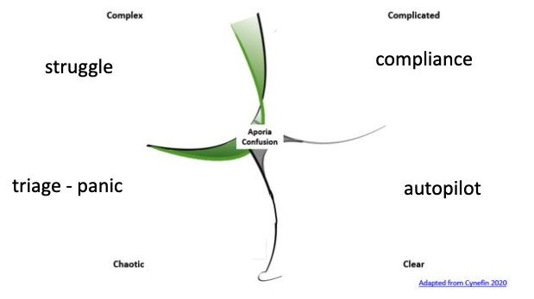

AUTOPILOT – Clear (Obvious) Space Thinking and Response
Clear Space response is to work on autopilot based on pre-established, often unconscious, and rigid constraints. Clear space contexts are where we think everything is known and there is full stability and predictability. In many contexts, this is a good thing. When we have stability and predictability in physical and psychological safety, we can focus and give attention to our work. Stable, predictable routines, e.g., not being food or shelter insecure, clear work or classroom structures, algorithms in computer programs help us work efficiently. But autopilot thought and action become dangerous in complex contexts and new situations with differences and divergences, or multiple needs and practices. Here, rigid constraints of deep-seated, implicit assumptions, beliefs, and expectations lead to missteps, misunderstandings, conflict and injustices.

COMPLIANCE – Complicated Space Thinking and Response
Complicated space response is often compliant thinking to governing constraints defined by paradigms - established theories, norms, experts, and gatekeepers. Things can be known and the experts and/or those in power define these. Governing constraints support efficiency, protect the robustness of bodies of knowledge, and ensure coherent social process. Cultural traditions and practices are governing constraints that define and support cultural continuity. This is reinforced by "gatekeepers" - social norms, cultural elders, peer pressure, and experts. For example, what can be published, what counts as Art, what good science is, definitions of the "educated" person, of "success" etc. Hence, there are in-groups and out-groups. In-groups have cultural capital (they know the "rules"), and thus access, power, and privilege according to the established paradigm. Out-groups do not have cultural capital, are different to the established paradigm, and lack access, power, and privilege.

ADAPTIVE STRUGGLE & EMERGENCE – Complex Space Thinking and Response
Complex space response is adaptive in relation to changing and emerging situations. Complex space situations have unknown unknowns – i.e., we do not know what we do not know! These are situations where what we know emerges as we explore. There are new and different ideas, things, contexts, or people that might contradict or call into question our experiences, what we already know, our expectations and beliefs etc. There is therefore a sense of instability and unpredictability. For example, travelling to a country where customs are completely new to you, encountering the COVID-19 virus for the first time, learning something for which you have no previous experience.
In spite of the inherent dissonance of this type of domain, this also means there are potentials and possibilities - expansion of knowledge and connections across differences. Emerging information and experiences might call previous assumptions, expectations, norms, and theories into question while also presenting multiple “truths” and ways of doing things – multiple conceptions of God, different cultural foods and customs, innovations in strategy etc. We use why not and what if questions – what if the why not votes for women, what if we recognized multiple genders and sexual orientations, what if we reframe GDP using elements of happiness, , is rationality really the center of human experience?
Potential, possibility, emergence – are wonderful but also destabilizing and so this is also a cognitively and emotionally dissonant space that unmoors us from certainty, and brings discomfort, even distress.
However, if we have capacities and skills to engage with dissonance, emergence, and potential, we can respond adaptively. Adaptive response is allowing oneself to be in the liminal space of not knowing and staying open to discovery – through probing (listening, asking questions, exploring), thinking of struggle and mistakes as part of the process rather than a judgment of our abilities, connecting and creating a new understanding which then enables us to move forward. Notice that this is what we do as scholars as researchers. Do we also do this in life encounters? And especially, how can this happen in teaching?

TRIAGE – PANIC – Chaotic Space Thinking and Response
Chaotic space response is rapid action in response to unfathomable change. Chaotic space situations are crises: it is not possible to know anything, and immediate action is imperative. This is like triage - we might not know the context or causes, but we act first to stop the bleeding, rescue someone. Having done this, we can move into Complex space thinking to explore and discover more about the situation and then respond adaptively or return to Complicated space thinking to work within governing constraints. Think of natural disasters, hospital Emergency Rooms, war zones.
A common response when we perceive ourselves to be in crisis and feel overwhelmed is the fight-fight-freeze response. (note that this is subjective; what is overwhelming to one might not be for another.
Relationship dynamics overwhelm me | Flight - Retreat to loneliness – which at least I know well  Fight - Blame the other person each time.  Freeze – Do nothing and allow the situation to continue.
Mathematics makes me feel crushed. | Flight – Walk away from math. “I will never get it”  Fight – Blame math. “It’s a useless subject anyway”  Freeze – Avoid practicing math … leading to self-fulfilling prophecy of failing math.

Example: Locating Teaching Approaches In Cynefin Spaces.

Teachers Who Use Clear domain thinking (fixed or rigid constraints).
Teaching and learning involve rich, complex contexts. Clear domain sense-making can be dangerous when habituated thought and rigid unquestioned assumptions and beliefs are used in a fixed sense-categorize-respond mode:
- Struggling to learn - indicates lack of ability and aptitude.
- Girls are bad at math - You should not study aeronautics.
- Student does poorly on a test. Since tests measure learning – you're not smart or did not study.
- These types of parents are not interested – I won’t bother reaching out to them.
- Students who do not speak up in class - not interested in learning – lose participation points.
- If we do not assign grades, students won’t do the work.
Clear domain sense-making views the status quo as desirable. The system works fine; if some students are left out, that’s just how things are, and they clearly are not “cut out to fit in”. Clear domain thinking perpetuates the legacy system as it draws on social and disciplinary conditioning to guide thought and action. It makes us resistant to change and innovation in teaching. We cannot see the point of change and can easily become overwhelmed if asked to change how we work.

Teachers Who Use Complicated domain thinking:
Complicated sense-making works with established and governing constraints or paradigms of knowledge and practice. This helps us function in systematic and efficient ways. In teaching, the governing constraints are institutional, departmental, and classroom rules and policies that determine what will be learned, what the processes are, and how students ought to conduct themselves. Many experts have contributed to creating good, shared practices that enable us to work coherently and effectively.
- The curriculum is prescribed. Authors and texts have been determined by experts. Curriculum can also be developed state and nation-wide. Textbook selection is done by people in authority, and faculty follow these prescriptions.
- There are prescribed norms in disciplinary discourse and communication – definitions of what good writing, speaking, and classroom participation are supposed to be.
- Assessment of learning are standards that experts have determined that we follow.
- “You should know … “culture. Students are expected to know how to navigate institutional space and the hidden curriculum. These are things like knowing how to use office hours, how to speak to professors, know about and use resources, get in with the right crowd, ask the right questions. Those who are unable to do this are deemed to be not capable or good enough to take the rigor of the discipline or college level learning.
In Complicated domain sense-making, we accept change hierarchically from points of authority. We are not comfortable with change but handle it with guidance from experts and a relatively measured pace.

Teachers Who Use Complex domain thinking:
Complex domain sense-making in education begins with awareness of a problematic legacy system as a governing constraint and the discovery of hidden crises in education – foundations of Eurocentricity and racism that otherize, marginalize, and oppress learners, inequities of access and success, our own positionality, and alarming misalignments between the legacy system, current contexts, and emerging futures. From Aporia, where we discover what we don’t know in a reflexive process that examines our own conditioning, we are able to move into Complex domain sense-making.
Complex domain sense-making is also a disposition to embrace the diversity, plurality, and complexity of learners and contexts and to use the fluid potential of dissonance as a process for change. We explore the interconnected and entangled nature of education to question, expand, dismantle, and transform the paradigm intentionally so all learners can engage and flourish. Using Systems and Design thinking, we consider multiple possibilities and divergent ideas. We are curious, open, and imaginative – asking “What if …?” and “Why not?” These are the seeds of transformative teaching that lead us to try things out, seek input and feedback to co-create learning that is meaningful and useful to our students, and to be ok with things emerging as we teach. We are reflexive – thinking critically about who we are and what we bring to teaching and learning with the purpose of constant improvement and relevance.
- Who are my students – how do I ensure that their identities, histories, goals, and lived experiences are invited and included in the learning space I design?
- Who am I as an educator – what is my purpose or mission, and what values and beliefs guide that purpose? How does who I am (my identities, history, and lived experiences) affect the way I approach teaching?
- My curriculum and course design cannot remain static because my students and contexts, and who I am, are always changing. How can I expand, change, and present the curriculum so that it is relevant and meaningful to the learners in my classroom?
- What opaque words and processes in teaching should I examine and unpack so that I work more intentionally to make teaching and learning meaningful and useful?
- What do I know from education trends and research that can help develop my teaching?
- What feedback can I get from my students, self-observation, and peers to develop my teaching?

TASK. WATCH: Kimberle Crenshaw on Confronting America’s Racism. [6:30 mins]
Kimberle Crenshaw is one of the founders of Critical Race Theory (CRT). Here, she explains why CRT seems a threat to some people, and how it is in fact a way to move the nation forward. As you listen, see if you can spot the thought patterns Clear, Complicated, and Complex domain thinking, and why some people might fall into Clear and Chaotic domain thinking in response to CRT.

Beyond the microlevel of the classroom and classroom teachers, what are some ways institutions or the whole system of education engages in Clear and Complicated domain thinking? Think about SATs and college access, institutional policies, residence life, abilities/disabilities, approaches, etc.

Chapter 4: Change Tool: Design Thinking to Center Learners and Identities

This Chapter moves us from the macro systems view of the systems in education to the critical relational core of teaching and learning - the learners.
- We explore identity as a microsystem through the framework of complex intersectional identities that we will expand using a socio-ecological model of identity development. This helps us to see each person as a micro-system of intersecting identities – biological, physiological, neurological, socio-cultural, historical, and lived experience. Each person is a complex microsystem of multiple identities and experiences, who is in turn embedded in a network of others who are each as complex. Imagine this embodiment multiplied by the number of students in a classroom! As part of this process, you will apply this to create an identity map of your own.
- We define and clarify what we mean by JEDI: Justice – Equity – Inclusion – Diversity.
- We learn the Design Thinking framework, which is both a counter mapping tool and mindset for changemaking. Design Thinking is a process that comes from human-centered design. Using the framework for transformative education, we center learners and learning as well as a justice-oriented purpose in questioning the status quo and revealing gaps and opportunities for transformation.

“It’s not ‘us versus them’ or even ‘us on behalf of them.’ For a design thinker it has to be ‘us with them’”
Tim Brown, CEO and President of IDEO

“Human-centered design is a philosophy, not a precise set of methods, but one that assumes that innovation should start by getting close to users and observing their activities.”
Donald A. Norman, Co – founder of Nielsen Norman Group

“We can’t solve problems by using the same kind of thinking we used when we created them.”
Attributed to Albert Einstein. This connects with Audre Lorde’s idea that you cannot dismantle the master’s house with the master’s tools. ￼

Complex Intersectional Identities
“I am large, I contain multitudes” – Walt Whitman. Song of Myself, 51

The concept of complex intersectional identity was developed by legal scholar Kimberlé Williams Crenshaw arguing for a holistic and authentic understanding of the experiences of Black women within the framework of critical legal studies. Here is how she describes what it is:
"It’s basically a lens, a prism, for seeing the way in which various forms of inequality often operate together and exacerbate each other. We tend to talk about race inequality as separate from inequality based on gender, class, sexuality, or immigrant status. What’s often missing is how some people are subject to all of these, and the experience is not just the sum of its parts." ... "Intersectionality is simply about how certain aspects of who you are will increase your access to the good things or your exposure to the bad things in life." Crenshaw, 2020. Interview by by Katy Steinmetz
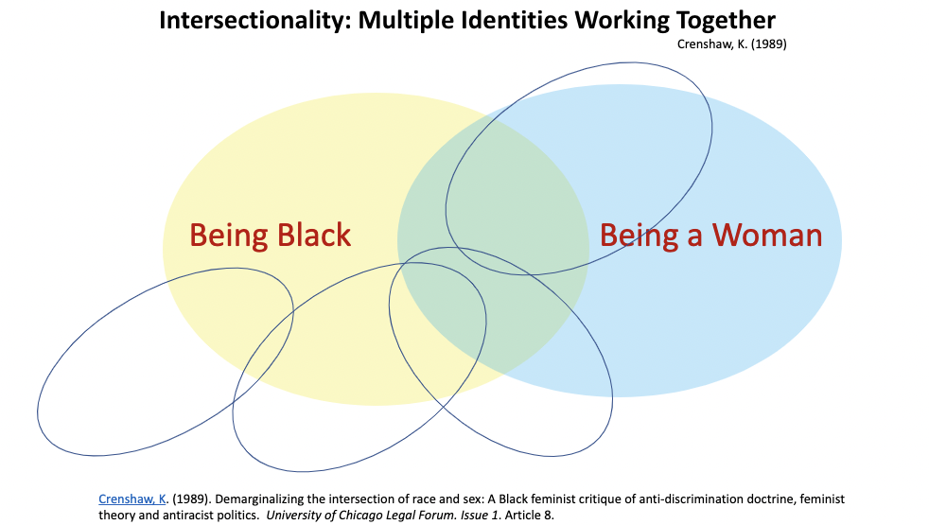
Image Source: Shamini Dias
Crenshaw, K. (1989) Demarginalizing the intersection of race and sex. A Black feminist critique of anti-discrimination doctrine, feminist theory and antiracist politics. University of Chicago Legal Forum, I(8).

In this article, Crenshaw draws from feminist and Black feminist critique of multiple systems of power, to describe how the experiences of a Black woman’s oppression was more than the sum of the marginalization and oppression of women (sexism) and the marginalization and oppression of Black populations (racism). She points to the “problematic consequence of the tendency to treat race and gender as mutually exclusive categories of experience and analysis ... to contrast the multidimensionality of Black women's experience with the single-axis analysis that distorts these experiences” (p.139). That is, not seeing the microsystem of identities an individual embodies fails to capture the ways in which multiple social identities shape the lives of oppressed individuals. “Because the intersectional experience is greater than the sum of racism and sexism, any analysis that does not take intersectionality into account cannot sufficiently address the particular manner in which Black women are subordinated” (Crenshaw, 1989; p. 140).
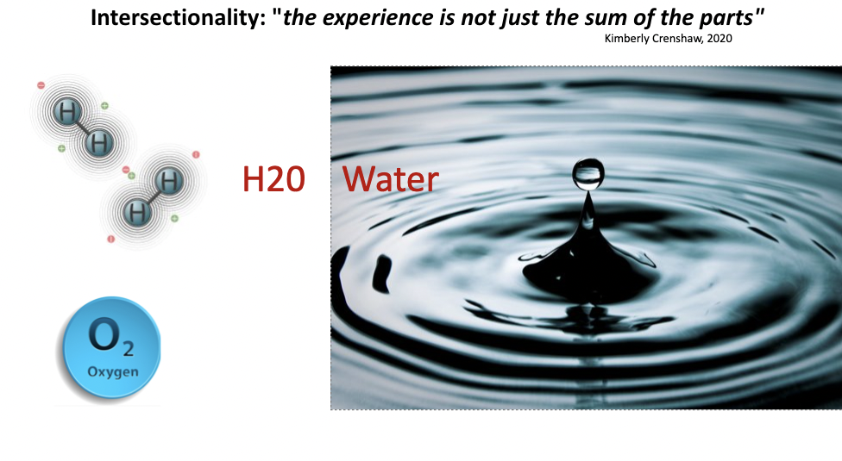
Image source: Shamini Dias

Social theorist and Black feminist scholar Patricia Hill Collins describes complex intersectional identities as an interdependent phenomenon of oppressions based on multiple factors like race, class, gender, sexuality, abilities, nationality and other socially defined categories. She describes intersectionality as the analysis of the interactions between “social inequality, power, and politics” and that was “closely tied to social justice projects and social movement politics (Collins, 2012; p. 450).

Here is a granulated description of intersectionality by Museus and Griffin (2011) synthesizing scholarship of key authors:
- “Intersectionality can be defined as the “relationships among multiple social dimensions and modalities of social relations and subject formations” (McCall, 2005, p. 1771). In simpler terms, it can be defined as the processes through which multiple social identities converge and ultimately shape individual and group experiences (Shields, 2008).”
- “Structural intersectionality refers to how multiple social systems intersect to shape the experiences of, and sometimes oppress, individuals (Crenshaw, 1991). In higher education, for example, structural intersectionality can be used to make sense of how both racial and gender inequities converge to shape the experiences of women of color in higher education.”
- “Political intersectionality refers to how the multiple social groups to which an individual belongs pursue different political agendas, which can function to silence the voices of those who are at the intersection of those social groups (Crenshaw, 1991). For example, political intersectionality would explain a case in which racial minority students refuse to address discrimination against lesbian, gay, bisexual, and transgender (LGBT) students of color to avoid having those issues become public and risking tainting the image of those communities of color.”
This is a good article to read if you are interested in the use of intersectionality in educational research.

Socio-Ecological Determinants of Learning: Integrating Bronfenbrenner’s Theory

We can expand our understanding of intersectionality by integrating a systems developmental perspective. Uri Bronfenbrenner’s theory of the bioecological systems model of human development helps us visualize and contextualize intersectional identity within a social-temporal system of experiences. He explained human development as shaped by interactions between the individual and multiple “ecological systems” at different levels of social and historical or temporal structure.
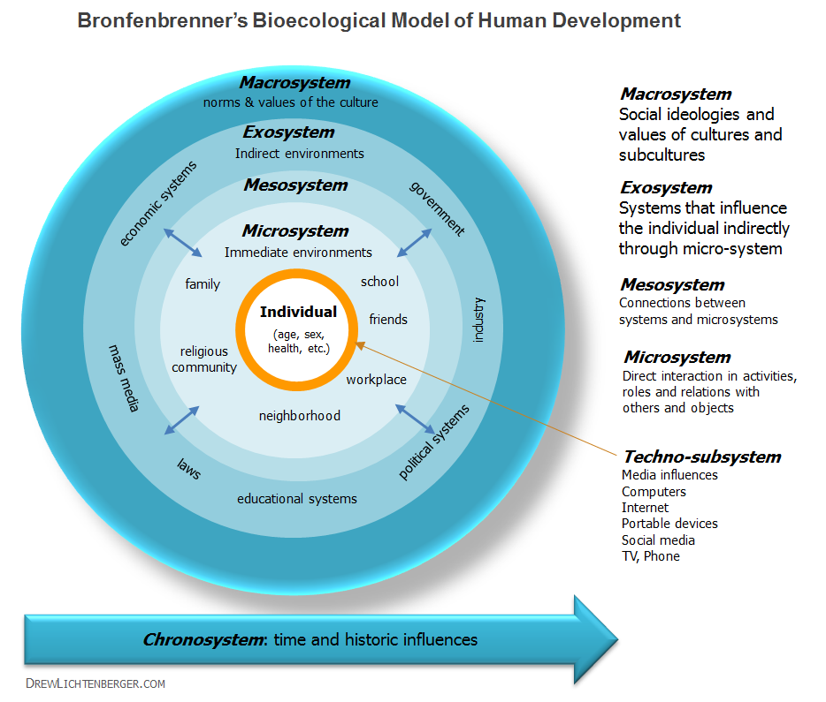

TASK
READ an explanation of Bronfenbrenner’s bio-ecological model by Drew Lichtenberger. He gives a very succinct explanation of the idea of bio-ecological systems that shape human development.
“The inner circle represents the most direct interaction with parents, friends and objects. Family plays the most prominent role in the development of a child. A healthy family v. one of dysfunction has a significant impact on the way a human develops. Next are the various environments of that individual’s family and areas in which they live. The outer circle considers the most dominant societal norms and values situated in a given point in history, while the circles in between represent various systems which have indirect influences through the microsystem. Finally, the orange ring in the center represents how technology can now mediate many of our direct interactions with our world and one another. The way these various systems interrelate can be rather complex in the way they work in combination on the development of a person.”

WATCH: Brofenbrenner’s model applied to college students [6:57 mins]
In this video, Rachelle Tannenbaum, a college professor explains the model and also gives an example of how it applies to a college student.

Systems and Complexity Integration: Intersectional Identities as Microsystems

Integrating intersectionality with an ecological systems-approach, we understand its complexity in how it affects educational processes on a systems and individual level.
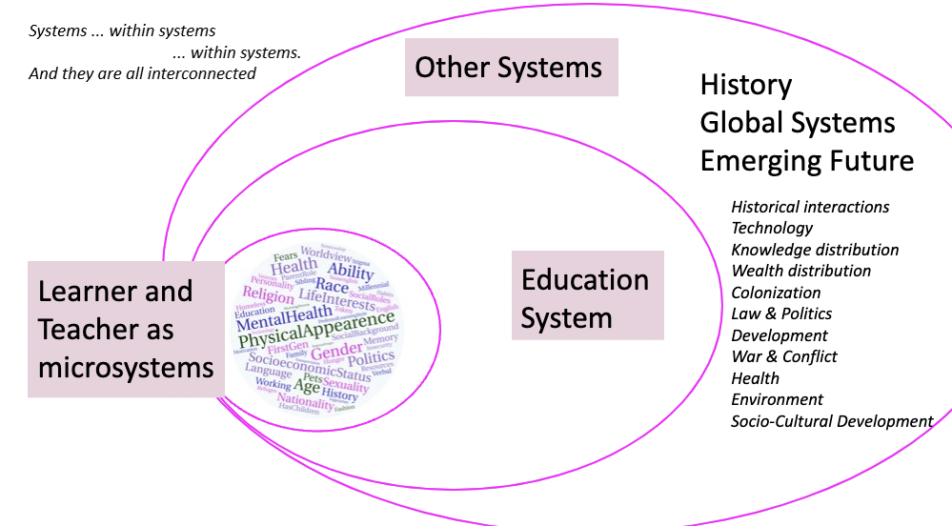
Image source: Shamini Dias

Identity is not singular. We embody a multiplicity of identities.
We are microsystems. From a systems-perspective, identity is not a single dimension, nor a linear construct of multiple additive identities treated separately. The whole of who I am and how I experience the world is are inextricably woven strands and cannot be explained by my separate identities and roles. We each are a microsystem of identities and experiences, some biological (skin color, height etc.,), but most defined socially and historically (language, culture, history, social roles etc.). Thus, we are more than the sum of different parts; we are defined by a gestalt whole of the myriad identities we embody that intersect to create our unique experiences. For example, being a Black Female is uniquely different to being a White Female or a Black Male. Being Transgender Black American is different to being Transgender Korean, or Transgender Nigerian, and being a Pakistani Muslim Female is different to being an American Muslim Female. To this we can add social class, disabilities, religion, geography etc.
Therefore, we must consider all intersections simultaneously, seeing individuals as embodied microsystems of experiences, connections, identities, histories, assets, who in turn interact with others of equally complex intersectional identities, all of whom are embedded in multiple complex social and physical systems that are interacting as well.

RESOURCE: Inclusive Language
Website Inclusive Language Guidelines. American Psychological Association. Comprehensive overview of dimensions of identity with guidelines and further research connections.

Privilege is Unearned.
Privilege is a function of who we are and our relative status in relation to the groups and identities around us. It is an advantage you usually do not control and is therefore typically invisible to you. You have it by virtue of being part of a dominant group that defines the status quo. It is something you do not even have to think about, and hence is often deeply unconscious. For example, you embody privilege if you never think about whether wearing a hoodie might get you shot, or if you shop in a store and it never occurs to you that a security guard or staff would follow you around to monitor your actions, if you can walk into any store or restaurant and be well-treated, or if you never have to work out how you might navigate the stairs of a building.

Privilege is Relative.
You can be privileged in one situation, but this shifts in a different context. For example, I might have citizenship privilege in my own country, but am less privileged when I am on a visa in another country and am deemed an “alien”. Or I have privilege as a Muslim in an Islamic nation but might suffer oppression in a society that has issues of Islamophobia.

Power and Privilege Dimensions
Here are just a few examples typical of American urban societies. The descriptors on the left side have more privilege and give an individual more power.
- European vs. Non-European
- White skinned vs. Dark skinned
- Presenting as Male vs. Other genders
- Heterosexual vs. Non-heterosexual
- Able-bodied vs. People with disabilities
- College Educated vs. Non-College Educated
- White-collar job vs. Blue-collar job
- Human vs. Visitor from another planet (alien)
- Citizen vs. Non-Citizen (also “alien” in official terminology!)
- Adult – Child
- Tenured faculty – Untenured Faculty - Adjuncts
What else can you think of?

Further Exploration
Here is a definition and a list of privileges on the website, The Antiracist Educator.

Arizona State University has a resource with checklists for a number of privilege dimensions. You can use the checklist to gauge your level of privilege.

Mapping Your Complex Intersectional Identity

As you’ve seen above, we embody complex intersectional - visible and invisible identities and roles. From a systems perspective, we are each a microsystem of identities, histories both personal and cultural, lived experiences and circumstances both pre-determined and chosen, goals, interests, abilities etc. These make you uniquely who you are.
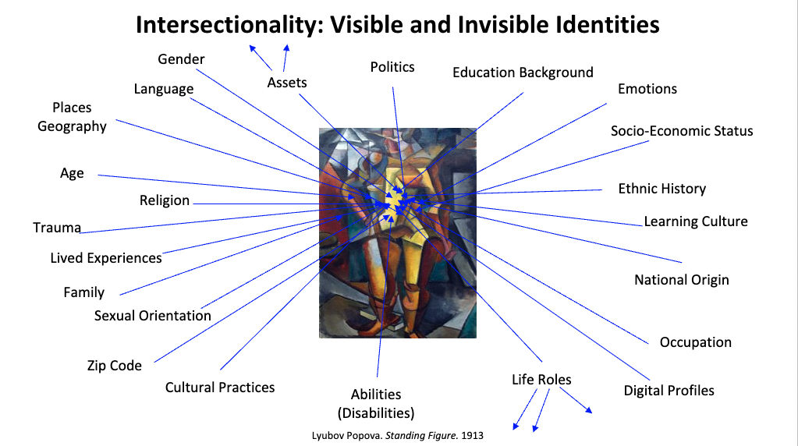
Image Source: Shamini Dias

TASK. Create an Identity Map.
Create a "map" representing who you are that shows your complex intersectional identities.
- Put yourself in the middle of a sheet of paper. From there radiating out, put all the different dimensions of who you are. Feel free to draw and decorate and add images.
- Some large social identity categories to consider: Class, Citizenship, Ability, Age, Generation, Race, Religion, Sexual Orientation, Cis/Trans Status, Gender. Also consider social, professional, and kinship roles: Parent, Caregiver, Partner, Spouse, Child, Sibling, Employee, Supervisor, Educator, Researcher, First-Gen Student etc. Travel opportunities – in the US, Outside the USA. Add other aspects of yourself – especially invisible aspects that significantly shape you and your interactions with the world, e.g., artist, introvert, extrovert, diver etc.
- You can do this on a sheet of paper and take a photo or you can do this on a PowerPoint and save it as an image to add to your Journal.
- Try using a mind-mapping tool like GITMIND – Basic steps:
  - When you begin a new mind map it gives you a central or floating node. Put the word ME or your name in that node.
  - Use the menu or right-click to add sub-nodes to add words and phrases the present different aspects of your identity, history, and other dimensions of your life that are significant to you. Include both visible and invisible identities.
  - You can add images to your map as well.

RESOURCE: Use Identity Mapping with Your Students
Creating identity maps (or "Me-Maps" as some of my students have named it) is a fun and conversation and connection inducing activity. Asking students to sketch a map of who there are, adding images, drawings, key words etc. Engages them in creative introspection. You can make a Gallery Walk for students to put up their maps and explore freely. Students get talking and connecting with each other on similarities and differences. There's a lot of "I didn't know that you also ..." or "I'd never have guessed", "It's so cool that you ....".

To share who they are with peers and make connections.
- Have students do an identity map. Instruct them to only add what they are willing to share. Make sure to share your map as a guide and to take the first step in sharing who you are.
- Make it anonymous – rather than their name, use the word “I” or “ME” at the center. This helps in sharing. Students will identify themselves as they feel comfortable.
- Put the maps up on a wall, or on tables around the classroom (Online: put the maps on a PPT that all can access).
- Let students browse and use post it notes to write short connecting comments (“me too”, “just like me”) or add stars and stickers to each other’s maps. (Online: use comments)
- To conclude, ask students to share what they appreciated or liked about someone else’s map
- You can extend this by asking students to write a short reflection on what they learned about themselves or about their peers that is encouraging to them as learners in your class.
- Allow students to identify who they are if they choose to but make this optional. The aim is to create a holistic sense of each other and find connections. Trust that generally, this activity together with a welcoming and supportive classroom overall will get students talking, sharing more, and making connections. Trust and a sense of community takes time.

To discover and share the assets that they embody.
- Brainstorm what is meant by assets – give them examples and have them generate more. This helps those who are not used to thinking of their own assets by giving them items they can recognize and claim or inspire more ideas - speaks more than one language, courage, knows how to persist when things are rough, rapper, sings, good listener, organizer, loves to dance, design and drawing, likes to write, good with calculation, nurturer, cooks, likes to present stuff, takes are of family, good reader, notetaking, healthy eating … Notice that assets are not all academic skills but include values, character traits, hobbies etc. It is important to facilitate a broad ranging brainstorm, so students see that many things generally perceived as “outside school” are also valuable in holistically sharing who you are and what strengths you bring.
- Guide students to create an asset map (my strengths and superpowers).
- Repeat the facilitated sharing and connection activity above.
- When we share and explore assets that students embody, we welcome their full selves into the classroom. Students – and you – will also see broader possibilities for how they engage in learning. For example, if a few students are into dance, or design, they might get together to present a class assignment in a different form. Or just engage with peers to make friends and have fun outside of class.
- Ask students to write a short reflection on what they learned about themselves or about their peers that is encouraging to them as learners in your class.
- You can also return to the asset maps later in the semester to ask what else can be added that they have gained or newly discovered in class work and interacting with each other. It’s great to ask them to name assets that they see in their peers.

Teachers’ Complex Intersectional Identities
“We teach who we are … But seldom, if ever, do we ask the “who” question— who is the self that teaches? How does the quality of my selfhood form— or deform— the way I relate to my students, my subject, my colleagues, my world? How can educational institutions sustain and deepen the selfhood from which good teaching comes? – Parker Palmer. 2017. The Courage to Teach. p. 7-8.
Teaching is a profoundly human relational process.
Just like our students, we embody a complex set of intersections of identity shaped by our biology, history, cultures, and lived experiences. It is therefore an entangled process – complex, constantly shifting and emerging as our many complex intersectional identities engage within an equally complex learning and teaching context. A number of implications from this are critical for engaging in ethical, culturally sustaining pedagogy.
- We do not have a neutral stance as teacher-scholars. We are subjective perceivers and actors.
- Our complex identities shape our worldviews - our assumptions, values, and beliefs – our sense-making, decisions, and actions, as well as our blind spots, misassumptions, and biases.
- Critical awareness of ourselves and what we value can guide us toward authentic presence and relationships with our students and shape our work as ethical educators.
- Reflexivity supports us in deepening critical awareness through learning about our assumptions, so that we can approach our work with humility as advocates for a diversity of learners.

TASK: Add to Your Diversity Statement Worksheet
Your Diversity Statement (DVS) worksheet engages you in explicitly examining and articulating your values, beliefs, purpose, and methods as an educator. Your DVS specifically focuses on articulation of how your lived experiences (especially as a learner) and your complex identities prepare you to be a transformative educator for justice and the future.
- Apply complex intersectional identities and socio-ecological determinants of development and learning. What histories, identities, social roles and responsibilities do you embody that emerged explicitly in the identity map you sketched? Did anything surprise you and why?
- What privileges do you embody? Where do you not have privilege, are marginalized, or blocked? When and how did you come to be aware of your privilege, power, or lack thereof?
- How did your privilege/lack of privilege play out in your schooling journey, especially at college? Was it different at different levels of school and why do you think it was (or not)?

Look at QUESTION 3 in your DVS worksheet in your assignment book. Using the exploration above, make notes in response to the question and its accompanying thinking/analysis prompts.

Justice: Integrating Diversity, Inclusion, and Equity
A key question in education is how we design for and work with these rich embodiments of identities in the diversity of learners who enter our classrooms? In this section, you will explore definitions of Diversity, Equity, Inclusion in the service of Justice, and Design Thinking as a tool for operationalizing equity-minded teaching design and facilitation.
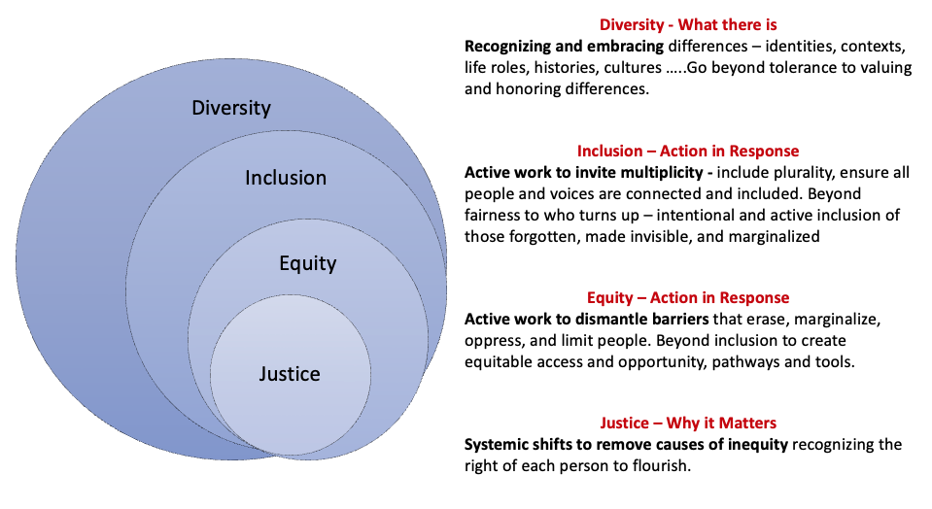
Image Source: Shamini Dias

JUSTICE guides transdisciplinary pedagogy’s mission from which we develop our philosophy and approach. Justice-orientation helps us think of purpose in teaching, our practice, who we affect and how. It is part reflexive practice to question assumptions in disciplines, legacy systems, and in ourselves.
DIVERSITY: Recognize and embrace differences, plurality, and complexity. With systems- and complexity-mindsets we see diversity in identities, knowledge creation, and ways of being that are dynamically interconnected in a vast global system. Therefore, we go beyond tolerance to delight in honor, and invite differences, recognizing diversity as a rich asset to be sought rather than avoided.
INCLUSION: Invite and include plurality. Inclusion goes beyond being fair to those who have turned up. It extends to proactively designing spaces and processes to recognize and invite those who are invisible, forgotten, marginalized, and erased.
EQUITY: Remove barriers and support flourishing. Inclusion only gets you through the door; it does not automatically lead to success. Equity means to proactively identify and remove barriers that create inequities. For example, including more first-generation students of color in college is just the first step. They face many inequities, for example textbook costs, expectations of digital access, having to work full-time to go to college, etc. How do we design proactively to address these points of inequity?
NOTE: The term JEDI was coined to integrate Justice into DEI work. It’s a cool acronym of the fight for justice taken from Star Wars. However, we should also be mindful of potential associations of the Star Wars subtexts – “(white) saviorism and toxically masculine approaches to conflict resolution” – Read more here if you’re interested.

Clarifying Equality – Equity – Justice
We can use this popular cartoon to clarify the difference between equality, equity, and justice. The cartoon uses the metaphor of a playing field where a game is going on, surrounded by a wooden fence. There are people standing outside the fence (systemic barrier) that blocks their view depending on their height (access depending on identity).
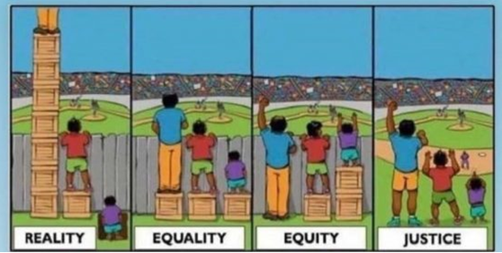
From @restoringracialjustice – Jorge Santos

Reality – the different children have different resources as a result of their history, biology, and lived experiences. One has more than what is needed to see over the fence and access the game, another has just enough to see over the fence, and the third has no access at all.

Equality – the assumption that fairness gives all the same support and equal distribution. Each child is given one box each. The tall child does not need it, the second child has what they’ve always had, and the third child is still unable to see over the fence. Equality does not account for different circumstances and identities that are still blocked from success.
Equity – differentiating support according to what’s needed for different people to overcome barriers to success. In this case, the tall child does not need a box, and the very short child needs 2 boxes. Equity takes a people- and context-centered approach; it involves embracing the complexity of differences.
Justice – reframes the problem, addressing and transforming the system altogether. Reframing here is about embracing the diversity of people, moving the “problem” out of who they are – their different heights are not an issue. Instead, we address the systemic issue of the wooden fence. We question the assumptions of the fence - is it there just because it is historical? Do we actually need it? Can we remove it altogether? By questioning assumptions and reframing the system, we design a more flexible environment that is both inclusive and equitable. You will explore this further in a later chapter on Universal Design for Learning (UDL) and Multiliteracies.

Here is another cartoon with the same story, inspired by Shel Silverstein’s story of The Giving Tree.
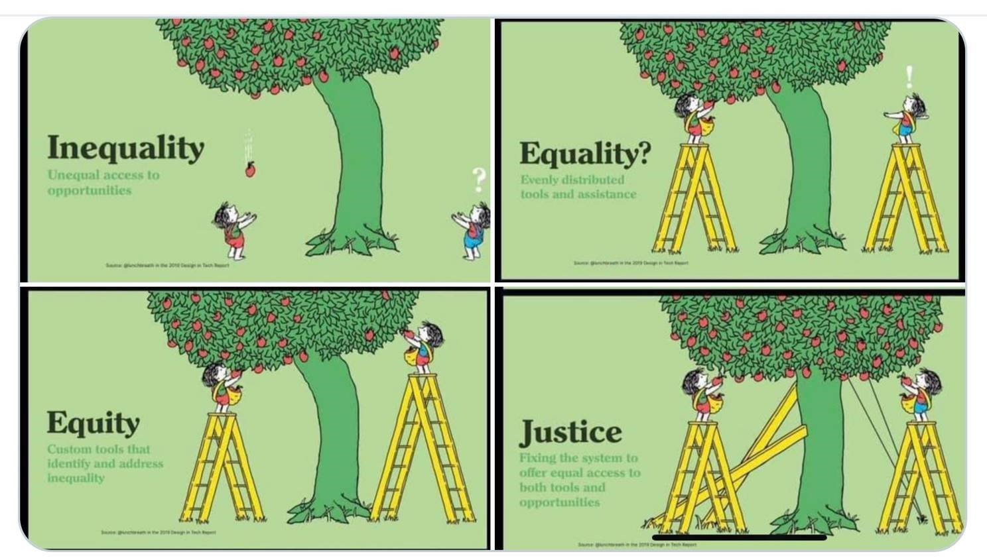
Image: Tony Ruth and Avinash Kaushik – inspired by Shel Silverstein’s The Giving Tree
In this metaphor the reality of inequality is the unequal access to opportunities (apples). Equality attempts an even distribution of tools to get to the apples. But the tree (the system) is skewed away from some people who still remain without access in spite of the tools; ironically those who might not have needed the tools have even better access. Equity recognizes differences and creates custom tools that identify and address unfairness and inequalities. This seems to help everyone, but still ignores the system. Justice addresses the skewed system and acts to change it. Together with equity it shifts the system to be open to all.
There must exist a paradigm, a practical model for social change that includes an understanding of ways to transform consciousness that are linked to efforts to transform structures. - bell hooks

Here are some optional links to explore or add to your resources.
- Here is a definition and a list of privileges on the website, The Antiracist Educator.
- Arizona State University has a resource with checklists for a number of privilege dimensions. You can use the checklist to gauge your level of privilege.
- Sam Killermann is an artist and activist focusing on gender, sexuality, and global justice. He created The Genderbread Person, and It’s Pronounced Metrosexual a free online resource.
- Anderson, S.K. & Middleton, V.A. (Eds.) (2018). Explorations in Diversity: Examining the complexities of privilege, discrimination, and oppression. Oxford University Press, Incorporated. E-book at Claremont Colleges Library . A collection of stories that articulate what privilege, discrimination, and oppression are as experiential, embodied phenomena.

Nuancing Ideas and Actions for Equity
Loretta Hammond (2020) proposes three key areas to consider in engaging in equity work.
Multicultural  Education | Social Justice  Education | Culturally Responsive  Education
Focuses on celebrating diversity. | Focuses on exposing the social political context that students experience. | Focuses on improving the learning capacity of diverse students who have been educationally marginalized.
Centers around creating positive social interactions across differences. Diversity and inclusion efforts live here. | Centers around raising students’ consciousness about inequity in everyday social, environmental, economic, and political situations. Anti-racist efforts live here. | Centers around affect and cognitive aspects of teaching and learning. Efforts to accelerate learning live here.
Concerns itself with exposing privileged students to multiple perspectives and other cultures. For students of color, the focus is on seeing themselves reflected in the curriculum. | Concerns itself with creating a lens to recognize and interrupt inequitable patterns and practices in society. | Concerns itself with building cognitive capacity and academic mindset by pushing back on dominant narratives about people of color.
Social Harmony – connecting across differences to embrace and celebrate plurality. | Critical Consciousness – begins with teachers working on developing their critical consciousness and intentionally counter-mapping teaching and learning. Involves teaching students to reframe themselves as empowered to learn and flourish. | Independent Learning for Harmony – developing emotional and cognitive learning skills, from metacognition of the learning process, strategies to engage in productive struggle, to work with rather than against turbulence.
Adapted from Hammond (2020).

PAUSE TO REFLECT: Connecting with your values and approach as an educator.
So far, you have examined identity using a systems and complexity lens to unpack intersectionality and social determinants of identity and learning, and looked at how we can unpack what we mean by Justice-oriented education that integrates Diversity, Inclusion, and Equity.

What ideas and perspectives connect with your values and goals as an educator?
Imagine you are being interviewed as “Educator of the Year” at the college at which you teach. You are asked “In a nutshell, what is your approach to DEI and why does this matter to you?”. Respond to this question taking no more than 1 minute.
Look at your Teaching Philosophy Statement (TPS) and Diversity Statement (DVS) worksheets questions and make some notes in response to the different questions.

Reframing Difference as Essential: Foundations of Your Teaching Philosophy

In Chapter 2, you read about the primacy of difference – that differences are an integral characteristic of systems; a system is an interconnected and dynamically interacting network of different elements. Plurality, multiplicity, and difference are not only natural but necessary. Human perspectives of difference as “less than” determined power dynamics and wrote the history of colonization. This binary perspective of a singular dominant narrative – the single story – has shaped our extant social and global systems. The danger of a single story in education has been demonstrated in the inequitable structures in teaching and learning that marginalize, oppress, and erase many different types of learners.
If you deny any affinity with another person or kind of person, if you declare it to be wholly different from yourself...you may hate it, or deify it; but in either case you have denied its spiritual equality, and its human reality. You have made it into a thing, to which the only possible relationship is a power relationship. And thus you have fatally impoverished your own reality. You have, in fact, alienated yourself.
Ursula Le Guin, American SF and the Other, 1975

The following perspectives from different cultures and practices reflect the systems characteristic of interconnectivity, where the whole is greater than the sum of its parts.
- Mitakuye oyasin - (we are all related or "all my relations") is a Lakota phrase that captures an essence of tribal education, reflecting the understanding that our lives are truly and profoundly connected to other people and the physical world.
- Ubuntu - Nguni Bantu philosophy - I am because we all are - sees multiplicity as the defining the essence of existence.
- Interbeing - Thich Nhat Hanh - “to be is misleading, because we cannot be by ourselves alone. ‘To be’ is always to ‘inter-be’”, a new verb form that better captures the sense of integral interconnectedness. The English Language does not actually have a verb that captures this meaning, hence the coining of this new verb.
- No man is an island – expressing the Interconnectedness of all people - from 17th century poet John Donne - that the seeming autonomy of the individual is an illusion because we emerge out of our histories and experiences and in turn respond to what impinges on us.

PAUSE TO REFLECT: Add to Your Teaching Philosophy
As educators, this systems-thinking perspective can lead us in reflexive analysis to reclaim the natural richness and importance of plural, relational thinking – and to discover assumptions and beliefs that we might need to examine and reframe. In formulating a living teaching philosophy and approach, consider your values, beliefs, and assumptions about learning and teaching.
In what ways do they reflect:
- Connectedness and relationality?
- Plurality as richness and expansion of capacity and knowledge?
Add notes to your Teaching Philosophy worksheet – Question 1 and 2.

Design Thinking for Ethical Education
In this section, you will explore how Design Thinking, a robust reflexive framework to center learners and contexts in any teaching-learning design and facilitation. Design Thinking helps us to create and actualize equity-minded, justice-oriented teaching and learning.
“Design thinking is in many ways the obverse of scientific thinking. Where the scientist sifts facts to discover patterns and insights, the designer invents new patterns and concepts to address facts and possibilities. In a world with growing problems that desperately need understanding and insight, there is also great need for ideas that can blend that understanding and insight in creative new solutions. Implicit in this notion is the belief that design thinking can make special, valuable contributions to decision making.” - Charles Owens. Design Thinking: Notes on its nature and use p. 17
"When we design for humanity, we cannot stop with people. We must consider the entire globe: all living things, the quality of the land, water, and air.” Andy Marsden and Geetika Kejriwal. NESTA.org Blog

Overview
Design Thinking came out of studio practices in design science, product design, and architecture. It is especially relevant to Universal Design in architecture and urban planning (We will explore Universal Design for Learning in a later chapter). Design thinking principles have strong connections to audience-focused information and communication science and arts.
We will use the Design Thinking framework developed by David Kelly and Tim Brown at IDEO, a design firm that champions human-centered design. This is also the framework used by the Stanford d-school – “a place, a community, and a mindset” that fosters creativity, and that was founded by David Kelly.

TASK - WATCH: What is Design Thinking. [1: 55 mins]
This video from IDEO in introduced by David Kelly and explains what it is and why it is useful. While they do not refer to teaching and learning, engage in transdisciplinary boundary crossing to ask how these ideas are relevant to education, how they might illuminate and affirm things we are already doing, and how they might help us sharpen and shape our strategies toward equity-minded design in teaching and learning.

TASK - READ: The evolution of Design Thinking [estimated 3 mins.]
IDEO website. This overview shows the system of many disciplines from which Design Thinking emerged. What transdisciplinary principles from Chapter 1 do you see reflected in Design Thinking? How does Design Thinking connect with your values and approach to teaching and learning?

Design thinking is:
- Being open and curious, assuming nothing (a beginner’s mind). Ask questions. Collaborate.
- Embracing ambiguity and unknowns, breaking binary thinking, looking for multiple points of view as opportunities for discovery and creativity.
- Tinkering and testing – failing early and often as a means to learn (rapid prototyping).
- Approaching tasks and solving problems in collaborative human-centered ways.
- Empathy and deep listening to discover what matters and our contexts of design.
- Reflexivity in checking status quo and our implicit biases and assumptions.
These processes work in integrated, iterative ways with critical reflexivity as an integral element in justice-seeking Design Thinking.

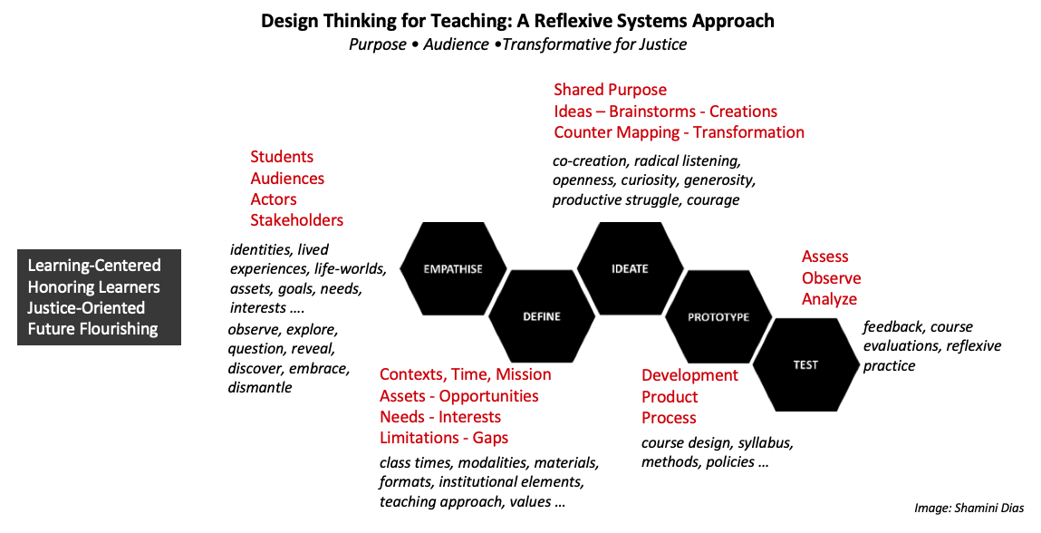
Image Source. Shamini Dias. Adapted from Dam, R. & Siang, T. (2018, June 14). 5 stages in the design thinking process. Interaction Design Foundation
Justice in Design Thinking
Design thinking is about human-centered design. However, an undifferentiated notion of “human” raises the question of justice for whom? For example, human-centered design that has focused on user convenience has led to the creation of products and processes with unintended consequences that harm the environment. Our legacy system of education has been human-centered – but only for certain groups of humans. Legacy education in the United States was centered on and designed for White, male, cis-gendered, wealthy, able-bodied humans – not for ALL humans.

Framing and Questioning
Framing Design Thinking with the question of WHO we are centering and WHY, we are better able to intentionally use Design Thinking for justice, with purpose and values leading the way. We ask – human-centered with justice for whom? Thus, Design Thinking operationalizes counter mapping as a tool for intentional design for inclusion, equity, and justice in classrooms and larger institutional spaces. Using Design Thinking for justice, the Empathize and Define space is critical for asking reflexive counter mapping questions that reveal people, contexts, perspectives, power, and motivations we might otherwise miss.
- Positionality. Who are you and how do your intersectional identities and roles shape your privilege and power (or lack thereof) in creating justice-oriented education? How have you been complicit in perpetuating systems of inequity? And how can you address this through reflexive analysis of opaque language and implicit assumptions in our design.
- Purpose. What is your WHY – what core values and beliefs support your design goals?
- People and... Who are the human and non-human players in the situation, especially those whose voices and presence have been blocked, marginalized, or erased? For example, in considering course design, do we remember indigenous and international cultures, abilities and disabilities, the impact of what we teach on planetary sustainability?

PAUSE TO REFLECT
Are you a design thinker? To what extent do you embody these habits of thought and action in your scholarship and life practices? What aspects of Design Thinking do you want to sharpen?

How to Use Design Thinking in Education

EMPATHIZE – WHO. Start with learners and learning.
We begin – and always return to – our learners to understand contexts of inclusion and exclusion. Learners are the key actors in future-focused education. Empathizing with learners helps us integrate their rich intersectionalities of identities, assets, histories, interests, and lived experiences in shaping outcomes, assessments, materials, and activities, as well as in building community in our classrooms. Don’t forget the teacher as guide and learner. What do we bring in knowledge, mission, and values that explicitly and holistically position us in a relational process of teaching and learning with our students.

DEFINE – examine CONTEXTS both situational and temporal.
Clarify contexts and constraints that affect the teaching-learning process for the learners you examined in the Empathize phase. Consider things like course day and time, length of sessions, level of course, as well as learning environments, policies, and practices that can affect learning engagement, motivation, persistence, and sense of meaningfulness and belonging.
Use reflexive systems thinking to critically question status quo or legacy elements; what processes and expectations in institutional practice and disciplinary scholarship include and exclude students? What opaque discourse hides implicit assumptions; where does gatekeeping happen and why? This helps you to notice deep conditioning and habits of thought and action that cause inequities. Areas to consider:
- Physical spaces – on-ground, digital, learning environments​
- Digital spaces, tools, and access ​
- Policies and practices – class policies, institutional policies​
- Co-curricular services, programs, and opportunities​
- Language – opaque, punitive, inviting​
- Content – curricula materials, authors, topics …​
- Community & belonging – representation, inclusion, mattering​
- Time – class scheduling, duration, deadlines​
- Methods – lectures, online/on-ground, discussions, modalities (written, visual…)​
- Assessments – high-stakes testing, grades, assignment types …​
- Assumptions – definitions of success, excellence, rigor, failure ... ​

Together, systems thinking using the Empathize and Define phases reveal:
- Complex social determinants of identity that support or block learning success.
- Legacy structures and processes that cause exclusion and inequity - opportunities and access for some while blocking and oppressing others.
- Gaps in our perspectives or mental models (shaped by our experiences and assumption) about the above that we must address to reframe and design equity-minded teaching and learning spaces and processes.

The Empathize and Define process together is an intentional observation and reflexive analysis of learners in the context of the legacy system that reveals inequities. We question Clear and Complicated domain thinking of deeply conditioned ideas and impulses that are entrenched in legacy education.

Having begun with Empathize and Define, you are ready to engage in the creation – IDEATION – cycle. This is where you counter-map, using perspectives gained in the Empathize and Define phase to innovate designs for teaching and learning that are justice-oriented and center all learners and learning. The Ideation-Prototype-Test process – as with all innovation – engages Complex domain thinking, being open to emergence, embracing multiple possibilities, and working adaptively.

IDEATE – Intentional Design. Imagine and innovate for equity
Empathize and Define phases inform your Ideation or creation phase, where you can intentionally transgress, transcend, and transform the teaching-learning process. What course and facilitation design will engage, motivate, and be meaningful for all learners? What assessment designs will work equitably and inclusively? Do you have equitable strategies to make learning visible along the way so that you and your students can gauge progress and adjust for improvement?

PROTOTYPE & TEST. Iterative Design. Engage reflexively in the teaching-learning journey.
Design does not stop at Ideation. The courses that you design are only a prototype. As you teach, you get feedback, troubleshoot, find new possibilities. You critically reflect to check assumptions and identify gaps – often making micro-adjustments as you teach. You might have to cycle through the Empathize and Define phases again to learn more in order to make the necessary adjustments.

Design Thinking can feel linear moving from Empathize-Define-Ideate-Prototype-Test
Image Source: Shamini Dias

However, in practice it is an iterative (often messy!) process:
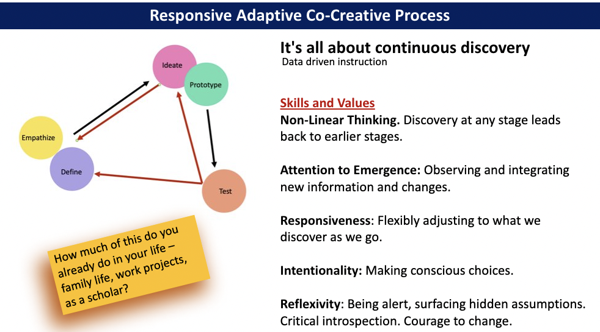
Image Source: Shamini Dias

Design Thinking as a tool and process activates mindful attention and criticality that keeps us agile and creative in transgressing legacy education and innovating justice-focused methods. It is a systems approach that adds to traditional data-informed teaching by expanding “data” to include all information, observations, feedback emerging from the teaching process. This iterative nature is why we use the concept of “prototype”. Teaching is emergent and moves through many reflexive cycles; we use what we have designed but remain alert for information to improve our prototype ad infinitum.

Design thinking reminds us of the multiple interpretations actors in a situation bring, and the importance of Empathizing and Defining to find a shared ground and purpose

TASK: Think through the following scenario:
You’ve been invited to teach! But class begins in 2 weeks…
List the first 3 things you will begin thinking about in designing your course.
Image credits: Smiley face, Worried face

- Were the first 3 things in Ideation - e.g., listing course topics, outcomes, assignments?
- Were your first 3 things in Empathize and Define – questions about students’ identities, course schedule and time, course time?
While it does not matter where we begin (as long as we move through the Design cycle), note that moving immediately into Ideation can lead us into designing teaching that perpetuates the legacy system and our own conditioning and implicit biases. But if we pause and remember to begin with Empathize and Define, we are more likely to bring a criticality that will help us integrate students’ identities, interests, and contexts in creating goals for subject mastery and future preparedness.

Imagination Pause
Take a moment to imagine the complex richness of multiple life-worlds and experiences that come into the spaces in which we teach and learn with our students:
- Each individual is an embodied microsystem of biology, experiences, connections, identities, histories, emotions, assets etc.
- Each one is in dynamic interaction with a complex network of others, all of whom are defined by both differences and commonalities.
- All these interactions are embedded in multiple complex social, temporal, and physical systems, within and across time.
Imagine this just for one student and a teacher. Then expand this to a classful of students.
In knowing how richly complex people and contexts are, we can no longer make assumptions and engage in practices that deny this diversity of learners. We cannot think of a homogeneity of learners when we know that:
- There is no “typical student”.
- There is no single way of accessing and engaging with information.
- There is no single way of expressing learning.
The legacy system was designed for a narrowly homogenous group of students, viz., White, Wealthy, Cis-Male, Able-Bodied, Protestant. The policies and processes of education were therefore grounded in racial, patriarchal, and cultural agendas and assumptions that reinforced and perpetuated the social-economic power structures of a Eurocentric capitalist system.
In transgressing, transcending, and transforming the legacy system, we ground Design Thinking in a justice-oriented purpose and a relational approach that ensures flexibility, choice, and multiple ways to access, engage, and develop knowledge and skills. Principles of counter-mapping and awareness of the multiple domains or paradigmatic assumptions, help us sharpen our applications of Design Thinking.

Chapter 5: Learning and Teaching as a Complex Adaptive Process.
This Chapter is a turning point. In Phase 1, you explored key perspectives, principles, and tools in transdisciplinary pedagogy, legacy education, and dynamics of change making. In Phase 2, you will begin the process of applying the tools and frameworks to transform teaching and learning.
To begin this process, we will explore a number of learning and motivation theories, synthesizing the key principles to frame meaningful learning as a complex adaptive process of flourishing in community.

We will explore the following learning and motivation theories:
- Maslow - hierarchy of human development
- Dweck - self-theories for growth and fixed mindsets
- Deci & Ryan – self-determination theory
- Piaget – cognitive assimilation and accommodation
- Vygotsky – Zone of Proximal Development
- Social Emotional Learning (CASEL model)
- Seligman – PERMA (positive emotions, engagement, relationships, meaning, achievement)
Each is presented in thumbnail fashion with a visual and a short explanation. To dig deeper into any of the theories, look for further references at the end of this chapter.

If there are other frameworks and models of learning that you know and feel would be useful for us to look at, please share with your peers and with me and we can explore connections to this curated set.

Your goal is to find connections between different theories, your values and goals, and the ideas we have explored thus far about humanizing learning and centering a diversity of learners. Through this synthesis you will enrich and shape your approach to designing inclusive equity-minded teaching.

Your essential question as you explore:
How do principles from learning science inform and illuminate my teaching philosophy (values, goals, and approach?

Overview: Learning as a Complex Adaptive Process
We can use the Cynefin sense-making framework to explain learning is an emergent, dissonant process:
- Not knowing. To learn, we enter a state of not knowing.
  - We expand from old knowledge (certainty – the Ordered domains) into uncertainty, unknown, unmastered new knowledge and skills (Aporia and the Complex domains). This causes cognitive and emotional dissonance; we feel unstable and uncertain.
  - We work emergently and iteratively – developing understanding and mastery, failing, getting feedback, and adjusting how we work. Learning – growing knowledge and skills – is a complex adaptive process.
- Complex adaptive mindsets. To do this well and become independent learners, we need mindsets, capacities, and skills that support us in working with emergence, dissonance, and uncertainty. These include capacities such as agency and self-efficacy, curiosity, a positive orientation to not knowing, seeing errors as points of learning, metacognition in learning how to learn, self-regulation and self-awareness, working with others, positive emotions, and meaningful engagement.
- Relationality supports all the above. Positive relationships and a sense of connection help learners engage and persist through uncertainty – the safety and support of a community, caring and esteem, trust, a sense of mattering and relatedness so that we can engage in learning with others. Here, the Ordered (Clear and Complicated) domains can provide strong support – or become barriers for some learners:
  - Support: Learners are supported and empowered in complex sense-making through intentional creation of safe, transparent, and predictable environments, a caring and supportive community, a sense of mattering and belonging, scaffolding knowledge structures and guidance.
  - Barriers: Learners are blocked in learning through exclusionary policies and practices, extrinsic and transactional regulation through punishment and reward, high stakes work processes with no safety to fail, and a lack of community and guidance.

As you read the thumbnail descriptions of the different learning and motivation theories, look out for ways in which they connect with the above description of learning using the Cynefin framework.
TASK: WATCH 3 lenses on learning Behaviorism, Cognitivism, Constructivism [2:58 mins]
The video presents 3 perspectives on learning - behaviorism, cognitivism, and constructivism that have shaped teaching practices and design.
- How do these lenses on learning connect with or diverge from your definitions of teaching and learning?
- Which perspective most represents the ways in which your discipline (especially in undergraduate settings) has traditionally approached learning?
- The video uses metaphors to describe the human mind - a black box (behaviorism), a computer (cognitivism), a rhizome (constructivism). Which do you most resonate with and why? If you had to come up with your own metaphor for the human mind, what would it be?

Explore Learning and Motivation Theories

Maslow: Hierarchy of Needs
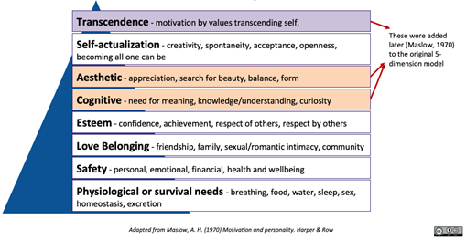Image Source: Shamini Dias

Maslow's (1943, 1954) original five-stage model was expanded to include cognitive and aesthetic needs, and then transcendence needs (Maslow, 1970b). Maslow distinguished between Deficiency needs (Physiological, Safety, Love and Belonging, and Esteem), and Growth needs (Cognitive, Aesthetic, Self-Actualization, and Transcendence).
Deficiency needs when unmet negatively affect a person’s development; we seek to satisfy them in order to avoid feeling bad. Growth needs are not about a lack of something, but a desire to flourish.
While the model presents needs in a hierarchy, Maslow (1987) pointed out that motivation is complex and that “any behavior tends to be determined by several or all of the basic needs simultaneously rather than by only one of them” (p. 71). For example, one might be hungry and face safety risks, but be deeply motivated to search for beauty and new ideas, or work for social change. There are also cultural and contextual differences in how needs manifest and affect motivation and engagement. Tay and Diener (2011) found, for example, that in many societies, people whose basic needs had not been met reported having pursued higher level needs such as social relationships and self-actualization.

Maslow and Cynefin
Maslow’s framework gives us a heuristic guide for sense-making and designing teaching-learning. Locating these in the Cynefin model: the stability and predictability of Clear and Complicated spaces support Deficiency needs – stability of physiological and safety needs, being part of a supportive community for Love & Belonging and Esteem needs. Growth needs are fostered through capacities and support to flourish in complex sense-making for learning and self-development.

Self-Theories • Carol Dweck
Dweck identified two main perceptions or “self-theories” that affect our learning motivation:
Entity or Fixed Mindset – see intelligence as fixed and stable. Hence, they can be confident, motivated and will try as long as they feel the task is within their grasp. But they will avoid taking risks - error or failure would imply they had reached their limits. Therefore, they tend to be performance goal oriented and avoid situations they perceive as risky.
Incremental or Malleable Mindset – see intelligence as fluid and changeable. Hence, they are oriented to errors as points from which they can learn and improve. They like challenges and are more mastery-goal oriented and willing to take risks. Dweck calls this the learning mindset.
Learning – by its very nature – means starting in a state of not knowing, without full competence. Building competence includes trying, failing, and correcting errors as we develop mastery. The malleable mindset is more suited to learning than an entity mindset.
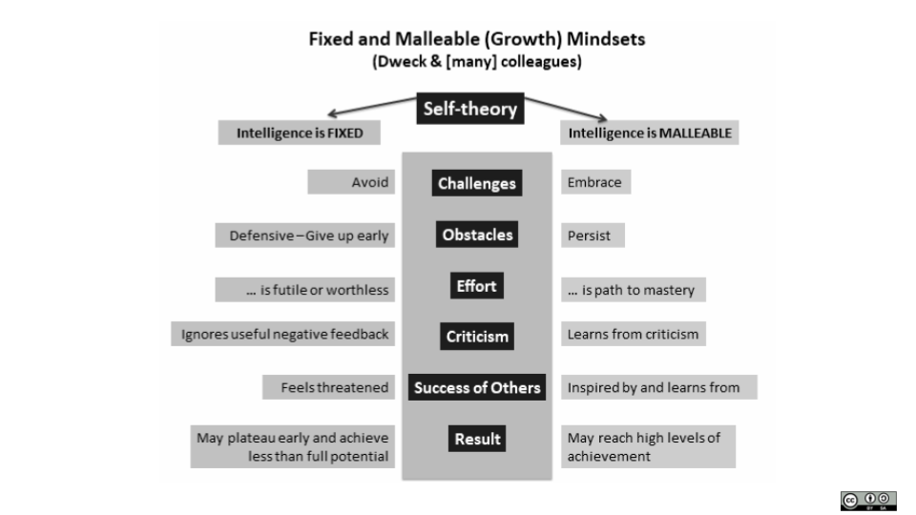
Image Source: Shamini Dias.

TASK: Watch: Growth Mindset. The Power of Yet [11:19 min]
Carol Dweck speaks on enabling change by fostering a malleable, learning, or growth mindset. Learning engages an individual in being curious, wondering, exploring. Experimenting and playing helps one understand that “failure” is not a bad thing; real discovery is about walking into the unknown, taking risks, trying things out that do not work, but using that trial to discover what works.

Dweck’s Mindsets in Cynefin
Using Cynefin, if a learner’s self-theory is fixed (ability if limited), they may seek stability and certainty, thus locating learning Clear and Complicated domains and can be highly dependent learners. They thus will not be motivated to venture into the complex adaptive space of exploration, unknowns, and trial and error. If a learner’s self-theory is malleable (ability evolves), they have a high tolerance of the dissonance of unknowns, explorations, seeing errors as formative to learning. Can you think of strategies to move learners away from a fixed mindset toward a growth mindset? What can you do in course design, assessment and assignments, community development, your facilitation methods etc.?

Self-Determination Theory (SDT). Edward Deci & Richard Ryan
SDT focuses on the interaction between external factors that impact us and intrinsic drives and motivations toward action. It also focuses on how social and cultural factors affect our sense of agency and motivation. Six mini theories make up the larger SDT and one of the fundamental theories in SDT is Basic Psychological Needs Theory (BPNT) that looks at 3 universal needs – Autonomy, Competence, and Relatedness. Ryan & Deci (2000) defined a basic psychological need as critical for the “optimal functioning of the natural propensities for growth and integration, as well as for constructive social development and well-being” (p. 68).

TASK. Watch: Edward Deci on Self-Determination Theory [8:02 mins]
Edward Deci explains self-determination theory - autonomous or volitional motivation (as opposed to controlled motivation), and the universals of the need for autonomy, competence, and relatedness.

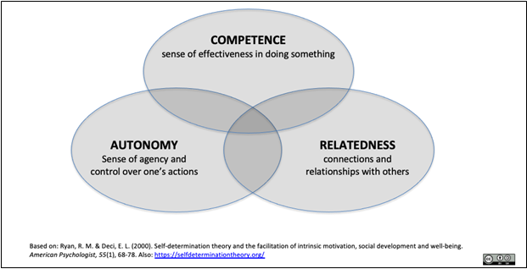
Image source: Shamini Dias

- Autonomy: The experience of having control or volition and being willing. When we have autonomy. we experience a sense of authenticity in the integration and validation of our actions, thoughts, and feelings. Not having autonomy, we feel pushed in unwanted directions, blocked, and often experience conflict.
- Competence: The experience of mastery or being effective at something when we engage in activities that enable us to use and extend our knowledge and skills effectively. Not having competence, we feel helpless and a failure.

- Relatedness: The experience of positive connections and care, meaningful sense of belonging. Not having relatedness, we feel alienated, excluded, and invisible to others.

The Self-Determination Continuum
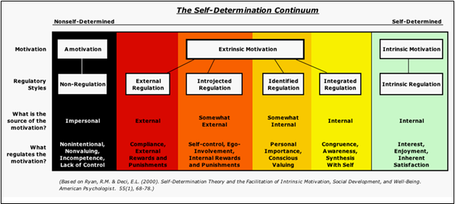

Deci & Ryan (1985) introduced an Organismic Integration Theory as part of SDT that articulated how contextual factors like levels and sources of regulation affect different levels of intrinsic and extrinsic motivation. Intrinsic and extrinsic motivation are not binaries, but a continuum ranging in degree of external and internal (self-determined) motivation sources.

Amotivation – source of motivation is impersonal, no regulation. Not valuing an activity or not feeling competent to do something - there is no action or action with no intention (going through the motions). Apathy. I have homework – who cares.

Extrinsic Motivation is gradated by different kinds of regulation:
- External Regulation – completely external source of motivation. Regulation is imposed through compliance, with external rewards and punishments. If I do not do homework, the teacher will punish me. If I do the homework, I get to have candy.
- Introjected Regulation – source of motivation is still external (impacts someone else) but is not yet one’s own actual desire. We act to avoid guilt or anxiety – “contingent self-esteem”. If I don’t do homework, I will let my parents down and feel bad.
- Identified Regulation – source of motivation is somewhat internal but there is a conscious valuing through identification so that we own and accept the action. Doing homework will help my college application and I want to go to college.
- Integrated Regulation – source of motivation is internal. Regulation of actions comes from assimilation into internal values and sense of self. This might sound like intrinsic motivation, but the difference is that integrated regulation is still done to achieve something rather than for the inherent enjoyment. Doing homework reflects my work ethic and sense of responsibility.

Intrinsic Motivation - source of motivation is internal, regulation is internal. Deeply valuing an activity and engaging for inherent satisfaction. Highly autonomous, full self-determination. I love history – what a kick I get from this!
Self-Determination Theory in Cynefin
Interpreted through the Cynefin framework - one needs self-determination to persist in learning because learning – the development of new understanding, mastery of skills – is first venturing into the unknown and coming to know through effort we make. Learning happens in the Complex domain. Autonomy and self-efficacy support learners in persisting through the inherent dissonance of learning. In order to engage in productive struggle – the exploration, attempts, first drafts, errors, formative feedback – we need autonomy and self-awareness to make choices in our learning process, and a sense of confidence in the tools, knowledge, skills, and capacities we bring with us in learning and learning how to learn. Relatedness is critical in supporting this – the resources others can provide and the support of those who have our back in navigating uncertainty, not knowing, and coming to know.

PAUSE TO REFLECT
In which sense-making spaces could we build scaffolds that will help learners develop the autonomy, competence, and relatedness needed to persist in the Complex space where learning happens?

- Can you think of areas in your life in formal schooling and informal learning or professional work where you experienced each of these different levels of motivation?

- Many students have been in school and/or socialized into being more extrinsically motivated. What pedagogical principles and strategies can you think of that support students to move further along the continuum toward intrinsic motivation? ￼

Cognitive Equilibration - Assimilation and Accommodation • Jean Piaget
In addition to his stage theory of child development, Piaget explained learning or knowledge construction as a process of equilibration or adaptation, moving from assimilation to accommodation.
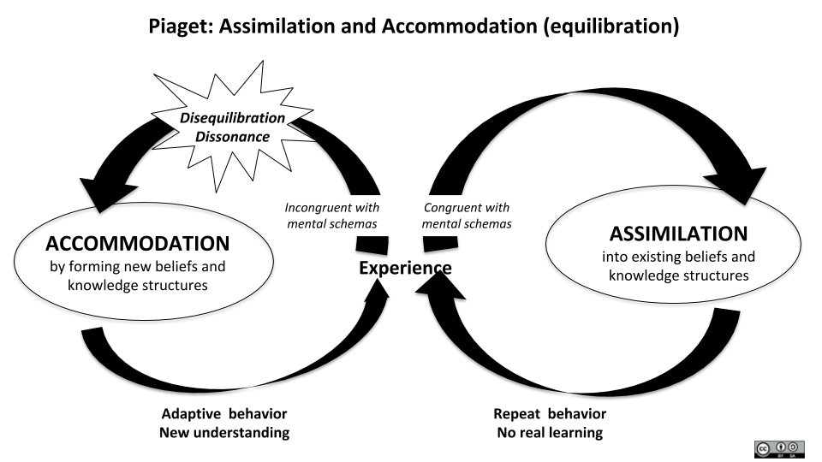
Image source: Shamini Dias.

Assimilation
When we meet a new object or situation, we operate automatically in Clear and Complicated sense-making, using existing schema or knowledge structures to explain or understand it. This is a conserving process; no new knowledge is created as we explain what we see through knowledge we already have. We have a knowledge schema for “dog” and so when we meet a new 4-legged creature that barks, we will interpret it as a “dog” – we engage in an assimilation process. While we have added to our knowledge base, we have not made any significant shifts.

Accommodation
When we meet something that existing knowledge structures or schema cannot explain, we find ourselves in disequilibrium, an unstable state that is cognitively dissonant. If we can create new knowledge structures to accommodate the new item or experience, we regain stability. Thus, we construct knowledge.
For example, travelling to a new culture, we see things that our existing knowledge structures cannot explain - people helping themselves to food from a shop without paying. We experience cognitive dissonance, feeling puzzled, even alarmed. But if we ask questions and learn about this cultural practice, we develop a new knowledge schema about community sharing; we accommodate the experience.
A more extreme example: Human space-travelers land on a distant planet. They see something with leaves, stems, flowers that they assimilate into existing knowledge schemas – “it’s a plant”. Then the “plant” moves, branches extending leaves and flowers toward them. The resulting dissonance and disequilibration might lead to instinctively seeing a threat and shooting it down – starting an inter-galactic war with a sentient plant-like civilization. But if they paused, approached cautiously, remained in Aporia for a while and tried to accommodate the paradox - “looks like a plant, but seems sentient” – they might make first contact with a new form of sentient creature, leading to cultural contact and exchange between Earth and this planet. And avert intergalactic violent conflict!

Disequilibration, Accommodation, and Cynefin
Piaget’s concept of learning through accommodation as an adaptive process locates dissonance as a natural part of coming to know something, of expanding and developing knowledge. Learning is sense-making in the Complex domain. The learner enters a state of disequilibration in encountering something new. Much depends on whether or not mindsets and skills for learning are at play such as growth mindset, autonomy, self-efficacy, relatedness, a sense of safety etc., and whether learning and life contexts support and foster these. The learner could persist through the dissonance, engaging in productive struggle, or feel overwhelmed and fall into Chaotic domain sense-making, and disengage.

PAUSE TO REFLECT
Learning in itself involves dissonance in working from not knowing something toward mastering knowledge and skills. Some learners experience additional dissonance and disequilibration.
- What factors in legacy teaching and learning add turbulence and disequilibrium to the natural dissonance of learning something new?
- How do socio-ecological factors and different elements of systemic barriers and oppression create this additional dissonance? How do learner identities add to learning dissonance?
- What pedagogical principles and strategies can address this additional dissonance so that students can effectively engage with the natural dissonance of learning?

Zone of Proximal Development • Lev Vygotsky
Social constructivism sees language and culture as critical in learning development. Learning happens through social and community interactions; knowledge is co-constructed with others.
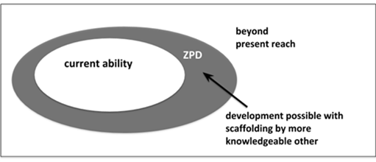
Image Source: Shamini Dias

Vygotsky’s Zone of Proximal Development (ZPD) is a zone of potential and optimal growth. This is where the skill is just beyond what the learner can achieve independently, their competence level, but which is possible to achieve IF the learner is assisted. The person assisting – or scaffolding the learning (Wood, Bruner, & Ross, 1976) - is a More Knowledgeable Other (MKO) is not limited to the teacher; it could be a peer, a community member etc. This framework supports research in peer-based and community engaged learning.

ZPD and Cynefin
Vygotsky’s ZPD being just outside of the learner’s ability/knowledge locates learning in the Complex domain of Cynefin - the ZPD is potentially a dissonant space. Social learning, with the support of More Knowledgeable Others helps learners persist in the dissonant stretching involved in building new skills and knowledge. The self-determination and growth mindset this needs comes through the interaction of safety, community support and esteem that builds self-efficacy and autonomy, the reassuring guidance of experts, etc. Learners’ sense-making their learning environment to find stability in Clear and Complicated domains are able to persist in the ZPD.

PAUSE TO REFLECT
- What kind of scaffolding can you use to help students work effectively in stretching their skills and abilities?
- How can you begin with where students are, and help them take incremental steps to stretch their skills and reach new ability levels?
- Consider how you break down steps in giving instruction, whether you point out clear steps when you model and demonstrate, and how and when you have students teach each other.

Social-Emotional Learning
Emotion has long been absent from educational settings.
Pause and think about the strangeness of the idea that learning is all about cognition. Part of this can be attributed to the binary distinction we make between “cognition” and “emotion”, rational thought and irrational feeling, where it seems as if the former of these pairs is somehow superior, and that emotions takes away objectivity and rigor. In college level teaching, we also have the added idea that emotions are just part of K-12 teaching and learning; after all, many pioneers of holistic education like John Dewey, Maria Montessori, and the Reggio Emilia Schools are from the K-12 space. At college, we are expected to work with rational people who can go about the business of learning as a cognitive process of knowledge development. However, neuroscience research (Damasio 2005, Immordino-Yang, 2011) shows that emotions are woven integrally into all decision-making. motivation, and learning through our lifetime. They are certainly a significant dimension of learning (Cavanagh, 2016).

TASK WATCH: CASEL Social Emotional Learning [6:14 mins]
CASEL (Collaborative for Academic, Social, and Emotional Learning) is a Chicago-based nonprofit organization that catalyzed research and practice in social emotional learning (SEL) and needs and began defining this field more than 20 years ago. In this video, they explain what SEL is, and why it is important. Consider why and how this is important for college level teaching and workspaces ... and why we have been slow to bring this in.

Emotions are at the heart of human experience and interaction.
- “the classroom is already a highly charged emotional atmosphere; why not harness that power and direct it at learning” (p.9) – Susan Rose Cavanagh, The Spark of Learning. 2016
- “First, emotion and cognition are intertwined, and involve interplay between the body and mind. Second, social processing and learning happen by internalizing our subjective interpretations of other people’s beliefs, goals, feelings, and actions, and vicariously experiencing aspects of these as if they were our own. Together, these two results from neuroscience could have important implications for the design of learning environments” – Mary Immordino-Yang, 2011.
- Human beings have distinguished themselves from all other beings by creating a spectacular collection of objects, practices, and ideas, collectively known as cultures. … Language, sociality, knowledge, and reason are the inventors and executors of these complicated processes. But feelings get to motivate them and stay on to check the results… Cultural activity began and remains deeply embedded in feeling. The favorable and unfavorable interplay of feeling and reason must be acknowledged if we are to understand the conflicts and contradictions of the human condition. (p 3- 5). Antonio Damasio, The Strange Order of Things. 2018.
- “Social and emotional learning (SEL) is the process through which children and adults understand and manage emotions, set and achieve positive goals, feel and show empathy for others, establish and maintain positive relationships and make responsible decisions”. CASEL (Collaborative for Academic, Social, and Emotional Learning).
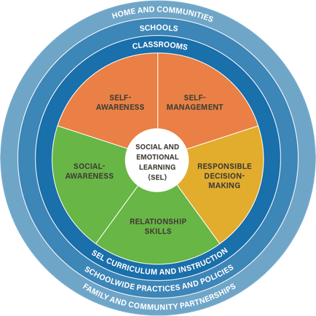

Self-awareness: Able to accurately recognize one’s emotions and thoughts and their influence on behavior. This includes accurately assessing one’s strengths and limitations and possessing a well-grounded sense of confidence and optimism.
Self-management: Able to regulate one’s emotions, thoughts, and behaviors effectively in different situations. This includes managing stress, controlling impulses, motivating oneself, and setting and working toward achieving personal and academic goals.
Social awareness: Able to take the perspective of and empathize with others from diverse backgrounds and cultures, to understand social and ethical norms for behavior, and to recognize family, school, and community resources and supports.
Relationship skills: Able to establish and maintain healthy, rewarding relationships with individuals and groups. This includes communicating clearly, listening actively, cooperating, resisting inappropriate social pressure, negotiating conflict constructively, and seeking and offering help when needed.
Responsible decision-making: Able to make constructive and respectful choices in personal behavior and social interactions based on ethical standards, safety concerns, social norms, the realistic evaluation of consequences of various actions, and the well-being of self and others.

PERMA and Positive Psychology
Another framework that positions emotions as critical to cognitive process and especially learning is the PERMA framework developed by Martin Seligman (2011). PERMA stands for Positive Emotions, Engagement, Relationships, Meaning, and Accomplishment.
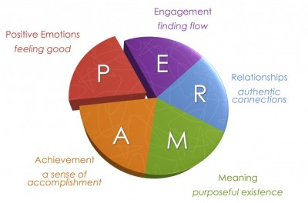
- Positive Emotions: Experiencing emotions such as joy, gratitude, contentment, interest, hope.
- Engagement: Full absorption and attention in activities that are challenging but draw on your competence (experiencing Flow).
- Relationships: Experiencing relationships of mutual trust, that are meaningful.
- Meaning: A sense of belonging and connectedness to something we see as bigger than oneself.
- Accomplishment: Experiencing mastery and success.
PERMA is connected to research on Subjective Well-Being led by Edward Diener (2012), Sonja Lyubomirsky (2006) and others. Health disciplines have adapted PERMA, adding Health (PERMAH) to integrate nurturing health habits as part of positive education (Norrish & Seligman, 2015).

TASK: WATCH - Martin Seligman on PERMA [4:43 mins]
A quick overview by Seligman defining the 5 elements of PERMA. How is PERMA important in transforming teaching and learning toward equity and inclusion for excellence in learning?

SEL and PERMA as Capacities for Complex Sense-Making
Consider how emotions are especially critical in navigating new and different ideas and in the formative process of mastering knowledge and skills, i.e., learning (Complex domain sense-making). SEL and PERMA capacities support the development of learning how to learn skills and empower learners to be independent and self-determining in navigating the natural turbulence of learning.

PAUSE TO REFLECT
SEL and PERMA clarify how emotions and social-emotional capacities support learning engagement. Our social-emotional capacities are at the heart of learning motivation, effective learning, and strong learner identities.
- What strategies and processes have you seen in your experience of teaching in your discipline – or being a learner in your discipline – that have integrated elements of SEL and PERMA?
- In recognizing the place and role of emotions, we also see how negative emotions can block learning and flourishing.
  - How do assumptions and practices in legacy teaching cultures of your discipline foster negative emotions that block learning? What types of learners are most affected?
- What connections do you see between SEL/PERMA and
  - Other learning and motivation theories?
  - Learning as a complex adaptive process?
  - Capacities for future flourishing?
  - With culturally sustaining inclusive, equity-minded education?

- What values and principles could you bring to design teaching and learning environments and processes that recognize, invite, and create positive emotions?

PAUSE TO REFLECT: Learning Theories and Your Experiences as a Learner
Write some notes in response to these questions about yourself as a learner and see whether in retrospect, you can identify elements of the different learning and motivation theories and how they were present, absent, blocked, or erased in your learning journeys.
- Think of yourself in any learning experience - any age - where you were fully engaged, motivated, and enjoyed the learning process. This can be in formal or informal situations. What contributed to your positive engagement and learning in this situation – what learning and motivation theories can you use to explain this?
- Think of yourself in any learning experience - any age -where you were NOT fully engaged, motivated, and enjoyed the learning process. This can be in formal or informal situations. What contributed to your negative engagement and learning in this situation – what learning and motivation theories can you use to explain this?
- Babies and little children love to learn - they are hungry to learn and find it joyful. Why do you think some people grow up to not love learning or going to school?

Learning Science and Learning Cultures

Learning science principles help us understand learning. However, learning cultures are messy and can get in the way of implementing these principles for equity-minded teaching.
We embody learning cultures as a result of our education and disciplinary discourse. Like us, our students too have been shaped by their own educational journeys. Play and exploration as part of learning (a grounding in complex adaptive skills) might have been in some students’ learning cultures and absent for others. Rote learning and high stakes testing have enculturated many students into a culture of competition and reward/punishment. Some students’ learning cultures have led to passive dependency, while the learning cultures of others fostered independent learner skills. In some cultures, storytelling and oracy are integral to learning, yet this is not part of their formal schooling. In some disciplinary cultures, girls and students of color are regarded as having less of an aptitude for success (strong examples are mathematics, statistics, and engineering). Students can move through the same course/program and experience different learning cultures depending on their identities.
- Our learning culture. We are often unaware of how our educational experiences have shaped assumptions and beliefs that we in turn apply as educators. Reflexive questioning of these assumptions and beliefs, an awareness of learning inequities, supported by principles from learning science help us to intentionally decide what values, knowledge, goals, and methods we can apply as educators. This is part of our internal paradigm shift about learning and teaching and a key aspect of developing culturally sustaining pedagogies.
- Students’ learning culture. Transforming teaching and learning is not always a simple matter of doing the right thing; the challenge is students’ mindsets and emotions. Students who have been long conditioned to a different way of learning – even if that does not actually help them – can resist changes because they sense-make using Clear and Complicated domain thinking (I’ve never done it this way, this seems hard, I’m not used to this, it’s not what my other teachers have ever done...). Students used to high stakes exams might resist project-based assessment, those used to passive lectures could find active learning in class too difficult, students used to rigid compliance-based instruction might find choice and creativity daunting, those shaped into dependent learning resist the actions needed to become empowered, independent learners.

TASK: EXAMINING LEARNING CULTURES
In understanding how different learning cultures foster different learner identities and habits of mind and action, we can address two important areas:
- What is your own learning culture history?
  - What aspects of your learning history and the perspectives, assumptions, and actions you consequently developed are supported by and/or contradicted by learning science?
  - List 5 guiding lights or principles based on learning science to support learning that will be integral to your teaching philosophy.
- How do I support my students in shifting from negative learning cultures toward flourishing?
  - List 3 transformations you want to make for equity-minded teaching and learning.
  - For each one, how and why might students resist?
  - What can you do to scaffold them into a paradigm shift that will empower them?

Recap: Learning as a Complex Adaptive Process

TASK: Connect learning theories to complex adaptive processes

Learning is not a linear nor additive process of gathering facts. It is a complex adaptive process that looks like this:
Learning is … leaving solid certainty behind
entering Aporia of uncertainty and unknowns.
encountering disequilibration and dissonance
moving through affective and cognitive dissonance
Learning is … making mistakes, falling, failing, getting lost, starting again.
Learning is … challenges and roadblocks of the mind.
Learning is … walking on the very edge of Chaos.
Learning is … looking for, asking for, finding feedback.
Learning is … connecting emerging knowledge with embodied experience.
Learning is … meaningful engagement of cognition and emotions.
Learning is … constructing new knowledge and skills.
Learning is ... emergent, iterative, formative growth.

Examine these statements about learning that depict a complex adaptive process. What learning theories apply that would support learners to engage in this process without falling into Chaotic domain thinking and disengaging?

From Theoretical Frameworks to Practice
We explored a few learning and motivation theories, mapping them with the Cynefin framework to conceptualize learning as a complex adaptive process. While each of the theories was developed separately and at different times by different researchers, many key principles connect, especially when applied to the practice of teaching.
TASK: Connect Theory to Practice
In anticipation of the chapters to follow where we look at methods for different dimensions of teaching and learning, think about how you would apply learning science principles to develop culturally responsive, equity-minded, and future-focused teaching and learning. For each principle below, can you think of the different learning theories that would support it? Add 1-2 more ideas and strategies that you have experienced, used, or observed. Feel free to add ideas even if you do not think you’ve seen them before – innovate!
- RELATIONALITY. Develop an exploratory and meaningful classroom culture – a paradigm or microsystem - invite curiosity, exploration, questions. Explicit care, connection, and community. Make trust and respect part of class culture, collaborative work, joy and fun.
- MEANINGFULNESS – Create authentic connections and relevance – invite and engage the whole student – recognize identities, histories, and lived experiences as assets, collaborative active learning, connecting contents to students’ lives, current events, and future needs.
- PLURALITY. Create flexible learning environments. Use UDL and Multiliteracies to create learning structures, resources, and processes that create meaningfulness, access in multiple modalities, in order to support a diversity of learners in engaging and persisting in learning.
- FAIL-SAFE. Make errors just another part of learning - space and time for mistakes, a culture of “mistakes as part of learning”, curiosity to explore.
- FORMATIVE. Focus on growth through process - drafts, low-stakes assessments, feedback, revision, collaborative work and assignments, multiple opportunities to revise and improve.
- METACOGNITION. Build learning awareness and learning how to learn – self- and peer-feedback, learning reflections, mentoring, coaching.
- AGENCY. Build autonomy and competence – student choice, flexible options, co-creating work processes with learners, make learning visible to students as they work, celebrate progress, self-assessment of learning strengths
- REFLEXIVITY. Critically examine your curriculum and teaching design – use Systems and Design Thinking to intentionally engage in questioning assumptions and given practices through a cycle of Empathize-Define-Ideate-Prototype-Test. Use periodic and open student feedback, reflect with students.
- JOY & POSITIVITY. Make learning a fulfilling positive experience – choice and autonomy in assignments and assessments, co-create with students, celebrate generative feedback, highlight struggle for success.

Further Exploration
These references and links are optional if you are interested in exploring any of the theories further.

Abraham Maslow.
http://www.simplypsychology.org/maslow.html - a good website for quick overviews of many psychological theories. This page on Maslow has a good video explaining the theory.
Maslow, A. H. (1987). Motivation and personality (3rd ed.). Pearson Education.
Tay, L. & Diener, E. (2011). Needs and subjective well-being around the world. Journal of Personality and Social Psychology, 101(2), 354-365.

Carol Dweck. Growth and Fixed Mindsets
TED Talk by Carol Dweck (2014) The Power of Believing That You Can Improve.
Mangels, J. A.; Butterfield, B.; Lamb, J.; Good, C.; Dweck, C. (2006). Why do beliefs about intelligence influence learning success? A social cognitive neuroscience model. Social Cognitive and Affective Neuroscience. 1 (2): 75–86.

Richard Ryan and Edward Deci. Self-Determination Theory
http://www.selfdeterminationtheory.org/theory
Ryan, R. M., & Deci, E. L. (2000). Self-determination theory and the facilitation of intrinsic motivation, social development, and well-being. American Psychologist, 55(1), 68–78.
Reeve, J. (2002). Self-determination theory applied to educational settings. In E. L. Deci & R. M. Ryan (Eds.), Handbook of self-determination research (p. 183–203). University of Rochester Press.

Jean Piaget
The Equilibration of Cognitive Structures: The Central Problem of Intellectual Development (Chicago: University of Chicago Press, 1985) [L'equilibration des structures cognitives (1975), previously translated as The development of thought: Equilibration of cognitive structures (1977)].
Britannica Entry for Piaget’s Theory of Cognitive Equilibrium.
Boom, J. (2009). Piaget on equilibration. In U. Müller, J. I. M. Carpendale, & L. Smith (Eds.), The Cambridge companion to Piaget (pp. 132–149). Cambridge University Press.

Lev Vygotsky
https://www.simplypsychology.org/vygotsky.html - overview of Vygotsky’s theory.
Kozulin, A., Gindis, B., Ageyev, V., & Miller, S. (Eds.). (2003). Vygotsky's Educational Theory in Cultural Context (Learning in Doing: Social, Cognitive and Computational Perspectives). Cambridge: Cambridge University Press. doi:10.1017/CBO9780511840975. E-Book at Claremont Colleges Library

Social Emotional Learning
Quinlan, K. M. (2016). [10 pages] How emotion matters in four key relationships in teaching and learning in higher education. College Teaching, 64(3), 101–111.
Reinert, P.M. (2019). Social-emotional learning: a model for higher education [1.5 pages], Journal of Research in Innovative Teaching & Learning, Vol. 12 No. 2, pp. 114-115.
Durlak, J. A., Weissberg, R. P., Dymnicki, A. B., Taylor, R. D., & Schellinger, K. B. (2011).[27 pages] The impact of enhancing students’ social and emotional learning: A meta-analysis of school-based universal interventions. Child Development, 82(1), 405–432.
Dena Simmons (2019) Why we can’t afford whitewashed social-emotional learning.

Martin Seligman. PERMA
Watch Martin Seligman explain PERMA https://youtu.be/iK6K_N2qe9Y [View Time: 25:05 minutes]
Martin Seligman (2018) PERMA and the building blocks of well-being, The Journal of Positive Psychology, 13:4, 333-335.
Positive Education applied in an Australian school - the Geelong Grammar School. There are some excellent pages where they describe positive education and key elements in their model and how they have applied it in teaching and learning.
Seligman, M. E. P. (2011). Flourish. New York: Simon & Schuster.
Diener, E. (2020). Happiness: the science of subjective well-being. In R. Biswas-Diener & E. Diener (Eds), Noba textbook series: Psychology. Champaign, IL: DEF publishers.

Chapter 6: Designing the Future: Culturally Sustaining Pedagogies

This chapter leads you in selecting and crafting your teaching mission, I.e., your pedagogical approach grounded in your values and purpose as an educator. Our collective goal is to develop a mission for teaching that is justice-oriented and future-focused, that will support a radical re-imagining of teaching and learning strategies and environments. To do this, you will explore 2 areas:
- Culturally Sustaining Pedagogy and related liberatory pedagogies.
- Metaphor as a tool for counter mapping and teaching mission expression.

Review Frameworks & Tools
Before you move on, take some time to look back to the pathways we have explored and review and refresh key frameworks and ideas.
TASK: Self-Check Review
Do a quick mental check for each of the ideas and tools below – would you be able to explain these briefly to someone? (You might want to sit with a friend or family member to try it out – it’s a great way to check if you can articulate knowledge in ways that are meaningful to someone quite outside of these areas of study – will they see connections to their life and work?)
- Education is a wicked problem.
- Transdisciplinary pedagogy as liberatory - transgression, transcendence, transformation.
- Transdisciplinary perspectives and principles. Transdisciplinary habits of mind and action.
- Transdisciplinary habits of mind and principles are appropriate for a VUCA world.
- Systems thinking and legacy education:
  - The complex “messiness” of systems.
  - The primacy of difference and its colonizing impact. The danger of a single story.
  - The banking- and problem-posing models of education. The imperative to humanize education.
  - Misalignment of legacy education with current demographics and contexts, emerging futures, and learning science.
- Complex intersectional identities as microsystems embedded and shaped by social determinants of learning.
- Diversity-Inclusion-Equity values for justice-oriented education.
- Paradigm shift and resistance to change.
- Change tools:
  - Reflexivity and double loop analysis
  - Design Thinking centering justice and learners to humanize teaching and learning.
  - Counter mapping to reframe. Complex adaptive thinking (Cynefin)
  - Transmission to Empowerment Framework for Education

Culturally Sustaining Pedagogy: Shifting the Mission
“What would our pedagogies look like if this [white] gaze weren’t the dominant one? What would liberating ourselves from this gaze and the educational expectations it forwards mean for our abilities to envision new forms of teaching and learning? What if, indeed, the goal of teaching and learning with youth of color was not ultimately to see how closely students could perform White middle-class norms but to explore, honor, extend, and, at times, problematize their heritage and community practices?” Django Paris and Samy Alim, 2014.
READ 2 Articles
- Chapter 1: Alim, S. & Paris, D. What is Culturally Sustaining Pedagogies and why does it matter? [17 pages]
- Chapter 15: Lee, C. D. (2017). An ecological framework for enacting Culturally Sustaining Pedagogy. [9 pages]
in Paris, D., & Alim, H. S. (Eds.). (2017). Culturally sustaining pedagogies: Teaching and learning for justice in a changing world. Teachers College Press. E-Book at Claremont Colleges Library.
What connections can you make between Culturally Sustaining Pedagogy and the concepts, frameworks, and tools we have explored so far? Consider: the primacy of difference, the VUCA world, systems and complexity thinking, complex intersectional identities, reflexivity through double-loop learning, the Cynefin framework’s Clear, Complicated, Complex, and Chaotic domains, the Transmission to Empowerment framework.

Background: Culture and Education
The deficit paradigm of culture in education makes a binary distinction between dominant education culture and other cultures as one explanation of the educational achievement gap. Different languages, literacies, knowledges, and ways of being and knowing of other cultures are deficits – a lack of cultural capital in knowledge and know-how - that get in the way of academic and life success, i.e., that prevent “fitting in” and acquiring dominant culture and knowledge transmitted in schooling. We have seen explicit egregious practice of this in the eradication of Native American culture with schools practicing a philosophy of saviorism (“kill the Indian … save the man”), in British colonial education supported by a missionary saviorism that groomed people in colonized nations to convert to Christianity, to acquire British language, culture, and lifestyles, and to serve in British-governed civil service. More insidiously, we still use curricula defined by Eurocentric discourse practices and knowledge bases, institutional structures and pedagogical processes, assumptions, and expectations that marginalize or erase the richness of different cultural languages and literacies, and different ways of knowing and being.

Asset-based paradigms reframe diversity in cultures, identities, languages, and literacies as assets that we honor and include in teaching, learning, and broader school culture. Students’ cultures are not the problem; instead, they empower learning and learners. Landmark developments were in Culturally Relevant and Culturally Responsive Teaching by Gloria Ladson Billings (1994, 1995, 2014) and Geneva Gay, (2000, 2018) where teachers use “the cultural knowledge, prior experiences, frames of reference, and performance styles of ethnically diverse students to make learning encounters more relevant to and effective for them.” (Gay, 2010. p. 31). Scholars such as Paulo Freire, Norma Gonzalez and Luis Moll (Funds of Knowledge), Daniel Solorzano and Dolores Bernal (transformational resistance), Tara Yosso (Community Cultural Wealth), Henry Giroux among many others, pushed the envelope of cultural inclusion not just as a recognition of multiple cultures, but as a form of identity empowerment that fostered agency and success in academia. These moves grew from the rich ground of critical theories in education, post-colonial, critical feminist, queer theories, critical literacies, and linguistics.

PAUSE TO REFLECT
In your own discipline, has there been a critical reflexive questioning of the assumptions, values, and goals of your discipline? How does the perspective of asset-based paradigms enter your scholarship?

Culturally Sustaining Pedagogy
Following this rich landscape of asset-based moves, Culturally Sustaining Pedagogy (CSP), developed by Django Paris and Samy Alim (2012, 2015, 2017), pushes the envelope even further to question the end-goals of success. Many culturally inclusive initiatives still focus on access to and success within a singular dominant system of academic norms, discourses, and knowledge bases. CSP adds a complexity- and futures-oriented purpose into pedagogy in a double-loop learning question: “What is the purpose of schooling in pluralistic societies?” (Alim & Paris, 2017; p.1). This recognizes significant world-shift and pushes beyond inclusion to question its effect as a scaffold in a one-way assimilation to the perpetuation of dominant schooling discourses and knowledge and invalidate other forms of knowing and communication. “CSP seeks to perpetuate and foster-to sustain-linguistic, literate, and cultural pluralism as part of the democratic project of schooling and as a needed response to demographic and social change” (Paris & Alim, 2014; p. 88). With CSP, inclusion of plurality in all its forms is part of “schooling for positive social transformations” (Paris & Alim, 2017; p. 1) and includes:
- Differences as richness valuable in themselves. Inclusion must reify and sustain a plurality of life-worlds, literacies, language, and cultural practices as inherently valuable in themselves so that “our languages, literacies, histories, and cultural ways of being as people of color are not pathological” (Django & Alim, 2014; p.86), hence not less than legacy educational culture but equally relevant and critically significant. They see outcomes of learning as “additive rather than subtractive, as remaining whole rather than framed as broken, as critically enriching strengths rather than replacing deficits” and as sustaining “the lifeways of communities who have been and continue to be damaged and erased through schooling” (Alim & Paris, 2017; p.1).
- Dynamic cultural dexterity as a social good. “[P]romoting linguistic and cultural dexterity is no longer about equally valuing all of our communities – it is also about skills, knowledges, and ways of being needed for success in the present and future” (Alim & Paris, 2017; p. 5). In developing complexity and plural mindsets – the agility to work with differences and inter-perspectivity - all students (students of color and White students) are empowered for democracy and life success in increasingly multilingual and multicultural worlds.
- Reflexivity as central to empowerment. Teachers must be open to seeing how their perspectives and experiences may or may not align with those of their students and be open, curious, and eager to learn. Awareness of social-political inequities and a willingness to act on these in their classrooms helps students in turn to think critically and be empowered in recognizing the validity of who they are and what they bring to learning.
In essence, the notion of “sustainability” in CSP is a non-binary “yes and” move. It’s not about cultural representation in order to learn “proper” or “correct” academic discourse. Rather, it is about including and validating a rich diversity of cultures that integrate different knowledges, ways of knowing, expression, and communication as equally valid parts of the educational process. This involves deep transformation of curricula and methods, outcomes, and the purpose of education that truly make room for the whole learner. We have to ask – if we recognize and invite different ontologies and epistemologies, then what shifts must happen in our expectations and design of teaching and learning?

Culturally Sustaining Pedagogies as a Gathering of Liberatory Pedagogies.
Culturally Sustaining Pedagogy (CSP) points the way to engage with inclusion in teaching and learning by first asking the essential question of purpose – to what end? This question evokes a spirit of counter mapping. Many scholars have explored this question to create new pedagogies - counter maps of teaching and learning that share the purpose of humanizing education, integrating the full richness of our lived experiences, and transforming learning as a meaningful, life-giving process.
In this section, you will explore these pedagogical counter maps from which you can develop your philosophy and approach as an educator. As we explore specific teaching dimensions in upcoming chapters, you will be able to add specific strategies and tools to support your teaching philosophy.
TASK: Explore Pedagogies
- You will explore a few different pedagogies that are grounded in a common purpose and overlapping values – look out for these connections.
- Each pedagogy is presented briefly with its key principles. The references given are optional – they are there for you if you want to do a deeper dive into a pedagogy that intrigues you.
- Look for principles and values that connect with your own that you would like to integrate into your developing teaching philosophy and diversity statement.
  - How do these pedagogies or parts of these pedagogies resonate with your values, how you think about education and schooling, and what you hope to do as an educator?
  - Is there one that might work as your foundation - from which you can bring in ideas from other pedagogical frameworks?
  - Is there a pedagogy you want to create that is not listed? Feel free to bring what you have or be creative and build your own. You can draw ideas from different pedagogical ideas to create a pedagogy around a core idea or value – like Hope, Peace, Joy, etc.
- Make a list of your values and principles based on this exploration and add to your Teaching Philosophy and Diversity Statement worksheets.

Things to remember
Pedagogies are interconnected and they are not formulaic. Rather they are lenses into values, histories, goals, and approaches as to why and how we engage and support learners. In the few pedagogies sketched here, I hope you see correspondences and overlaps as well as different colorings, emphases, and developments of each one in seeking to articulate the philosophy and vision they bring.
Pedagogies are embodied. Yolanda Sealey-Ruiz, in a conversation on abolitionist pedagogy pointed out there is no magic pedagogy, only the deep work we each do with ourselves if we are to be ethical educators. We create our unique embodiment of teaching. This also connects with Parker Palmer’s idea that we teach who we are.
Pedagogies are fluid because they are embodied. Know that your pedagogy will change - as you change, have new experiences, and grow as an educator. So, your pedagogy will evolve along with you. You might find that just within this semester, working with your team will open new insights and question assumptions you hold and that could lead to shifts in your pedagogy before the course ends.

Holistic Pedagogy
- Rudge, L. T. (2016). Holistic pedagogy in public schools. A case study of three alternative schools. Other Education. A Journal of Educational Alternatives, 5(2). 169-195. The article has a good theoretical overview of the background and philosophy of holistic pedagogy.
- Holistic education website - short articles and overviews of the approach and a bibliography

“holistic education integrates the idealistic ideas of humanistic education with spiritual and philosophical ideas; it incorporates principles of spirituality, wholeness, and interconnectedness along with those of freedom, autonomy, and democracy” (Rudge, 2016; p. 170).
Key Principles
- Wholeness and authenticity. Spirituality - Reverence for Life/Nature - Interconnectedness - Human Wholeness
- Freedom and Democracy. Recognizing and promoting the unique meaningfulness of each individual and their lived experiences, the importance of mutual love and caring relations toward freedom, autonomy, and a true democracy.
- Caring. Learning is founded upon caring relationships in the classroom - compassionate learning and peaceful classrooms, connections with school, homes, and wider community. The whole child’s experiences are valid and integrated. Bronfenbrenner’s bio-ecological model.
- Transformative. Learning is not transmission and transaction - Learning is transformative engagement of the whole student. Connects with constructivist epistemology. Meaningfulness and personal connection, learner self-awareness (metacognition of learning). Fink’s dimensions of Caring, Human Dimension, and Learning How To Learn are relevant to holistic pedagogy.
- Flexible and open classrooms - flexible pacing and formative processes, creative processes.
- Transdisciplinary - thematic connected curriculum rather than fragmented into separate disciplines. Focus on inquiry - Project based and community engaged learning across the curriculum.

Contemplative Pedagogy
- Tree of contemplative pedagogy - a graphic representation of the different practices.
- Kaufman, P. (2017). Critical contemplative pedagogy. Radical Pedagogy 14(1). - Kaufman shows how principles and practices of contemplative pedagogy connect with critical pedagogy.
- Contemplative Pedagogy Network
- Laura Rendon - Contemplative Practices Centering Social Justice - video. [View time: 42:39 mins] While this is a long video, it is worth watching if you are interested in how contemplative pedagogy as a tool can further social justice goals and outcomes.
Key Principles
Contemplative pedagogy is a relational and holistic approach to education.
- Non-duality that includes interconnectedness and interdependence. Hence rejection of the notion of dominance and “otherness” as causing suffering and injustice, seeking connection as the basis for peace and justice.
- Recognition of impermanence and fluidity and hence of emergence and change. Teaching is therefore an intentional, mindful, and responsive approach.
- Learning is an embodied experience that connects the mind, heart, spirit, and community. The inner and outer worlds of students and teachers are inextricably connected and part of the learning process. Learning thus focuses on meaningfulness to self and to self-in-community and the importance of the full self-turning up in the teaching-learning process.
- Multiple modalities for learning, including art-based processes, the use of contemplation through integration of mindfulness processes such as meditation, deep listening, silence, free writing and journaling etc. It also embraces and promotes the legitimacy of different ways of encountering the world, of knowing, and expressing one’s full self. This therefore makes space for multiliteracies and students’ cultural histories, practices, and identity expressions. When used as tools, contemplative practices can be powerfully integrated in pedagogies of liberation and justice.
- The human-centered classroom - moving away from the power dynamics of compliance structures toward co-creative, open, flexible, and joyful ways of teaching and learning. Based on the principle of non-duality, there is also an impetus to dismantle the implicit power dynamics of compliance based teaching and Freirean dismantling of the authoritarian teacher-student dynamic toward opening to the wisdom and mutual exchange possible between learners and educators at all ages.

Indigenous Pedagogy
- Pulling Together: A Guide for Curriculum Developers by Asma-na-hi Antoine, Rachel Mason, Roberta Mason, Sophia Palahicky, and Carmen Rodriguez de France. This is a thorough Open Access resource at the University of British Columbia.
- Indigenous Epistemologies and Pedagogies -a good overview of this approach.
- Allen Luke - videos on Indigenous Education.- Allen Luke is an Australian researcher. He explains the different facets of indigenous pedagogy and implementation in Australia.
- First Nations Principles of Learning - Video [8:59 mins]
- Sand Talk. How Indigenous Thinking Can Save the World. While not directly about education, this book by Australian indigenous scholar Tyson Yunkaporta shares indigenous mindsets and approaches to life and learning that can inform how we design our pedagogies.

Allen Luke - Engaging with indigenous cultures goes beyond political correctness, white guilt, post-colonial concerns, but rather with planetary well-being where traditional ways of healing and living are working where western ways are not. Learning from the wisdom of elders is important for the future.
Key Principles
Epistemological and ontological concepts:
- Relationality and interconnectedness - we are all related and connected with each other and the natural environments i.e., a worldview that is not anthropomorphic.
- Sacred and secular are intertwined - the world is an inextricably linked process between material and spiritual dimensions. The spirit and spiritual well-being of the child is as important as the physical (body), cognitive (mind), social and emotional (Heart) well-being.
- Ancestral knowledge and the future are connected. Tradition, history, and place are important aspects of identity and experience. Learning as an embodied, place-based process forms the connection between past and future.
- Therefore, the whole is greater than the sum of its parts and pedagogy must be holistic, place-based, and open to the learner’s full development. The 4 interconnected dimensions of knowledge are Spirit, Heart, Body, and Mind. Teaching and learning therefore is holistic, reflexive, experiential and relational. - It is grounded in place, community, and reciprocity.

Abolitionist Pedagogy
- Davis, A. Y. (2003). Are Prisons Obsolete? New York: Seven Stories Press
- U.S Incarceration compared to nations in the OECD - graphic.
- Interview with Bettina Love - author of We want to do more than survive: Abolitionist teaching and the pursuit of educational freedom. Boston: Beacon Press. 2019. She explains what it really means “to matter” and how this enters into education.
- Bettina Love explains aspects of abolitionist pedagogy - series of video clips.
- Abolitionist Teaching Network
- Dunn, D. C., Chisholm, A., Spaulding, E., & Love, B. L. (2021). A radical doctrine: Abolitionist education in hard times. Educational Studies, 57(3), 211–223.
“Embracing the historical necessity of innovation, improvisation, and radical rearticulation ... to generate new epistemic and intellectual approaches to meaning, knowledge, learning, and practice for the sake of life, liberation, and new social possibilities.” (Rodriguez, 2010; p.9)
The foundations for this pedagogy is the parallel between the carceral state (racist policing and prison system and the schooling state that similarly controls and is punitive) - “when children attend schools that place a greater value on discipline and security than on knowledge and intellectual development, they are attending prep schools for prison” (Angela Davis, 2003; p. 39)
Schooling is an industrial process that parallels the prison industry - categorizes and places students in various hierarchies and pathways - gifted, at-risk, undocumented, gang affiliated, exceptional, average, as well as through demographic determinants like race, class, neighborhood etc. Students are also categorized and mechanically sorted through testing systems. Schooling is built around power imposition, compliance, and policing of bodies, movement, voice, and thought toward standards and outcomes that perpetuate the dominant narrative of white supremacy. Students are privileged or alienated. “The idea of the U.S. prison apparatus as a regime, in this context, brings attention to how prisons are not places outside and apart from our everyday lives, but instead shape and deform our identities, communities, and modes of social interaction” (Rodriguez 2010, p. 9)

Key Principles
- Freedom not reform - “choosing to engage in the struggle for educational justice knowing that you have the ability and human right to refuse oppression and refuse to oppress others, mainly your students”. (Love, 2019; p. 11).
- Mattering. All Black, Brown, or Indigenous children are powerful; no one is disposable, i.e., “mattering” upholds the importance of loving Blackness, freedom dreaming, and Black joy.
- Freedom Dreaming - refusing the victim status, engaging the imagination for new visions; “any revolution must begin with thought, with how we imagine a New World, with how we reconstruct our social and individual relationships, with unleashing our desire and unfolding a new future on the basis of love and creativity rather than rationality” (Kelley, 2002; p.191)
- Teaching as resistance as a way of life and living in how we see the world and take action against injustice: “It seeks to resist, agitate, and tear down the educational survival complex through teachers who work in solidarity with their schools’ community to achieve incremental changes in their classrooms for students in the present day, while simultaneously freedom dreaming and vigorously creating a vision for what schools will be when the educational survival complex is destroyed. ... Currently, we are tweaking the system, knowing that these adjustments are what we need for the here and now, but we are always keeping our eyes on the root cause of dark children’s suffering.” (Love, 2019; p. 89)

Critical Race Pedagogy
- Critical Race Theory and Education - Gloria Ladson Billings - Video [view time: 1:32:54]
- Lac. V. T. (2017). In real time. From theory to practice in a critical race classroom. Inquiry in Education, 9(1). Article 3.
- Ladson-Billings, G., & Tate, W. F. (2006). Toward a critical race theory of education. In A. D. Dixson & C. K. Rousseau (Eds.) Critical race theory in education: All God’s children got a song (pp. 11-30). New York, NY: Taylor & Francis
- Lynn, M., Jennings, M. E. & Hughes, S. (2013) Critical race pedagogy 2.0: lessons from Derrick Bell. Race Ethnicity and Education, 16(4), 603-628,
- Derrick Bell - Critical Race theorist - discusses racism. Video. [View time 29:08 mins].
- Derrick Bell - Faces at the bottom of the well. The permanence of racism. This is a powerful book - a collection of articles that are parables that show the deep roots of racism in the United States as a result of the “ultimate betrayal” of slavery and thus, the failure of integration.
- Delgado, R. (Ed.). (1995). Critical race theory: The cutting edge. Philadelphia: Temple University Press

Critical Race Pedagogy is rooted in critical race theory and postmodern critical theory, especially the Frankfurt School, and includes radical feminism, black feminism, queer theory, post-colonialism, deconstruction, and Marxism. American critical race theory was formalized in 1989 in the first Workshop on Critical Race Theory organized by Derrick Bell. Paulo Freire is a originating figure in establishing a critical approach to education in his distinction between banking and problem-posing education.
McLaren (2003) - “From the perspective of critical educational theorists, the [legacy] curriculum represents much more than a program of study, a classroom text, or a course syllabus. Rather, it represents the introduction to a particular form of life; it serves in part to prepare students for dominant or subordinate positions in the existing society” (The Critical Pedagogy Reader, p. 86).
Key Principles
- Racism and other oppressions are normal and not aberrant. - it is in the fabric of the dominant paradigm. Meritocracy gives the idea of equal opportunity, which is not the case, and in fact maintains the status quo of those in positions of power and privilege. Critical Race Pedagogy seeks to emancipate students from their unconscious participation in an oppressive system by building explicit awareness of racism and other oppressions as part of the curriculum.
- Positionality. The process of education is not neutral nor benign; rather it is a systematic imposition of a dominant narrative of white supremacy. Therefore, the teacher takes a deliberate stance, an explicit positionality that is transparent to the learners and that guides the learning process toward emancipation.
- Center intersectionality of race, class, gender, and sexuality in one’s approach to designing and leading teaching and learning. Use explicit awareness of how this creates privilege and barriers; integrate intersectionality as assets that empower learners.
- Integrate the lived experiences of students as counter stories and a legitimate source of knowledge. This multidimensionality of other “knowledges” and ways of knowing disrupts the idea of a metanarrative rooted in a white western hegemonic epistemology and ontology. Therefore, allow alternative personal narratives that bring forward marginalized experiences as critique, revelation, and celebration toward inclusion and justice.

Arts-Based Pedagogy
Maxine Greene institute - Maxine Greene was a proponent of engaging the individual and social imagination through the arts.
ArtsEdge by the Kennedy Center for the Arts - a resource site for arts-integration education. ArtsEd Search database - a great database to look at research on arts in connection to multiple aspects of education for social justice.
Theatre of the Oppressed - Augusto Boal inspired by Freire created a process theatre approach with liberatory and transformative goals. Here is a London based group that uses theatre of the oppressed to address and humanize homelessness.
Catterall, J. S. (2012) Doing well and doing good by doing art. A 12-year national study of education in the visual and performing arts.
Process Drama - open, improvised, scaffolded role play in learning. Created by Dorothy Heathcote in the UK, it has been used globally for transformative, reflexive learning. Here is a description as used in a high school class exploring the 8th Amendment. Theatre in Education video - View Time: 3:30 mins.
10 Lessons that the Arts Teach – based on work by Stanford professor, Elliot Eisner
Art “is the social technique of emotion, a tool of society which brings the most intimate and personal aspects of our being into the circle of social life” (Vygotsky 1971, p.249)
Art as social practice connects people and contexts in ways that can develop a metacognition of self and other and the social spaces and modalities that oppress or help us flourish. Maxine Greene describes the idea of “wide-awakeness” - without the ability to think about yourself, to reflect on your life, there’s really no awareness, no consciousness. Consciousness doesn’t come automatically; it comes through being alive, awake, curious, and often furious.”
Key Principles
- Disrupting fear-based, compliance cultures of schooling. Using creative processes drawn from the arts brings open exploration, contemplation, imagination and playfulness into the classroom. This necessitates a flexible learning environment and process, student autonomy, sharing, and celebration that counters fear-based, authoritarian, compliance cultures of schooling.
- Holistic and meaningful. Arts-based processes enable students to bring their whole selves into the learning space, integrating their lives, interests, and hidden talents meaningfully.
- Community. Arts based pedagogy creates community in the classroom in sharing, helping, and celebrating each other’s work, and can extend to integrating community-based work that connects learners, families, and local / global communities.
- Arts as disruption and revolution. The arts give us rich examples as well as processes to interrogate and understand our lived experiences, histories, and identities, to reveal spaces of oppression and spaces of joy.
- The centrality of imagination and transformation - arts-based processes open opportunities for re-imagining the self and the self in the world. Through the arts students can build empowering narratives of who they are and are becoming.
- Voices - the multiple modalities and multiliteracies of arts-based learning encourage and foster the development of each learner’s unique voice and stories, revealing them to themselves in the metacognitive, reflexive process of arts-based learning, and scaffolding them toward a full expression of who they are and are becoming.
TASK: Find Your Guiding Pedagogy

What is the big story about teaching and learning?
Connect with learning and motivation theories.
Think back to the learning and motivation theories in the previous chapter. How do the principles of the pedagogies you read connect with learning and motivation theories?
What “story” about teaching and learning emerges for you in seeing these connections?

Start building your fluid pedagogy
Do you identify with one of these pedagogies or maybe with principles from different ones? Select a pedagogy or a list of principles that really speak to you. What are your top 5 illuminating values that helped you make your choice?
Consider these distinctions:
- Legacy Schooling - the compliance-based, authoritarian, legacy system of education that contains, reflects, and perpetuates social-political-economic inequities in larger society.
- Justice and Future-Oriented Education - a humanized ethical practice that seeks to liberate and empower learners to flourish both in the microcosm of the classroom and in their future engagement with the world around them.
How do principles from learning science and these pedagogies support the distinction we make between legacy “schooling” and justice and future-oriented education?

Counter Mapping Tool: Metaphorical Thinking
Metaphors are a form of thinking and communication that permeates all languages and cultures. In TD practice, metaphors are powerful tools for crossing and connecting across boundaries and to transform how we think and work. In this course, you have already encountered many metaphors – the industrial model of education and education in the Transmission mode, the notion of a web or network in systems thinking, the metaphor of stories to represent paradigms, and stories as patterns that shape our minds. In reading about Culturally Sustaining Pedagogies, we saw economic metaphors or “capital” and “assets” in negotiations of inclusion and access to education.
In this section, you will explore metaphors more explicitly to use metaphors as a counter-mapping tool to clarify and question opaque language and legacy practices, as well as to re-imagine, reframe, and transform how we approach teaching and learning.

Overview of metaphors
We are highly visual beings – we drew before we wrote, dreamt before we spoke. Imagination (IMAGE-ination) is one of our most powerful gifts. The word “metaphor” come from Greek metaphora or “transfer” in the sense of carrying meaning over from one word to another. They are essentially a bridge connecting thoughts with a network of associations, values, emotions, beliefs, and lived experiences.
Hence, metaphors communicate more than ideas. They are prisms for revealing, clarifying, and sharing understanding, deep connections, values, and priorities. Metaphors have been at the heart of religions, cultural identities, scientific progress, and social revolutions.
- Gandhi galvanized a nation with the metaphor of the spinning wheel and salt gathered on a seashore to signal non-violent protest based on Hindu philosophy and the life worlds of ordinary people in India.
- In his speech I have a Dream, Martin Luther King Jr. spoke of contrasting metaphors that viscerally connected with his audience: “this sweltering summer of the Negro’s legitimate discontent will not pass until there is an invigorating autumn of freedom and equality”.
- Educational debates between teacher-centered and child-centered approaches are illuminated by metaphor; are we molding students who are putty in our hands, shaping them as we see fit, or providing fertile soil and sunshine for a garden of different plants to grow to their own heights and shapes?

Metaphors bridge the gap between feeling and expression. They help us see beyond the ordinary and understand things that may be hard to articulate or communicate. Have you struggled to explain in words the precise color and sensation of your feelings? But use a metaphor, like ‘her words blanketed me from my cold, empty world’, ‘my feet danced a mad jazz riff all the way home’ and you make a bridge that helps another person connect with your thoughts and feelings. We often associate metaphors with poetry and art. Here is the poet Langston Hughes who in a few short lines, communicates the spirit of hope.
Hold fast to dreams
For if dreams die
Life is a broken winged bird
That cannot fly.
The simplicity of this metaphor is pure magic! These are 4 lines that a child and an adult can understand. In 4 lines we see, feel, and know so much more than we might at an hour’s lecture on ‘The Importance of Actualizing Your Potential’. And we don’t fall asleep…
Metaphors in Daily Language and Thought
But metaphors are more than the language of poets. They are deeply embedded in how we think, hence often quite invisible to us. Metaphors abound in ordinary discourse:
- We weave ideas together.
- We build ideas on good foundations.
- We hit a wall or exploit loopholes in policy making.
- We are deluged by a flood of information and drown in email.
Can you think of other common metaphors embedded in ordinary discourse?

Linguists George Lakoff and Mark Johnson (1980) explored how metaphors reveal the deep, unconscious assumptions and values that shape our thought, perceptions, responses, and actions. They found that societies have shared central metaphors that shape perspectives.
“Metaphor is for most people a device of the poetic imagination and the rhetorical flourish—a matter of extraordinary rather than ordinary language. Moreover, metaphor is typically viewed as characteristic of language alone, a matter of words rather than thought or action. For this reason, most people think they can get along perfectly well without metaphor. We have found, on the contrary, that metaphor is pervasive in everyday life, not just in language but in thought and action. Our ordinary conceptual system, in terms of which we both think and act, is fundamentally metaphorical in nature.
The concepts that govern our thought are not just matters of intellect. They also govern our everyday functioning, down to the most mundane details. They structure what we perceive, how we get around in the world, and how we relate to other people. Our conceptual system thus plays a central role in defining our everyday realities. If we are right in suggesting that our conceptual system is largely metaphorical, then the way we think, what we experience, and what we do every day is very much a matter of metaphor.
But our conceptual system is not something we are normally aware of. In most of the little things we do every day, we simply think and act more or less automatically along certain lines. Just what these lines are is by no means obvious. One way to find out is by looking at language. Since communication is based on the same conceptual system that we use in thinking and acting, language is an important source of evidence for what that system is like.
Primarily on the basis of linguistic evidence, we have found that most of our ordinary conceptual system is metaphorical in nature. And we have found a way to begin to identify in detail just what the metaphors are that structure how we perceive, how we think, and what we do.” (p. 8)

TASK: WATCH Metaphors we live by. [12:05 mins]
An explanation of metaphor based on the work by Lakoff and Johnson

Central Metaphors: A Systems View of Deep Assumptions and Logic
Lakoff and Johnson (1980) analyze a conceptual or central metaphor that reveals a system of thought-action in English Language. The concept of “argument” is underpinned by a system of assumptions and images of war that give us many expressions of conflict when we describe argument.

Link to Image source
“Your claim is indefensible - He attacked what I said - His criticism was right on target - I demolished his argument - You disagree? OK, shoot - If you use that strategy he’ll wipe you out - He gained ground in the argument - Put up a good defense - He shot down all my arguments - The thrust and cut of debates - Winning and losing arguments. People often are afraid to put forth an idea for fear of being shot down; they might “lose face”. Even in positive expression, we say “You killed it”, it was “da bomb”, “she slayed the audience with her performance”.

Lakoff and Johnson explain how central metaphors shape thought and action.
“...we don't just talk about arguments in terms of war. We can actually win or lose arguments. We see the person we are arguing with as an opponent. … Many of the things we do in arguing are partially structured by the concept of war. Though there is no physical battle, there is a verbal battle, and the structure of an argument—attack, defense, counterattack, etc.—reflects this. … The metaphor is not merely in the words we use—it is in our very concept of an argument. The language of argument is not poetic, fanciful, or rhetorical; it is literal. We talk about arguments that way because we conceive of them that way—and we act according to the way we conceive of things.”

“We act according to the way we conceive of things” – our internal, and often unconscious metaphors, that are part of our social-cultural discourse systems (Clear and Complicated domain thinking) shape how we respond to the world. The metaphor Lakoff and Johnson examine locates thinking in a binary space; the options in a discussion or debate are to win (get your point across and persuade the other “side” to accept it) or lose (give up on the point you want to make because you are not able to persuade the other side to accept it). Notice again the imposition of difference (in this case ideas) existing in binary relationship with each other in this system of thought.

Lakoff and Johnson then examine a hypothetical culture where the system of thought or central metaphor for arguing is “to dance” rather than to battle.

Link to Image source
To argue is to: Find a balance - Going back and forth and around – using multi-directions - Movement exchange - Supporting each other through different movement ideas – Observing and listening - Partner and collaborator - Developing through resonance – Yes-and - Synthesize and create - Improvise and discover – expand.
“Imagine a culture where an argument is viewed as a dance, the participants are seen as performers, and the goal is to perform in a balanced and aesthetically pleasing way. In such a culture, people would view arguments differently, experience them differently, carry them out differently, and talk about them differently. But we would probably not view them as arguing at all: they would simply be doing something different. It would seem strange even to call what they were doing "arguing." Perhaps the most neutral way of describing this difference between their culture and ours would be to say that we have a discourse form structured in terms of battle and they have one structured in terms of dance. “
In this culture where the dance metaphor shapes their sense of argument, the process is less linear and binary - it could be circular, supportive back and forth, or amplifying and extending. An onlooker coming to this culture from the culture of English Language might be confused at the flow of conversation or discussion that seems non-linear, where stories are told that seem tangential and might not immediately connect, where one person is first pushing against and then weaving in someone else’s idea. Argument as dance is a whole new paradigm, with different values, beliefs, and assumptions about “argument”; one must shift perspectives entirely to make sense of this culture’s notion of argument.

Reflexive Analysis of Embedded Purpose
Metaphors are part of our thought-action systems that are deeply conditioned, and often unconscious- why play if not to win the game, why argue if not to win the debate, why set up a business if not to grow and expand, why teach if not to test that they have learned?
But these are not a priori logic; they are assumptions from contexts, histories, and lived experiences. So, it’s possible to have a different purpose and change our thought-action systems. In economics and sustainability science, the concept of “degrowth” questions the automaticity in the central metaphor of economic growth as expansion in size and profits (Demaria, Schneider, Sekulova, & Martinez-Alier, 2013; Escobar, 2017). Can growth be reframed as circular or flourishing without expansion or increasing profits, but rather to contribute to flourishing communities? What might be a new metaphor here?

Examples: Metaphors for Counter Mapping and Change
Metaphors are not right or wrong – they reveal. Therefore, they are good reflexivity tools to surface and examine our values and assumptions. Metaphors reveal and clarify perspectives. Used intentionally, they help us examine assumptions, deep-seated beliefs, and value. And by intentionally changing a metaphor, we can shift systems of thought and action. In fact, when we intentionally coin a metaphor (speaking metaphorically!), the metaphor is more salient because they are not the ones that pass unnoticed through long use. We have actively and intentionally chosen a particular metaphorical lens and developed a different system of thought and action.

Example 1: Favelas
In Rio de Janeiro and other South American cities, the existence of shantytowns or favelas were perceived through negative metaphors of toxicity – a blight on the landscape, a cancer that spreads. Favelas are hence regarded as undesirable to a city with negative perspectives that view them as unsanitary spaces with rampant crime and violence. In this toxic blight metaphor, the governing assumptions take a deficit view of favelas as diseased, people as helpless, without resources, and needing charity and services. The solution then is to raze favelas to the ground, bring in structures and services that “normalize” life based on the assumptions of experts in city planning, and essentially eradicate the blight and cancerous growth on the city.
However, this deficit metaphor ignores the actual lives, desires, and assets of the people living there. A reframing of favelas, changed the metaphor, revealing a different picture: Favelas as rhizomes, with networks of connections and interdependencies among the people, with positive social connections and mutual care. The new metaphor counter maps perceptions of favelas. In the rhizome metaphor, favelas are not diseased, but are tightly knit communities; people are active, resilient, caring, and adaptive. In changing the metaphor, perceptions change. We question assumptions. Reframing favelas led to the development of Sustainable Favela Networks that uses a Design Thinking approach of Empathizing with the people in the favelas. This is the collaborative Assets Based Community Development approach to reimagine and co-create flourishing communities with people of the favelas as citizens, protagonists, and actors in their own futures.

Example 2: Love
Here are different metaphors for love, each with a set of embedded assumptions and feelings.
- Love's wing molts when caged and captured, Only free he soars enraptured. – Thomas Campbell, 18th century British poet. Freedom and Love
- Love is a crocodile in the river of desire. Bhartrhari, 5th century philosopher in Śatakatraya
- Happiness is the China shop; love is the bull. – H.L. Mencken, A Little Book in C Major
- They say love is a two-way street. But I don't believe it, because the one I've been on for the last two years was a dirt road. – Terry McMillan, Waiting to Exhale
But what happens when we change the metaphor intentionally – Love as a collaborative work of art?
What ideas and images come to mind?
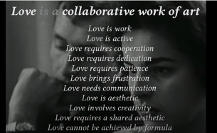
How do perspectives shift through the metaphorical lens of love as collaborative work of art? – love is work, active, requires cooperation, dedication, patience, frustration, communication, is aesthetic and requires a shared aesthetic, involves creativity, and cannot be achieved by formula. Love reframed collaboration in art making, reveals a set of values and actions of cooperation, delight, and creativity coupled with frustration and patience as part of the process. Do you find this shift delightful because it aligns with your perspectives of Love? What aspects of love as artistic collaboration surprise you? Or puzzle you? Paying attention to how metaphors connect (or not) with us, reveals our implicit values, assumptions, and orientations to that idea.

Transforming Metaphors in Re-Imagining Teaching and Learning
What are the values, beliefs, and assumptions about teaching and learning in these metaphors?
- “Education is not the filling of a pail, but the lighting of a fire” – W. B. Yeats.
- Teaching is like white-water rafting: “Periods of apparent calm are interspersed with sudden frenetic turbulence. Tranquility co-exists with excitement, reflection with action. … All teachers regularly capsize … Being aware that we inherently face insolvable dilemmas in our teaching, and that we hurt from these, is an important indicator that we are critically alert.” Stephen Brookfield, 2006; p.8 The Skillful Teacher
- Friedrich Froebel, educator and originator of the term “kindergarten” (In German, this translates as a child’s garden) chose that word because he thought about teachers as gardeners.

Case 1: Metaphor Analysis to Re-Imagine Teaching and Learning
Double-loop thinking helps us examine metaphors and reveal its (and our) deep assumptions and values. In doing this, we are able to find new metaphors that counter map and reframe teaching and learning to better reflect our values and purpose. Metaphorical analysis helps us distill what we really care about.
Here is an example of a metaphor for teaching that one teacher started with and how they engaged in reflexive thinking to develop a more intentional metaphor. Look out for the breaking point in analyzing metaphors because that is where our assumptions are revealed and questioned. And when that happens, we can intentionally adjust our metaphorical thinking or even find a new metaphor that better represents our values and purposes.

Metaphor – teaching is growing a garden.

Many elements of this metaphor aligned with and reflected their values & intentional goals – creating nurturing spaces, providing the right “nutrients” so the “plants” (students) can grow and stretch up in the sunshine. These were values that were explicit in their thinking.
The breaking point. However, double-loop analysis surfaced the deeper assumptions and logic of this metaphor. The plants/students are passive and are being “done to”, while the teacher/gardener controls everything. This power dynamic did not align with the teacher’s explicit philosophy of active students co-creating learning with them. The metaphor posed a challenge.

Reframing the metaphor: The responsive gardener.

The teacher did some research on how plants actually grow. This is what they found - plants can be seen to be in a co-creative relationship with the gardener. Each plant has different characteristics and needs. The gardener must get to know their plants well in order to design a space that invites and nurtures all plants to flourish. This revealed values of listening, empathy, 2-way communication, and responding actively in designing inclusively for diversity. In this analysis and expression of the metaphor, the teacher articulated the value of including a diversity of learners, and ensuring students had voice in the learning space and could bring their whole selves in.
Staying with the breakpoint and exploring it revealed more ideas that enabled the teacher to reframe the metaphor to integrate what they learned about gardening.

Paradigm shift: Re-Imagining Teaching and Learning as a Community Garden.


The assumption of teacher as gardener and students as plants still located students as relatively passive in the scope of the gardener’s work. Pushing the metaphor further, the teacher engaged in double-loop questioning of assumptions of agency and teacher-student relationships. This led to a true paradigm shift, from garden to a community garden. The teacher (gardener) is no longer in the middle. More importantly, students are not plants; they too are gardeners growing their own plants (learning) - so teacher and students are gardeners, all working to foster learning (the plants).
This significant shift came out of revealing a deeply tacit assumption in the original garden metaphor for education - teacher as the central figure. Through reflexive analysis, the teacher was able to see that they held this assumption. Through counter-mapping, they were able to transform the paradigm: What if students had agency to lead themselves in growing their knowledge and skills? The teacher is decentered and becomes a guide and mentor, sharing knowledge with young gardeners (learners), supporting them in gardening (learning how to learn), discovering the seeds and soil (contents), and inviting and supporting new seeds (students’ ideas and knowledge). This reflexive process led the teacher to think about what they cared about, what they wanted to change, and how this impacted their course and facilitation design, i.e., to articulate their teaching philosophy and response to diversity and work inclusively in equity-minded ways. Metaphors as counter mapping tools sharpen our reflexive thinking toward developing transformative action in our classrooms.

From Metaphor to Teaching Philosophy and Mission

TASK: Distill Your Teaching Philosophy Using Metaphors

Use these questions to analyze a metaphor about teaching to surface and examine your values, beliefs, and assumptions about teaching and learning. What does the metaphor you selected reveal about unconscious values, assumptions, and beliefs that you might have developed through your own journey through legacy education systems? How does this metaphor help you question, shift, and explicitly clarify your values, beliefs, and goals? Would you reframe the metaphor or find a new one?
- Choose a metaphor for teaching. You can also draw it or paste an image.
- What teaching and learning assumptions and processes are represented through the metaphor? Examine how the different parts/processes in the metaphor correspond to teaching and learning.
  - What corresponds to the teacher? What corresponds to the learners?
  - What parts of the metaphor speak to the teacher-learner relationships and the student-to-student relationships?
  - What does the metaphor tell you about elements of teaching and learning such as engagement and motivation, community, student autonomy, inclusion and equity, diversity, opportunities for experimentation or “failure” etc.
- What does the metaphor imply about relationships - power, trust, authority, etc.?

- Check the transformative potential of your metaphor. How does it reveal and challenge assumptions in legacy teaching and learning? How does the metaphor connect teaching and learning with inclusion, equity, and preparation for a future defined by VUCA? Where does it sit in the Transmission to Empowerment framework?

Re-Imagining Education

“For the master’s tools will never dismantle the master’s house. They may allow us to temporarily beat him at his own game, but they will never enable us to bring about genuine change.” – Audre Lorde (1983)

Culturally Sustaining Pedagogies invite us to re-imagine education, re-envisioning to ask “What-If”?
“Instead of being oppressive, homogenizing forces, CSP asks us to reimagine schools as sites where diverse, heterogeneous practices are not only valued but sustained. In fundamentally reimagining the purpose of education, CSP demands a critical, emancipatory vision of schooling that reframes the object of critique from our children to oppressive systems” - (Alim & Paris, 2017; p. 2-3)

What would our pedagogies look like if this gaze (and the kindred patriarchal, cis-heteronormative, English-monolingual, ableist, classist, xenophobic, Judeo-Christian gazes) weren’t the dominant one? What would liberating ourselves from this gaze and the educational expectations it forwards mean for our abilities to envision new and recover community-rooted forms of teaching and learning? What if the goal of teaching and learning with youth of color was not ultimately to see how closely students could perform White middle-class norms, but rather was to explore, honor, extend, and, at times, problematize their cultural practices and investments?
(Alim & Paris, 2017; p. 2-3)

The invitation is to counter map - reveal and transform the deep assumptions and the logic underpinning legacy education in order to create teaching-learning environments, structures, and processes integrate justice- and future-oriented values and purposes at the heart of education. What does the new map of teaching and learning look like?

TASK: Explore Artistic Counter Mapping of Education
Artists have had plenty to say about legacy education. Browse through this Padlet that presents The Artistic Eye on Education offering critiques of and counter maps to legacy education.
Pop Song: We don’t need no education. Pink Floyd.
Poem: The Minister of Exams. Brian Patton
Poem: First Day of School. Roger McGough
Poem: You Can’t Be That. Brian Pattern
Poem: The Child is Made of One Hundred. Loris Malaguzzi
Spoken Word: Standardized Education. Malachi Bryd
Slam Poetry: Simon Says. Ashley Davis and Oompa
Visual Art: School Works. Political implications of U.S. Education. Jerry Troung
… and more …

- Do you know of other artistic work – film, music, plays, visual art – that critiques legacy education? Please add to the Padlet.
- What deep conditioning or assumptions drive the system based on these works, your experience, and reading?
- What metaphor would you choose to represent the legacy education system?

Your Turn: Reframe and Re-Imagine
How would you counter map teaching and learning in ways that would remove barriers and invite a diversity of learners to engage in meaning learning, in spaces of wellbeing and joy in learning, where they mattered, and that would support them in being successful in school and into their future?

TASK. Re-Imagine Teaching and Learning: Reframe and Counter Map
Bring frameworks, principles, and tools from previous chapters into this brainstorming. Your goal is to reframe and reimagine different aspects of education – in effect build a counter map of teaching and learning. As you do this, note areas of resistance to change – who would resist and why?
- Reimagine students and learning. What are the assumptions about the “typical” student – what metaphor would fit? What metaphor would you select to reframe legacy assumptions about students and learning?
- Reimagine assessment. What assessments and assignments are typical in your discipline? How do we design assignments that cultivate curiosity and openness? If you can re-imagine how we assess learning, what would it look like?
- Re-imagine curriculum. What does a curriculum look like that brings together a multiplicity of voices and perspectives?
- Re-imagine the teacher. What capacities must we as educators cultivate to be able to work with change? What kinds of activities and assignments can I bring to empower students as independent or self-determining learners who are comfortable with taking learning risks, who have learning how to learn skills, and growth mindsets?
- Re-imagine the process. How do we humanize our courses and facilitation to transcend the metaphor of teaching-learning as contract – what is a new metaphor that speaks to a relational co-creation of learning - for example, journeys, weaving, dance?

What connections can you trace between Culturally Sustaining Pedagogies and your re-imagining and reframing of education? How do the perspectives from CSP inform and expand your teaching philosophy and diversity statements?
Plan to add to your notes for this task as we move through the next phase of our learning journey to explore teaching tools and strategies.

TASK: Write a Mission of Education
Free-write (notes, bullet points) – a mission statement based on your explorations above. In writing your mission:
- Allow yourself to be fully aspirational – what you think education should do – without worrying about practicalities and objections. This is a dreaming moment.
- Think about the following: Immediate purpose, future purpose, values and principles.
- Visualize education – draw a picture or map of what it will look like, feel like for teachers, learners, and other stakeholders, what kind of world it will lead to. Literally mapping it out with a drawing or mind map will reveal a lot and help you express your vision and mission.

Chapter 7: Transformation 1 – Reframing Outcomes
This chapter begins the first in a series of transformations of different dimensions in the teaching-learning process. In this chapter, you will explore learning outcomes:

Learning Taxonomies
Learning taxonomies are useful categorizations of cognitive, social, and emotional dimensions of learning. They help us design teaching to intentionally guide learners toward planned outcomes.
Please remember these taxonomies are a convenient way to analyze and design teaching processes, but that they do overlap. Also, that we plan outcomes before we actually meet our students. While we can anticipate the students who will take our courses, we must also remain agile and responsive, ready to co-create – and revise if needed – the specific destinations to which they journey in the course.

Counter Mapping Metaphor for Course and Outcomes Design
We often hear of the contract metaphor in education, especially in connection with the syllabus. Policies are often punitive and require compliance. Outcomes are targets that students much hit in order to earn the grades. Unpacking the contract metaphor, we see transactional assumptions of compliance, rewards, and punishment often in a context of competitiveness. Teachers are authoritarian centers of power; learners are compliant workers without much agency (unlike real contracts, students have no negotiation power!).
The above is typical of the transmission model of teaching. But, if we want to shift this paradigm toward the Empowerment model, we can begin by shifting the metaphor from contract to journey.

The Journey Metaphor for Learning and Teaching
Element in Teaching | Metaphorical Articulation
Course | A learning journey of exploration, discovery, and arrival
Teacher | A guide for the journey who’s travelled this landscape many times
Students | Travelers who will explore, discover, and move toward the destinations
Syllabus | Our map
Outcomes | Destinations (selected by the guide, and possibly modified with the travelers)
Active Learning | The process of exploring and discovering in getting to destinations
Assessments | Compass check periodically to ensure we’re on track to the destinations
Formative Grades | Milestones on the way toward the destinations

This metaphorical shift presents the teaching-learning process as a fluid, emergent, and co-created process that actualizes the Empowerment model of teaching. In designing our learning destinations – the outcomes – we engage the Empathize and Define process to be mindful of our students, their lives and interests, and the capacities they need to flourish in the future world. In implementing our course, we remain open to some destinations changing or new ones to emerge.

Bloom’s Taxonomies
Bloom’s taxonomies are named after Benjamin Bloom who chaired a committee of educators in creating a set of taxonomies of learning objectives in the early 1950s. Their aim was to improve curriculum design and assessment. They developed taxonomies for Cognitive, Affective, and Psychomotor objectives. In each taxonomy, learning at higher levels follows attainment of skills and knowledge at more basic levels.
- Cognitive: Remembering, Understanding, Applying, Analyzing, Evaluating, Creating
- Affective: Receive, Respond, Value, Organize (accommodate), Characterize (adopt perspectives)
- Psychomotor: Perceive, Sets (ready to act), Guided Response, Mechanism, Complex Overt Response, Adaptation, Origination.

Bloom’s cognitive taxonomy is the most well-known. This is not surprising as education - and assessment in particular – in most subjects have focused on cognitive skills. The other two taxonomies were not as well-developed; more recent learning research such as self-determination theory, SEL, and PERMA have developed and refined the elements of psychomotor and affective dimensions of learning.

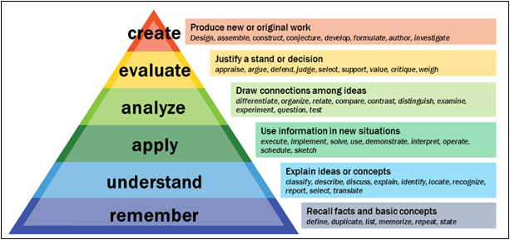
Image Source

REMEMBER. This level is recall of information. The associated cognitive processes are to recognize or locate knowledge in long-term memory and recall or retrieve that knowledge to demonstrate remembering. Assessment of learning therefore are prompts and questions that help students to do this, such as fill in the blanks and multiple-choice quizzes.

UNDERSTAND. Learners might be asked to explain a concept in their own words or summarize, describe a mathematical graph, make inferences and explain causal connections based on given information, see connections between ideas, find examples for a concept, classify items into categories.

APPLY. Application is about using what we learn in new situations. This includes processes such as using learned terms and concepts to explain a new or unfamiliar situation or phenomenon. This ranges from linear applications like using mathematical formulae to calculate and solve new problem sets, to non-linear applications such as applying housing policy to new situations that include unhoused populations.

ANALYSE. Engaging in analysis, learners examine the structures within and between concepts and being able to differentiate, recognize, and organize patterns and trends, categorizing and connecting causality and contiguity. For example, looking at poems to break down poetic elements in order to determine the genres they belong to, or looking for trends and social patterns to explain phenomena, e.g., causes of the K-Pop phenomenon, or finding patterns of thought and action to explain someone’s perspective.

EVALUATE. Learners critically assess and critique a situation or someone’s perspective and are able to justify their opinions. This includes being able to unpack fallacies, misassumptions, and biases. Evaluation requires both knowledge of canonical standards as well as personal values and perspectives. For example, we need to be able to trace if conclusions follow logically from evidence and assertions or justify selection of one thing over another.

CREATE. Learners use their knowledge and skills to create original work and solve problems. For example, they might create artwork, create new models or ideas that could be tested, create solutions, engage in planning and production.

An alternative way to think about Bloom’s taxonomy
Is learning hierarchical? Why do the lower levels of “Remember” and “Understand” take up so much of our teaching and assessment work? This hierarchy makes sense within the framework of transmission teaching (Freire’s banking education) where students more passively receive canonical knowledge from teachers who are “experts” and selected approved texts. When they are deemed to have understood, they can move on to higher order thinking. There is no expectation of autonomy or plurality of thought.

Restructuring Bloom’s Taxonomy
Consider the following:
- Inclusive active learning methods that invite student agency and lived experiences do not have to begin with transmission and reception of canonical knowledge. In fact, learning might proceed more effectively if we begin with students’ prior knowledge, lived experiences, and experiential explorations to prime them before they critically explore canonical knowledge.
- We design learning and teaching in a world where information is widely available; the teacher is no longer the only source of input as students bring their cultures, embodied experiences, and knowledge that add richly to the learning process. Teacher and students have reciprocal roles; they are both teachers and learners.
- We know from learning sciences that motivation and engagement are strongest when students actively engage in co-creating learning that meaningfully integrates their lives and experiences.
Therefore, we can flatten out and use Bloom’s cognitive taxonomy in a more integrative way.
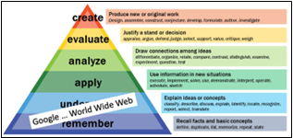

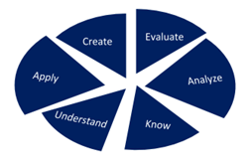

From the perspective of constructivist epistemology, inclusive active learning methods using projects, student-created processes and collaborations, portfolios, arts-integration etc., can foster higher order thinking from the start. This means that we integrate processes of knowing and remembering through active engagement in creation, evaluation, application, and analysis. At the same time, this makes it easier to engage and develop capacities and skills that equip students for their futures such as collaboration, communication, social personal responsibility, self-and other-awareness, and learning how to learn, right alongside developing content knowledge.
This reframing of Bloom’s taxonomy questions some legacy assumptions:
- Why do we still do closed-book, timed exams testing at Bloom’s taxonomy levels when knowledge seeking, gathering, and construction in the world is more often collaborative, consultative, and uses resources from multiple sources?
- Why do we use a single textbook in passive transmission when learners can gather information from databases and web searches, while developing information literacy skills to do good searches, evaluate sources, and synthesize information?

Fink’s Taxonomy of Significant Learning
Dee L. Fink published the Taxonomy of Significant Learning in 2003. This taxonomy addresses learning for a diverse, interconnected, and information saturated world that is in constant flux and hence increasingly unstable and unpredictable (the VUCA world). Fink’s taxonomy is useful in helping us design inclusive, culturally sustaining course that responds to these essential questions:
- What skills and capacities do students need to encounter and flourish in a VUCA world?
- How do we invite and integrate ontological and epistemological plurality (different cultures of knowledge and knowing, discourses, and expressions) into the learning process?

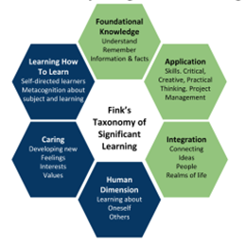
Adapted from: Fink, L. D. (2003). Creating significant learning experiences: An integrated approach to designing college courses.

Fink’s Taxonomy integrates these 6 areas.
- Foundational Knowledge: Facts, principles, relationships (contents) students must understand and remember. Similar to Bloom’s taxonomy – Remember and Understand.
- Complex Application: Physical and/or cognitive engagement in problem solving, decision-making, creative thinking. Able to integrate and work with complexity, flexibility, and process. While similar to Bloom’s Application, rather than linear application, this involves complexity-thinking using iterative, formative processes.
- Integration: Identify and connect different subjects, perspectives, theories, trends, including embodied cultures, life-worlds, and ways of knowing. Inter- and transdisciplinary.
- Human Dimension: Gain self-knowledge. Learn and to interact with others. Empathy and connection. Strong connections to social-emotional learning elements and reflexivity.
- Caring: Finds meaningfulness and relevance in connecting subject matter to the larger world, a sense of values and interests associated with learning and knowing. Belonging and mattering in community.
- Learning How To Learn: Metacognition and self-regulation, reflexivity, lifelong learning skills.

According to Fink, significant learning is:
- Learning-focused rather than content-centered. This supports learner-centered design that invites the whole learner and their lived experiences into the learning journey.
- Embodied and transformative – there is significant change in the learner:
  - More than cognition, learning is developing embodied knowledge that shapes the learner’s engagement with themselves, others, their world, and the future. Learning involves cognition, affect, social-emotional, physical, and physiological dimensions of the learner.
  - Transformative. Learning involves meaningful change in the learner that impacts personal, professional, social, or civic dimensions. Learning changes how students perceive, think, feel, or act in real life.
- Integrated. All components of the taxonomy work together for significant learning to happen.

Fink’s taxonomy moves beyond subject matter mastery and acquisition of declarative knowledge. It helps us address the complexities of learning as well as integrate social-emotional skills, meaningful connections with students’ lives, and metacognitive dimensions that support independent learning.
- The first 3 categories – Foundational Knowledge, Complex Application, and Integration – seem to be similar to Bloom’s taxonomy – Remember and Understand, Application, Analysis and Evaluation. However, these dimensions explicitly address active, experiential learning and help us design learning experiences that engage students in meaningful, relevant, and culturally sustaining learning.
- The last 3 categories – Human Dimension, Caring, and Learning How to Learn – bring teaching and learning even more explicitly into the space of meaningful learning for life. Using these dimensions, we can intentionally foster self- and other-awareness and collaboration, design authentic connections to the larger world and student’s lived experiences, as well as build processes for self-regulation and learning how to learn skills.

Fink’s taxonomy is integral to transdisciplinary pedagogy because it helps us intentionally design teaching and learning that supports movement toward the empowerment model of teaching in helping us engage the following:
- Active, collaborative learning
- Formative iterative processes to develop work.
- Multiple modalities of knowledge creation and expression.
- Student voice and cultures for meaningful and authentic connections to the larger world.
- Integration of social-emotional dimensions of learning and inter-personal skills.
- Development of learning how to learn skills and mindsets.
These elements strongly scaffold teaching design toward critical questioning of traditional pedagogies. We become more aware of the richness possible in learning, which illuminates the limitations and oppressions of many legacy practices. We are better able to address the areas of development needed to support a diversity of learners to engage meaningfully with their own holistic development in mastering a subject while also becoming socially responsible global citizens.

Essential Learning Outcomes (ELOs)
Association of American Colleges & Universities (AAC&U)

The AAC&U Essential Learning Outcomes came from AAC&U’s LEAP project (Liberal Education and America’s Promise) of research, advocacy, and campus work to champion the importance of liberal education for the 21st century. The ELO’s focus on shaping the contents and outcomes of education in preparing learners to achieve excellence in disciplinary subjects while developing themselves to contribute to a thriving democracy. The project has 3 components:
- Essential Outcomes – outcomes for success in life, civil society, and work in the 21st century.
- High-Impact Educational Practices (HIPs) - engaging and challenging students through first-year programs, intensive writing, collaborative assignments, undergraduate research, service learning, internships, learning communities, diversity experiences, and major projects that help students achieve Essential Learning Outcomes. Chart of High Impact Practices.
- Authentic Assessments - using students’ own work and faculty-validated rubrics, probing whether individual students have developed essential capacities and can apply their learning to complex problems and real-world challenges.

This document presents the Essential Learning Outcomes (ELOs). In addition, you can read a summary of The Essential Learning Outcomes here.

Essential Learning Outcomes
Essential Learning Outcome Statement | How Outcomes Are Implemented
Knowledge of human cultures and the physical and natural world. Science and mathematics, social sciences, humanities, histories, languages, the arts. | Focused on: Engagement with big questions, both contemporary and enduring.
Intellectual and practical skills. Inquiry and analysis, critical and creative thinking, written and oral communication, quantitative and information literacy, teamwork and problem solving. | Practiced extensively across the curriculum, in the context of progressively more challenging problems, projects, and standards for performance.
Personal and Social Responsibility. Civic knowledge and engagement local and global, intercultural knowledge and competence, ethical reasoning and action, foundations and skills for lifelong learning. | Anchored in active involvement with diverse communities and real-world challenges.
Integrative and Applied Learning. Including: Synthesis and advanced accomplishment across general and specialized studies. | Demonstrated through the application of knowledge, skills, and responsibilities to new settings and complex problems

Connecting Outcomes to your Emerging philosophy
The most common taxonomy that most teachers use is Bloom’s taxonomy. However, Fink and ELO frameworks offer ways to think about designing teaching that align with an ethical approach to education. Integrating Fink and LEAP taxonomies with Bloom:

- Helps move teaching design from a linear content-based transmission approach toward a student- and learning focused empowerment approach.
- Brings in aspects of learning supported by learning science such as meaningfulness and connections to the larger world and lived experiences, the interpersonal dimensions of engagement, motivation, and learning, a range of literacies, as well as identity development for personal and social responsibility.

Here are 2 examples that focus on higher order skills while integrating other areas of development such as collaboration, information literacies, and cultural relevance. Can you see the cognitive levels in Bloom’s taxonomies, the dimensions of Fink’s taxonomies and the ELOs in these examples?
- American Politics: Students learn about history and principles of democracy not just through lectures, midterms, and finals, but through interviewing community members and testing out ideas from readings and lectures. Their interviews include a critical analysis of perceptions of democracy in the lives of different population groups. They create a multimedia presentation about the meaning of Democracy grounded in social-cultural contexts thus building knowledge and understanding of a subject area while also developing many other empowering and meaningful skills and capacities.
- Mathematics. In learning about parabolic curves, students explore applications in wider society, in global art and the history of math, including women and people of color in this mathematical topic, and cultural representations of parabolic work. They create a poster presentation for the school community about the art, science, and history of parabolic curves. Not only do they learn the math of parabolic curves, but they develop appreciation and broader critical thinking and collaboration skills in an authentic way that makes learning meaningful.

PAUSE TO REFLECT
Having read about the taxonomies:
- Which outcomes align with your values, beliefs, and mission or goals as an educator?
- Which outcomes are least addressed by teaching practices in your discipline? Can you think of innovations to bring them in? For example, how would you bring quantitative literacy into a literature course? Or creative writing into a STEM subject? How do you integrate ethical reasoning into a course in statistics? How does Fink’s Human Dimension come into designing assignments?

Backwards Design: Starting with All Learners and Future in Mind

In Chapter 4, exploring Design Thinking, you did an imaginary course design scenario that showed the importance of pausing before Ideating in order to Empathize and Define, i.e., consider learners and contexts as integral to any educational process.
In approaching course design, identify your instinct or habit. Are you:
- Content-focused? Your first thoughts are about texts or what to cover in the course.
- Activity-focused? Your first thoughts are about the kinds of activities you would use.
- Destination-focused? Your first thoughts are to generate learning outcomes

None of these are wrong in themselves and we need all of these in action with each other.
However, starting with destinations or outcomes that are clearly rooted in an understanding of our learners and goals to support future flourishing helps us to work effectively and inclusively in pulling together contents and activities. Think if this as Equity-Minded, Future-Focused Backward Design, a commonsense notion of designing led by goals of justice and future orientation.
- Who are our learners? What skills and capacities do they need to flourish in the future?
- Grounded in this, what are our intended results or outcomes? - destinations.
- How will we and our students know they are moving along well? – progress checkpoints, formative feedback, revision, artifacts of learning.
- What must the teacher and students do to get there? – lesson plans, facilitation, tools.
We can also represent it as a triangle of processes for Destinations, Contents, and Activities in dynamic interaction with each other informed by a learner and future-focused mission. Putting DESTINATIONS at the top of this dynamic triangle positions futures and outcomes as guiding considerations, while acknowledging that we might iteratively move between outcomes, contents, and activities.
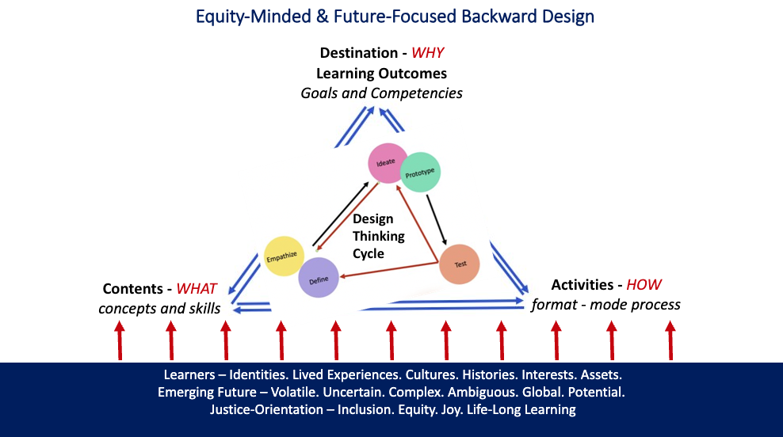
Image Source: Shamini Dias
Backward design is more common than we might think.
We engage in Backward Design in many aspects of life - planning vacation trips, weddings, work projects, family events, constructing buildings and bridges, media campaigns etc.
“Starting with the end in mind means to start with a clear understanding of your destination … to know where you’re going so you better understand where you are now, so that the steps you take are always in the right direction.” - Stephen Covey. The Seven Habits of Highly Successful People

Here are some professions where backward design is integral.
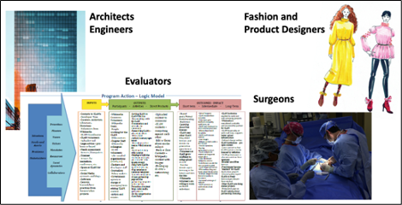
What else can you think of that uses backward design? What about research – in what ways does your research process use principles of backward design? Backward Design simply means knowing what we want to see happen, then putting plans into place in steps that will get us there.
- Equity-Minded Backward Design uses Design Thinking to begin with Empathize and Define to understand and integrate people and contexts in justice-oriented planning.
- Responsive Backward Design uses Design Thinking with a reflexive process that stays alert to emerging information and changes in people and contexts and adjusts or adapts as needed, while still navigating toward the intended destinations or goals. Sometimes, situations will warrant that the outcomes or goals are also adjusted.
The combination of an equity-minded and responsive design approach in backward design helps us work intentionally from the outset when we plan and facilitate our courses.
NOTE: Backward design isn’t always linear – know the destinations and put a plan in place to get there – in practice even the best laid plans can go awry and require agility to adjust. Surgeons encounter an unexpected internal condition that necessitates modification of the surgical process; evaluators might have to adjust their summative logic model to accommodate new developments in the program (Michael Quinn Patton created developmental evaluation for just this reason). In responsive teaching especially, unexpected situations or emerging information mean we adjust, make detours and even new destinations for some, if not all, students.

Backwards Design in Pedagogy
Backwards Design in pedagogy has been around for a while, at least since the 1947 publication of Basic Principles of Curriculum and Instruction by Ralph Tyler. It was re-conceptualized and made more visible by Grant Wiggins and Jay McTighe in their 1998 book, Understanding by Design. Since then, Backward Design has been used widely as a framework in establishing key goals in course design as the start to aligning goals with assessment plans and activities.
TASK: Watch Shelly Moore explain Backward Design [5:50 mins]

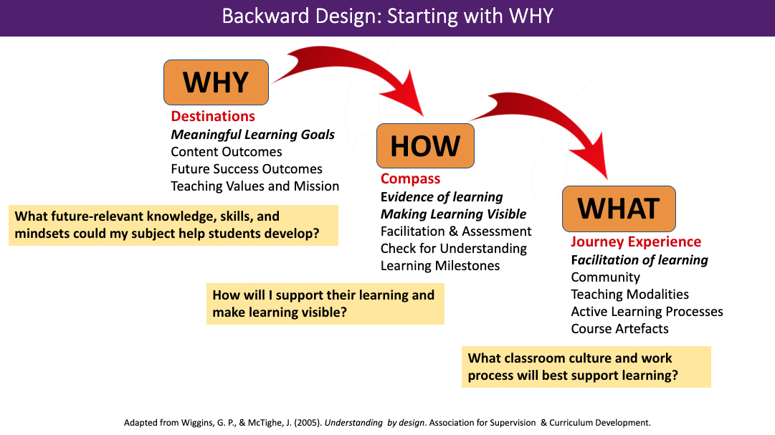
Image – Shamini Dias. Adapted from Wiggins, G. P., & McTighe, J. (2005). Understanding by design.

Using the metaphor of teaching-learning as a journey:
WHY. OUTCOMES = destinations. To what ends are we guiding students? We determine this by thinking about knowledge outcomes as well as skills and capacities we want them to develop in order to flourish beyond the course and into their futures.

HOW. EVIDENCE OF LEARNING = compass. As students move through a learning journey, we design formative assessments and learning processes that make their learning visible – to us and to them. This helps them to sharpen their work, and more importantly, develop learning metacognition and learning how to learn skills. Using an equity-oriented approach, we bring in strategies that are flexible, learner- and learning-oriented, and meaningful to our students.

WHAT. JOURNEY EXPERIENCE = actively facilitating and experiencing the journey. Once outcomes and assessments are aligned, we design the activities and modalities for teaching and learning. We think about the teaching-learning environment, relationships, and processes we can use to facilitate our students’ learning journey toward the outcomes.

Outcomes as a Transformative Move

Culturally Responsive and Sustaining Pedagogies
Can the seemingly prosaic act of writing student learning outcomes have a revolutionary and transformative role? Can SLOs significantly shift the legacy system of education in our classrooms?
YES!
Outcomes are destinations to which our students progress. Through outcomes crafted through a design thinking process that focuses on learners and learning for the future, we create a learning map that shapes our courses - students’ learning journeys, and thus, the knowledge, skills, and capacities they take into their futures. Outcomes must:
- Build capacity for future study, work, and life. Students in my History course might never major in history. Hence, what is there in the study of history that will be meaningful and useful to all learners? This makes me focus on intentional integration of critical thinking skills, collaboration, current life-worlds with history content.

- Connect to my teaching mission. As a scholar and educator, my mission is to share the amazing practice of historical study and how it is relevant to us today and the future. I also have a mission to ensure that my students’ identities, histories, and cultures are invited into this exploration so that history becomes a living discipline that is meaningful to their lives.
Based on the above imperatives, here are some possible outcomes for this History course together with the kinds of assignments that make learning visible, meaningful, and provide rich experiences:
- Analyze historical events to trace and explain causal patterns that connect with current events.
  - Pairs create visual representations of connected historical and current events.
- Work in teams to find and curate a creative commentary on key historical events.
  - Teams select 5 events on a theme, time sequence, location etc. to design an exhibition.
- Work in teams to apply historical frameworks in exploring the history of local communities.
  - Teams explore their home communities, researching archives, meeting city councils and community leaders/elders to create an exhibition of their community history.
In creating meaningful student-focused outcomes, we significantly shift the teaching-learning paradigm. Outcomes can work holistically in inviting students’ voice, cultures, and agency into the study of history that on the surface might be culturally and temporally distant. They also bring to bear a very useful set of capacities and skills even for those who will never do History as a subject:
- Analyze texts and other media for patterns – trends, causal connections.
- Find connections in information (in this case between historical and current events).
- Information literacy – search terms, finding material, evaluating sources, justifying choices, communicating concepts to different audiences.
- Digital literacy – creating final products, collaborative tools.
- Project management – collaboration, communication, coordination, time-management.
- Personal values and caring – discovering personal connections to place and time.

Inclusive and Equity-Minded Backward Design
Intentional backward design is more than designing good outcomes. It integrates inclusive, culturally sustaining, and equity-minded strategies across the entire process, from crafting outcomes that connect subject knowledge to students’ lived experiences and future capacities, to assignments and activities that center and empower a diversity of learners.

OUTCOMES – meaningful to learners - contents and capacities for life. Can you identify elements from the different taxonomies, especially from Fink and ELOs?
- Apply literary deconstruction to Shakespeare’s plays to reveal power dynamics.
- Explain how computer programming is used for both ethical and unethical purposes.
- Collaborate with a community group in a creative project.
- Demonstrate critical thinking in debating current global economic issues.
- Engage with a community to explore social networks and community assets.
- Find connections and differences between historical and current events.
- Use descriptive statistics to explain a social issue.
- Find and explain examples of calculus used in real world settings.
ASSESSMENTS – flexible and formative learning. Rather than just mid-term and final exams that raise unfair barriers and issues of inequities, meaningful backward design includes flexible assessments that support and facilitate learning in non-punitive ways for a diverse student group.
- Students have a choice of assessments from a given range.
- Explain the “why” of assignments to connect with both disciplinary and future knowledge and skills.
- Give rubrics with assignments.
- Design rubrics as guides for feedback and revisions – teacher, peer, and self-review.
- Flexible or co-created deadlines.
- Low stakes or ungraded, multiple attempt tests (checks for understanding).
- Opportunities to revise for improvement – retake tests, rewrite papers etc.
ACTIVITIES – flexible and invites all learners. In-class activities that support and empower student engagement in multiple ways.
- UDL and multiliteracies principles in teaching, class activities, and in assignments to integrate multiple ways of engaging, self-expression, representing information.
- Flexible engagement – students have choices, use synchronous and asynchronous processes.
- Active inclusive learning activities in class as well as asynchronous activities in an LMS.
- Use peer-based learning and co-create with students. Invite their contributions.
- Use multiple modes and forms of engagement and participation.
Provide opportunities for peer-engagement in and outside of class.
TASK: Practice applying inclusive backward design.
Use a current syllabus that you have or think of a course you want to teach.
Craft 1-2 outcomes considering Bloom, Fink, and ELOs that will address both disciplinary knowledge and future capacity and skills development.
Then, work backwards to design some assessment and assignment ideas, and activity strategies you might use in class (synchronously) and/or in an LMS (asynchronously).

Integrating Equity-Minded Teaching Philosophy with Backward Design
Your course design - from outcomes selection to assessments, activities, and materials – is an articulation and concrete manifestation of your teaching philosophy. Being explicitly aware of this helps you work intentionally and coherently in designing courses and facilitating learning.
Use the Cynefin framework when you design teaching. It will help you to remain alert in course design to check and question the habituated thinking of Clear and Complicated domains – “what we’ve always done” that would perpetuate non-inclusive and inequitable legacy practices. Doing this helps you to mindfully and intentionally design culturally sustaining outcomes and assignments that support a diversity of learners. You are grounded in and guided by your teaching philosophy.
- Purpose - why I teach, who I teach, and why they matter
- Method – how I teach and assess learning in ways that support all learners equitably
- Experience - what I will create together with my students in a learning journey.
These questions from the teacher’s perspective informs the backward design application:
- Outcomes - What will students know and be able to do? What prepares them for their future?
- Assessments - How will they know they are learning? How will they learn how to learn?
- Process – How is the journey meaningful, joyful, and relevant to students?
When your teaching philosophy aligns with Outcomes, Assessments, and Process, you will have a design that guides your students along a coherent and meaningful learning journey in ways that are grounded in an equity-minded and future-focused philosophy.
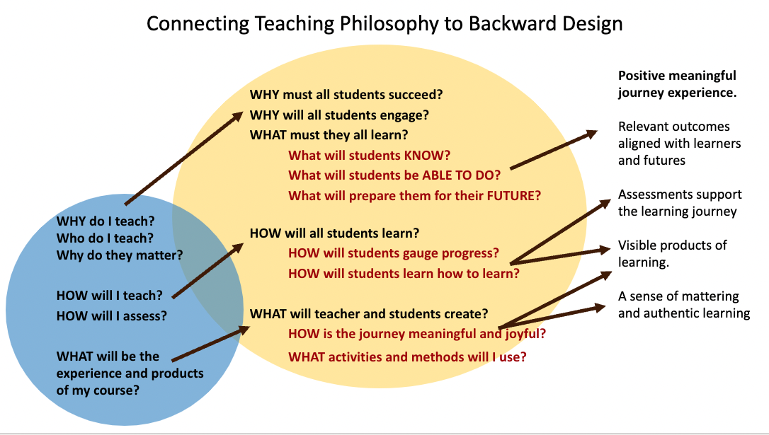

TASK: READ SLO Curveball. What I really want for my students. Josh Ashenmiller, 2015.
Josh Ashenmiller is a history professor who understands the importance of outcomes but is left wanting more for his students that springs from a place of passion as a scholar and educator.
As you read, think about what you teach or want to teach and make a list of your own passionate “I want” statements. What do you really in your heart of hearts want your students to learn?

Chapter 8: Transformation 2 – Inclusive Active Learning
Inclusive active learning is a powerful approach to transform teaching and learning toward the Empowerment model of teaching, to operationalize culturally responsive and sustaining pedagogies.
In active learning, we shift the focus from the teacher and teaching to the students and learning. Active learning fits within the Design Thinking framework; instead of jumping into planning our teaching from a content delivery mindset, we pause and move into the Empathize and Define phases to focus on the learners and contexts of teaching and learning. This helps us intentionally integrate and create inclusive and equity-minded processes and spaces.

Actively Learning About Active Learning
This part of your textbook is an asynchronous active learning process to learn about active learning. In this process, we ask you to do some thinking, recalling, guessing, then read a set of notes, and then come back to your initial ideas to review and revise.
Work through this section by alternating the tasks given with the notes. Use your Journal.

TASK 1. Priming: Starting with your input
Respond to the following statements – make a guess - before reading the notes on active learning on the next page, so you can come back to compare and expand on your ideas later.

Think about contexts where you have led, seen, or experienced what you might think of as “active learning”. Or just make a guess. How would you fill in these blanks?

I define active learning as___________________

I think active learning may differ from ‘traditional’ or legacy forms of learning because __________

Now read the notes below about Active Learning. Look for and highlight connections to the ideas you wrote above as well as new ideas that you did not think about.

Defining: A Model of Active Learning
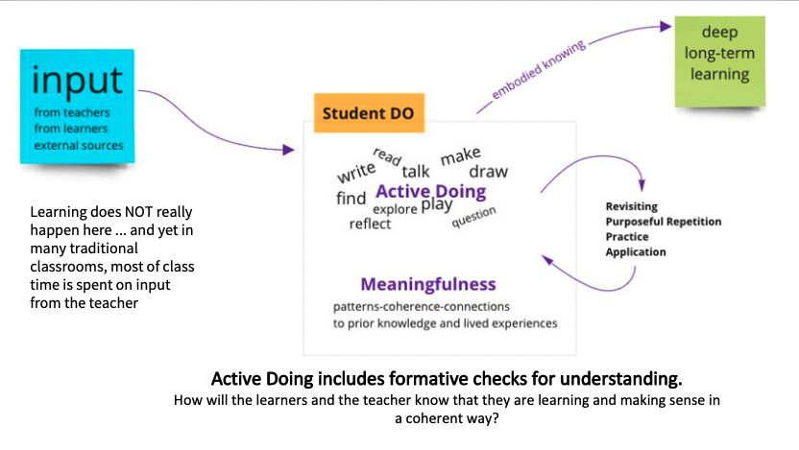
Image Source: Shamini Dias
This is a sketch of the journey or process for moving from input in teaching to deep learning. Notice that the real learning – knowledge construction into deep learning happens outside of the input. And yet, when we consider many traditional classrooms, much of the lesson is spent on the teaching giving input in the form of lectures taking precious time away from the actual knowledge construction for learning!

Here is a model for active learning design.
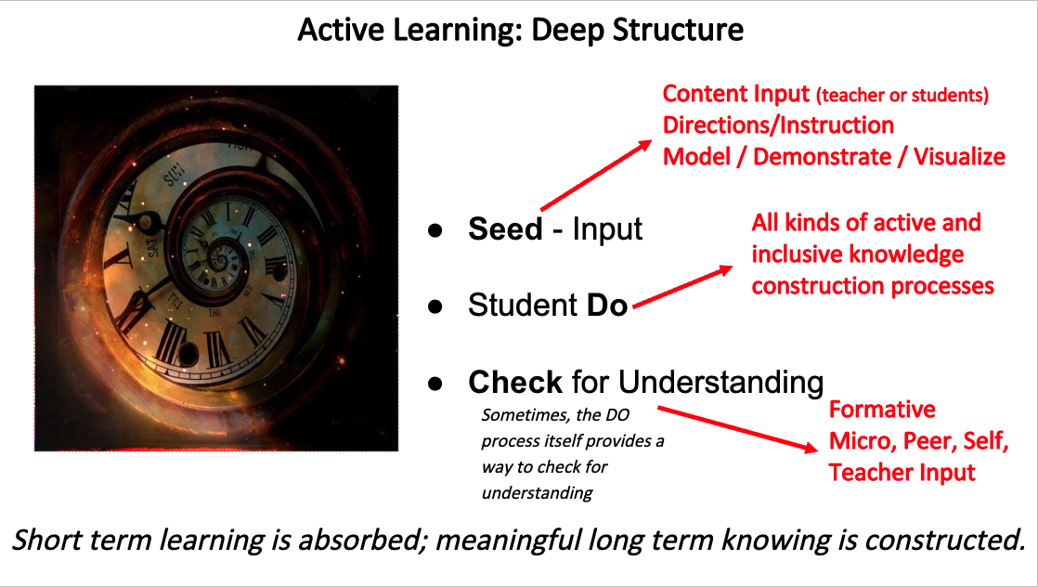
Image Source: Shamini Dias

Active learning design can be analyzed in 3 connected elements:

The INPUT or seeds to stimulate the learning process. Input is often from the teacher. However, it can also come from students or external sources. Examples: lectures, demonstrations, readings/video/web pages etc. before class or in class, reflections of experience, prior knowledge etc.​

The STUDENT DO to engage in knowledge and skills building. This is where learning happens. Students use input in solo, pair, or group settings and DO something with it. The teacher facilitates and the process (unpack, connect, compare, contrast, analyze etc.) to help students build knowledge and skills.

The CHECK FOR UNDERSTANDING processes. These processes address the critical question of how the teacher and learners will know that they are on the right track, that they “got it”? Knowing how they are doing – what they understood and where they need to focus more – is informal formative assessment that optimizes learning. It also helps students develop a metacognition of their learning and learning how to learn skills. For the teacher, checks for understanding help us gauge the effectiveness of our facilitation and where we need to adjust. Examples are think-pair-share discussions, short low stake quizzes, polls, reflections and synthesis work, peer reviews. Often the actual student activities are in themselves checks for understanding - if the learners can address the problem or successfully create something with the input, then they are on track. ​

This table shows you the shift in focus moving from legacy teaching to active learning.
Notice in legacy or traditional teaching that uses a transmission model, the focus is the teacher and content. The significant transformation in moving toward an empowerment model is to focus on learners and learning in a relational process, starting with the learners using a design thinking process.
Legacy or Traditional Teaching Focus | Expanded Equity-Minded Focus
Who are the learners? What are their contexts? What are our contexts for teaching and learning
design thinking - empathize and define
What should I teach? | What will they learn? What will they achieve?
What is the content I bring?  What do I want them to learn? | How will they use the content I bring?  What content can they bring?  They will expand and alter what I bring. They will question what I bring.  I might learn from what they bring.  They will construct what we all bring into new forms in connection with their knowledge and lived experiences.
Formal summative assessment  Learning is visible to the teacher, not always to the learner.  Assessment is focused on measuring and categorizing learners. | In-process checks for understanding.  Learning is visible to the students and the teacher.  Assessment is focused on supporting and optimizing all learners toward mastery.

Principles and Characteristics of Inclusive Active Learning
- Active learning can include physical and collaborative activity. These can take the form of role-playing, using post-its, drawing, making something, doing something outdoors etc. Engaging physically and collaboratively with peers, learners focus and articulate thought, bringing in a sense of exploration, creativity, and playfulness.
- Active learning does NOT always have to be physical. It can be quiet; focused tasks done solo or with others. It might look “passive”, but it active in cognitive engagement in specific processes. Listening to a lecture might be passively hearing a stream of words. But an active lecture will facilitate specific processes, e.g. recall and connect ideas, compare and contrast something as part of notetaking, or short pair share moments to review ideas.
- Active learning is about activating thinking and doing. We facilitate a process to help students engage in specific thinking processes that we want to help them develop. Therefore, we first must know what our intentions/goals are in designing activities – e.g., do we want to them to recall, compare-contrast, summarize, connect, question etc.? Knowing this, we can proactively design activities to foster these skills.
- Active learning is not always speaking up in class. We can design to include shy and introverted students, Language Learners, those unsure of themselves by allowing time and space to first prepare and edge-in without being put on the spot for example in a Think-Pair-Share. Or we can use pause for reflection, sharing ideas in Chat, a simple app like Jamboard, polling or post-it sheets etc. to engage all students in ways other than speaking.
- Active learning can happen asynchronously outside of class. We can make preparation work active by providing guiding questions for reading or reflection before class, for example the “Tasks” and “Pause to Reflect” moments in this textbook. This will help all students come to class more prepared and better able to engage.
- Revision – Purposeful Repetition – Practice and Application. Active learning includes these types of processes that help students deepen and embody what they have learned. Purposeful or goal-oriented work is important. Revision and repetition are not mindless and unproductive if it uses the approach of rehearsal and practice, integrating peer-review and analysis to improve.
- Meaningfulness supports active learning. Students engage with active learning activities more deeply when can find coherent patterns and connections between the material and prior knowledge and their lived experiences. Meaningfulness also comes from peer conversations, reflections, and journaling.

TASK 1 …continued
Check back with your initial idea of active learning in Task 1 above. In a different colored pen/font, add notes from the reading above to expand and sharpen your definition.

TASK 2. Connect with your lived experiences.

Consider this quote - “Students must be doing something ... discovering, processing, and applying ... not just reading or listening to a lecture”. Also consider that learning is by nature a cognitively dissonant process because we have to encounter things we do not know, work with them to build our understanding.

What active learning processes have you experienced in your schooling? Consider K-12, college, and graduate studies. Make a list of strategies you recall your teachers using that engaged you in active doing to build understanding. Is there a pattern of more or less active learning in the different levels of your schooling?

The WHY of Active Learning
In this section, you explore how active learning benefits students in helping them succeed in your course as well as prepare them with future-flourishing skills and capacities. Active learning engages us cognitively, socially, and emotionally in higher order processing - analyze, create, evaluate, apply, connect different pieces of information (synthesize), connect to prior knowledge and lived experiences.

TASK 3: The Benefits of Active Learning
List how active learning supports and fosters each of the listed areas of teaching. Remember, you are guessing before going on to read the rest of the input so that you can compare your guesses based on your own experiences with the information we share. After reading the notes below, come back and check your responses to expand your ideas.
- Learning success:

- Classroom community:

- Student engagement and confidence:

- Student voice:

- Preparing students for their futures

Active Learning Benefits. A Quick Research-Tour
- Significant reduction in failure rates. Freeman et al., 2014.
- Grade increases. Hoellwarth & Moelter, 2011.
- Increase in knowledge retention, student engagement, and overall student success. Baepler & Walker, 2014; Olson & Riordan, 2012; Petersen & Gorman, 2014; Prince, 2004
- Increased engagement in communication and collaboration, willingness and motivation to persist, increased flexibility and adaptiveness, a sense of fun and excitement. Allsop et al. 2020.

Here is a summary of the benefits of active learning.
- Reduces failure – better grades – better retention - increases student success ​
- Deep learning - Increases knowledge retention – long-term learning​
- Higher confidence, persistence, and motivation to learn.​
- Operationalizes the empowerment model of teaching ​
- Increases co-creation in knowledge construction – students think along with the teacher and each other.​
- Increases student engagement and voice – students are invited to bring their ideas into the learning process.​
- Increases relevance and meaningfulness in learning.​
- Learning becomes visible to students and teachers.
- Students develop competence and self-efficacy.
- Helps the teacher gauge learning as students work.​
- Inclusive. Makes room for diverse learners to engage in different modalities. ​
- Fosters future-flourishing capacities and skills
- Develops higher order thinking – analyze, synthesize, evaluate, create.​
- Develops interpersonal skills - sharing, collaboration, and communication skills and hence self- and other awareness​
- Develops learning how to learn skills (if we use active metacognitive processes)​.

TASK 4: Check For Understanding:
Compare your guesses about active learning in Task 3 above to the summary list here.

Add more notes from this research summary to expand the points you initially had.
How do each of these benefits of active learning contribute to inclusive education?
How does active learning as a method support your values, beliefs, and goals as an educator?
This is an opportunity to add more to your evolving teaching philosophy and diversity statement worksheets.

Active Learning for a Future-Focused Education
In this section, we connect active learning as a framework to actualize transformation from a legacy education system toward an approach more aligned to current and future world needs.

The emerging future
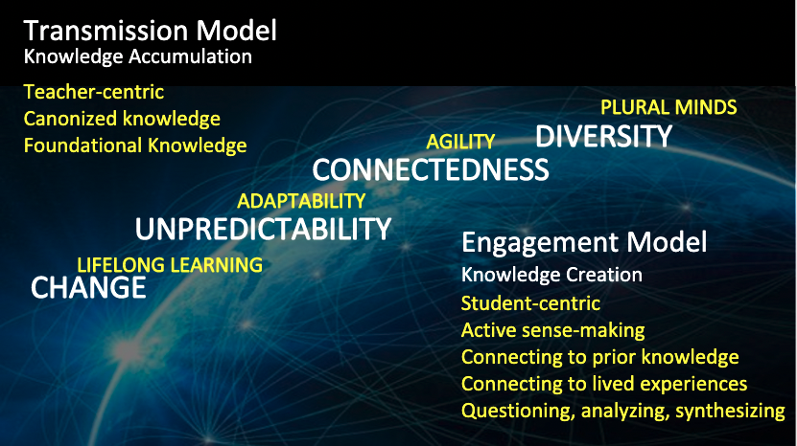Image Source: Shamini Dias

The internet was a global game-changer from the middle of the 20th century, significantly accelerating change and the interconnectedness of human interactions. The diversity of identities, cultures, histories, experiences, and worldviews with which we live are more prevalent and visible. Rapid change means we live with unpredictability; life in one generation is radically different from the next as new kinds of work, living conditions, and opportunities keep emerging. This is very different from the times where parents could predict a trajectory into the future for their children. The transmission model with its single-story approach does not work to support students entering a radically different global paradigm.
Active learning supports the paradigm shift we seek for equity-minded and culturally sustaining teaching that prepares all students for this emerging future. It operationalizes the following:
- Active construction of knowledge that connects meaningfully with lived experiences.
- Listening to and working with different perspectives in flexible adaptive ways.
- Working with others who are different – learning to listen and engage​
- Working with process rather than a single attempt.
- Doing, checking for understanding, and redoing​ – unlearning and re-learning.
- Learning how to learn through review, feedback, and reflecting on learning.
- Embrace errors and changes as a positive process in life rather than a threat.

TASK: CHECK FOR UNDERSTANDING. Create a Visual Representation
Use the ideas you have gathered about the benefits of active learning. Transform this linear list of ideas into a visual representation that organizes them in a way that makes sense to you – a mind map or table – that shows interconnections between them (cause-effect, same category or type of benefit). This engages you in active selection, connection, and synthesis of your ideas thus far.

Take a photo of your visual representation and add it to your Journal.

Expect your visual representation to be messy – this is a sketch of how you understand active learning. The important process is the active processing you do to organize and connect ideas, to seek out patterns. Pattern seeking is a strong indicator of constructing explicit knowledge schemas.

TASK: Questions Arising. Consolidate and reinforce your understanding of active learning.

Having done a tour of active learning, make notes on the following:
- What for you are the most significant reasons for using active learning in teaching your subject?
- What questions do you have about any aspect of practicing inclusive active learning?
- What is one word/short phrase that you would use to explain “active learning” to someone who has never heard of it?

​

How to Design Active Learning Facilitation
You can design active learning using the Active Learning Deep Structure model. A useful metaphor is cooking. How do you cook up an active learning lesson?

Image Source: Shamini Dias

Ingredients. SEEDS: What are your ingredients for input? Consider content input from multiple sources, instructions, teacher modeling. ​Consider whether some input can come from students such as reflections, brainstorming ideas to use for an activity, student sourced materials etc.

Cooking Process. STUDENT DO. What are the steps students will take to use the seeds to construct their understanding? ​What instructions and materials must you get ready to guide them in using the input to construct knowledge and skills?

Tasting. CHECK FOR UNDERSTANDING. What process will you use to help students and yourself as teacher to know they have learned or mastered something?​

You will use this structure to develop your Lesson Plans for your Lesson Plan assignment as well as use it as a framework for your Teaching Field Observation assignment.

Inclusive Active Learning and Lectures


Lecturing is frequently derided as an outdated, boring, and inefficient tool for student learning at any educational level. Despite its well-earned reputation for ineffectiveness, lecturing continues to be one of the most popular ways to present information to students – particularly at the college level. Lectures are a deeply ingrained part of higher education culture, and hence they are a comfortable and familiar teaching format for most college professors. At their best, lectures allow educators the opportunity to deliver a considerable amount of information to students in a limited amount of time, and to communicate a “big picture” narrative that aids students in organizing and structuring new knowledge in a meaningful way.
Image Source

What hurts learning is lecturing as 100% teacher input with no chunking and pauses to actively process the input. Lectures have the potential to be a wonderful instrument in any professor’s teaching toolkit – but only if they are designed to meaningfully engage students in a learning experience.
Excellent presentation – presence, content design – can engage some learners deeply in responsive co-construction of understanding. For example, in listening to a lecture, a learner might be:
- Thinking in parallel – making connections, seeing gaps.
- Emotionally responding – “yes exactly!!” “Just what I think”, “Wait! That’s not right!”
- Questioning – “What are the implications for ….? “What if …?”
- Writing (not scribing word for word) – key ideas and organizing them as they take notes.
- Just enjoying the flow of the story – because the subject matter is meaningful to them – knowing they will continue to think about this, read more, and process later.

Have you experienced lectures where the above was true for you? When this happens it feels wonderful! We are in flow with the lecture.
And yet, many students do not experience lectures in this way. This is the result of many factors coming together – listening and dialogic exchange skills, a socio-cultural history of independency and agency, notetaking skills, a keen interest in the subject matter, prior knowledge that enables making connections, no information processing barriers, and no social-emotional disruptions that break focus.
There is a great deal of academic privilege in this profile.

Many learners do not embody this academic privilege. It is certainly not the norm in any diverse classroom. Empathizing with our students in design thinking, we know the diversity of learners who enter our classroom who collectively bring the following profile:
- The learner is new to the subject, and hence they do not have much prior knowledge to which they can connect as they listen.
- The learner is not (YET) cognitively and emotionally invested in the topic and so they might not “see” the story with which to engage. This is especially so if the subject matter does not connect meaningfully or is not presented in a way to evoke meaningful connections.
- The learner has not been previously prepared on how to listen actively and take notes, or is a language learner, or has a learning challenge and needs time and space to process ideas.
- The learner is unable to focus fully in the moment due to life challenges.
Therefore, when we teach, we must be mindful of the variation in capacity and pre-conditioning, as well as academic privilege that is not evenly shared.
Example: Teacher writes on the board as she talks. This is NOT active learning. But it could be if:
- Students do explicit in-parallel processing: Students have a parallel activity to sort, connect, or respond to what the teacher is writing. This is teacher input AND student do together. A good scaffold is an empty outline which is a document with key headings, or a graphic organizer, or questions that helps students actively listen and take notes.
- Students do response processing: After a bit of teacher-talk and writing, there is a pause and students are invited to add to or ask questions about what’s on the board. In a small class, this could even be silent discussion by students using post-its to write and add ideas (also good for shy non-speaking students, language learners, and emerging learners not fully confident yet). Notice the chunking - first teacher input and then student do.

Benefits of Lectures That Engage Thinking
When you design lectures to include time and space for active intellectual knowledge building and reflection:
- You move students from lower- to higher-order cognitive processes. This shifts students from passive listening in order to memorize information (and the stress of trying to “get everything”) to re-articulating, responding, critically questioning, creatively engaging with information, and even building upon it to discover new knowledge.
- You help students stay focused through class, leading to more positive feelings about learning.
- You become adept at presenting content to students in different ways – using images, video, polling, Jamboard activities etc. This helps students engage in multiple ways, benefitting all but especially Language Learners, those with focusing challenges, note-taking learners, or are new to the subject and struggle to process the large amounts of information in a lecture.
- You create a safe space for abstract learning to take place. Being introduced to complex information can make students feel insecure and disengage from learning. Designing lectures that lead students to gradually interact with new ideas in manageable chunks, helps lower the degree of intellectual risk that these ideas may pose to students. And by doing so, you develop their ability to actually take intellectual risks as learners.

Fundamental Principles for Active Lectures
Effective lectures are crafted and delivered based on the fundamental principle of intentional design with a focus on the audience and their learning. We can design lectures to move learning from passive reception of information to active construction of understanding. This means integrating the active learning structure – Input - Student Do – Check for Understanding we lecture to ensure our audience is still with us, and more importantly, understands our material?

Teaching (providing input) Does Not Equal Learning
In a lecture, we tend to fall into a transmission mode of delivering content, especially because we have a natural desire to try and share a lot of information. Lecturers often use the metaphor of “absorbing” information. However, the more time we spend lecturing and the less time students have opportunities to articulate their understanding, the less certainty we and our students have about whether they are learning what we teach. It is also easy to lose focus and engagement. Just because we have “taught” something is no guarantee that students have “got” it, or that they can apply it critically and creatively. Think of lecturing as facilitating learning at higher levels of Bloom’s taxonomy, and elements of Fink’s taxonomy and the ELOs.

Make Time for Thinking and Processing Information
Lectures provide a narrative stream. It is hard enough to take notes, watch/read slides, focus in listening to the teacher as they deliver the lecture. Many students have been “trained” to listen passively in class, or feel shy or hesitant to ask questions. Some might be Language learners or international students who are challenged with a new language and/or different learning cultures. Some have listening and focusing challenges. Others are shy or intimidated for many reasons such as not feeling confident, being distracted and tired etc. Accept the quiet people. But ensure they are engaged and learning by creating processing time through active facilitation to scaffold learning. This needn’t be complicated; all that is needed is intentional pause to process an idea – using silent thinking time, think-pair-share etc. Silence and stillness help students to focus, re-engage, and think. When we present a complex idea, they need time to let it sink in, to consider it, connect it to other ideas. Pause intentionally to make time for thinking. In fact, highlight it by saying “I’m going to stop for a minute and let you think about this” so they feel safe in the silence and actually think about the idea. This helps all learners, from those with focusing and information processing challenges, to Language Learners, tired and distracted people etc.

Lecture to include and engage a range of learning modalities and needs
Lectures privilege learners who have training to listen and take note, and can focus for a length of time, and who have prior training to take good notes. Lectures are hard for those with hearing or seeing disabilities, and for Language Learners. Therefore, we should design our slides and delivery to facilitate effective listening and note taking. For example, visually impaired students need to “hear the visuals”, so rather than saying “as the chart shows”, you would say “the chart shows an increase in X over time”. While a school might assign hearing-impaired students a signer, you can help by providing a set of notes they can use to follow along. Accommodation proof your lecture as far as you can by using Universal Design for Learning methods ensuring accessible slide design such as captions as you speak, using clear fonts and colors discernible to visually impaired learners. This also helps many others who do not have official accommodations.

Chunk Content for Structure and Flow
Break your lecture into smaller chunks, for example 10-2-minute explicit sections or sub-topics, each of which engages students in actively gathering, organizing, or responding to information you present
- Chunking clarifies the structure of the information you are presenting and helps students understand each piece of your full lecture and see connections between them. This aids their note taking and hence also their knowledge development and retention.
- Chunking focuses on active knowledge construction as you provide input.
- Chunking supports attention and focus as students have opportunities at each chunk to take a breath and reset their attention..
- Chunking allows you to do quick formative assessment of whether students have understood what you just lectured on before moving on.
Through formative checking for understanding, you help students to gain a better grasp of the material as you lecture and can scaffold them asking questions (using anonymous Jamboards or Chat supports this). This engages them more effectively with the material, and builds agency in assessing their own learning. Over time, they become better at realizing when they have not understood something and in asking clarifying questions.
Alternate Input Chunks with Student Do Interaction
We can only ensure students are building a coherent understanding of what we are lecturing on if we make time for critical thinking and reflection. Even small moments mindfully designed into a lecture can make a large difference. Asking students questions, checking on and facilitating listening skills help to maintain a continuous feedback loop in the teaching-learning process. Do this by alternating lecture content chunks with mindful periods of active intellectual space, in which students think, question, write, draw, or role-play in response to the information you just gave them. Use different modalities – silent writing or drawing, working with partners or small groups, using digital brainstorming (Chat, Jamboard, Miro etc.), using post-its to share, sort, and synthesize etc. This helps us and our students gauge whether or not they have understood the lecture as it progresses.

Sustain Relationality
Lectures easily create disengagement between people, simply from the physical environment and the process of information delivery. Center relationality as part of learning by intentionally not lecturing from behind a lectern or desk, but moving in closer to students, and making eye contact as they enter the room and as you lecture. Use students’ names when calling on them and encourage them to do the same in responding to each other. Have students make name cards until you learn their names. In large lectures, leaving name cards up through the semester helps everyone use each other’s names. In large classes, making time for pair and small group activities helps reduce impersonality and allow students to get to know each other. In engaging in conversation, acknowledge all contributions. If something is off topic or wrong, first accept and acknowledge the act of responding before correcting the content. These ideas apply to online teaching. Because we cannot more physically closer to our students in online classes, even more intentionality is needed to humanize the learning space in lectures. We cannot move physically closer to students, but we can take some time to greet them by name and allow time to share news before lecturing.

RESOURCE: In-Lecture Learning Process Activities
- Think-Pair-Share: Students think on their own (30 seconds - 1 minute) in response to a prompt on what you have just lectured, then share with a partner (1 minute), and then share in a small group (2 minutes). This can be effectively done in a large lecture hall.
  - Offer students a chance to ask clarifying questions.
  - If you use a learning management system, students can log on and post questions to a discussion prompt you can set up before the lecture.
- Written responses to a lecture chunk can use the full range of Bloom’s taxonomy; ask students to do simple summaries to check understanding, a critical or evaluative response, apply the material to a given scenario, come up with new ideas and alternatives etc.
- Students “translate” what they have heard in a lecture into a different genre or communication format. Ask students to draw in response to a prompt about a lecture chunk. For example, you can ask students to create a figure or model that represents/encapsulates the core themes of a complex sociological process.
- Bring mini debates into a lecture between pairs or groups.
- Move. Depending on the environment and class set-up, activities between lecture chunks can creating quick discussion groups, standing to debate with partners, using the whiteboard or walls for short activities in response to what was just lectured.
- One Minute Paper (OMP). After a lecture chunk, pause to give students a response question, e.g., “What are the key dilemmas of ___ that you noticed in the presentation?” If in a 30-minute lecture you have 2 OMPs, students leave with solid notes for review later. Even those who just enjoy listening to the lecture and can take good notes will gain from this short summary reviews as they go. Less is lost into the ether after class, and you are helping them gather good review notes for their assignments and assessments.
- Mini assessments. Do quick quizzes, polls, or one-minute papers (e.g. what I learned, what I have questions about) to assess learning in between lecture chunks or end of the lecture.
  - If technology allows, set up mini assessments online and give students access during your lectures.
  - If you do one-minute papers in class, you can collect these and look them over using a check, check plus, check minus approach.
  - Have note cards and a box in the room. Students can write questions they feel are important and you and/or a TA can respond to these after class and either send an email to students with the responses or share in your learning management system.

RESOURCE: Facilitation for Engagement and Focus
- Use priming prompts to focus students on the topic and engage attention and interest. Put the prompt prominently on a slide – actually stop and give students time to think, engage them in a quick verbal exchange before moving to content slides and the rest of the lecture.
- Use signposting to indicate transitions, e.g., what we just saw was, in the next section we will, now it’s your turn to think about, etc.
- Time to see before narrative. When presenting images or visuals, ask students what they see and give them a few moments to look and think before explanations and descriptions.
- Pre-alerting listening scaffolds – explicit directions to listen for something, e.g., “listen for 2 opposing views”, “list the solutions you hear in this next part”.
- Be specific. Rather than asking “Does anyone have a question?” (to which the response is often deafening silence), ask for specifics: “What might be some ways to respond to this situation?” “What is the hardest part of this equation?”
- Stop to question. Make asking questions explicit by pausing and asking students to chat with peers around them to find questions to ask that would clarify or question what you presented. This engages them in recall, review, as well as thinking critically.
- Wait for more hands. When you ask a question, do not call on the first hand to go up or take the first correct response. Establish a norm of having students raise their hands if they have an answer or question. Wait for many hands before calling on someone. Gather many answers before giving your response about the “correct” answer. This builds a culture of thinking and discussion moving away from an attitude of only seeking the correct answer.
- Connect the material to your students. Engage their lived experiences, their imaginations, and emotions as you lecture. For example, rather than immediately defining “social justice”, begin with a moment for connection by asking, “What experiences have you had or seen that you would think is a social injustice?”. Ask students what excites, intrigues or frustrates them above a topic before you begin lecturing on it. Even if you do not engage them in a discussion, the time for thought and connection you allow creates a more receptive cognitive and emotional space that helps students engage with the topic.
- Facilitate peer engagement. Have students respond to their classmates’ questions or responses to a question before you respond. This helps disrupt the conditioned response we have that every student response will be judged, clarified, and “fixed” by the teacher. By inviting students to respond to each other before you give your perspective, you help create more natural conversations in a lecture while also maintaining attention to the process.
- Move from simple to complex. Participation is hard enough for many without the additional cognitive load of having to suddenly respond to complex questions. Scaffolding sustains engagement and deepens learning. Do simple solo and pair tasks to get the process going – e.g., summarize the key points of a lecture chunk or related article extract, make a list of ideas based on a lecture chunk etc. Then introduce complexity, e.g. compare and contrast, question the ideas, connect to something else etc. Having warmed up to the process in the simpler activity, students have more confidence, are more focused, and better able to engage in the more complex task.

RESOURCE: Scaffolding Notetaking
Discussion is another very opaque word in education – NOTE TAKING. What does that mean? For some, it’s racing to write each word down, for others it’s listening out for key ideas, or taking key ideas and responding in parallel with one’s own thoughts, for some its creating a mind-map of ideas as they listen. And what about purpose – why do we take notes? For some students, it’s a record of what the professor said in lectures to review for exams, for others, notes help them re-read or read ahead and understand the subject. What has it been for you?
We know our students enter our courses not all knowing how to take useful notes, or how to organize ideas as they listen. This is a critical information literacy skill they need no matter what they go on to do. It is therefore helpful to create some explicit scaffolding of note-taking as active learning. This investment of time and effort has massive pay-offs in student engagement and achievement. The ability to take relevant, useful notes helps students maintain focus during a lecture, effectively gather the information being shared so they have useful material afterwards to review and use in assignments. When students walk out of a lecture feeling they have a solid grasp of the material and notes to back that up, they are going to be more engaged and motivated in that course.

- Make notetaking as a goal explicit and tell your students. You can even make it a learning outcome for information literacy, e.g., “Students will be able to gather and organize information from lectures into coherent knowledge to use in assignments”.
  - Make it meaningful – explain that notetaking is a life skill. Give examples from careers and further study. Share examples of good notes annotated to show how they work.
  - Invite the Writing Center to do a guest workshop on note-taking skills.
- Use Empty Outlines – key headings or a graphic organizer that gives students a structure within which to take notes. This can also be a notetaking template students can use consistently. A popular one is Cornell Notes (see sample template below)
- Track and support good notetaking.
  - Collect student notes from time to time and use a tracking rubric to check (no grading). Have students submit lecture notes the first few lectures so you can check and intervene where necessary to build note-taking skills. Also, having to turn in their notes for a period of time supports their building a habit of note-taking.
  - Make a simple tracking rubric (NOT grading) and share with students. An example:
    - Notes are organized under clear sub-topic headings.
    - There are some connections made to previous topics.
    - Each lecture has a short bullet point summary of main ideas.
  - Have students do peer review of notes using the rubric so they gain clarity about what they are aiming to achieve.
  - Respond: Offer coaching, connections to the writing center etc. for developing information gathering and organizing skills. Look for growth over time.
  - Stretch students who are doing well in basic note taking – can they also make connections to prior topics and own experiences. Look for growth over time.
This kind of intentional skills-based teaching no matter the subject is invaluable in setting students up for success in college no matter what they major in, and also for life/career.

Inclusive Active Learning Discussions

DISCUSS is another one of the opaque words in teaching and learning.
Discuss comes from the Latin discutere” meaning to shake apart or to agitate. It gives us the current meaning of examining using argument and debate; discussion includes analysis and plurality of views.
While teachers might mean this when they tell students to “discuss” something, what exactly do students thinking they must DO? For many students “discuss” vaguely means summarizing something.
However, effective discussion engages multiple levels of thinking. For example in directing students to discuss an article, we can specify any of the following:
- Make a list of the key points in the article.
- Describe the concepts in the article.
- Connect ideas in the article to other articles, websites, videos etc.
- Connect ideas in the article to previous topics.
- Question some of the author’s assumptions and biases.
- Identify areas where the author’s ideas can be applied.
- Identify how the ideas in the article connect with your own lived experiences.
- Look for ideas that are surprising, delightful, or challenging and say why.
- Assess whether the evidence or support for arguments the author brings is effective.
- Identify areas of agreement and disagreements among peers and explore why.

PAUSE TO REFLECT
What are the different levels of thinking that are addressed by each type of exploration? Can you see connections to Bloom’s cognitive taxonomy, Fink’s Significant Learning Outcomes, and the Essential Learning Outcomes?
How is scaffolding active discussions an inclusive and equity-minded move?

Discussion is conversation that helps us expand our thinking and understanding of something.


“… a way of thinking called story-mind. There is more to narrative than simply telling our stories. We have to compare our stories with the stories of others to seek greater understanding about our reality. It is a test of validity and rigour for new knowledge. The symbol shows two people sitting, bringing their stories together to share through sand talk to extend their knowledge. False narratives do not stand up well to this kind of analysis. Story-mind is a way of thinking that encourages dialogue about history from different perspectives, as well as the raw learning power of narrative itself.”

Image of Story Mind – Tyson Yunkaporta. Sand Talk. How Indigenous Thinking Can Save the World. (2019)

What discussion is not: antagonistic debate, polarized argument, deciding on a single correct answer.

The National Paideia Center defines Socratic Seminars as ““collaborative, intellectual dialogue facilitated with open-ended questions about a text”. This also describes “discussions”.
In a discussion, individuals share their knowledge and perspectives about the thing being discussed. The goal is for the group to inquire together to clarify meaning and develop a shared and expanded understanding. Each one leaves the discussion with a mind expanded by the different perspectives and ideas that arose in the discussion; it can be a transformative process.
Discussion as inclusive, equity-minded learning conversation aims to achieve an authentic and shared understanding about something – an idea, a problem to solve, an innovation - that might comprise a complex entanglement of different perspectives. It is a creative dance – not an antagonistic battle (remember the metaphors you explored in a previous chapter about argument as battle and dance).
Therefore, in leading inclusive and equity-minded discussions of course materials, we integrate an explicit awareness and structuring in exploring ideas. This means that as facilitators we need:
- An explicit awareness of a diversity of embodied perspectives in a group. How do we invite and honor these voices so they have space and generosity to speak?
- An explicit awareness of the often singular narrative assumptions of legacy texts we use. How do we guide explorations so that there is a framework to alert students to seek and find these?

Qualities of inclusive, equity-minded learning discussions
- All voices matter and are needed – seek multiple perspectives rather than “one correct answer”.
- Divergence of ideas is as important as convergence of ideas; each direction has a role to play.
- Question finding not just responding; focus on new questions emerging from the discussion.
- Reflexivity through double-loop thinking. Critically examine assumptions that are shaping the discussion, and to ensure that all actors in the space have opportunities to contribute and be heard.
- Deep listening in exploration and discovery. Respectful, thoughtful, generous contributions and listening. Invite each other to bring ideas in and are not antagonistic in their responses.
- Analytical, connective, constructive. Care is taken to ensure there is evidence to support claims from research, the larger world, and lived experiences. Multiple ways of knowing are respected.
- The direction of discussion is to learn – to expand thought and action.

TASK. Analyze discussions you have had.
Think of discussions in which you have participated, as a learner, in professional work, and in life. Go through the 8 dimensions of inclusive, equity-minded, learning discussions. Which of these were present in the discussions. Which were missing and why do you think that was the case?

TASK: Apply Principles of Learning Discussion
Brainstorm some active learning strategies to facilitate each principle.
Principle of Learning Discussion | How to facilitate them in a class
All voices matter and are needed – seek multiple perspectives rather than “one correct answer”.

Divergence of ideas is as important as convergence of ideas; each direction has a role to play.

Question finding not just responding; focus on new questions emerging from the discussion.

Reflexivity through double-loop thinking. Critically examine assumptions that are shaping the discussion, and to ensure that all actors in the space have opportunities to contribute and be heard.

Deep listening in exploration and discovery. Respectful, thoughtful, generous contributions and listening. Invite each other to bring ideas in and are not antagonistic in their responses.

Analytical, connective, constructive. Care is taken to ensure there is evidence to support claims from research, the larger world, and lived experiences. Multiple ways of knowing are respected.

The direction of discussion is to learn – to expand thought and action.

RESOURCE: Integrate Checks for Understanding in Preparation Work
Fact Check Quiz based on preparation material. These can be set to be taken multiple times to get things right as formative assessment. They require no grading on your part. Also, your LMS analytics will indicate engagement and who’s having trouble so you can do 1-1 outreach as needed.
Preparation Tickets. Ask students to write something in response to questions you will expand on in a class session - such as summarize ideas, organize ideas into categories, higher order tasks such as take a position and justify, identify assumptions, identify alternative perspectives, write a counterpoint response, connect to one’s lived experiences etc. These can be submitted in a Discussion Post or to the Assignment Tool in your LMS. They should not be graded or be very minimally weighted.
Selecting to Share. Ask students to find one thing to share in response to a question you pose about the material. For example, after reading an article on conservation, ask a question on the effectiveness of this approach and support their view. Create a shared, editable page - in your LMS or link to a Google Document to submit their ideas. Students post on the page with their few lines of annotation. With this, you can extend the process in class:
- Students browse and briefly comment on each other’s contributions.
- Connect these contributions to your class meeting session by viewing the page in class, picking out themes and making connections to what is covered in class.
- Create group work in class to review the contributions as part of a discussion activity to view the contributions, synthesize key ideas, and articulate a response to a question on the topic.
The “Muddiest Point” List. Ask students as they prepare for each session to keep a running list of things that are unclear or puzzling. Set up an editable page in your LMS or a link to a Google document and invite them to share their “muddy” items on this page. Encourage them to clarify items for each other. Peer-teaching like this builds a sense of competency as a community of learners. As the instructor, you gain a sense of what areas you might need to give more time and attention to and what you must clarify when you meet together in class.

CATs are small ungraded tasks that we do in class. They are part of active learning, especially checks for understanding. They give us and our students on-going learning feedback in an adaptive learning-teaching process: Checking-in and adjusting as we go. When done consistently with support, CATS create safe-fail spaces for students to raise questions that help their learning.
Explore: Classroom Assessment Techniques. This is a great overview by Vanderbilt University’s Center for Teaching with examples, and why and how to use CATs.

More Active Learning Resources
This model shows a useful selection of active learning techniques ranging from simple to complex in terms of time and task design. You will find many of these techniques in the databased in the next item – ABL Connect 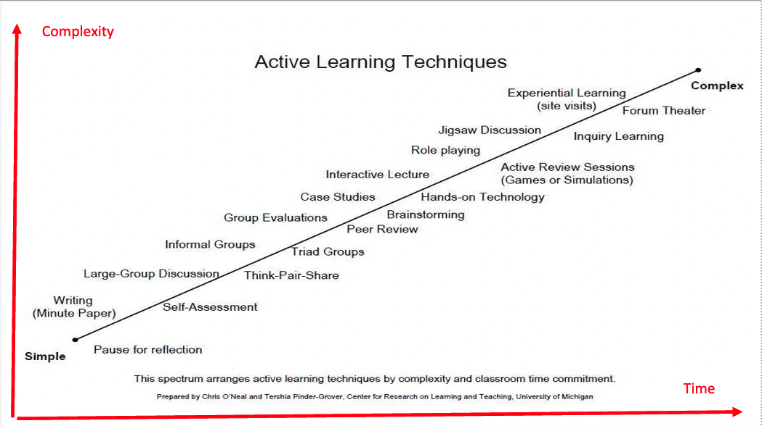
Prepared by Chris O’Neal and Tershia Pinder-Grover. Center for Research on Teaching and Learning, University of Michigan.

ABL Connect. This is a magnificent active learning resource at the Derek Bok Center at Harvard University. The resource is a database - you can filter by discipline, type of activity, learning objective, length of activity, and award winning activities. They have other resources as well - active learning online principles, and a ton of research summaries organized by categories and references.

Mazur, E. (1996). Peer instruction. A user’s manual. Pearson Publications
This is a step-by-step guide for using peer-instruction in lectures, especially for introductory courses with large class sizes. While some of the resources are for STEM courses, especially math-based physics courses, the strategies and principles apply across disciplines.

Inclusive Active Learning: Digital Tools for Analog Spaces

Active learning is important in all teaching-learning contexts. Just because we teach in physical or analog spaces does not mean we forego digital tools and processes. Many techniques that have emerged in online education are actually useful for more inclusive active learning with a diversity of learners. They can be applied in physical classrooms, synchronous online classes, or asynchronous online courses for class preparation scaffolding, and in-class to support all learners in lectures and discussions.

Learning Management Systems (LMS). When teaching in physical spaces, do not overlook the engagement potential of your LMS to present material, organize learning processes, communicate with students, and engage them in active work as preparation or as classroom activity.
- Discussion Boards and Chat Channels. Students can engage with peers asynchronously to discuss ideas as preparation for class activities. In class, they can meet in small groups to discuss something and upload their views to a discussion board for other groups to read and respond.
- Collaborative Pages. Use LMS pages to set up collaborative pages where students can add information and ideas around a topic both in class or asynchronously.
- Group Work Space. With project work, you can use the LMS group tool to create a shared space with cloud access for students to organize and collaborate. This also develops important knowledge management and information literacy skills that will be useful beyond the course.
Class preparation has traditionally been done by assigned readings and textbooks. Digital tools and modalities can expand inclusivity and remove learning barriers. Class preparation can include videos, podcasts, e-books, Open Educational Resources, etc.
  - Cost barriers are removed, especially the monopoly of textbooks.
  - Expansion of perspectives. Curating materials available digitally allows us to better represent a diversity of voices and knowledges.
  - A variety of modalities reduces text dependency and supports busy students, Language Learners, and students with reading challenges, while expanding information literacies for all learners.
Peer Based Learning. Class preparation and in-class work can be scaffolded more effectively using discussion boards, apps like Jamboard and Padlet that invite students to express themselves and connect with peers in responding to input.
Chat channels. In a physical classroom, we can still use a Chat channel – Zoom, Teams, What’sApp, Discord, Google Chat - projected on the classroom screen. Intentional use of Chat creates access and opportunities for many students – shy, introverted, Language Learners, socially awkward – who might otherwise not be able to participate. It also makes us question that opaque word “participate”, opening it beyond speaking up in class to engagement through writing.
Digital Polling. If we use slides projected on a screen in facilitating learning, we can keep using digital polling apps like Poll Everywhere and MentiMeter for students to think about and respond to ideas.
Jamboard and Miro. These and other similar brainstorming tools can be integrated into a physical class. Students working in groups can log in to these spaces to engage in generating ideas and working to develop ideas visually.
Padlet and other expression tools. Students can use these in class or asynchronously to respond to something, share reflections, or express themselves creatively in response to a topic.

Chapter 9: Transformation 3. Relationality & Community in Classrooms

"Sense of community is a concept that is primarily psychological: It refers to the personal knowing that one has about belonging to a collectivity. There is an I-you sense that differentiates oneself from the collectivity, and there is a we sense of belonging together. These are reciprocal aspects of belonging, each requiring the other. The United States is a particularly interesting social experiment, because it has been loosening the we sense into much more of an I-you sense. And the direction of that has been I versus you (rather than I and you), where the dominant process has been one of individuation and ego enhancement. American society seems to allow, even provide, maximum opportunities for the development of the ego. … There is a yearning for community that has been growing steadily in America ..." Newbrough, J.R. and Chavis, D.M. (1986), p. 3.

What is a sense of community? Before you dive into the material in this chapter, do the following tasks to connect your lived experiences to perspectives from artists, and ideas from research.
TASK: View a Music Video and Poetry Slam
Watch: Another Brick in the Wall – by Pink Floyd. [6:00 mins]. While hyperbolic and surreal, the video presents a dehumanization of education in erasure of relationships outside that of power, control, and oppression. It was released in the UK in 1979.
Watch: Simon Says – Ashley Davis and Oompa. [3:01 mins]. This video is from a poetry slam in 2016 that brings in the school to prison pipeline.

TASK: Brainstorm: Drawing from your lived experiences.
How do you understand the idea of “community”? Make a list of words and phrases that define what “community” means to you. Or draw (find) a picture to show “community”.

TASK: READ McMillan, D. W., & Chavis, D. M. (1986). Sense of community: A definition and theory Journal of Community Psychology, 14(1), 6–23.[12 pages] Link to Article.

MacMillan and Chavis define community as a subjective sense of belonging and relationality (I matter to you - you matter to me, we matter to each other), as well as a belief/faith that all our collective needs can be met through our commitment to each other. They look at communities defined by geography/territory (neighborhoods), relationships (spiritual, professional) and define a sense of community through 4 elements:
- Membership: “The feeling of belonging or of sharing a sense of personal relatedness.”​
- Influence: “A sense of mattering, of making a difference to a group and of the group mattering to its members.”​
- Reinforcement: “Integration and fulfillment of needs… the feeling that members’ needs will be met by the resources received through their membership in the group.”​
- Shared Emotional Connection: “The commitment and belief that members have shared and will share history, common places, time together, and similar experiences.”​

Based on your reading, draw a visual model representing their concept of community.

List 3 strategies teachers can use in their classrooms to foster a sense of belonging and mattering in class. Consider your experiences, observations, and ideas you believe that would be good to try.

Aspects of Community

Given and Chosen Communities
There is a tension between a given community – the place you were born and lived in childhood, a workplace – and a chosen community. Sometimes, they align perfectly; we choose our communities from those into which we are born or located by other social-economic forces. Sometimes, we intentionally choose communities that may even be difficult to get to because it is there that we feel we matter and belong. This is similar to the difference some people feel between their biologically given family and an “intentional” family with whom they have built special relationships.
- What are your given and chosen communities?

Community As Place
There was a time when a community was physically and geographically defined, the place where we lived, our village, town, city. It was also for a long time, the place where we worked, where we would meet our colleagues and supervisors at the market, at places of worship, at the park, at games, at town celebrations, where our children would attend the same schools and we’d know the same teachers.
- What are your community places? How have they changed over the course of your life?

Community As Connections
With social mobility through the late 19th and 20th centuries, globalization through the 20th century, and especially the development of the internet in the last quarter of the 20th century, “community” is now a more dispersed concept. I might have no community where I actually live and a strong sense of community with my department at work, I might live in one town and attend school in another town or online, I might live in one town but attend a place of worship a 2-hour drive away. My most salient communities might be on social media with relative strangers from around the world but with whom I connect for deeply meaningful interactions.
- Do you have community that is distant or dispersed online?
Community As Systems
Taking a systems perspective, we can look at communities at macro and micro scales. An important consideration is at what level or scale does a community become salient and meaningful to an individual? There is a tension in society between the microcosms of identity-based communities and the macrocosm of the whole multi-diverse community called “the society”. The emergence of virtual communities adds a layer of complexity to this tension. How do we define ourselves and where we see our communities? Am I a “citizen” and community member of my city, my country, or my identity group/s? Can I be a member of all these systems?
- Which communities are more salient to you and how does that impact your participation and sense of personal and social responsibility?

Mattering as Key
Membership is not sufficient. We might belong – say in official ways of being enrolled in a class – but do we matter? Mattering is a sense of one’s significance and our sense of value or worth in who we are and what we embody and bring to a situation. Mattering is feeling that our presence and actions are meaningful to others, that we are seen. (Costin & Vignoles, 2020; George & Park, 2016; Martela & Steger, 2016).
- Given all the different aspects and types of communities above, in what communities do you feel you matter? In what communities do you wish you mattered? How does this change in your different professional and social-life roles?

Institutions and Organizations as Community
Are institutions and organizations communities? And for whom? A college has a mission based on a set of values, and a common purpose uniting and directing the work done across all levels and departments. It is a system of stocks and flows. But is it a community?

Within an institution, there are micro systems or possible communities that are both formally established or organically evolved that serve as spaces and resources for different populations of students. If a sense of community comes from a sense of connection, meaningfulness, and belonging, who has that experience? What elements or processes in institutional life can foster these experiences? In ethically including all student diversities, what might be the limits of an institution?
PAUSE TO REFLECT
Remember complex intersectional identities and the socio-ecological model of Social Determinants of Learning circumstances of our students.
Who do you think is recognized and who is still invisible in the community infrastructures that exist on a college campus?

The college in the larger social system. In ethically including all student diversities, what might be the limits of an institution? Whose responsibility is it to serve these diverse needs; who is ultimately accountable? How do institutions share the responsibilities and accountabilities of larger social systems?
Systems are connected. What are the stocks and flows connecting an educational institution and the larger social system? Should/will institutions of the future be integrated with larger social systems in partnerships that can better serve the diversity of student identities and needs? What might that look like if you had the power to re-imagine and reframe educational institutions?
The classroom as an intentional community. The classroom is the primary point of contact between educators and students. What can you do to create an intentional classroom community that will make your class a salient, meaningful space for being (and being visible), mattering, and learning? How is community created in course design, in expectations and protocols for class engagement, in your choice of learning and assessment modalities? How do you create safe and brave spaces and processes for students to be who they are as they learn, to bring in their identities, histories, and lived experiences?

Classroom Community
“Do I matter to my classmates and my teacher?
“Does it matter to my life that I am here?”

These existential questions often unconsciously work in the background and impact engagement and success. A classroom is a given community – but for many, it might not be a chosen community.
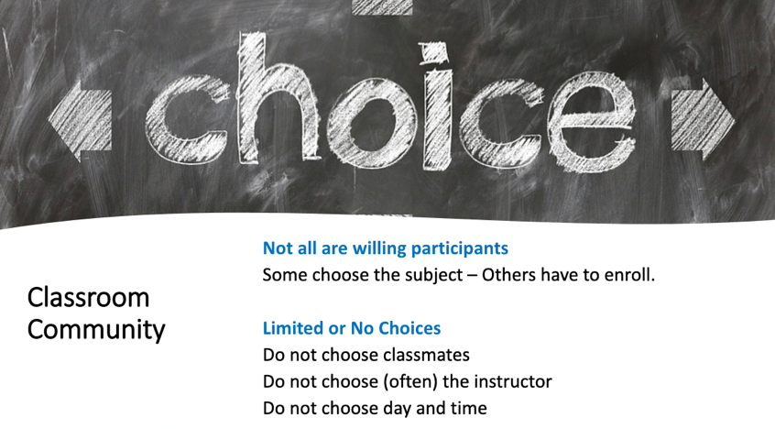
Image Source: Shamini Dias. Graphic image source

Students are in your classroom (just as we are in our workspaces) from a number of reasons:
- They want to take a class with you
- They have to take this course and you are not their instructor of choice
- This class fits their schedule.
- Their best friend is taking the course … etc.

There are other circumstantial factors that affect their sense of community:
- They do not know anyone in the class – they know most of their peers
- Some peers make them feel uncomfortable – they feel welcomed by the peers
- They are in the minority – they are part of a majority group.
- The day and time of the course suits them – is challenging.

So, when we begin with our students, we are a random bunch of people, brought together by a modicum of choice and a great many circumstantial reasons. Yet, the class is often the place of greatest and constant contact between students, their professors, and their campus. From a random gathering of individuals, how can we become an intentional classroom community where students feel that they matter, and that is a meaningful space for learning and bringing one’s full self into the process?

TASK: READ Kay, D.; Summers, J., & Svinicki, M. (2011). Conceptualizations of classroom community in higher education: Insights from award winning professors. Journal of Ethnographic & Qualitative Research, 5(4). 230-245 [15 pages].

This is a multiple case-study with 16 professors across different disciplines, demographic backgrounds, from 2 major universities that examines conceptualizations of classroom community. The authors use a systems perspective to present the dyadic and social system of a classroom.
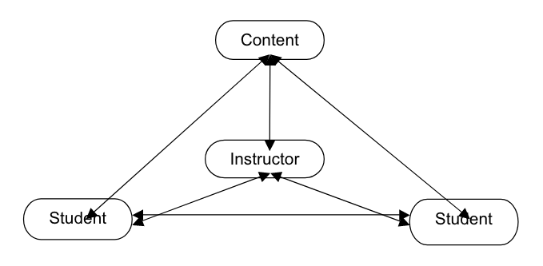

Consider these excepts from some of the participant’s comments. Have you experienced these scenarios in your education journey? What do you think the teacher does to foster these settings?
- There may be a room full of people who don’t have anything in common other than that class right now. You know, they’re thrown together or brought together as a result of registering for the same course, and then over the course of the semester, as time passes, there’s an opportunity for them to feel a bond or kinship or a closeness with other members of the class that, you know, is very positive, or can be very positive.
- I love for the people to feel that they are participating in a common intellectual adventure. More a place where they are intellectually stimulated, they seek one another out for this common, um, for this common interest. They’re communing with each other! I mean, they’re communing in this intellectual arena, which is what I really want them to be doing, is to be talking, you know, with the challenges, having the intellectual challenges be what they do.
- When everyone is working together cohesively, we are discovering things together. We are sharing information and it is very much a give and take.
- I also think classroom community involves feeling like this instructor is not on the stage in (name of auditorium), this sort of figure that stands aloft that I cannot approach. I mean, I think community also involves me being willing to learn with them, not just to impart knowledge to them.

Managing or leading classrooms?
What is the difference between a manager and a leader? We hear a lot about “classroom management” and not so much about “classroom leadership”; we ought to examine why.
We are accustomed to using the language of management and compliance: Policies – control - compliance – rules and penalties – one-policy to rule them all…
How can we transform this to honor and work with a diversity of learners and contexts, and create learning environments that are meaningful, that humanize learning and teaching, and where we all feel we matter? Can we write guidelines from the perspective of leading and supporting learning?

The Journey Metaphor Again for Transformation
You encountered this metaphor in the chapter on starting with outcomes grounded in justice and future flourishing. Applying this now to fostering community in our classrooms, we can examine how we set up our guidelines for success (rather than policies for policing).
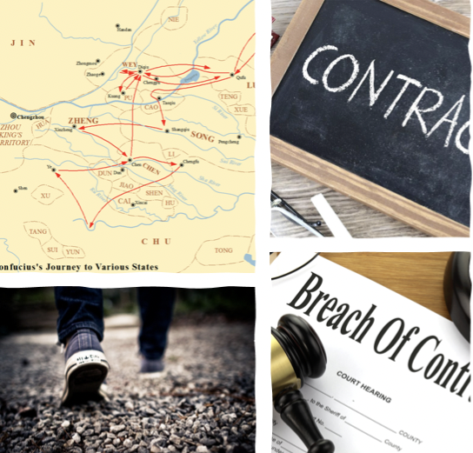

What parts of education in your experience are a contract?​ Rules and conditions, enforcement, compliance, binding, rigid, one-size-fits-all, expectations of perfectionism
What parts of education in your experience are a journey?​ Effort and process, exploratory, emergent, co-creation and dialogic, flexible, open, seeking excellence.

POLICY – RULES – CONTRACT. These are common metaphors used in thinking and talking about courses, syllabi, and teaching. Consider what unconscious assumptions these contain.
- A transactional relationship – very much in the mode of transmission-based teaching.
- A power dynamic of compliance. Students must play by the rules or face penalties.
A contract or rules are designed with a singular idea of what is a “good” student. This works against a diversity of learners. Those who do not fit the constraints of the rules are designated as less compliant and hence not a “good” student. Policies, rules, and contracts focus us on controlling management.

ROADMAP - GUIDELINES – EXPECTATIONS. This moves away from the compliance-based approach toward a facilitation and empowerment approach.
- A community-focused relationship. Guidelines are helpful shared criteria that signal a culture of care toward excellence.
- Guidelines are designed with a diversity of learners in mind. There is no judgment implied of who is a “good” or “bad” student. Guidelines are written with broad boundaries that allow different situations and needs to be met while keeping students engaged toward success.
- A co-creative dynamic of flexibility and communication that helps each student get to the outcomes optimally. The teacher establishes flexible parameters for working.
- Roadmaps, guidelines, and expectations focus us on co-creative leadership rather than classroom management through compliance. .

This is not to say that rules are unimportant.
Rather, think of “rules” as guiding structures that help students self-manage and work effectively. To create this, we begin with intentional design focused on learning and the learner. Using design thinking we acknowledge and embrace diversity starting with considerations of identities and contexts. We ideate to create inclusive, equitable guidelines that are flexible in order to support a wide range of learners. Within these flexible parameters, we have strong expectations and clear boundaries for growth and excellence. Flexibility in guidance is not mutually exclusive to excellence in work and development; it facilitates it. The ultimate goal is to support rather than block learning excellence and growth.
Fostering community and mattering is supporting learning success. Learning depends on both cognitive and social-emotional focus. Punitive anxiety blocks or reduces learning capacity. Students need social and emotional connection to the learning process so that they can engage without being overwhelmed or distracted by feeling marginalized or disconnected. Belonging and mattering helps learners feel supported by the teacher and by a community of peers.

TASK WATCH: What I wish my professors knew. [7:25 mins]
This video by the Stanford Diversity and First-Generation office features students talking about experiences that made them feel they did not belong, and their ideas for professors to help students feel seen and that they matter.


Ubuntu as Community
Read a short description of the Ubuntu philosophy. “I am because we all are” – that sees multiplicity as the defining essence of our existence.
The term comes from the Nguni phrase umuntu ngumuntu ngabantu, which translates as, "a person is a person through other people", although there are many versions of this in different African languages. The term “ubuntu” was used by Archbishop Desmond Tutu and by Nelson Mandela to try and express the shared humanity across differences.

In Chapter 4, you read about reframing difference as connections to a common humanity. The systems characteristic of interconnectivity, where the whole is greater than the sum of its parts apply in understanding the importance of community and a sense of mattering and connection with each other. Here are the ideas we looked at – consider them now in the context of community and Ubuntu.
Image Source

- Mitakuye oyasin - (we are all related or "all my relations") is a Lakota phrase that captures an essence of tribal education, reflecting the understanding that our lives are truly and profoundly connected to other people and the physical world.
- Interbeing - Thich Nhat Hanh - “to be is misleading, because we cannot be by ourselves alone. ‘To be’ is always to ‘inter-be’”, a new verb form that better captures the sense of integral interconnectedness. The English Language does not actually have a verb that captures this meaning, hence the coining of this new verb. https://www.garrisoninstitute.org/blog/insight-of-interbeing/
- No man is an island… Any man`s death diminishes me, because I am involved in mankind. This sermon by 17th century poet John Donne expresses the Interconnectedness of all people and the idea the seeming autonomy of the individual is an illusion because we emerge out of our histories and experiences and in turn respond to what impinges on us. Meditation XVII. 1624

TASK. READ this article on pedagogies of mattering.
Gravett, K., Taylor, C. A., & Fairchild, N. (2021). Pedagogies of mattering: Re-conceptualising relational pedagogies in higher education. Teaching in Higher Education, 0(0), 1–16.

Transforming policies for mattering and belonging

Building a sense of community – belonging and mattering - in classrooms begins even before we meet our students, in the undramatic, seemingly prosaic space of our course syllabus. And yet, the principles of our “course policies” and the tone in which we present them communicates loudly how we envision and facilitate our classes. Drawing from the metaphor above, moving from “contract” to “journey”, how might we transform course policies into success guidelines?

The purpose of classroom or course guidelines and expectations. Policies are often taken for granted, sometimes part of the “boilerplate” template of a syllabus that is accepted as the status quo (Clear and Complicated domain thinking). In calling legacy teaching practices to account from an inclusive, equity-minded lens, we begin by asking the question of purpose. Why do we have classroom policies?
- Clarity. Explicit and transparent information that helps students manage their learning.
- Optimizing Teaching. Policies that help teachers to be effective in ensuring student success.
- Optimizing Learning. Policies that support inclusive and equitable learning for ALL learners.

Transforming course policies from compliance to inclusive, equity-minded learning support
Apply Design Thinking – Empathize and Define. What diversities of identity and lived experiences will impact your course design? What are the limitations your students might be facing? Do your policies work for a diverse group, which includes:
- Shy or introverted students
- Socially awkward students
- LGBTQ students
- Students facing stereotype-threat
- Students who are the minority in your class
- Students from different cultures including international students
- Working students
- Students with caregiving responsibilities
- Older students
- Neuro-divergent students
- Students with accommodations.
- Students with needs and disabilities who are not able to get accommodations
Who else might we add to this list?
We hurt the heart of learning when we grade behaviors by assigning points to things like attendance, participation, technology use etc. Grading (which we cover in a later chapter) is a formative process to support knowledge construction and skills development. Grading class behaviors blurs the definition of assessment while creating punitive settings that negatively impact learning.
Oppressive policies signal that only one type of perfect student matters, an idea that comes from assumptions of homogeneity in students. They ignore important realities: working, older, caregivers, language learners, neurodivergent and differently abled learners, international, students of color, gender and LGBTQ identities. While we cannot be all things to all individuals, we can begin with broader, more flexible guidelines for success. These speak to awareness of lived experiences and contexts of being a student and a willingness to work with where they are.

TRANSFORMATION TASK: Explore and transform course policies into guidelines for success.
Below are some course policies taken from different syllabi.
- Apply the metaphors of contract and journey. Do you see legacy education practices of the contract metaphor in the policies? Can you identify Clear and Complicated domain thinking?
- What assumptions are being made about students, learning, and classroom conduct?
- What types of students might experience the policies as barriers to success? ​​
- How might we adjust the policies to remove barriers and include all learners to support learning with care and meaningfulness?​​

Technology Policies – each one is from a different syllabus:
- As we will discuss in class, we are working to create a lively intellectual experience. Unfortunately, cell phones, texting, email, and other social media are a powerful form of distraction. The class is only 50 minutes in length. For a series of complex reasons, the class policy is for students to not use laptops in class. Doodling, daydreaming, and even occasional dozing, however, have historically been part of the university experience; this class will not be an exception to that pattern. There is not a problem with bringing in food or drink.​
- CELL PHONE USE AND TEXTING ARE NOT ALLOWED IN CLASS. Either one will count as an absence.​
- Electronic Devices: Cell phones, laptops, I-Pads, Kindles, and other electronic devices must be turned off and put away during class. Anyone who is observed text messaging or using an electronic device during class will be asked to drop the course.​

Who are you excluding and what do you prevent in learning if you do not allow use of digital devices? Consider students with disabilities (who might be spotlighted if they have accommodation to use a digital device while others are not allowed), or language learners who need some translation and look-up help. Also consider that students might want to look things up as they engage in class. Instead of an outright ban, what guidelines for digital device use will support appropriate ways to use digital devices?

Late Work Policies – each one is from a different syllabus:
- Assignments are expected to be completed by due date. Assignments submitted after the due date will not be accepted.​
- For every day the assignment is late after due date, 25% of the maximum will be deducted from the assignment score. No assignments will be accepted once they are three or more days late.​
- The penalty for late homework is substantial: 10 points/day. A late assignment runs the risk of receiving little credit. Penalties may be waived if you have a good reason -- talk to the Professor, before the assignment is due if possible.​

Participation Policies – each one is from a different syllabus:
- This is a class for talkers, so come expecting to participate actively in all discussions.​
- Class presence and participation points are given to encourage your active class participation and discussion. You will be rewarded with a perfect score as long as you frequently come to class and actively contribute to the class discussion during recitations and lectures.
- Participation in weekly discussions will be graded on the following scale:​
- Unexcused absence = 0 points​
- In class, but asleep or obsessed w/laptop = 1 point​
- In class, but silent or ill-prepared = 2 points​
- In class and making an okay contribution = 3 points​
- In class and making quality contributions = 4 points​
- In class, but your cell phone rings = -5 points​
Who do we exclude with a narrowly defined participation policy? Consider how you define “participation” and what you’re actually measuring. Is it fair to limit participation to spoken responses? Can you instead gauge participation in multiple forms and modalities – writing, engaging in collaborative work, submitting class notes, asynchronous work in the LMS etc.?
Participation grades are an external regulation of behavior that can be punitive for many students. Also consider the idea that if the teacher’s role is to engage all learners inclusively and actively, then participation should be designed into the process. How can we write engagement guidelines as an invitation to engage rather than a set of penalties that do not work for many students?

Here are some other legacy policies to think about transforming:
Attendance Policy
Who are you excluding with a strict attendance policy? Consider that some students cannot afford doctor’s visits for a doctor’s note and that there are many life situations beyond ill-health that cause students to miss class. For example, care-giving emergencies and obligations, or work-related issues. Sometimes, students with the deepest motivations and intentions to persist through college while working or being parents are the hardest hit with life events. First check your own teaching design - while missing class affects learning, have you created pathways to catch up on what was missed (e.g., buddy groups, recorded lectures, submitting notes from catching up etc.)? How can you create attendance guidelines that explains the importance of coming to class and what students should do if they miss a class to ensure that they are keeping up and learning? Our goal should not be to control their attendance, but to optimize and support their learning.

Academic Integrity Policy
In promoting academic integrity, policies traditionally are worded punitively in only highlighting punishment. Who are we excluding in this approach? Consider students who are inherently honest, but have missed appropriate prior knowledge, experience, and skills to integrate sources effectively, or who do not quite understand the technicalities of plagiarism. How might we add guidelines to an official Academic Integrity Policy that begins by trusting students, and that acknowledges and respects their intention to be honest and invites them to learn how to effectively engage in academic writing and practice. Providing links to resources that can help them learn, for example library and other online resources is as important as providing links to the official institutional policy.

TASK: ANALYSE A SYLLABUS.
Find a syllabus in your discipline. This can be one of your courses if you are teaching. Or it could be a course you’ve taken as a student. Or a course in your discipline you found on the internet.
Examine the policies and annotate how they block learning and how you might adjust them to support learning and build a sense of connection and mattering.
Beyond course policies, what other aspects of a syllabus might create – or break – a sense of connection, belonging, and mattering? What would help students feel they are welcome, that they matter, and that you are inviting them into a supportive learning space?
Make a list of strategies that would transform a syllabus into an inviting and community building tool.

PAUSE TO REFLECT: Applying ideas to teaching and learning
Based on your understanding of community as a sense of belonging and mattering, reflect on how you might create a sense of community in your course design and teaching. Also bring back to mind the learning and motivation theories and pedagogies you have explored.
- How is community created in the language you use to write your syllabus?
- How can course expectations and policies be designed to help students feel they matter and have a nurturing space to bring their whole selves into learning?
- What assessment and assignment practices would help students feel included in a safe and brave space for learning and growing?
- What strategies would create a classroom environment where all voices were welcome and there is a sense of reciprocal respect and trust?
- What can you do as an educator to help students connect with the larger community of the campus and to build bridges with them to the resources and opportunities that are often invisible to them?

TASK: Connect with your Diversity Statement Worksheet
This chapter on community, belonging, and mattering connect closely with the following questions on your Diversity Statement worksheet.
DVS Q2. How do I practice justice in education in my approach to designing curricula, learning environments, and processes in teaching my discipline? What are my guiding values and principles? What specific strategies do I use to ensure all voices are invited, honored, and supported in my curricula materials and class engagement?
DVS Q3. How do I engage with DEI work beyond the classroom at the campus level? How do I engage formally and informally with campus resources and initiatives that support DEI? In what ways am I an ally to students and an advocate for greater inclusion and equity on campus?

Resource: Fostering community in classroom facilitation
These strategies work for on-ground as well as online classrooms. Building community takes time and work. Icebreakers only on the first day won’t do it. Make time and space for students' voices. Formal classrooms don’t lend themselves naturally to organic conversations (this is amplified in online classes). Therefore, structure the process; once it gets going, it can be student led.
- Pre-class presence. In live sessions (online and physical classrooms), arrive a little early so students who are early can chat with you or each other. To help those who are shy, scaffold this time with a while-you-wait activity - a poll or puzzle, a chat prompt for personal stories, a drawing prompt (share later by holding up to camera).
- Post-class time. Many students will want to leave a class immediately when it ends. But some might want to hang out and ask questions or chat. Staying 15 minutes after class supports this. Sometimes no one will stay but hold the space as a caring move.
- Community Announcements. A weekly announcement helps students stay connected and on track. Your announcement can be an overview of the week’s work, a recap of class, events and opportunities on campus and beyond, news about students that they are happy to share with peers etc.
- Sharing Life Events. Make time at the start of class and invite students to share happenings in their life. This builds peer connection signals that ALL of who they are matters. Encourage this by sharing first yourself so that students see you as more than just “instructor”.
- Creative multimodal experiences. Connections happen around shared creative experiences.
  - A class portraits page. Students add a photo of themselves, an image or drawing that represents them and share something about themselves. Have them revisit the page from time to time to add to their “portraits” and leave comments for each other.
  - Create a class music playlist and have it playing as students enter. Co-create this with students - ask them what they would add to it. They might find peers with similar music tastes or learn about new music and artists from each other.
  - Bring in art images you like - invite students to share what they like, or their own work. Help them think of art as creative expression rather than art with a capital A.
  - Film - ask students to share a movie they like. Do the same yourself. This can spark conversations about common interests and help create connections.
- Pause for personal connection. During teaching, structure time to pause for reflection in how something connects personally with students. Finding and sharing meaningful connections builds a sense of a shared experience in the social-emotional space rather than only in the cognitive space of subject matter.
- Explicit caring about learning. During teaching, check in on learning. Is this challenging, are your brains exploding with excitement? How new is this idea to you? Giving students time and space to think of HOW they are learning helps create connections of shared experience with each other (I thought I was the only one who thought it was odd, I had the same idea!)

Resource: Mattering Through Co-Creation
We feel we matter and belong when we are part of the process in ways that engage our ideas and voices. Create some of the learning process WITH your students. Giving students autonomy, choice, and opportunity to take charge of something in pairs and small groups fosters connection, ownership, and intrinsic motivation which build mattering and community.
- Class created quizzes. Students collaborate in small groups to come up with quiz questions on topics they are learning as well as the correct answer. Use their questions in your quizzes. Creating quiz questions also doubles as review of material.
- Student choice creative assignments. Give students creative options for doing an assignment, for example: write and perform a song or rap, make a short video, write something in different roles, make a piece of art, build a model etc. Students collaborate in groups to choose and build their creative response.
- Create rubrics with students. For selected assignments, have a class meeting, go over the assignment and ask for feedback on criteria for assessing the assignment. This both builds metacognition as well as gets students collaborating with each other and with you to work out an aspect of their learning journey. It also readies them to excel in the assignment.
- Collaborative resource sharing. Set up an editable page and ask students to add things connected to something you are teaching - websites, videos, blogs, images = with a 1-2 sentence explanation of why it’s awesome. Make sure to bring this into either a live class session to review and celebrate with students, or to send an announcement so students will feel recognized, and peers can see their contributions.
- Shared class reflection blog. Or use something like Padlet or Flipgrid. Or just a Google page. Introduce reflection by asking students to do micro-reflection work: What’s one class thing that you’re enjoying this week and why? How do challenges in class and in life make you feel? What are your assets as a student and human being ... what’s your secret power? They do not have to write a lot - the goal is to share something of themselves with their peers. Model this. To build a community, be part of it. Share your reflections too in the reflection space.

Chapter 10: Transformation 4. Assessments at the Heart of Learning

This chapter focuses on the very heart of learning – assessment. Without assessment, we do not know if we are learning, making progress, or growing. And yet, assessment – and the assignments that come along with it – have become anxiety and fear inducing so that they hurt the heart of learning.
This chapter examines why this is so and reframes assessment goals and methods as formative processes that support learning. Learning is also reframed as a creative adaptive process that is emergent, time-bound, and iterative and therefore in need of a formative process to make learning and growth visible as it happens.

You will explore the following areas about assessments
Foundations:
- Learning as a creative adaptive process.
- Examining what “assessment” really means and our conditioned responses to it.
- Assessment as a process to make learning visible.

Formative Approaches:
- Reframing learning as productive struggle.
- Formative processes as productive struggle.
- Positive, inclusive rigor and learning sciences.
- Designing assessments and assignments.

Review: Learning and Assessment as a Creative Adaptive Process

Learning and assessment are a creative (complex) adaptive process over time. We engage with information, connecting that with prior knowledge, experiences, and questions to build knowledge. Or we practice skills, stopping to adjust and modify as we gain mastery. Assessment is part of this adaptive, emergent, and formative process because if we persist and have feedback, we do come to know and do. In the Cynefin figure below, learning and assessment are located in the Complex domain.
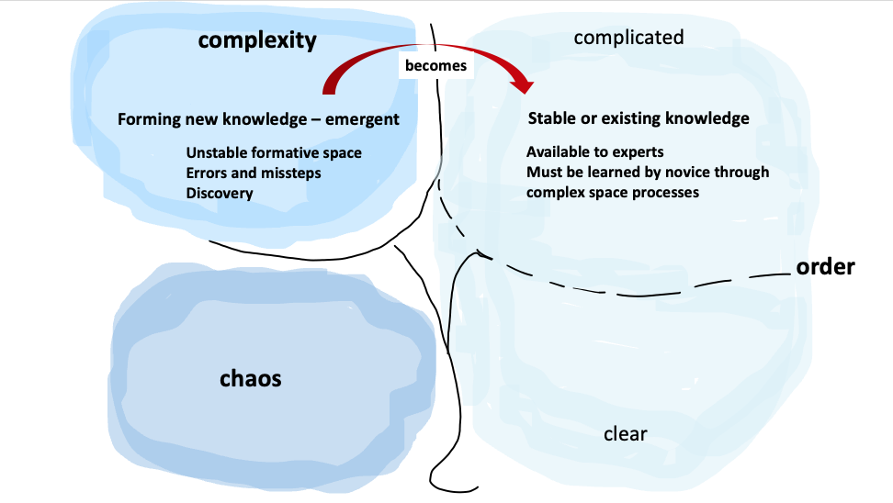
Image Source: Shamini Dias

Learning is iterative – we can repeat, expand, and modify to improve knowledge and skills.
Learning necessarily includes missteps and errors. Because learning is a process of entering the unknown – new knowledge and skills – we naturally will make errors and go down wrong paths. These are rich points of information or feedback that help us to modify, adapt, sharpen, and improve work.
Learning is naturally dissonant. When we learn something new, we are in a cognitive-affective space where things are not known, not mastered (yet). Learning is transitioning from knowing something (my stable state of prior knowledge), to not knowing something (starting to learn), to an emergence of new knowing and skills development. This is naturally dissonant because we experience moments of not understanding, struggling with ideas, trying things out, making mistakes. We might experience contradictions with conflicting ideas and perspectives. Things seem paradoxical, “out of joint”.

The added dissonance of inequity. Many learners experience added dissonance beyond the natural dissonance of learning. This comes from intersections of inequitable and oppressive teaching design and from multiple social determinants of learning like work, life responsibilities, hardships etc. Together, they create marginalization, exclusion, and erasure of learners. More insidiously, they create self-judgment and a lowering of self-worth that significantly affects learning outcomes.
- For example, learning calculus, a new challenging subject creates dissonance. Productive struggle with support will help me stay engaged. But, if I am socially isolated, or feel I cannot ask questions, or make mistakes, or I am exhausted working 2 jobs, if the process is punitive and inflexible, these added factors increase dissonance and tip the balance into disengagement (I fall into Chaotic domain thinking). I am more likely to believe that people like me are not good at math, or that it’s no use trying, and give up.
Mastery moves knowledge into a stable space. As we master something, the knowledge we created is aligned to current paradigms of knowledge, i.e., stable knowledge. In Cynefin, new knowledge and innovations eventually become part of established knowledge in Complicated space. For example, the internet evolved as innovation in Complex space but now everyone uses it.
Creative thinking and innovation also happen in complex space thinking – where we form new knowledge because we see beyond or question the existing paradigm to expand or replace ideas. Creativity and innovation therefore – like learning – are emergent, turbulent, include missteps and error, and are iterative. Framed this way, we can think of learning as a creative, adaptive process.

Examining the Foundations of “Assessment”

What Does “Assessment” Really Mean?
Think about the word “assess” in the context of formal teaching and learning - what other words and images come to mind? What has been your lived experience with this word?

Unpack the Opaque Idea – ASSESS. “Assess” comes from Latin Assessus - “sitting by” or “sitting beside” - to assist in the office of a judge. Originally, this role was for estimating the amount of a tax. The word "assess" simply means to gauge something (how far we've travelled, if something is sufficiently cooked). Feedback is simple action and response (we touch something and feel how hot or cold it is, the faces of an audience as we are speaking tell us if we are sufficiently audible etc.).
In education, assessment is at the very heart of learning (we only know we are learning if we can gauge progress). But for many of us, schooling has hurt the heart of learning. Assessments occupy a negative cognitive-emotional space. We fear them – they signal being judged, being inadequate, not smart enough. For many learners, assessment is anxiety-filled, oppressive, counter to well-being, something to avoid, if possible, to be survived if not avoidable. Assessment done badly dampens the drive to learn.

A natural drive to learn. However, we did not begin life this way. We are all born with a drive to learn and a natural inclination for assessing learning, simply to know – we did it!
Think about young children in your life – and your own childhood. Children begin with curiosity to explore and discover. Especially before formal schooling, assessment is natural and joyful; it’s discovery of whether or not something is happening or possible as we try things out. Think of babies learning to crawl or stand; toddlers exploring books, learning to talk, draw, write; figuring out how a toy works; learning to ride a bicycle or skateboard etc. When we engaged in all this pretty intense learning, we sought assessment in feedback. We did not feel so anxious about taking a learning risk, failing, and falling. In fact, it might have been quite exciting and revealing! Why is this instinct to learn and get feedback so powerful? One reason is that the human brain is the only organ still unfinished at birth. Brain development depends on interaction with our environments; we are thus integrally interconnected with our world. In addition to our genetic code that determines many things about us, our neurobiological interactions with the world shape the languages we speak and think with, the social mores, assumptions, values, and beliefs that we embody.

A sense of play. Our drive to explore and discover overcomes falling and making mistakes - especially in play. When children play, we often hear the refrain of “Again! Again!” (in serious parlance – iterative learning through feedback!). Play based learning research points to the significant role that playing has in human development. There is also some research on play in adult learning and encouragement to bring playfulness into college teaching.
TASK: READ a summary article about the value of play for learning.
Read this article by Gillian Judson, a researcher who focuses on imagination and creativity. She sums up key themes in Stuart Brown’s (2009) book Play: how it shapes the brain, opens the imagination, and invigorates the soul.
What connections do you see to learning as a complex and emergent adaptive process? How can incorporating the elements of play address some of the learned fears and mindsets learners have about assessment?
Children around the world are very good at the following capacities they develop through play:
- Asking questions … the endless “Why?” “what if”, “how” ...
- Non-linear, divergent, philosophical thinking.
- Risk-taking – exploring, being curious.
- Imaginative thinking – what ifs, maybe, exploring possibilities and impossibilities.
- Observing – noticing, giving attention to something, looking behind and beyond
- Persisting and struggling to get something.
- Rising skills – falling and getting up both physically and in other ways.
- Embodied learning – engaging with their minds, bodies, all their senses, emotions.
- Seeking and using feedback – they want to know if they’re ok.
These are all powerful skills for adaptivity, learning how to learn, creation and innovation, and working well with others, and especially important in a VUCA world (Volatile, Uncertain, Complex, and Ambiguous). Leaders, skilled professionals, and scholars apply these skills a lot! These are the skills we seek to foster in all learners to prepare them for the future.

Assessment becoming negative. Some legacy schooling practices dampen this, transforming learning, assessment, and feedback into negative judgments and rankings in a binary “good-not good” determination. This shifts many learners into a mindset and emotional space of anxiety and perfectionism about assessments, grades, and feedback.
This learned response suppresses (or erases) our natural drive to learn. Learning becomes transactional with the focus on points and grades rather than on actual achievement of knowledge and skills. How often have we “learned for the test” and promptly forgotten what we learned right after?
More insidious is the development of negative narratives such as:
- Assessments are a judgment of how smart a person is (and I’m not smart)
- Assessments are filters that select the best students to enter the next level (I won’t make it)
- Not everyone is smart enough for the rigor of this discipline. (I’m not cut out for this subject)
Stereotype threat, “a type of social identity threat that occurs when one fears being judged in terms of a group-based stereotype” (Murphy, Steel, & Gross, 2011; p. 829), exacerbates this, especially for non-majority students, such as women in STEM, students of color across all subjects, students with disabilities etc. for whom assessments have the added dissonance of judgment based on their identities.

PAUSE TO REFLECT: Lessons from children on learning mindsets.
- Which of the qualities above from children’s sense of play do we want to foster in college students, working adults, and community members? Why? Beyond succeeding in academic work, what are some other reasons for fostering these qualities?
- How and why are these qualities suppressed or erased by schooling and other social conditioning factors?
- Think about how your discipline traditionally assesses learning. How do these approaches prevent some learners from developing these qualities? Are these flourishing and learning drives dampened more in some populations or types of learners than others – why and how?

TASK. A Drawing Reflection – Recollections of Assessment
In this task, you will make 2 drawings – each one a visual representation of your response to assessment in different contexts.
- Assessment outside of formal schooling. Think of informal, non-schooling contexts, at any age, where you learned something. How did “assessment” and “feedback” (by someone else or by you in self-assessing) feel in this process? Write a list of words/phrases that describe how you felt.
- Assessment within formal schooling. Think of formal schooling contexts at any age. How did “assessment” and “feedback” (by someone else or yourself) feel as you learned something? Write a list of words/phrases that describe how you felt.
Stick figures are welcome. Your drawings can also be abstract representations of how you felt. Add your images to your Journal.

Our Conditioned Responses to Assessment
The drawing task might have revealed some of your embodied and conditioned responses to “assessment” depending on whether your experiences were generally positive (empowering, joyful, engaging, fun, deep learning, meaningfulness) or negative (stressful, inducing fear, guilt, self-doubt, imposter syndrome). Was there a pattern you noticed between school- and outside-school assessment?

Here are some common associations with the word “assessment”. Which are positive and which are negative? (Careful …. Some are tricky!). What other associations would you add?
- Actions: compete, evaluate, gauge, judge, measure, observe, rank
- Forms of Assessment: conversations, drafts, exam, final papers, observation of activities, presentations, performance evaluation, rehearsals, quiz
- Measures and Indicators: criteria, checklists, grades, GPA, points, rubrics
- Processes: compete, peer-review, submit for judging
- Emotions: anticipation, anxiety, caring, curiosity, interest, negative stress, passion, trepidation,

On Rigor
“Culturally relevant teachers envision their students as being filled with possibilities. They imagine that somewhere in the classroom is the next Nobel laureate (a Toni Morrison), the next neurosurgeon (a Benjamin Carson), or the next pioneer for social justice (a Fannie Lou Hamer). The perspective moves the teachers from a position of sympathy (“you poor dear”) to one of informed empathy. This informed empathy requires the teacher to feel with the students rather than feel for them. Feeling with the students builds a sense of solidarity between the teacher and the students but does not excuse students from working hard in pursuit of excellence.” – Gloria Ladson-Billings. White Teachers/Diverse Classrooms 2006. p. 31

Rigor is an “opaque” word in education. In equating rigor with academic excellence and high standards, we can fall into the trap of locating it diametrically opposite to care and empathy (which some see as being “soft”). They seem to be mutually exclusive.
To clarify what “rigor” means, consider two types of achievement:
- EXCELLENCE IN ACADEMIC ACHIEVEMENTS. “Rigor” in teaching is often associated with upholding high standards of knowledge and skills – the excellence that students must achieve. These are the standards to which we hold students (and ourselves).
- EXCELLENCE IN ETHICAL PROCESS. This “rigor” is often forgotten but critically important. This is rigor in equity-minded thought and practice, in questioning assumptions of legacy education that block learning and learners, and rigor in creative reframing and design to remove barriers to access and learning. How intentionally do we seek out research and professional development to understand learning and socio-cultural contexts, to find ethically grounded methods to reach and support a diversity of learners?

In your experiences and observations of schooling, which of these two types of rigor are more common? Which one is less focused on? Why?

Does thinking of ethical rigor detract from academic rigor?
We are ethically responsible to uphold the standards. Lowering them does learners a disservice in not adequately preparing them for their next steps. It is also taking a deficit view of learners.
AND
We are ethically responsible to NOT impede learning through methods that seem rigorous but penalize learners for the circumstances of their identities and lives.

For example, do closed, timed exams in fact measure advantages and barriers to student learning? Do large summative and highly weighted assignments create high risks for some students more than others depending on life contexts? A student who worked hard through the semester might not do so well in the single opportunity of the final or large summative assignment for many contextual reasons. In a timed, closed book midterm, is one student’s A-grade a measure of being able to afford a tutor, have dedicated learning space and time, and does the other student’s C grade really a measure of their working 2 jobs or being a caregiver who could not get enough sleep the night before the exam? Do high-stakes, timed assessments oppress learners who experience anxiety because of high pressure to succeed, a learned fear of failure, stereotype threat, etc., that collectively lower confidence? Many assessment formats are inflexible and do not make space for variation in the interaction of students’ learning and life contexts. Assessments therefore are not accurate measures of learning but become yardsticks of privilege in learning.
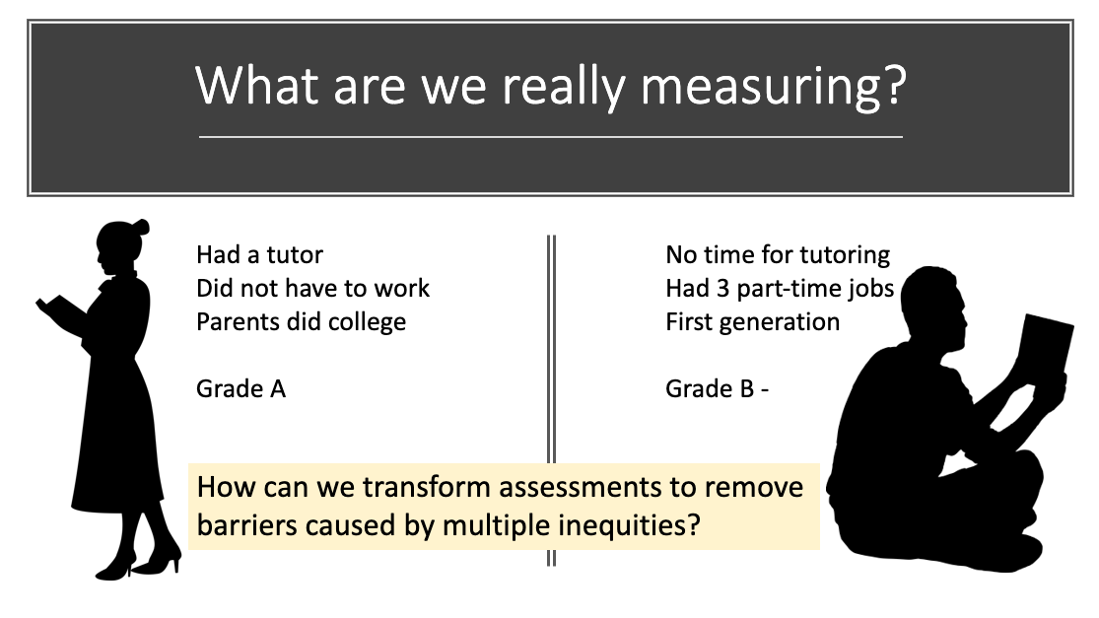
Image source: Shamini Dias

Sometimes, in the quest for "rigor" or excellence, we only think about the first type – academic knowledge and skills mastery. But we give less thought to the second kind of rigor - high standards of ethical process with evidence-based equity-minded teaching. But we can work to integrate the two, and in fact through rigor in equity-minded design and practice, we can support and expand academic rigor:

A metaphorical note: Rigor can also mean rigidity (as in the morbid rigor mortis!). Maybe a more useful metaphor for excellence is growing and plants – excellence as robust flourishing. In this plant metaphor, we can think about symbiosis – the mutual dependence for life sustainability between two species. In teaching, there is symbiosis between academic excellence and excellence in ethical process. Each supports the other. We use ethical thinking and strategies to support all learners in order that they will persist and push forward to grow and reach high standards of excellence.

TASK: WATCH 2 videos that speak to ethical rigor for inclusive excellence

Shelley Moore – Bowling metaphor for inclusive education. [3:08 mins] Teaching to the middle is not rigorous; teaching to be inclusive, aiming for students hardest to reach helps us reach them all. Rigor is being inclusive.

Todd Rose – TEDx – The Myth of Average [18:26 mins]
This presentation uses the analogy of fighter plane design based on Universal Design principles that include and make it possible for a very diverse group of pilots to all be effective. Rather than designing for the best (ignores needs and misalignments), the weakest (deficit views that also leave many out), or the average (meaningless one-size-fits-all that ends up not fitting many) - design with flexibility and choice in include everyone.
(Contributed by Amber Riehman, TNDY 430 Spring 2022)

Assessment as Visible Learning
Assessment is about making learning and learning processes visible.
“Recognizing when learning is taking place and making this visible is another of the foundations on which inclusive practice is built.” – Project Zero. Harvard University

We know we have learned something if we can use it, articulate it, or repeat it.
“It is critical that the teaching and the learning are visible. There is no deep secret called “teaching and learning”: teaching and learning are visible in the classrooms of successful teachers and students, teaching and learning are visible in the passion displayed by the teacher and learner when successful learning and teaching occurs, and teaching and learning requires much skill by both teacher and student. The teacher must know when learning is correct and incorrect; learn when to experiment and learn from the experience; learn to monitor, to see and give feedback, and know to try alternative learning strategies with others do not work. … The more the student becomes the teacher, and the more the teacher becomes the learner, then the more successful are the outcomes. This explanation of visible teaching relates to teachers as activators, as deliberate change-agents, and as directors of learning.” – John Hattie. Visible Learning, 2009. p.25.

Notice in this description of learning made visible, there is a creative adaptive process at play with experiment, experience, monitor, feedback, alternative strategies, failure or unpredictability. Assessment is not a singular linear process. Instead, assessment is part of a complex system of learning – the dynamic interactions of teachers, learners, work processes, guidelines, instructions, feedback, revision, and growth.

In light of the above, think how we can reframe the idea of “assessment”? Here is a typical metaphor for assessment as measurement. What are alternative metaphors that present assessment as making visible learning that is emergent and complex?

Image source

In these images, consider what is being assessed, who is doing the assessing, and how the learning is made visible.


Image source

Gardening – planting something small (seeds of learning) and then tending it as it grows. What is the nature of the relationship between work - assessment – feedback – and growth? Are both teacher and learner involved in assessing and responding to keep the learning growing? In what ways is learning made visible? How does this metaphor reflect learning as an emergent, adaptive process?

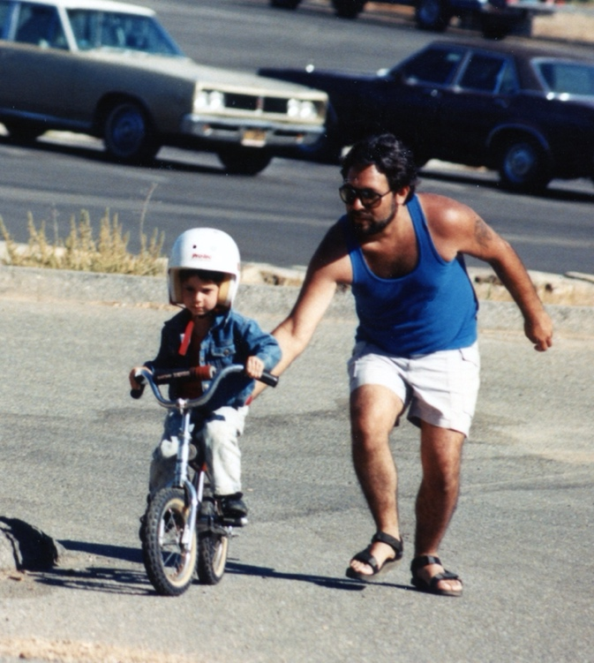
Learning to ride a bicycle.
Becoming familiar, finding balance, moving from wobbly and falling to steady riding. What is the nature of the relationship between the work-assessment-feedback-and growth? How is the learner involved in assessment that helps them to adjust and keep developing balance and dexterity? How is learning made visible? How does this metaphor reflect learning as an emergent, adaptive process?

Image Source

Reframing Learning: Productive Struggle
Struggle means to make visible effort to be free of restraints or limitations. This process takes on different coloring in learning:

Here are some common associations with pain and struggle. Which ones do you seem to embody?
- No pain, no gain. Tough love. [struggle is part of growth and achievement]
- It sorts or weeds out those who cannot do it. [struggle is how we sort out fit from unfit]
- It feels really bad and hurtful and we must avoid it [struggle is bad –hence no struggle is good]
- If I am struggling or failing, I clearly do not have the ability. [struggle = inherent inability]
Struggle = anxiety. Schooling unfortunately teaches many of us to dislike and avoid struggle. Tasks become measures and judgements of how clever and capable one is. Struggle becomes an indication we are not smart or good enough and we learn quickly to judge ourselves negatively when struggle appears. Struggle becomes a signal that failure might be around the corner, and that we’re probably not smart enough. And so, we eschew struggle, giving it up to avoid persisting through challenges.

Is there such a thing as positive stress and positive struggle? – YES
Think about times where you successfully learned something hard – but that was meaningful to you and hence you really wanted to learn it. This might have been large organic things like learning to be a good parent, learning to be a supportive partner in a relationship; or more focused specific things like learning to play a game or engage in a craft or a sport. You might have experienced some or all of the following:
- Effort. You worked hard and gave it your all.
- Struggle. You pushed against challenges, doubts, and limitations, external and internal.
- Barriers. You encountered all manner of setbacks.
- Failure. You made mistakes and fell down multiple times.
- Feedback. You got feedback that might have been painful to hear.
- Pain. You felt frustrated, things seemed impossible, you cried and wanted to give up.

Struggle as growth. Struggle can be a positive process: Crossing a threshold, stretching beyond current capacity to reach new levels, making effort, and focusing on moving beyond current capacity, restraints or limitations. Difficulty and challenge are inherent and natural to the process; struggle involves falling and failing. We often see young children relish struggle, laughing in delight as they try, and things go awry. They want to “do it again” until they reach the delight of doing it well. And then … on to a new struggle. If struggle led to really good outcomes – you felt yourself to have grown, to have reached a higher level of understanding or ability - you might also have experienced some or all of the following:
- Meaning. You kept at it because it felt meaningful to do so.
- Mattering and Purpose. You knew why you were doing it – there was purpose either inherent in the thing you were struggling to learn or some larger purpose or person that mattered to you.
- Connection and Community. You knew you were not the only one going through this – there was a sense of community and belonging in the process.
- Support and Scaffolding. You had the support of others – either going through the same process and/or those helping you through the process.
- Formative feedback. You got feedback that you could use and concrete directions for growth.
- Joy. You felt energized, deeply satisfied, and worthy through and/or at the end of the process.
Struggle = Indicator of Growth in Process

“Productive struggle is a state of engagement that enables students to work through increasingly challenging problems and new problems they have never seen before.” Mind Research Institute – ST Math

We don’t need students to calculate quickly in math. We need students who can ask good questions, map out pathways, reason about complex solutions, set up models, and communicate in different forms.” – Boaler, 2015

The concept of “productive struggle” comes from research in Mathematics education (Baker et al., 2020; Murdoch, English, Hintz, & Tyson, 2020). While this research has extensively focused on middle and high-school mathematics, productive struggle applies to all learning given the fundamental nature of learning as an emergent process that includes uncertainty and not knowing. Productive struggle reframes “struggle” as a positive indicator that a learner is stretching beyond what they know and reaching toward achieving something new; it is a signal that learning and growth are happening.

- Productive struggle explicitly recognizes the concept of STRUGGLE and that it has cognitive, social-emotional, and physical manifestations for learners. It especially recognizes and addresses the perspective many learners have as a result of their educational and social conditioning that “struggle” is a negatively loaded word.
- A productive struggle approach surfaces, makes explicit, and transforms struggle into a positive process, hence the qualifier “productive”. Productive” reframes the nature of struggle as a positive process that with support yields growth and achievement.
- Productive struggle is grounded in multiple learning and motivation theories:
  - Growth mindset – self-theories of a malleable expansive ability – that responds to error and feedback as positive opportunities to learn.
  - Vygotsky’s Zone of Proximal Development (ZPD) that optimizes learning as a between challenge and ability.
  - Positive emotions and self-regulation as part of reframing approaches to uncertainty, errors, and feedback. Models such as PERMA and Social-Emotional learning are useful guides in designing to integrate productive struggle.
- Productive struggle shifts teacher and learner attitudes to seeing struggle as a positive, growth-oriented indicator rather than a signal of lack of capacity and failure. If learners – and teachers - can embrace productive struggle, they are less likely to be limited by a fixed sense of their abilities and to persist in a task.
- In engaging productive struggle, teachers become “warm demanders” who create a sense of community and caring, hold high standards and expectations for students, and use intentional scaffolding and formative learning processes and feedback.

Warm demanders "expect a great deal of their students, convince them of their own brilliance, and help them to reach their potential in a disciplined and structured environment – Lisa Delpit, Multiplication is for White People: Raising Expectations for Other People’s Children. 2013 p.77).

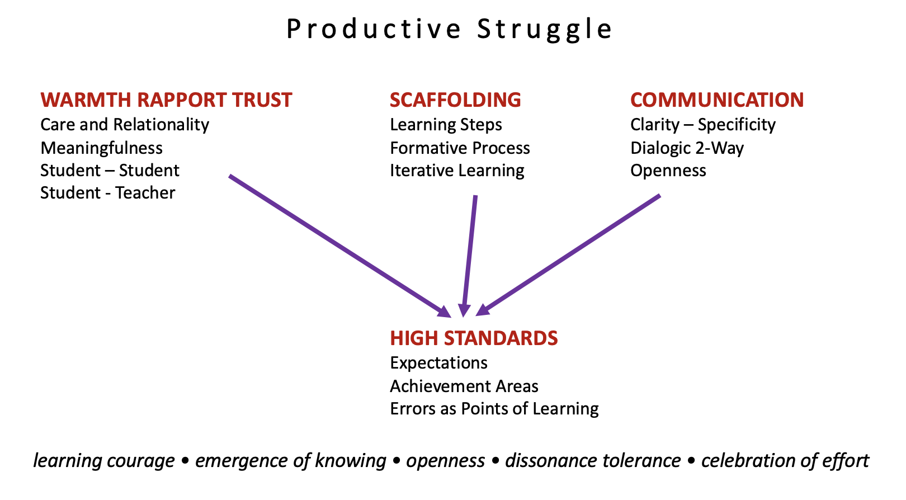
Image Source: Shamini Dias

Key Elements of Inclusive Productive Struggle and Warm Demander Approach
Productive struggle intentionally reframes mindsets to normalize errors as a natural part of inclusive, equity-minded learning and foster positive learning identities.
- Clear and meaningful goals. Learners should know specifically what they are trying to achieve (learning destinations) and see these goals as relevant and meaningful to them.
- Asset based perspective. We assume that all learners can develop excellence.
- Learning how to learn – Learning independence. Formative processes build learner self-awareness, metacognition, and learning how to learn skills that foster positive and internal self-regulation and autonomy, greater self-efficacy, and a more intrinsic interest in the subject.
- Scaffolding supports learning. We balance levels of ability and challenge (Vygotsky’s ZPD) through constructive feedback.
- Community of learners. We build opportunities for autonomy, choice, and peer collaboration to solve problems.
- Safe-Fail learning. Rather than expectations of perfection that judge errors as indicators of inability, we normalize errors as part of learning.
  - Low points or ungraded drafts and practice, opportunities for multiple attempts.
  - Feedback is formative - provides direction for continuing and improving the work with time for revision and development.
  - Remove high stakes assignments by using an even distribution of points.
  - Explicit communication that mistakes are part of the process and points of useful information rather than indicators of ability.

Mini-Case: Math Education. Countering Deficit Perspectives
Research in math education shows the impact of stereotype threat resulting from social narratives about women and people of color not being “good with numbers”, as well as from existing cultures in math and engineering disciplines that exclude women and people of color. Research has shown that math achievement, persistence, and engagement in math-based careers are more about stereotyping environments/cultures and educational inequities than inherent ability (Baker et al., 2020; Charlesworth & Banaji, 2019; Heyback & Pickup, 2017; Murdoch, English, Hintz, & Tyson, 2020). This applies to other disciplines – such as art, music, history, statistics etc. where a deficit view exists often on gender and racial lines as to aptitudes and abilities to succeed. Additionally, there is a social narrative stemming from a popular neuromyth about “aptitude” - that some people just do not have an aptitude for math. “Math people” are more left-brained and logical while “artists and creative types” are more right-brained, messy, divergent thinkers who are not logical. This is untrue – while there are 2 brain hemispheres and parts of the brain associated with different neurological functions, this binary division is patently wrong. Thinking – logically and creatively – is a whole brain activity. Both math and art demand creative, visualization, and algorithmic processing.
Educators could have 2 responses:
- Assumption: Not everyone can learn math. Struggling is a sign that indicates this. Action: I will not lower standards. So, if they fail, that’s just a sign they are not good at math. We leave them behind. Deficit view, assumptions of aptitude and stereotypes. Unbalanced rigor.
- Assumption: Everyone can learn. Some students. struggle with mathematics for a whole host of reasons. Action: I will not lower the standards. But I can shift the process to ensure they engage effectively with support to learn. Positive capacity view, balanced rigor – warm demander.

PAUSE TO REFLECT
Think of your schooling experiences. Were there subjects where you experienced A or B assumptions and actions?
- As a learner, how did these different assumptions and actions shape your learner experiences and engagement with the subject?
- As an educator, do you find you have unexamined assumptions about learning and learners in your subject area (within yourself or in the manner in which your subject is generally taught) that you could review and revise? In moving toward a warm demander stance and reframing your assumptions what are moves could you and your colleagues use?

Formative Processes = Productive Struggle in Assessment
Consider the differences between assessment OF learning and assessment FOR learning. How does assessment for learning connect to working inclusively and removing learning barriers?
- Assessment OF Learning: This perspective sees assessment as something that comes after learning in an evaluative determination to measure and judge if learning has taken place.
- Assessment FOR Learning: This perspective sees assessment embedded in learning as part of a process that ensures learning happens.
While both are important, the latter – assessment for learning – still lags behind the former. Assessment for learning is formative assessment. It is at the heart of any learning process and can be designed as an intentional process to remove learning barriers and guide learning. Formative assessment reframes assessment as integral to learning. It is in fact where the learning is activated and stretched. Formative assessment enables us to engage learners in productive struggle, making learning visible so that we and our students can gauge progress – without judgment. Assessments as part of learning supports learners in making timely adjustments to deepen, correct, or stretch learning, to reframe assignments to align with students’ interests, and to help learners develop learning how to learn skills.
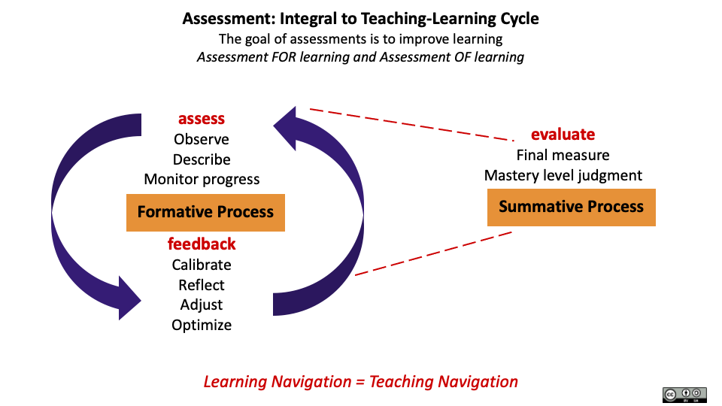
Image Source: Shamini Dias

Formative Assignments and Assessments | Summative Assignments and Assessments
Allows students to practice. Scaffolding breaks tasks into chunks that build knowledge and skills. | The level to which a student has mastered knowledge and skills at end of unit, course, degree. Judges and categorizes learners.
Involves feedback and revision or re-doing. Feedback can be from teachers, peers, or self-assessment and helps students reflect, calibrate, and adjust to optimize learning. | Feedback for final version does not usually lead to revision.
Not counted in final grade or has low weightage. | Counts in final grade. More highly weighted than formative work.
Supports metacognition of learning and development of learning how to learn skills

Integrating Formative Processes
Formative processes are any tasks that “form” or shape learning and create opportunities for:
- Feedback from teachers, peers, and self-assessment, with time and opportunity for revision.
- Practice before a graded attempt.
- Scaffolding or chunking into smaller elements that build knowledge and skills that students will then bring into a graded task.

Formative processes are SAFE, ITERATIVE, SCAFFOLDED, COLLABORATIVE
- SAFE: Formative assessments are low-stakes work - either ungraded or graded with low points. This makes them safe-fail processes which lower anxiety and encourages trying, taking learning risks, and engaging in productive struggle.
- ITERATIVE: Students have opportunities with feedback to revise, improve, and stretch. This makes them more willing to focus on effort to improve which in turn fosters a growth mindset.
  - Multiple sources of feedback. Feedback can be from teacher, peers, as well as self-assessment using a clear set of criteria in a rubric or checklist.
  - Time. Ensures students can use formative feedback to stretch and improve their work.
  - We normalize “errors” and “failing” as a natural and expected part of learning.
- SCAFFOLDED: Formative assessment is scaffolded by chunking large tasks into smaller steps with feedback.
  - This includes quick activities to gauge learning - check-ins, observations, peer-reviews, checklist rubrics – that support learners iteratively in achieving end goals.
  - Providing transparent rubrics with the assignment as a guiding tool helps students understand the assignment outcomes and plan their work to meet the requirements. More than just a grading tool, rubrics help develop metacognition of learning and learning confidence and autonomy.
- COLLABORATIVE: Formative learning is empowered in co-creative, dialogic exchange between teacher and learner, as well as between students. Apart from teacher feedback, formative assessment includes peer-review where learners use the rubric and guiding questions to give each other feedback. In fact, engaging in peer review helps students build metacognition of the assignment and subject matter and their own learning.
PAUSE TO REFLECT: Examine the impact of legacy assessments.
- To what extent have you experienced formative learning and assessment processes in your undergraduate experience? If you did, how did they work for you? If you did not experience formative learning and experience, think about how they might have helped you?
- Think of a course you teach or plan to teach. Do you need large summative high stakes assignments? Can you build a series of formative assignments allowing revision for improvement up to the end of the course?

RESOURCE: Categories of Formative Assessment
- QUIZZES & TESTS – open book, multiple attempt quizzes, low grade weightage with highest grade taken at the end, or not graded, Practice test with feedback before actual test. Practice quizzes and tests in take-home format – bring answers to class to check and discuss. Students creating test items to be used in final test – solo or in small groups - with correct responses as formative review and preparation. Groups quizzing each other on topics.
- PEER REVIEW: Guided peer review using a checklist or rubric in pairs or small groups, followed by class discussion. These guided reviews can be done in students’ own time asynchronously and then brought to class for discussion.
- SELF REVIEW. Students use a checklist to review and annotate work in a self-review to submit together with their first draft, or bring to class for discussion in pairs, small groups, or whole class format.
- TEACHER FEEDBACK: Summary feedback and action items in response to reading all or part of students’ work. This can be given asynchronously or in person – in summary to the whole class, small groups, or in 1-1 meetings.
- CREATION PROCESS IN STAGES. Chunking or scaffolding assignments to incorporate stages and time for drafting-feedback-revision processes. Each part then becomes a focused learning chunk that receives formative feedback that deepens learning and supports success in upcoming stages.
- FORMATIVE SCAFFOLDING. Having students work on problems in pairs/groups, discussing challenging points before taking on solo problem-solving tasks; non-graded or low-weighted problem sets for practice with feedback with time for revision and practice before final graded assignment.
- LEARNING REFLECTIONS – Ask students to reflect by responding to learning questions about an assignment (What did you enjoy doing? What was challenging (can be the same as what you enjoyed doing)? How did you address the challenge? What did you learn in doing this task?) Learning reflections support the development of learning metacognition and learning how to learn skills (Fink’s taxonomy).
- IN-THE-MOMENT CHECKS as part of active learning processes: One Minute Papers, polls, short quizzes, applying learning to build something, creating questions, analyzing scenarios, reflections on learning, exit tickets etc.

Positive Rigor - Learning Science – Inclusive and Equity Minded Design

Neuroscience research - suggests that education where stress and anxiety are lowered leads to better learning. This is not about taking away struggle and challenge, but making struggle and challenge enjoyable and meaningful to learners’ lives, interests, and experiences. This supports a productive struggle approach using formative processes that integrate students’ holistically.
TASK: Integrate Ideas for Inclusive Equity-Minded Learning

Take a look back at principles from learning sciences that connect with inclusive culturally sustaining pedagogies. How do they support this balance between academic and ethical excellence (rigor) so that ALL learners are able to stretch and grow.
- How does productive struggle using formative processes foster a growth mindset that helps learners develop a malleable sense of self?
- How can we integrate elements of self-determination theory – autonomy, competence, and relatedness – in our assessments of learning?
- Why might formative productive struggle lead more learners toward the integrated and intrinsic motivation end of Deci & Ryan’s model?
- How is Maslow’s model for motivation and self-actualization relevant for productive struggle? What can we do to apply these needs in designing inclusive formative assessments?
- How do the social-emotional aspects of learning justify the use of formative assessment and productive struggle approaches?
- How are the elements of PERMA – Positive Emotions, Engagement, Positive Relationships, Meaning, and Achievement – fostered through productive struggle and formative work?
- In what ways can formative assessment and productive struggle create a sense of meaningfulness and joy in learning?
- How can we integrate Fink’s taxonomy dimensions of Caring, Human Dimension, and Learning How to Learn in developing a formative, productive struggle approach for assessments?

In what ways can productive struggle and formative process be part of an equity-minded, culturally sustaining, empowerment approach to teaching and learning? Do you see connections to:
- Teaching and learning that is transgressive, transcendent, and transformative?
- The 6 principles of transdisciplinary education in Chapter 1?
- The move from a transmission to empowerment model of teaching and learning that actualizes Freire’s principles for education?
- Culturally sustaining pedagogies?
- Active learning processes?

Assessment Patterns in Course Design
Integrating formative processes, the assessment design of a course could have the following structures.
Formative work with summative assessment at the end of course.
- The course uses a series of formative assignments through the semester that scaffold learning. The knowledge and skills are then applied in final projects or summative assignments.
- Good for courses where all topics that are learned in a semester are connected and can be assessed together at the end of the learning arc, which is the end of the course.
- This design ensures that students have opportunities to engage with each element of the larger summative assignment to deepen knowledge as they go. This helps them bring their best work to synthesize into the larger summative assignment especially if they have received good feedback in the formative parts. For example, students do small formative assignments – outlines, annotated bibliographies, drafts of parts of a paper or presentation. These come together in the final paper or presentation at semester end. Or students work on short summary papers and quizzes in a formative process with feedback in preparing for a final exam.
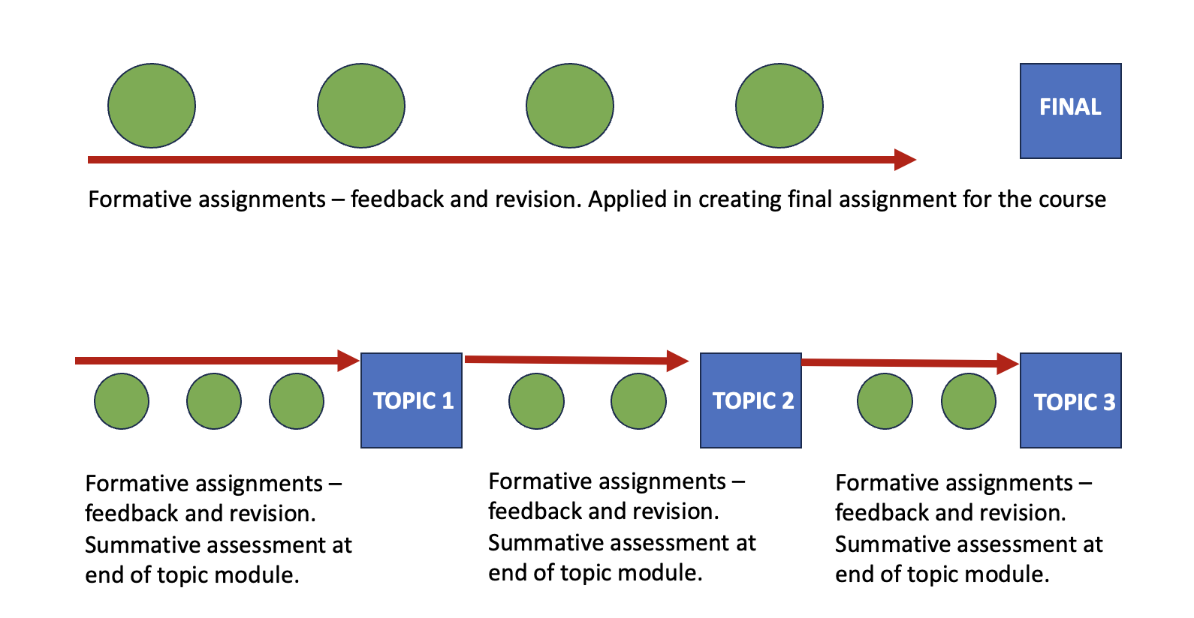
Image Source: Shamini Dias
Formative work toward summative assessment at the end of a topic.
- Good for courses that contain a series of topics that can be assessed separately, i.e., when the knowledge of one unit is not dependent on knowledge and skills from a previous unit. For example, in a survey course covering 5 different genres of literature or 5 key theories.
- The assessment design could be a series of formative assignments that culminate in a small summative assessment for that topic. This is repeated for each of the course topics.
- For example, in each topic, students do formative quizzes or problem sets with peers, short pieces of writing with feedback, before a summative topical assessment. Each summative topical assessment is added toward the final course grade rather than averaged. This helps learners achieve each topic’s goals without penalty because of issues in other topics.
Image Source: Shamini Dias

Formative assessment design enables productive struggle to happen without threat to the final product, especially if the formative work is not heavily weighted (or not counted) in the final grade. This allows students safe-fail space and time for growth before final assessment. Formative design also facilitates flexibility for a diverse group of students to ensure space and time to bring their best selves to the work, rather than a one-off design that would impose barriers for many students.

Designing Transparent Assignments for Equity
In designing assignments, we have a powerful opportunity to transform our courses into equity-minded, inclusive learning that is meaningful and prepares learners for their future.

What kinds of assignments can we design that would do the following:
- Engage students in higher order thinking skills (Bloom’s Apply, Analyze, Evaluate, Create; Fink’s dimensions of Complex Application, Integration).
- Empower learners to make meaningful connections between assignments and their lived experiences and the larger world; build a sense of personal-social responsibility out of the subject matter Fink’s dimension of Caring).
- Engage a relational humanized approach to learning through assignments so that students do not have to work in isolation (Fink’s Human dimension).
- Builds metacognition of learning and learning how to learn skills toward positive, generative learner identities (Fink’s Learning How to Learn dimension).
- Provide space and time for productive struggle that balances ethical and academic rigor.
- Enable multiple modalities of representation, expression, and communication, expanding knowledge and skills development and application with a range of information literacies.
- Engage and empower student’s cultures and voices – recognizing multiple ways of knowing and expressing knowledge and skills.
- Expand students’ range of information literacies both digital and analog.
This sounds like a tall order. Not every assignment will do all these things. But they are a good guide to help us transform assignments that make learning and teaching more meaningful.

Centering Students with Flexibility and Choice
No matter how carefully descriptive our feedback is, students are likely to have an internal narrative that judges themselves – I messed up again, I’ll never get this. We can surface and address these hidden narratives of shame, self-blame, and guilt. Bringing in flexibility and choice help you design more inclusive processes that align with your students’ life contexts.

Flexibility. Rethink strict deadlines and assignment requirements rather than just doing extensions piecemeal that end up creating more anxiety. Offering flexibility enables students to work with us to self-manage in ways that optimize their learning. Support students in creating a manageable calendar.
- “Stretch Deadlines” – allow students a range of time for submitting assignments. Example: The preferred deadline is Wednesday, but they have till Saturday evening to turn it in. This broadly supports different student situations.
- Remove rigid penalties for late work. Penalties for late work punish students who are likely already challenged by their life-study circumstances. It leads to grades that measure privilege and barriers more than learning.
- Make time early on to do a calendar check with everyone about course deadlines and deliverables. Explicitly invite students to discuss a plan with you (or a TA) to organize themselves for the semester.

Choice.
- Students select from a range of problem sets or topic areas and formats, and/or a range of difficulty. This allows students to begin where they are and grow through different assignments. We can guide students to choose items in a progression that will stretch them.
- Set up assignments due at different times of the semester from which students choose a set to do. This allows them to select assignments best aligned to their circumstances and other work they have due. For the teacher, this also spreads the grading load.
- Allow students to create their assignments. Give guiding parameters and let students create their own questions and formats. For example, rather than set a quiz or short answer test, ask students to submit questions with worked out answers to use in your exams. Instead of setting writing prompts, ask students to set writing prompts or project ideas that become the set from which the class chooses.
- Be thoughtful about what you are actually assessing. For example, unless you are teaching a course on grammar or explicitly teaching how to write academic essays in your discipline, an assignment can take other forms. You can give students the choice to do a video presentation or create an infographic instead to demonstrate the elements you have set as their learning goals. This brings in options in format that might work better with students’ interests, skill, and time. In avoiding a one-size-fits-all approach that sets up barriers for many students, you provide multiple pathways for students to demonstrate their learning.

Transparent Assignment Design
The purpose of assessment is to foster learning and growth.

Transparent assignment design walks the talk of inclusivity and equity-minded teaching. In transparent design, assignments are written so students know WHY they are doing it (relevance and meaningfulness) and HOW to do it (clarity and scaffolding) with explicit guidelines for success. Transparent design uses formative processes to guide students in achieving outcomes while developing learning metacognition, self-regulation, and learning how to learn skills.
The Transparency in Learning and Teaching in Higher Education project (TILT Higher Ed) is an award-winning national educational development and research project to help faculty implement a transparent teaching framework that promotes college students' success. It began at the University of Illinois, Urbana-Champaign in 2009-2010 and has involved over twenty-five thousand students in hundreds of courses at more than forty institutions in seven countries. Now housed at Brandeis University, the project invites participants from all institutions of higher education in the US and abroad. In 2014-2015, the Transparency Project began partnering with the Association of American Colleges and Universities (AAC&U) to focus on advancing underserved students' success in higher education.

TASK: Explore Transparent Assignment Design

Browse the Website: TILT in Higher Education

Watch this video on Transparent Design [7:43 mins] . Professor Mary Ann Winkelmes, The Principle Investigator of the TILT project gives an overview of a study on transparent assessment design and how it supports inclusive teaching toward student success. The study was conducted in 2014-2016 by AAC&U. Link a set of slides on this study,

Read: Ridiculously simple and very successful. (2021). [Approx. 6 min read]
A case study on transparent assignment design on the AAC&U website. “Transparent assignments help to take some of the guesswork out and demystify the curriculum … This is especially important for students who may feel more insecure about whether they belong in college.” – Jodi Fisler, senior associate for assessment policy and analysis for the State Council for Higher Education in Virginia (SCHEV.)

Read: Kasey Christopher 2018 - Biology professor. Blogpost [Approx. 2 pages]: What are we doing and why? Transparent Design benefits faculty and students alike. The writer shares an example of a transparent assignment.
"Briefly, transparent assignments are constructed with three key components: purpose, task, and criteria for success. This lies in stark contrast with the more traditional approach of providing only the task, perhaps with a rubric attached for higher-stakes assignments. ... I was shocked at the results; by simply mentioning that learning to make observations and hypotheses was part of the key goal, and providing a successful sample response, I avoided the vast majority of confused student questions. Concurrently, the depth of thought that students put into their hypotheses increased noticeably."

How to Use Transparent Assignment Design
These design questions help you think about inclusion and excellence in designing assignments. The questions engage you in Design Thinking to understand the learners (Empathize) and the contexts of learning (Define) before creating your assignment (Ideate). This practice is essential to design assignments that will support learning and remove barriers for a diversity of learners.

Task and Assignment Process:
- What is the final product?
- What is the process or key steps in creating the final product?
- Does it require specialized knowledge and when will I be teaching this?
- Do they have choices rather than a single option?
- Can they modify the assignment to connect to an interest?
- Will they work alone, in pairs, in groups? Will they collaborate in some parts of the assignment and do solo work in other parts?
- How much time will it take? What is the time needed for each stage?
- Will they have time in class for some parts of the work?
- How many drafts are reasonable? And what are the deadlines for these so that I can give feedback in a timely manner so they can make revisions?
Purpose/Meaningfulness:
- What skills are practiced, and knowledge is gained?
- Why are they doing it? Is it worth doing? How does it connect with students' interests?
- How does the assignment connect with previous or future assignments?
- How will this help in and beyond the course?
- Who is the audience - just the teacher, teacher and peers, an external audience? The more authentic the audience, the more meaningful the task becomes. For example, rather than write a paper for no real audience (the teacher being the only audience), they could write the same paper but as a policy brief for a larger world context, as a journal article with a specific academic audience, an op-ed for a specific publication whose audience has certain interests etc.
Criteria for Success.
- What does excellence look like? This is the basis for developing a useful rubric.
- How can students self-evaluate?
- Will students have rubrics to help them plan and do their work rather than just at the end for grading?
- Will there be self- and peer-review and when?

Resource: Template or Structure for Transparent Assignment Design
Use this as a template to create assignment-handouts.

Goal or Task: What is this assignment? Be specific. For example: In this assignment, we will analyze 2 contrasting cases of classroom engagement and suggest interventions.

Purpose: Why is this assignment important? What outcomes are addressed in doing this assignment - content knowledge mastery, skills development? How is this useful to students within and beyond the course?

Format and submission: Provide specific instructions for any formatting requirements and submission, for example number of pages, mode of submission, where to submit.

Deadlines: Provide all interim deadlines and final deadlines and any protocols and policies about missing deadlines.

Instructions and Resources: Provide critical scaffolding steps to guide students in working through the processes needed to do the assignment. If there are important resources provide information and links to them where possible.

Criteria for Success: provide a checklist of criteria for success that will help students plan and produce the work to meet the standards you are using for grading. It is best not to attach points to these and present that guidelines for success so that it’s a learning rather than a scoring tool.

PAUSE TO REFLECT
- What are typical assessments and assignments like in your discipline? What forms and modalities are used beyond writing and presentations?
- How would you transform assessments and assignments into positive and productive processes of growth? Think about the topics covered so far. What ideas from those topic areas can you use to create assignments that are meaningful, that engage learners actively, and empower them to co-create and use multiple modalities for expression?
- In developing your teaching philosophy and diversity statements, what values and principles will guide you in designing assignments and assessments. What is your assessment philosophy? This connects with question 4 in your TPS worksheet.

Resource: Ideas for Multiple Modalities Integration in Assignments
Use this table of different modalities and forms in creating assignments, either as final assignment format or as processes to develop ideas and “rehearse” learning. Planning a few different types of assignments, assessments, and activities helps you differentiate the teaching-learning process to cater to different learner’s interests and abilities.

Modality | Examples of text types and learning processes
Reading  Viewing | WHAT: advertisements (print, video), books (fiction, non-fiction), blogs, book reviews, extracts, film/video (movies, documentaries, news etc.), interview transcripts, journal articles (conceptual and empirical), magazines, newspapers (print and online), play scripts, social media feeds, reports, websites, etc.  SENSE-MAKING & ORGANIZING INFORMATION: Annotate, take notes, sort and categorize  RESPONDING TO READING: Summarize, critique/review, trace trends and patterns, compare and contrast, connect within and across texts, create visual representation or model of ideas from reading items (see visual category below), respond collaboratively (wikis, discussion forums, blogs), quick-write reviews
Writing | academic paper, annotated bibliographies, blog post, collaborative writing (paper/wikis), creative response, critique, essay, group writing, literature reviews, reflection journals (guided, open, solo, group, class), op-ed, posters, report, response paper, critique, summary, twitter responses, translating works
Listening & Speaking | debates (formal, informal), discussion (whole class, groups, on-line), following a set of verbal instructions, interviewing, verbal one-minute summaries, panel discussions, presentations (solo, group), role-play, readers’ theatre
Outside Class | community involvement/service projects (group or solo), group work meetings, observations and note-taking
Collaboration | Discussion forums, group projects, partner projects, whole class collaboration, wikis.
Visual, AV Presentation | 3D model or representation, collage, drawing, documentary, flow charts, flyers, film clip, photo essay, podcast, presentation poster, slideshow, storyboard, scrapbook, wall mural
Tests/Exams | fill in the blanks, lab tests, multiple choice, open book exam, open web exam, performance or hands-on tests, project presentation, quizzes, short answer, short essay, student constructed tests, take home exams
Portfolios (Individual Or Group) | Process based work – drafts are submitted for feedback (instructor/peer), final draft submitted for grading, all work kept in a portfolio (paper or electronic), whole portfolio submitted at end of semester together with a reflection and self-assessment piece
Performative | Performance art, dance, musical theatre, mime, human statues, physically acting out concepts, skits and dialogues representing concepts and key ideas, instructor performs - student responds (e.g., paraphrases, adds to)
Research Projects | Research - literature based, community-connected research, quantitative, narrative-based, ethnographic, visual research, curation...

Chapter 11: Transformation 5. Feedback and Grading

In this chapter, we continue exploring assignments and assessments focusing on feedback and grading issues and methods. Our goal is to reframe feedback as a positive, growth-oriented process as part of inclusive and equity-minded productive struggle.
Here is a metaphor for feedback – a magnifying glass that enables us to pause and take a close look at our work. Feedback helps us to magnify and focus on areas of strength that we can keep building and stretch, as well as errors or areas we need to sharpen and develop.
What other metaphors for feedback come to mind?


Image Source

TASK: Recall and Reflect on Your Own Experiences of Feedback (priming task)
- Write a single sentence definition of “feedback”.
- What is your first emotion when you realize you will be getting feedback for something? Consider how it felt through your schooling, in working life, as well as in personal life.
- Do you have any of the following internal responses and how do they differ in different contexts? Who or what situations make you feel these 2 different responses?
  - Brace for feedback – anxious or worried what might be wrong
  - Relish and anticipation – look forward to hearing what’s working and what’s not.
- What do you think made the difference for you in experiencing these different internal responses to feedback?

Exploring Feedback

Here are some words associated with “Feedback”. Notice that these are all value-neutral, but when associated with “feedback”, many take on positive or negative connotations.
- NOUN: Data, Information, Description, Observation.
- VERB: Assess, Analyze, Comment, Critique, Criticize, Correct, Describe, Evaluate, Explore, Guide, Gauge, Inform, Observe, Probe, React, Respond.
- The Outcomes of Feedback: Adjust, Adapt, Change, Discover, Focus, Modify, Navigate, Reframe, Respond, Revise, Sharpen, Stretch

“The most powerful single moderator that enhances achievement is feedback. The most simple prescription for improving education must be dollops of feedback. This does not mean using many tests and providing over-prescriptive directions. It means providing information about how and why the student understands and misunderstands, and what directions the student must take to improve”.
John Hattie (1999), Influences on Student Learning

There is no failure; there is only practice. - Resmaa Menakem. June 2020. On Being. With Krista Tippett (podcast)

“In a growth mindset, challenges are exciting rather than threatening. So rather than thinking, oh, I’m going to reveal my weaknesses, you say, wow, here’s a chance to grow.”– Carol Dweck

Vulnerability: Fear of Feedback – Fear of Failure – Fear in Learning
Learning is a constructive, adaptive process – moving from not knowing something toward coming to know through a process of building knowledge and skills with others. This engages Complex Domain thinking: the ability to embrace the dissonance of not knowing and feeling vulnerable, the ability to engage in productive struggle to explore, try, fail, get feedback to navigate through the process and build knowledge. Very young children have no problems with this.
However, our schooling processes inculcate fear of failure and of feedback. One of the most vulnerable spaces in education is making mistakes and getting feedback.
Think about the meaning of these words and phrases in your lived experiences both in school and outside school in personal and professional life.
- Failure
- Mistakes
- Errors
- Did not know something
TASK. WATCH Fear of Failure. [3:02 mins]
Brene Brown speaks of the connection between fear of failure and shame. As you watch, think of how this illuminates schooling and assessments, and especially our responses to feedback.

The Other Side of Vulnerability: Courage in Teaching and Learning
Vulnerability does not have to be a negative emotional space. In Complex Domain thinking – and creative adaptive work – positive vulnerability supports courage and persistence in adaptive learning behavior, i.e., in productive struggle. How this connected to these words?
- Open
- Curious
- Exploring
Here are 2 quotes from Brene Brown linking vulnerability to courage. What elements of Complex space thinking and learning emerge for you from these quotes?
“The courage to be vulnerable is not about winning or losing, it’s about the courage to show up when you can’t predict or control the outcome.” – Brené Brown. Link to webpage

“If you cannot manage discomfort, that sends you barreling into perfectionism, excuse making, blame, rationalizing, fixing it, cleaning it up without taking away the key learnings from a failure or a disappointment, or even a heartbreak.” Brene Brown. Link to webpage

TASK: READ Andrew J. Martin & Herbert W. Marsh (2003) Fear of failure: Friend or foe?. Australian Psychologist, 38(1), 31-38. [6 pages]. As you read, consider these guiding questions.
- How does vulnerability connect with productive struggle toward learning?
- Why might marginalized and underrepresented students have more negative vulnerability and fear of failure?
- How does working with inclusive process-based approaches to assignments and assessments support positive vulnerability and learning?

Feedback for Equity-Minded Teaching
Feedback is a under-estimated tool for inclusion and equity-work.
Many students come into college out of punitive, marginalizing systems where a large narrative – maybe their single story - was that they were not important and that learning and soaring in learning was not for them. In addition, legacy schooling creates a transactional approach to school; do the work in exchange for the grade. Penalties and negative judgements come with this. Ironically, learning is often not part of this story. We can create a counter-narrative that will help our students transgress, transcend, and transform this legacy narrative in which they have the agency to become strong learners who can learn for life.

Using Feedback to Support Inclusive Productive Struggle
Feedback is not only about improving the work at hand to get the grade. It can do so much more. Through effective, mindful feedback (and effective, empowering assignment design),we can support all students to engage in productive struggle by reframing learning as a process of growth that is designed for all rather than a competitive achievement race that those with privilege will win. In addition, students can develop self-awareness of their learning patterns, build their learner identity and self-efficacy as learners, and especially develop learning how to learn skills. Good feedback also prepares students to flourish in the VUCA world of their futures no matter what subject you teach.

The Structure of Feedback
Good feedback has 2 parts – observing or focusing on something and then constructive information to support moving the work forward. The following principles and strategies support this process:
- Focused and descriptive. The first role of feedback is to create focus and awareness, to call attention to something. Therefore, it is descriptive. For example: This argument needs evidence, the sources are unconnected to the text, your foot placement makes you unbalanced.
- Non-judgmental. Make feedback work-focused not person-focused, with no assumptions about the student. In the examples above, work-focused language allows the student to focus on the work without feeling blamed. It also sets the tone for providing action steps, and to continue conversations with the student.
- Reflective and/or question finding. Pose questions to deepen thinking and synthesis so that you invite learning. This helps students feel that you are not merely “checking” their work, but that you are engaging intellectually and meaningfully with them. For example, This makes me think of the last unit we covered on historical amnesia. Do you think what you say here can bring that in?; I have not thought of looking at trauma this way – I think you’re on to something. Do you think this applies to girls as well? Notice these examples invite the student into a co-creative process of revision. Rather than being told “do this” – the instructor is asking them to consider an idea, signaling agency and supporting the development of the students’ learner identity and self-efficacy.

- Both strengths and areas to fix. Focus on what’s working as well as what needs fixing. Explicitly understanding what they are good at helps students to intentionally do that again and stretch that ability. It also signals to students that feedback is not just a criticism of all the things that are wrong. Examples: Great use of evidence from peer-reviewed articles, You’ve made productive contributions to this group project, this argument logically connects commentary to the assertion, your pace and volume worked well to support the ensemble.
- Constructive directions for growth. Provide explicit direction and resources to help students with learning and moving their work forward.
  - Action steps. Give students action steps to address the issues or amplify the strengths you observed. If you are able, point to or provide resources. Examples: Bring in evidence from peer-reviewed articles. See this link for resources. Watch this video to learn how to work on circular breathing, Connect your commentary better to your assertion by bringing in a couple of current events that reflect the assertion.
  - Institutional resources. Your students – and you – have allies to help them improve work that are often missed. Some students might not know how institutional resources work for them, or not even know they exist (even though you might have them in your syllabus and mentioned them before). Bringing them in with feedback engages just-in-time learning and awareness. For example, part of your feedback could be to point to a helpful resource like librarians, writing centers, or technology centers. Receiving these as feedback will help some students seek them out to improve their work.

Wise feedback is a research-based practice for delivering critical feedback in a way that fosters trust, increases student engagement, and reduces performance gaps between White and Black students (Cohen, Steele, & Ross, 1999; Yeager, et al. 2014).
- Includes specific, actionable steps for your student to effectively make these improvements, which ensures that students won't repeat their same pattern of action.
- Avoids focus on learner identity; focuses on learning instead, assuring students of your belief in their ability to succeed, and learning as a process toward high expectations. This shifts learners toward a growth mindset. For example: I am giving you this feedback because I know you can develop your work toward these high expectations; note that my feedback comes from knowing you can do great work and we can get there together. We can also put a statement in the syllabus, our LMS, and in our assignment sheets about how and why we use feedback.

Feedback Sample | Analysis of Feedback
This is unacceptable work for a college student. Your arguments are not sound. Improve them for a higher grade. | Identity judgment – You do not fit.  Error without explanation.  No direction for learning.  Transactional emphasis - Grades not learning.  How might the student feel and respond in receiving this feedback?
Your arguments have assertions but need stronger supporting evidence. Look at notes from session 4 - add 2 sources to support what you are saying. I know you can do the work and reach our goals. | Focus on work, not learner’s self-identity  Explicit description of the issue.  Explicit direction for addressing the issue.  Explicit statement of belief in student’s capacity to reach the goals.  How does this feedback help foster productive struggle and positive learner identity?

Student work as feedback for the teacher. In looking at student work, we often see patterns in their strengths and gaps. Often this is an indicator of our teaching – if they are all making the same type of error, it could well be an area we can improve in our input and facilitation. Conversely, high achievements in an area signals that something we did in teaching this area worked well and can be applied further.

Curating Feedback for Students. We can share patterns in student work so that all can benefit from the feedback. For example, we can pick out critical aspects of an assignment’s goals with specific directions for improvement to share with the whole class. This signals a focus on learning that does not judge any individual student. We can do the same with patterns of strengths and share examples (with identities redacted) of good work that reinforces and expands learning for all as they work on revisions for the next draft.

Pathways for Feedback: Self-Assessment and Peer Review

Self- and peer-assessment are active, formative processes to provide actionable feedback. These processes also develop metacognition of learning and learning how to learn skills. Students work more strategically toward achieving learning goals while developing their capacity for life-long learning in understanding the iterative nature of feedback, learning awareness, and achievement. In effect, students learn to apply backward design (starting with the end in mind) to their learning and skills to manage the process.
- CLARITY. Students better understand the goals and criteria for success in applying rubric criteria to their work. Areas of confusion and opaque terms can be addressed, which also helps us in ensuring that the criteria we use are transparent.
- METACOGNITION: In self- and peer-assessment, students develop a keen sense of their learning patterns, strengths, and areas to develop.
- LEARNING HOW TO LEARN: Students develop skills in observing and analyzing strengths, errors, and gaps as well as what they need to do in addressing these. Through this analytical process and the resulting steps to revise the work, students develop a growth mindset, self-efficacy as learners, and explicit knowledge of work processes for good work.
- EMPOWERMENT. In doing the above, students take charge of their learning, making decisions of what needs work, where their strengths lie, and in seeking out resources. With peer-review, they also build relatedness and peer-support in collaborating to learn rather than competing.

How to engage students in self-assessment
Pre-alert this by using Transparent Assignment Design so that you have the rubric or criteria for success, as well as steps on how to do the assignment. Work proactively with the assignment sheet:
- Students use the rubric before submission of drafts. Students use a copy of the criteria for success or rubric where in their assignment they are responding to criteria in the rubric by highlighting or adding marginal notes.
  - This helps them see their strengths and gaps themselves rather than passively wait to be told by the teacher.
  - they will also be able to identify errors and make corrections. This is an opportunity to help them see that these are errors of process – missteps - rather than knowledge gaps.
  - They will also find things they are not able to address, i.e., actual knowledge and skills gaps. Any help they get on that will be “stickier”.
  - You can integrate this process with peer-review so students can help each other out. This also makes your feedback process more focused and effective, and usually less onerous and time consuming.
- Self-assessment reflection. Ask students to do a short self-assessment quiz or free write as part of handing in a draft that addresses the following:
  - What were your strengths in this draft?
  - What challenged you?
  - What do you think you need to do to sharpen this work? How can I help you?
This pause focuses on learning and productive struggle. For the teacher, this information can reveal patterns of areas you might want to address in your design and teaching.

Peer Review
Research has found that peer review and feedback helps students improve their work as well as develop capacities for learning and interpersonal development.
- Multiple ideas and perspectives. Peers are likely to introduce each other to ideas and writing/thinking strategies from different perspectives, especially when multiple peers are involved (McConlogue 2015).
- Reviewer benefits through metacognition. Peer feedback engages students in actively thinking about the contents and writing, and applying assignment criteria in discussing the work with peers. This subsequently helps them improve their own work. (Flower et al. 1986; Patchan and Schunn 2015). Some studies (Cho & MacArthur, 2011; Lundstrom & Baker, 2009) found that even when students give feedback without receiving any in return there were positive effects on the reviewers writing.
- Community of writers – a practice of peer review and writing develops an engaged community of writers where students share writing to give and receive feedback. This can foster the following:
  - A safe reciprocal process for developing writing.
  - Deeper engagement in writing.
  - Development of metacognition and learning how to learn.
- Audience awareness. Peer review is reciprocal and helps students experientially learn about audience needs and to read something from an audience perspective. (Beach & Friedrich, 2006; Englert & Mariage, 1991; Englert, Mariage, & Dunsmore, 2006).

What can go wrong with peer review? Here are some common teacher-anxieties about peer review:
- Students might not value peers’ comments as much as the teacher and thus pay less attention to the process.
- Students are not always able to identify and explain the problems to each other.
- Students can make superficial comments (“it’s great”) that may be inaccurate and unhelpful.
- Students might focus on minor editing issues rather than substantive writing issues.

Before reading ahead, consider what strategies you can use to preempt the issues above. Then continue to the next page.

Strategies for Effective Peer Review
Peer review only works when there is effective teacher facilitation and scaffolding. (MacArthur, 2016; Philippakos & MacArthur, 2016; Topping, 2005). Here are some elements to integrate into the process.
Intentionality and Instructions: Provide a dedicated time, clear instructions, guiding documents, and a reporting back time to share what they found that will also allow you to provide more input.

Clear Criteria for Review. Provide a rubric with specific criteria and check to ensure students understand what the criteria mean and how to apply them to the assignment. Clarify as needed.
- One way to do this effectively is through think-aloud modeling where you demonstrate reading, analyzing, and responding to a piece of writing using the criteria.
- It also helps to demonstrate this using samples that show a range of writing so students see exemplars of writing at different developmental stages.

Provide Feedback Structure. Scaffold good feedback by providing students an oral or written template that guides them in reading, analyzing, and communicating their feedback, for example: Identify the problem – explain why it’s a problem – suggest action to address the problem.
Training and Practice. Ideally, provide students time to practice on a common document so they can compare their observations and suggestions (essentially, do a norming process) as a way of checking that they understand the criteria/rubric you have provided.

Scaffold Reviewing Over a Semester. Students will get better a reviewing and providing formative, actionable feedback if you do it more than once. Begin with smaller and simpler assignments. Over the semester, as assignments get more complex, the practice they had in the simpler steps will help them continue to give good feedback.

Focus by Chunking. Keep the reviewing of content/structure separate from the mechanics of checking spelling, syntax, and punctuation. This will help focus students on the substantive aspects of an assignment and not get distracted by copy-editing and discussing the mechanics (unless of course that is the focus on the course!).

Grading

Who loves grading?
The students certainly don’t. And many teachers agree with them!

Grading – and grading in specific ways are part of our legacy system. It’s a hard area to transform because many of us think of grading using Clear and Complicated domain thinking: “we’ve always done it this way”, “this is what the experienced teachers do”, “if we do not grade this way, we lose rigor”, “students won’t do the work unless it is graded”.
To what extent do you think you share some of these assumptions? And are they all correct?
We can question this legacy paradigm of assessment and grading.
- Do students really learn because we grade them?
- How do we compromise ethical rigor in different grading methods?
- Do we lose learning rigor if we use different methods of assessment?

TASK: READ about grading
- What’s wrong with school grading this year? The same thing that is wrong every year. [approx. 6 mins]. The turbulence of the COVID pandemic, surfaced many underlying issues in assessment in learning in the legacy system that have been long ignored.
- Taking the stress out of grading. ACSD, 78(1). 2020. Joe Feldman. [approx. 13 mins]
In this article, Joe Feldman covers 4 outdated grading practices: Using a 0-100 scale, Curving Grades, Grading Homework, and Grading Participation. He then offers ideas and strategies on Retakes, Lowering Stress, and Increasing Equity.

Here are the reflection questions Feldman poses at the end of the post (to which we have added one more). Think about this in terms of your own classes (if you have taught/are currently teaching) or in terms of your learner experiences as an undergraduate.
- Which of these legacy grading practices are most prevalent in your discipline?
- How have you seen grades negatively impact students' mental health?
- Which of these four "outdated" grading practices could you commit to ending? What's the first step to do so?
- How could you make retakes a consistent part of your school or classroom's grading culture?

Standards Based Grading (SBG) – also known as Mastery Based Grading.
SBG focuses on learning and evaluates how students are progressing toward specific outcomes or learning goals. The goal is to support productive struggle by creating a visible pathway and documentation of students’ learning and growth. When integrated in a formative process of authentic assignments with a learning community, this is a powerful method to engage in meaningful growth-focused assessment.
SBG is an inclusive and equitable approach. Students enter college differently prepared in how they approach academic work, in understanding disciplinary discourse styles, and other college skills. Some will sail through assignments and others will find assignments opaque and confusing and the difference comes from social, contextual factors rather than intelligence or learning capacity.

Transparency, clarity, proactive work. Standards based grading takes the mystery out of the learning process and helps students plan their work proactively. It becomes the teacher’s responsibility to communicate the standards clearly.
- From the start, students know the assignment goals, and its specific criteria and deliverables.
- Well-written standards eliminate the issue of opacity in language and expectations, e.g., “a good argument”, “integrating sources”, or not realizing they need to use a specific academic style.
- This enables you to check-in with students to ensure they understand the criteria/standards, and to modify them as needed.

Focus on formative feedback and learning. Mastery-goals or standards signal to students that they are in a process to build toward the goals. Combining standards-based grading with formative assessment makes this clearer. All assessment therefore is designed to give them feedback to reach the goals.
Elimination of classroom management measures. Standards-based grading helps teachers really think about assessment of learning, rather than muddy assessment with classroom management criteria such as attendance, late-work, and participation grading. The latter are not part of making learning visible and ought to be something we do in classroom leadership and facilitation.

READ: Standards based grading. Definition, benefits, and comparison with traditional grading. (2021)
This web article summarizes the benefits of SBG compared to traditional grading. Pay attention to how SBG has potential as a tool to make assessment inclusive and equitable.
What resonates most with you as a learner and in thinking about how you might approach grading in your courses?

Ungrading. A radical transformation of assessment for learning
"Ungrading" means raising an eyebrow at grades as a systemic practice, distinct from simply “not grading.” The word is a present participle, an ongoing process, not a static set of practices – Jesse Stommel.
“When teachers give feedback together with a grade, the students see the feedback as justification for the grade, but if there is feedback without a grade, then students can see the feedback for its own sake and act on it” (Blum et al. 2020. p. 96).
This approach has emerged from the research and practice of educators concerned about the negative impact of grades on student engagement, motivation, and learning achievement. Jesse Stommel has been a strong advocate, as well as scholars such as Susan Blum, Alfie Kohn, Peter Elbow who have explored ungrading methods that reduce anxieties, remove barriers, and address biases of grading.
Ungrading moves the punitive judgement of grades out of the learning space, focusing instead on formative work with feedback and standards to guide, support, and expand learning. It also builds learning metacognition by engaging learners in self-assessment so they are empowered in a productive struggle; they can take risks, fail, and improve. No matter what we teach, ungrading principles help us design and practice flexibility, choice, and co-creation with students to develop authentic, meaningful assignments. As long as students are working toward course goals with clear criteria, we can differentiate some work so that they are not locked into all doing the exact same assignment using the same modalities. Rigid standardization is removed while inviting students holistically into meaningful learning.

At the end of the course, our departments might require a grade. This can be done in a number of ways:
      - Students keep a portfolio of their work, including drafts, feedback, and final drafts.
      - They write a general reflection of what they learned and how they grew using the course goals as their guide. This together with your viewing of the portfolio helps you determine a grade.
      - Make sure you check in with students at mid-semester so there is time for students to catch-up and plan revision, so they achieve the course goals.
      - Make grading choices with students. Define what letter grades mean so there is transparency and students can choose the grade level they want to aim for. (failure is of course not an available choice). For example:
  - A = ALL assignments complete, all stages done, assignment goals fully achieved or exceeded.
  - B = Assignments complete (up to 2 are incomplete). For completed assignments, all stages done and assignment goals fully achieved.
  - C = Assignments complete (up to 2 incomplete). For completed assignments, all stages done but up to 2 assignment goals not achieved.
Most students will choose A, but some might choose B or C if they have too heavy a load and other critical courses, e.g., for their major, or because of life circumstances. Being able to make this decision helps them self-manage. Keep the choices open through the semester so that someone who begins choosing a lower can change upwards or vice versa as situations change.

The principles of ungrading – and the core intention – is to remove grade anxiety, and reframe all work done in class as learning rather than transactions for a grade. Therefore, even if you do not use ungrading as a formal practice, you will still achieve the same intentions if you:
- Design assessment processes that avoid high-stakes, one-time-attempts for a grade.
- Design assignments using Transparent Design structures.
- Create explicit, safe-fail formative processes and engage productive struggle.
- Use formative feedback, including self- and peer-assessments that are focused on actions toward learning and goal achievement.

TASK: READ ABOUT UNGRADING
Ungrading. Baylor University. Academy for Teaching and Learning. [approx. 7 mins - a comprehensive overview of ungrading – why we grade, examples of ungrading methods and some good references.

Jesse Stommel is an educator and advocate for the process of ungrading – a movement gaining ground among educators seeking more equitable and learning-oriented ways to assess student work. In this blog post, he provides links to a bunch of articles on grading.
- Please read this one: The Case Against Grading – Alfie Kohn 2011. [approx. 15 mins] Alfie Kohn has done years of research on the interaction of grading and learning and has been a strong advocate to change how we assess learning.
- Select and read 1-2 other articles that are linked on the webpage. Link to webpage

How do ideas from ungrading resonate with you? What values and principles from your developing teaching philosophy and diversity statement connect with elements of ungrading that you can bring into your practice?

The Rubric as a Compass for Success

What is a rubric? A common understanding of "rubric" (another opaque word) is that it is used in grading. But rubrics can do so much more. Rubrics are:
- A transparent list of skills and knowledge that students aim to develop as they journey through a course or assignment
- A compass we can use to pause and check if we are on track or need to adjust the work. The rubric as compass can be used by the teacher, a peer, of by the learner themself to generate feedback that helps them adjust and move ahead effectively.
- A final gauge of how we have completed the journey. If the rubric is in the hands of students all along and they have used it well as they journeyed, they will arrive in good shape at the end of the journey. They should all do well.

PAUSE TO REFLECT
Think about your experiences with rubrics as a teacher and/or a student. Here are some questions to help you unpack and examine your perspectives on rubrics.
- Which kind of rubric is typically used in your discipline ... if at all?
- In your undergraduate studies, did you receive a rubric when an assignment was given out? How did this help you?
- Did you have any opportunity to use a rubric as a guide or checklist to help in doing an assignment?
- How is giving students a rubric as part of an assignment inclusive and ethical?
- How do rubrics help students develop metacognition of learning, self-regulation, and learning how to learn skills?

3 categories of rubrics: Analytic, Holistic, and Single Point rubrics.

Holistic Rubric
- Each level of performance has an organic description of what achievement looks like at that level. All criteria used to assess something are considered together.
- Holistic rubrics are appropriate when the elements you are assessing are all interrelated. For example, in an oral presentation, eye contact confidence is connected with posture and energy. It is hard to assess one independently of the others.
- Great for formative feedback as students and teacher can use this indicating which specific elements to work on, and where the strengths are to amplify.

Analytic Rubric
- This is a well-known format - arranged in a grid with sets of criteria and performance levels such as Emerging, In Development, Competent Performance, Mastery.
- The form helps granulate different categories of mastery so that we can give feedback to different areas of performance where students might be in different developmental stages. For example, a student might be great at logical argument but be struggling with grammar as a non-native user of a language.
Single Point Rubric
- This is like an analytic rubric with specific categories and criteria to demonstrate. But, there are no performance levels like developing, competent, or mastery.
- There is space on the left and right of the criteria – the left for notes on how to improve on a specific criterion, the right for notes how to stretch and go beyond the criteria. This makes single-point rubrics good for creative/innovative work as there is no upper limit for stretching oneself and thinking out of the box. This rubric also enables co-creating criteria with students and modifying assignments.

Resource: Sample of Rubric Types

Sample: Single Point Rubric. Writing an Argument Based Essay
Please note: If you do not recall what some of the terms in this rubric mean or what they should look like in your work, check our List of Writing Terms in Canvas, ask a peer, or ask me.
Improvement Actions | Competency Criteria | Going Above and Beyond
Introduction
- There is a specific focus on a social issue.
- You show how and why the issue is important.
- You end your introduction with a thesis statement that presents an overview of the rest of your essay.
Paragraph Structure
- Each paragraph has an assertion that connects with the thesis statement.
- The assertion is developed and explained with evidence and commentary.
- There are no irrelevant details in each paragraph; everything in the paragraph connects with the assertion.
Organization
- Each paragraph connects with and leads to the next one; your reader can follow the sequence or logic of your thinking from one paragraph to the next.
- As we read from one paragraph to the next, we can see how all your paragraphs connect to and support your thesis statement.
- You use transition markers to help your reader understand how one paragraph leads to the next.
Paraphrase and Citation (avoiding plagiarism)
- You use citations to indicate when you bring in someone else’s ideas.
- You use quote marks when you bring in someone else’s words.
Mechanics - Syntax, punctuation, spelling
- You have proofread your essay to correct errors of grammar, spelling, and punctuation.

Sample: Holistic Rubric. Presentation Skills
Please note: If you do not recall what some of the terms in this rubric mean or what they should look like in your work, check our List of Writing Terms in Canvas, ask a peer, or ask me.
You’re Flying High! All Goals Achieved
All the presentation is audible and comprehensible. Voice is energized and well-modulated through the presentation. Excellent eye contact with the audience consistently. Posture is open and faces the audience the whole time.

Almost There. Some Practice is Still Needed
Most of the presentation is audible and comprehensible. Voice has energy and is well-modulated through most of the presentation. Eye contact is quite consistent with occasional gaps. Posture is open and faces the audience with occasional lapse and turning away.

Coming Along. Let’s Work on Further Skills Development and Practice
Many parts of the presentation are not audible, some mispronunciations impede clarity and comprehensibility. Voice has energy for the most part, there is some modulation, but tends to drop in energy frequently. Eye contact is attempted but is inconsistent. Posture is open and faces the audience for at least a third of the presentation time. Nervousness is apparent but does not mar the presentation.

Emerging. You’ve Started … Now Let’s Focus on Building Skills.
Many parts of the presentation are not audible, some mispronunciations impede clarity and comprehensibility. Voice lacks energy and there is no modulation. Eye contact is missing for the most part. Posture is closed and often turned away from the audience. Nervousness is apparent and mars the presentation.

Overall Strengths:

Areas for Growth and Stretching Further:

Sample: Analytic Rubric: Debate Preparation.
Please note: If you do not recall what some of the terms in this rubric mean or what they should look like in your work, check our List of Writing Terms in Canvas, ask a peer, or ask me.
Category of Work | Emerging | Becoming Competent | Goals Fully Met
Selection of ideas | You have chosen a set of ideas to use.  You have tried to justify some of your ideas. Many ideas are left unjustified.  Your ideas are not connected to your position on the debate. | You have justified each one of your selected ideas.  Some of your justifications lack evidence from reliable sources. You do not show clearly how they support your position on the debate. | You have justified each one of your selected ideas.  In justifying them, you state clearly how they support your position on the debate
Use of evidence | You have some evidence but need to gather more.  You are struggling to explain how and why your evidence is reliable.  You have not yet connected most of your evidence items to specific assertions for the debate. | You have good evidence, but not all of it is clearly reliable or not fully explained.  Most evidence items are connected to the specific assertions you plan to make in the debate. | You have good evidence from reliable sources. You explain how and why your sources are reliable.  Each evidence item is connected to a specific assertion you plan to make in the debate.

Validated Rubrics You Can Use: The AAC&U’s VALUE project (Valid Assessment of Learning in Undergraduate Education) developed 16 analytic rubrics, each tested and validated by teams of faculty experts in colleges and universities across the United States. The rubrics cover their Essential Learning Outcomes:
Quantitative Literacy • Ethical Reasoning • Inquiry and Analysis • Problem Solving • Teamwork • Creative Thinking • Critical Thinking • Written Communication • Oral Communication • Reading • Integrative Learning • Civic Engagement Local and Global • Information Literacy • Global Learning • Intercultural Knowledge and Competence • Foundations and Skills for Lifelong Learning

You can view and download a set of analytic rubrics on the AAC&U website. Starting with these, you can modify as needed for your specific assignment goals.

I-Rubrics
This is online community that offers a rubric creation and sharing tool. With a free account you can filter their thousands of rubrics by subject and grade/college level, and then modify to work with your specific assignment. Again, no need to reinvent the wheel - use your time and energy to modify and improve what there is as a community resource. The good thing is the rubric you create is then shared back into the database of rubrics so the collection is continually growing.

Chapter 12: Transformation 6. Modalities. UDL and Multiliteracies

This chapter introduces you to frameworks for integrating inclusive, equity-minded modalities and forms of information access, processing, and use. In addition to engaging a diversity of learners, these frameworks also broaden students’ information literacies and communication skills.
- Conceptual Frameworks
- Universal Design for Learning (UD)
- Multiliteracies
- Digital Design Frameworks
- TPaCK (Technological Pedagogical Content Knowledge)
- SAMR (Substitution, Augmentation, Modification, Re-definition)
- Neurodiversity and Disabilities

Universal Design (UD)
Universal Design originated in urban design and architecture. UD recognizes and includes diverse types of people who navigate their environments. It is grounded plurality and differences as normal and as assets. This questions how we often design objects, spaces, and processes using singular one-size-fits-all norms that block and marginalize those who do not fit. Universal Design is based on the idea that we can intentionally design anything - a building, a space, an object, a process - so that many different types of people can use it. In doing this, we need only minimal or no adjustments later to accommodate diverse needs and abilities.

Here are some images of UD implementation. Can you apply this idea to teaching-learning processes? What can we design to support diverse learners to access and engage with materials and activities?


Sidewalk cut ins. While originally created with wheelchair users in mind, the sidewalk cut in is useful to a host of others - the elderly or convalescent, skateboarders, parents with strollers, people with luggage, workers with heavy items…



Low elevator buttons – Great for: someone in a wheelchair, a child, people with hands full….


Bus ramp - Great for: Wheelchair user, convalescent patient, people with luggage, pregnant women, elderly riders…

UDL in Education
UDL in education began in 1984 with the Center for Applied Special Technology (CAST). Originally focused on assistive technologies, which is why many still associate it with disabilities and accommodations, it developed methods to apply UD principles for equity and inclusion of all learners.
UDL’s mission: To transform education design and practice until learning has no limits.
- We thrive on high-quality creativity and relentless innovation.
- We celebrate individual differences and variability.
- We believe in self-reflection that feeds lifelong learning and improvement.
- We measure excellence in ideas and products by the impact these have to make life better for as many people as possible by making true learning opportunities available.
How do these CAST values connect with your values and beliefs in transforming education? Can you integrate them with your evolving teaching philosophy and diversity statements?

UDL strategies focus on 3 key areas:
- Multiple modalities of Engagement – GOAL … purposeful and motivated learners. Affective networks. The WHY of learning.
- Multiple modalities of Representation – GOAL … resourceful and knowledgeable learners. Recognition networks. The WHAT of learning.
- Multiple modalities of Action and Expression – GOAL … strategic and goal directed learners. Strategic networks. The HOW of learning.
UDL creates a flexible and open learning environment for multiple groups of learners. It also supports authentic and more meaningful learning and assessment processes that address issues of learning inequity to include all learners (Fitzgerald, 2020; Antiracism and Universal Design for Learning)

TASK: Explore UDL
Visit the UDL interactive model and explore the guidelines and ideas for teaching design and learning facilitation.

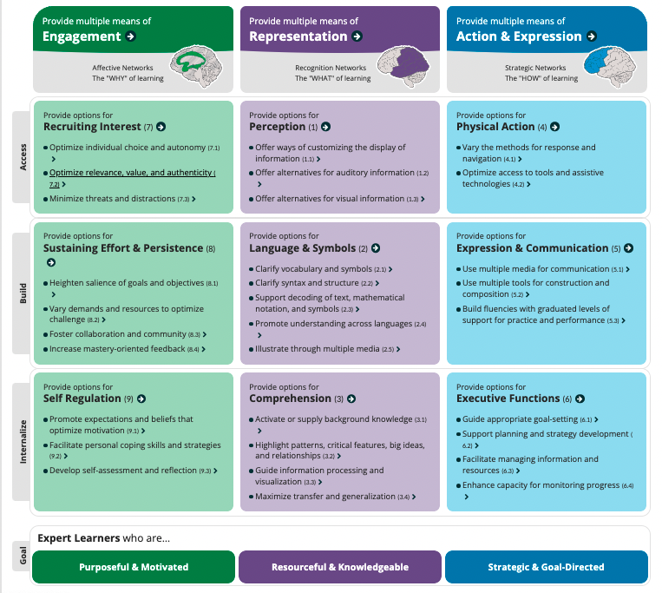

Multiliteracies
What do we DO with information? What are our available FORMS of information?
Information is a TOOL. We do not passively consume information - we use information to build knowledge, connect, and get things done. ​
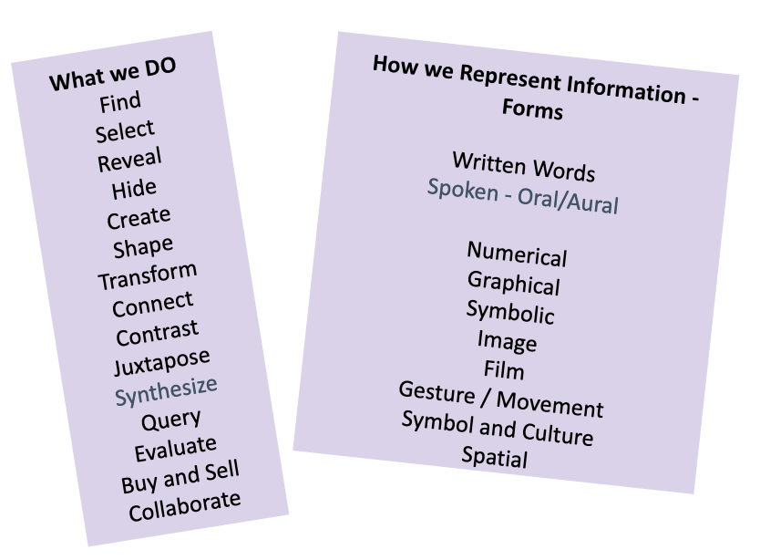
Effective integration of digital tools can empower and support inclusive equitable education in our classrooms. ​Wise integration of digital tools also creates opportunities for students to practice and build competence in a wide range of information and communication modalities. These are critical in navigating life, in workspaces as well as in practicing social personal responsibility at local, national, global, and planetary levels.

Multiliteracies is a framework for integrating multiple ways of knowing and multiples forms of knowledge that go beyond the assumptions of the forms of traditional literacy - the written word. While we will continue using this format, the information age in which we live and work uses multiple modalities. Therefore, our students need to master a range of information literacy skills.
Multiliteracies is based on two key principles:
- Variability of meaning - that communication is really about dealing with differences in intention, background, and ways of knowing and communicating. This means becoming self- and audience aware.
- Multimodality - there are multiple modes of communication and literacy, both in analog and digital forms. We do not just use words; we also use images, sound, movement, gesture etc.
“it is no longer enough for literacy teaching to focus solely on the rules of standard forms of the national language. Rather, the business of communication and representation of meaning today increasingly requires that learners are able figure out differences in patterns of meaning from one context to another. These differences are the consequence of any number of factors such as culture, gender, life experience, subject matter, or social or subject domain. Every meaning exchange is cross-cultural to a certain degree.”
“… we need to extend the range of literacy pedagogy so that it does not unduly privilege alphabetical representations, but brings into the classroom multimodal representations, and particularly those typical of digital media. This makes literacy pedagogy all the more engaging for its manifest connections with today’s communications milieu. It also provides a powerful foundation for a pedagogy of synaesthesia, or mode switching.” - from https://newlearningonline.com/multiliteracies
TASK: Explore Multiliteracies

Watch: What are Multiliteracies [2:06 mins]. This video features Mary Kalantzis, one of the key authors and founders of multiliteracies as a pedagogy.
Read: Theory Overview of key principles and approach; read nine slides that explain the principles, and the WHY, WHAT, and HOW of multiliteracies.
[Optional] You can also watch short videos on different aspects of multiliteracies.

Using UDL principles integrates multiliteracies.
In integrating UDL principles into your practice, you simultaneously integrate principles of multiliteracies and information literacy skills your students need. You disrupt the privileging of written text as the dominant form of academic discourse, opening pathways for counter stories and counter mapping of learning in other modalities and forms that integrate learners’ lived experiences and ways of knowing and communicating. Some examples:
- Captioning video with text (multiple means of representation) support those with auditory impairment, but is also great for Language learners and reinforcing listening with text.
- Assignment options to submit work using different modalities and forms – video or photo essays, rap or open mic poetry, an art installation, blog posts, poetry, story etc. invite students to explore their creativity, use their strengths, and learn new modes of expression. Many of these options also enable integrating authentic audiences among school, home, and wider communities.
Can you think of other examples for integrating multiple ways of accessing, communicating, and representing ideas and self-expression?

Caution: The Myth of Learning Styles
You might have heard educators, parents, professionals, and students refer to “learning styles”, often in the context that they have a particular learning style and cannot learn in other ways. For example, “I’m a visual learner and I can’t do numbers”, I’m a visual learner so I can’t read a lot of text”, “I’m not a numbers person so don’t make me look at charts and Excel sheets”. The notion of learning styles is a neuromyth that has escaped into society and shapes our self-concept (
In fact, our brains are not limited in this way. We can process information and learn in multiple modalities. We might have had certain literacies amplified and not have had opportunities to fully develop others. In addition, the complex information world we must navigate shows how important it is to have nimble literacy to access, process, and express ourselves in analog and digital forms, and to have narrative, visual, aural, cultural, gestural-body literacies. (Coffield, Mosely, Hall, & Ecclestone, 2004; Pashler, McDaniel, Rohrer, & Bjork, 2008)

UDL & Multiliteracies - From Disabilities to Full Inclusion

Originally, UDL was developed to support disabilities to ensure that all learners can learn. They quickly expanded beyond that still holding to their vision - “until learning has no limits”. Multiliteracies emerged from a recognition of the diversity of information and knowledge forms and modalities.
Together, UDL and multiliteracies support ethical pedagogy and offer counter stories to the legacy ableist narratives of “one-size-fits-all", and the “typical learner”. These methods and tools make it possible to center a diversity of learners in flexible learning processes that support a range of abilities and disabilities, while also being culturally responsive and future-centric.

- Dismantle the social concept of “disabilities” which is underpinned by a normativity of ableism, and sorts learners into able and disabled based on narrow definitions of a “typical learner” – someone without physical impediments to traditional instruction. UDL and Multiliteracies counter this in texts and learning environments, especially with regard to the read-write modality as the privileged mode of expression and representation. Academic discourse defines this even more narrowly in the kinds of texts it recognizes and includes it is canon.

- Integrate flexible learning. Many students cannot get official accommodations, are undiagnosed, or do not realize their options. There are many issues in the approach that puts the onus on students to disclose, afford diagnosis, and request accommodations, when a far more equitable and just solution is to question and transform ableist policies, practices, and spaces into flexible, inclusive learning practices. Intentional design using UDL and Multiliteracies principles can help us do this so that we need minimal or no adjustments to accommodate a range of needs and abilities. We can make our courses as “accommodations proof” as possible, while still encouraging and supporting students’ awareness and ability to get any accommodations they need.
- Culturally relevant and sustaining pedagogies recognize multiple modes of representation, engagement, and expression that include diverse cultures and epistemologies. Legacy practice excludes many forms of communication and expression that are more salient to students and their cultures, thus creating barriers to learning and excellence. UDL and Multiliteracies recognize that there are multiple ways of knowing, sense-making, creating, and expressing knowledge. Including oral storytelling, spoken work, video stories, drawing, role-play, writing in different genres such as graphic novels, regional dialects, and journalistic forms. These help us to expand the disciplinary canon and bring in diverse student lives and cultures meaningfully, giving students autonomy in articulating their growing subject mastery.
- Future-centric capacity development. UDL and Multiliteracies recognize an emerging world system of information and knowledge construction and exchange. In preparing students to flourish in their future, we cannot ignore the imperative to ensure they are competent beyond academic read-write skills. To engage as knowledge workers and effective citizens in their communities, they must be able to make sense of, use, create, and respond to knowledge in multiple modalities and forms.

Neurodiversity

“As a college educator in the field of neurodiversity and LD (Learning Differences) for more than three decades, I have seen many positive disruptive changes in the field of education. The most important change is that the deficit model for neurodiversity has been discarded, at least within the leading educational circles in the field. The idea that a student is broken and has come to an educational fix-up shop no longer makes intellectual sense. We have seen far too much evidence of what students can achieve to continue to cling to the model of brokenness that was first created in the middle of the last century.” - Maclean Gander. Educator and administrator Landmark College, Vermont. Landmark College is one of the colleges in the nation leading Neurodiversity advocacy.

The term “neurodiversity” was coined by Australian sociologist and activist, Judy Singer in the 1990s to advocate for people with Autism Spectrum Disorder (ASD). It later expanded to include ADHD, Dyslexia, and learning disabilities. Neurodiversity is an asset-based approach that sees "individuals with differences in brain function and behavioral traits as part of normal variation in the human population” and in practice focuses on "uncovering the strengths of neurodiverse individuals and utilizing their talents to increase innovation and productivity of society as a whole” - Stanford Neurodiversity Project.

Advocacy for recognition and integration of Neurodivergent learners counters ableist bias about interaction and learning based on legacy notions of “typical”. Is someone with dyslexia really “disabled” or is it that because we privilege the read-write mode? Would they be “disabled” if we naturally included oral or visual modalities in learning? Does Attention Disorder intensify this as a “disability” because we teach in rigid long lectures of intense focus? Would learners with Attention Disorder be more engaged and less harmed if teaching was designed in shorter chunks and/or more scaffolded to support focusing?

TASK: Explore Neurodiversity
Read: What is Neurodiversity (webpage). Harvard Health Blog.

Read: Neurodiversity as a Competitive Advantage (webpage) by the Harvard Business Review. [Est. 15 mins]. This article shows how some companies have shifted their HR processes to create access for neurodivergent people who have specific talents they need – like pattern recognition, memory, and math skills. The article gives a set of principles companies could use for more inclusive hiring and workplace practices. As you read – consider how these translate into practices we could adopt in learning institutions and classrooms.

Explore. Explore higher education institutions that have neurodiversity initiatives. If you are currently teaching, check out resources at your institution. If you are not currently teaching, identify colleges you are interested in teaching and check them out.

Read. Leweiki-Wilson, C., Dolmage, J., Heilker, P., & Jurecic, A, (2008) Two comments on “Neurodiversity.” College English, 20(3), 314-325. [4 pages]. The authors raise the principles of disabilities studies that question the normativity and ableist positioning that can be taken by well-meaning neurodiversity advocates.

Disabilities – Ableism
Disability: ‘a physical or mental impairment that substantially limits one or more of the major life activities of an individual’ (ADA 1990).
- Medical models of disability – see the person as impaired, needing to be cured, and needing documentation in order to receive accommodations. This is underpinned by a framework of ableism (Hutcheon & Wolbring, 2012).
- Social models of disability – emerging from Critical Disability Theory, society is seen as a barrier that causes or exacerbates disability because of social perspectives of normativity. The approach is therefore to reframe this. “The methodology of disability studies as I would define it, then, involves scrutinizing not bodily or mental impairments, but the social norms that define particular attributes as impairments, as well as the social conditions that concentrate stigmatized attributes in particular populations” (Minich, 2016)

Approximately 11% of post-secondary students (roughly 2.2 million) reported having a disability in the 2011-2012 data (National Center for Education Statistics – NCES – 2016). While this is what was reported, the actual number might be higher as many students refrain from disclosing. This trends upwards over time and so current numbers are likely to be higher. Smith, Woodhead, and Chin-Newman (2021) review literature to distill key barriers that students with disabilities face. These include:
- Institutional barriers
- Poor coordination (inclusive policies lack enforcement, enforcement of non-inclusive policies)
- Lack of knowledge among faculty, staff, and administration. Faculty are a significant barrier in unwillingness to adapt content and questioning disability authenticity.
- Stereotyping and stigmatizing beliefs and practices.

Official accommodations. Offices of Accessibility and Disabilities Services (the name varies across institutions) – do intakes, determines if a student is eligible for disability support and accommodations.
- Students approach the office – presents evidence such as medical documents.
- The office provides an accommodation letter. This is sent by the office to the faculty or the student is given the letter to present to their instructors.
However, this method does not always result in inclusion because students must initiate the contact and self-advocate (Hutcheon & Wolbring, 2012). While this approach goes by the letter of the law, it does not in fact remove institutional barriers; rather it often creates additional barriers especially when we take intersectionality of identities into consideration.
- Not all students are aware that such support exists.
- Students might be afraid to disclose for a host of reasons such as fear of stigma and discrimination. (Barnard-Brak, Lechtenberger, and Lan 2010).
- Students have to provide diagnostic evidence, often medical tests they cannot afford or are unprepared to do.
- Not all students are able to take on self-advocacy, especially if they are otherwise life-impacted (e.g., working, caregiving) and/or shy or introverted, or are part of an unrepresented and marginalized minority group, and do not have the cultural capital and privilege for self-advocacy. (Devlin and Pothier, 2006).
- Students might not be aware they have a learning disability; they have never been diagnosed and belief that they are just “slow” or “a bad reader,” when in fact they might be dyslexic.

Inclusive campus
This approach removes the inequitable burden on students and puts the onus on the campus to review and revise policies and practices toward inclusion of all students, regardless of disabilities (and all other identities) (Morina, 2017), i.e., it takes a Universal Design approach. Some suggestions include:
- Accessible physical spaces
- Proactive support and attention – especially in transitioning to college (first year).
- Faculty training to shift perspectives and develop abilities to meet the needs of students with disabilities.
- Peer training to shift perspectives that reduce ableist framing and stigmatization and to help students understand and support each other.
With an inclusive campus, while we maintain Disability Services and Offices of Accommodation, the majority of students will not need special accommodations because an inclusive campus will not pose as many barriers. For the most part, they can function effectively and be successful.

TASK: Explore Vanderbilt University’s Creating Accessible Learning Environments.
This guide emerged from a Learning Community that focused on Disability and Learning. It has a good overview of the theory and disability rights movement in higher ed. They also have a great set of strategies for creating accessible learning environments.
- What ideas are new to you? How does that change your perspective on creating accessible learning environments in your course design and classroom facilitation?
- What specific strategies will you adopt in designing your course and syllabus?

We know that students learn in many different ways. Students who are neurodivergent or disabled may struggle to keep pace with students using learning methods that benefit your able-bodied, neurotypical students. While it isn’t feasible to cover the minutia of every individual learner’s needs, it is helpful to consider the various types of disabled and neurodivergent students you might encounter, as well as some of the most notable resources and considerations you can include to support all students.
The Learning Disabilities Association of America presents learning disabilities in eight categories:
- Dyscalculia: People with dyscalculia may struggle to understand mathematical concepts, comprehend numbers, or use formulae.
- Dysgraphia: Individuals with dysgraphia may have trouble writing letters, numbers, and symbols. This may further interfere with their ability to organize sets of data or remember letters or numbers they have seen.
- Dyslexia: Dyslexia may cause difficulty in recognizing words and letters accurately and may also cause the individual to struggle with differentiating between phonemes (word sounds), recognizing rhymes, and identifying the syllables of a word.
- Non-Verbal Learning Disabilities: Research concerning this category of learning disabilities is still ongoing. Individuals with non-verbal learning disabilities have sufficient to strong reading, writing, and speaking abilities but may struggle with other areas of learning, including social interactions and spatial understanding.
- Oral/ Written Learning Disorder with Specific Reading Comprehension Deficit: This specific category of learning disability may inhibit one’s ability to understand or accurately express/ employ language.
- ADHD: ADHD, also known as Attention Deficit Hyperactivity Disorder, is not technically classified as a “learning disability” according to the DSM-5-TR, but it is classified as a miscellaneous disability type under the IDEA (Individuals with Disabilities Education Act) and many studies have shown that ADHD may affect learning. Additionally, some individuals with ADHD may have other learning disabilities- approximately 20 to 30% of children with ADHD have another, specific learning disability, for example. Individuals with ADHD are considered neurodivergent.
- Dyspraxia: Dyspraxia is a learning disorder that causes difficulty with muscle control. This, in turn, affects coordination, speech, movement, and balance. Often times dyspraxia may present in an individual who has dyslexia or dyscalculia.
- Executive Functioning Learning Disorders/ Disabilities: This category of learning disabilities is defined by an inefficiency or struggle in various cognitive areas of the brain, causing difficulties with processes concerning memory, cognition, and executive function. This can negatively affect one’s ability to remember details, solve problems, manage time, and more.

Further details can be found on the Learning Disabilities Association of America website.

RESOURCE: Inclusive moves for students with neurodivergences and disabilities
While it may be impossible to predict every situation, there are some changes that may make disabled and neurodivergent students feel more welcome and assist their learning.
- Consider using a dyslexic-friendly font to ease reading. “Open dyslexic” can be found online and is an excellent option. Other options found on most computers and programs include Arial, Comic Sans, Calibri, Open Sans, and Verdana. Avoid calligraphic or cursive fonts.
- Increase the inter-line spacing of your documents. This will increase legibility greatly especially for those with dyslexia.
- Allowing late work in a class or having flexible deadlines can be beneficial to those with Executive Functioning Learning Disorders and other learning disabilities. If you teach math, statistics, and other subjects that include numbers or data sets, providing students with additional time can increase accessibility for students with dyscalculia.
- Make audio or video recordings of your class or workshop to help students with dysgraphia as they may struggle to take traditional notes, while helping anyone who wants review.
- Allow for regular breaks. If teaching a class or hosting a workshop or other educational event that lasts longer than an hour, be sure to add scheduled breaks. If you are unable to include scheduled breaks, allow students to take their own breaks as necessary. This allows students to step away for moment and come back refocused.
- As much as possible, plan your courses to be regular in nature. For example, you might start every class session with a check-in, then move on to a review, and finish with a lecture and group discussion. Additionally, you might require journal entries to be turned in every class session, along with one assignment. Of course, this varies depending on subject and may not feasible depending on your class. However, creating a sense of regularity and fostering good habits can benefit students with learning disabilities, as well as students with ADHD.

In working to create an “accommodation proof” learning environment, we transform our classes to work for all learners – those with official accommodations, those who have neurodivergences or disabilities that are undiagnosed or they are unable to get official accommodations, as well as every learner who does not “qualify” for accommodations, but would benefit from a mindfully developed environment that offers flexibility, plurality of formats in representation, expression, and communication, and focusing space and time for learning. The best thing any educator can do for their students, whether they have learning disabilities or not, are neurodivergent or neurotypical, is to listen to their needs and be open to making changes.

Digital Tools in Teaching and Learning
Digital tools are not just extraneous tools in teaching and learning. They are powerful tools and processes to actualize and apply UDL, active learning, and inclusive, culturally sustaining pedagogies.

Technology = human-made tools to enhance thought and action​.
Here is a definition from Britannica.com: “The application of scientific knowledge to the practical aims of human life or, as it is sometimes phrased, to the change and manipulation of the human environment”. Technology therefore can be both analog and digital.”

Here are two short stories about the purpose of technology:
- When you go to the hardware store to buy a drill, you don’t actually want a drill, you want a hole … [T]hey don’t sell holes at the hardware store, but they do sell drills, which are the technology used to make holes. We must not lose sight that technology for the most part is a tool and it should be used in applications which address educational concerns. (p. 87)​ - Ingwerson, Donald W. (1996). A model for technology training: the Los Angeles County Office of Education's Technology for Learning Initiative. THE Journal [Technological Horizons In Education], Nov. 1996.

- It is said that in the space exploration collaboration on Earth’s first space station, there was the dilemma of writing in space. Ink tended to do odd things in zero gravity. The team met to problem solve. One nation’s team had blueprints for altering ballpoint pens’ ink delivery system, another team had new formulas for nanofiber paper that would prevent ink from coming off. Each team had unique ideas. The last team pulled out – a pencil. Problem solved. – An apocryphal story – origin unknown

Both stories highlight a focus on PURPOSE. WHY are we selecting a tool – a digital tool? The quote and story raise the principle of Occam’s Razor; the simplest tool that serves the purpose effectively is the best tool for the job. And sometimes, it’s digital; but sometimes it is analog. Our focus should be the outcomes toward which we travel. Technology is a tool to get there. In teaching, we should ask what are the best tools to create inclusive, equity-minded teaching processes and environments?

Questions we can ask as we choose modalities for teaching and learning:
- Who is it for?
- What learning and/or skill development do I want to have happen?

- What skills are necessary for a student to do well?

- Does this tool create greater inclusivity and equity in access, application, and learning? Who is going to be left out? Who might it leave our or pose barriers to? What must I do to avoid this?

Technological Pedagogical Content Knowledge (TPaCK)
Lee Shulman created the concept of PCK (1986) – Pedagogical Content Knowledge (PCK).
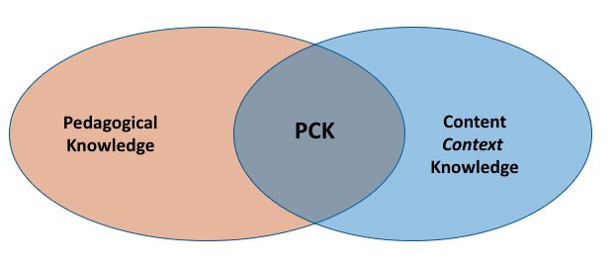
Image Source: Shamini Dias

In this figure, just being a content expert or just having pedagogical knowledge are necessary, but insufficient to help our students learn. The intersection of with Pedagogical knowledge helps us design strategies that help students work with the content to construct knowledge, i.e., to learn.
To Shulman’s model, I have added – CONTEXT. In practicing systems and design thinking for ethical education, the teacher also brings in contextual knowledge of students’ identities, contexts, and the teaching situation, i.e. applying Empathize and Define in the Design Thinking process. This enables us to design inclusive and equity-minded pedagogical strategies.

Mishra and Koehler (2006) created TPACK to integrate technological knowledge.
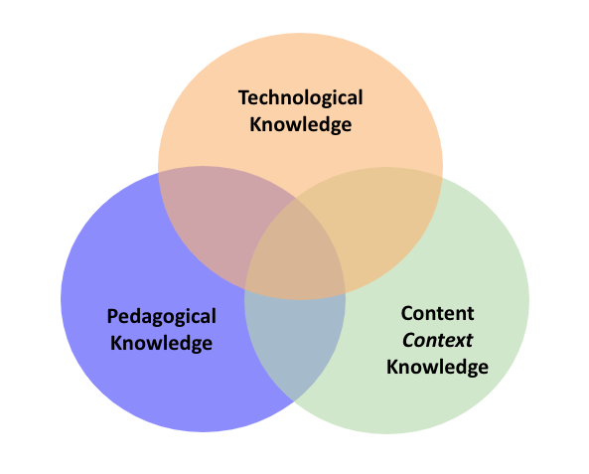

“Our model of technological integration in teaching and learning argues that developing good content requires a thoughtful interweaving of all three key sources of knowledge: technology, pedagogy, and content.” - Mishra & Koehler, 2006; p. 1029

Image Source: Shamini Dias. Based on Mishra & Koehler (2006)

An educator needs to engage and synthesize all three domains.
- We are Content experts. We use systems and design thinking to build Context knowledge that can inform how we present content.
- To this we add Pedagogical knowledge to bring in inclusive, equity-minded strategies.
- Our Technological knowledge helps us integrate technologies and multiple ways of finding, using, and sharing information.

Supporting all this are our explicitly examined and embodied values, beliefs, and goals for our students.

Substitution, Augmentation, Modification, Re-Definition (SAMR)

The SAMR model for transforming teaching and learning was developed by Ruben Puentedura.
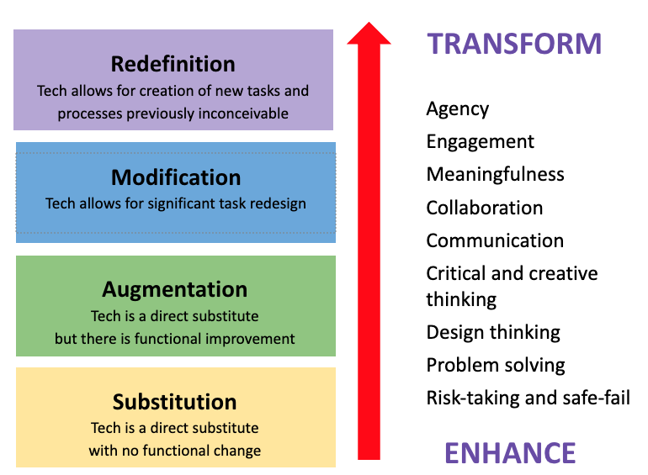
Image Source: Shamini Dias.

The model has 4 stages:
- We can substitute technology for a manual process without changing the activity functions.
- We can augment a process with technology that allows some gains in how the activity is done.
- We can modify a process using technology that actually changes the activity creating many gains in learning and teaching.
- We can redefine a process entirely bringing in new activities and ideas the reframe goals and approaches in teaching and learning.

According to Ruben Puentedura, who created this model, ALL levels are valid for teachers wanting to integrate technology. This is the notion of “edging-in”; starting with small steps, testing and trying, and using feedback to engage deeper integration. Over time, as we build confidence and self-efficacy with digital tools, we are able to conceptualize and create deeper integration that supports learning for more students in powerful equity-minded ways.
This forward movement of edging-in is critical for transformative education to actualize movement from the transmission toward the empowerment model. Digital tools enable us to design flexibility and access into many aspects of learning – albeit being mindful in the Empathize and Define phases of design of access issues with digital tools.
Notice that empowerment in teaching and learning expands as you move up from Substitution toward Redefinition. When we engage UDL principles and goals to work inclusively and create equity-minded spaces and processes for learning, we work with Modification and Redefinition.

We can use the SAMR model to transgress and transcend legacy practices – to transform education. The principles of technology integration for ethical, future-focused education:
- Capacity Building: Enhance learning experiences and outcomes to engage content mastery with meaningfulness, agency, higher-level thinking, and our ethical agency as educators.
- Adaptivity or Nimbleness: Build skills and capacities that help students flourish in our classrooms and into their futures. Develop nimbleness in our design and facilitation capacities.
- Justice – Diversity Inclusion Equity. Ingrate technology to include and empower diverse learners to succeed as well as to dismantle barriers to learning and flourishing.

TASK: Explore the SAMR Model

View How to apply the SAMR model with Ruben Puentedura [6:53 mins]. Ruben Puentedura explains how and why he created the SAMR model and gives an overview of how to use it.

Watch: Demystifying SAMR with Ruben Puentedura [15:33 mins] In this video, Ruben Puentedura speaks some common misconceptions and how to use SAMR effectively.

TASK: Use the SAMR Template
SAMR helps us remove barriers and amplify empowerment - student agency, voice, meaningfulness, and authenticity. Use this SAMR template and transform an assignment or activity to make a student-inclusive, equity-minded engagement through integration of UDL and multiliteracies. See the examples on the next page.
Level | Task | Pedagogical Change
Substitution  Digital technology is used – but does same task as before.​ | task | No functional change in the teaching-learning process; this is still teacher-centric. Nothing is gained from using the computer.
Augmentation  Digital technology creates more effective task performance. | task | There is some functional benefit.
Modification  Moves beyond traditional teacher-centric approach and towards some classroom transformation. | task | There is significant functional change in the teaching-learning process.
Redefinition  Digital technology enables new processes and outcomes that were previously inconceivable | task | There is a transformative shift in teaching and learning.  Digital technology is necessary and integral to the process.

RESOURCE: Examples of SAMR application – ESSAY WRITING
Level | Task | Pedagogical Change
Substitution  Digital technology is used - does the same task as before. | Students write an essay, then type final copy on a computer. Print out to hand in. | No functional change in the teaching-learning process; this is still teacher-centric. Nothing is gained from using the computer.
Augmentation  Digital technology creates more effective task performance. | Students draft the essay on a computer using citation management software. Revisions are edited and formatted on the computer. Canvas upload. | There is some functional benefit – Citation management saves time and is more accurate. Easier and hence more motivating to do revisions. The process is still teacher centric. Time saving efficiency helps busy students.
Modification  Moves beyond traditional teacher-centric approach and towards some classroom transformation.​ | Students write an essay on wiki pages in stages with peer-review and revision. | Significant functional change. Digital technology is necessary rather than an addition. Inclusivity is increased:  Wikis allow both in- and out-of-class collaboration at times that work for them to work on writing and do peer review.  The teacher can comment through the process of writing and so is more integrated in the process in a co-creative way.  More opportunity to support writing facilitation to student ability levels.
Redefinition  Digital technology enables new processes and outcomes that were previously inconceivable | Students do projects to make a documentary video or website that explores and responds to a topic/issue.  Each group takes on a different role/perspective in relation to the issue, conduct research using both scholarly and community sources, and build their final product that is presented online. | Digital technology is necessary and integral to the process.  Learning is student-centered and led. Students generate questions, lead discussions, and have autonomy in designing content. Teacher becomes project guide and resource facilitator.  Learning includes information literacy skills – search, identify, evaluate, compare, select.  Learning integrates outside classroom experiences connecting with community and engaging authentic audiences. Meaningfulness is enhanced.  Content knowledge and skills are learned as a result of developing the product for an authentic audience.

RESOURCE: Examples of SAMR application – ART HISTORY
Level | Task | Pedagogical Change
Substitution  Digital technology is used but does the same task as before. | Art terms. Students write definitions. Print out and hand them to teacher. Assessed in mid-term quiz. | No functional change in the teaching-learning process; still teacher-centric. Nothing is gained from using the computer.
Augmentation  Digital technology creates more effective task performance. | Art terms. Students submit definitions in a 1-page paper via Canvas. Teacher comments within the LMS. Assessed in mid-term quiz. | Some functional benefits. Students do not have to print – all work is done digitally.  Teacher able to read and give feedback to students more easily. If a student is not able to come to class, the work is not lost.
Modification  Moves beyond traditional teacher-centric approach and towards some classroom transformation. | Blog or wiki. Students post definitions - visible to peers. Students assigned to check and improve each other’s definitions, to add and expand, leave comments for each other. Teacher responds in real time, adds links to further resources for students to explore and develop definition. Assessed in process by teacher and peers. And mid-term quiz.​ | Significant functional change. Digital technology is necessary, not an addition.  Shared or Peer Learning – easier with digital tools. Students support and learn from each other. Feedback and resources for one student are available to all. Teacher does not have to repeat feedback to different students.  Community – modeling sharing and helping each other.  Multiple points of assessment – formative & summative.
Redefinition  Digital technology enables new processes and outcomes that were previously inconceivable | Students create their own blog page (connected to a main class blog) in which they explore their art term in relation to painting. Short assignments throughout the semester guide them in adding to their blog page - images, reflections, quotes, videos, links to websites, etc., all linked with their term. This gives a more in-depth understanding of painting terms, as well as allow students to be creative, sparking the interest of other students who can look through the pages to see what their peers have done. | Digital technology is integral  Learning is student-centered and led. Each student is “owner” of his/her blog page – autonomy and meaningfulness. Teacher becomes project guide, resource facilitator.  Information Literacy: Development of ability to search, identify, evaluate, select.  Learning Community – students learn a range of art terms by visiting each other’s pages.

PAUSE TO REFLECT AND CONSOLIDATE

RECALL your education journey and your goals as a teacher-scholar-leader to transform learning in any kind of space. How would you connect UDL and Multiliteracies to your vision and mission for teaching, leading, and learning?
- How are UDL and multiliteracies connected to educational equity? How can these frameworks prevent educational injustice and oppression?
- What UDL and multiliteracies principles are you seeing in this course?
- What UDL and multiliteracies principles do you think you can apply to your own teaching design?

Reflect on disabilities: In your undergraduate education, what was your experience of students with disabilities – either your own case, or in peer interactions? Make 2 lists in response to these questions:
- Looking back, were there ableist norms in policies and practices, in school environments?
- Were there elements of an inclusive campus, or at least an inclusive classroom?

Reflect on what you can do in the microcosm of your classroom to apply UDL principles to create an inclusive, equity-minded classroom community in the following areas:
- Course & and practices (especially in mitigating non-inclusive institutional ones)
- Teaching materials
- Class facilitation methods

Consider your further development. What can you do in order to:
- Deepen your awareness and skills to be more effective with disabilities inclusion
- Bring greater awareness and reduce negative perspectives of disabilities among your students.

Add to your TPS and DVS worksheets – can your reflections to some of these questions inform your responses to the questions on the worksheets?

Chapter 13: Transformation 7. Expanding the Disciplinary Canon

We continue exploring UDL and Multiliteracies as tools to expand and transform disciplinary content.

This chapter is an exploration of the following areas:
- Use Empathize and Define in Design Thinking to examine legacy discourses in the light of the current and future diversity of learners and contexts. This will help you to unpack and surface exclusions and marginalization in disciplinary forms of discourse, the canon of authors and sources of material in teaching and research, and the methods used in bringing this material to learner.

- Textbooks and Open Educational Resources (OER). We will look at OER based on Open Access principles as resources for helping us take away the barriers of textbook costs. This will also help us address gaps in representation of diversity in scholarship and teaching materials so that no matter what we teach, we are intentionally designing to expand and transform our legacy disciplinary canon.

- UDL And Multiliteracies in transforming content. As part of the above, we will also look at modalities of texts in creating greater inclusivity in content curation.

You will explore OER resources and begin developing your strategies for transforming your course contents.

Examine Your Discipline’s Discourse, Materials, and Methods

In this section, we will use Design Thinking’s Empathize and Define modes of analysis to reframe and ideate your disciplinary forms of discourse, the canon of authors and sources of material in teaching and research, and the methods used in bringing this material to learners.
TASK: Design Thinking in reflexive examination course content.
Think through the reflexive probes below that explore legacy assumptions and values. If you are not currently teaching, reflect on courses you took in undergraduate education, think about a course you plan to teach, and look on the internet for sample syllabi. Also look at your current scholarship in analyzing and surfacing the patterns of discourse in your disciplinary space. You do not have to answer all the questions; they are there to guide you in the overall goal of surfacing disciplinary assumptions and patterns.
Empathize and Define the larger contexts of education (review)
- Who are our learners today? Consider how broadly diverse they are in terms of cultures, histories, nationalities, abilities, and lived experiences. Make a list. Consider also the breadth of neurodivergence they bring.
- What are the contexts of learning today? Consider learner contexts such as employment, caregiving, full- and part-time learners. Consider future contexts of careers, citizenship, and the skills and capacities they need to be positively generative and to flourish. Also consider digital and physical spaces.

Critically examine the legacy paradigm of your discipline
- What constitutes the legacy paradigm of texts, ideas, methods, and authors that are officially recognized as representative of the discipline, especially in teaching curricula?
- Check alignment: To what extent has the legacy paradigm evolved in alignment with the global shifts – representative of diverse cultures, histories, methods of research, and forms of communication? To what extent have new voices in the field from non-Eurocentric spaces been integrated?

Critically examine your typical course curriculum
- Is there usually a set textbook for a course? To what extent is it possible to replace or supplement it with a plurality of sources, especially with Open Access materials?
- Is there a representation of scholars of color?
- Is there a representation of international voices?
- Are they multiple text types – different genres and forms like webpages, op-eds, podcast, video, journalistic writing, reports etc.? Is it mostly academic written texts?
- Overall, do you find a broad representation of scholarship and voices? Is there alignment with the multimodal information and knowledge world in which we live?

Open Educational Resources (OER) to Reimagine Course Content
TASK: Recall your experience with course material

Before jumping into this exploration, recall your experience with curricula material like textbooks through your undergraduate education.
- Were you required to buy course textbooks for your courses? Did most courses require a textbook? How much of your school budget did it take?
- Were you aware of courses – maybe in other disciplines to yours – that did not require textbooks and provide alternative material?
- If you used textbooks for your courses, did you see a diversity of scholars and scholarship represented in the textbooks?
- Did you get additional sources and materials that brought in alternative discourses from non-academic spaces or aesthetic spaces, and modalities (video and audio)?

Textbooks are a course feature we are so accustomed to that we often overlook how it creates significant inequities in education. Here are 2 of them:

Prohibitive costs: A system of textbook publisher monopolies have escalated textbook costs. Here is some information from the Education Data Initiative:
- The average postsecondary student spends between $628 and $1,471 annually for books and supplies as of the 2021-2022 academic year.
- Hard copy books can cost as much as $400, with an average price between $80 and $150.
- The price of textbooks increases by an average of 12% with each new edition.
We also know that many students use their financial aid to buy textbooks. In 2016, 5.2 million U.S. undergraduates spent a total of $1.5 billion of financial aid on textbooks – per semester. This cost has increased many times today. Student Public Interest Research Group. Covering the Cost (2016). Link to Student Public Interest Research Group website

Singular viewpoint that perpetuates the legacy paradigm: Textbooks are often written by one or a few authors whose curation of resources and bibliography is not representative of the students who will use the textbook. They often showcase a disciplinary legacy canon of male, European scholars especially in Math, Literature, History, and Art. They struggle to be culturally and globally relevant. This is not to say there are no well curated textbooks; however, they are still not the majority.
Open Educational Resources (OER)
“Expanding educational opportunities is more possible now than it has ever been before. …
However, our systems for sharing information in education have not caught up with the potential of 21st century technology. Instead, the educational materials market is held captive by legacy publishing models that actively restrict the dissemination and innovative use of resources in a world that craves educational opportunities. Textbook prices have continued to rise rapidly, leaving too many students without access to their required materials. Digital offerings from traditional publishers come laced with access restrictions and expiration dates with little savings in return, and print editions are too often out of date by the time they hit the shelves. … For too long, our educational systems have operated with a fundamental disconnect between practices left over from the analog world, and the vast potential of technology and the Internet to support more affordable, effective teaching and learning. The movement for Open Education seeks to close this gap” - SPARC Open Education

OER is part of the Open Access (OA) movement for knowledge diversity, inclusion, and equity in an effort to democratize knowledge. OA perspectives, tools, and methods can move knowledge outside of paywalls to make it freely available to the world.
NOTE: The links on this page take you to useful OA information and tools. While you do not have to read all these webpages in detail, do use the links to browse and bookmark some pages for your portfolio.

Definitions of Open Access (OA)
Open access is the “the free, immediate, online availability of research articles coupled with the rights to use these articles fully in the digital environment. Open Access ensures that anyone can access and use these results—to turn ideas into industries and breakthroughs into better lives.” (SPARC Open Access).
OA removes both price barriers (subscriptions, fees) and permission barriers (some copyright and licensing restrictions) to accessing and using materials. (Claremont Colleges Library)
“[T]eaching, learning, and research resources that are free of cost and access barriers, and which also carry legal permission for open use. Generally, this permission is granted by use of an open license (for example, Creative Commons licenses) which allows anyone to freely use, adapt and share the resource—anytime, anywhere. “Open” permissions are typically defined in terms of the “5R’s”: users are free to Retain, Reuse, Revise, Remix and Redistribute these educational materials. (Sparc Open Access)

Benefits of OA (Claremont Colleges Library) - How does OA support diversity, inclusion, equity, and the justice of knowledge creation and access?
- Improves the pace, efﬁciency, and efﬁcacy of research
- Increases authors’ visibility, and thus the potential impact of their work
- Removes structural and geographical barriers that impede the free circulation of information
- Increases the possibility of collaboration, which means there is a higher likelihood of better work and more capacity building.
- Enables the re-use and analysis of published material to build new knowledge
- Sparks innovation and facilitates interdisciplinary research and exchange of ideas
- Strengthens the dissemination, review, and development of breakthroughs, not only for the benefit of research and academic communities but for society at large.
Science Europe Working Group on Open Access. (Revised September 2015). Science Europe Principles on Open Access to Research Publications. Licensed under CC BY 4.0. D/2015/13.324/3

Integrating UDL and Multiliteracies and Open Access
In integrating OER, we can use UDL and Multiliteracies as tools to expand subject matter content in ways that expand equity-minded, culturally relevant, and multimodal course development.
We might easily get rid of a single, expensive textbook. The question then becomes – what do we in replacing textbooks? UDL and Multiliteracies present these strategic questions as you look at OER:
- What OER resources help me integrate UDL and multiliteracies principles with multiple modes of representation, engagement, and expression? How do I get beyond the dominance of read/write and paper formats?
- What OER resources help me bring in culturally relevant material and create a better representation of diversity in authors and discourse styles?
- What OER resources help me bring in meaningful and authentic narratives and images that create contextually relevant connections to larger-world events, people, and information?
- What OER resources help me create a non-ableist set of course materials? What else must I learn in order to do this effectively?
- How can OER help me build opportunities to co-create with students enabling them to bring in culturally and personally relevant material to their learning.

In releasing us from textbooks and a single legacy modality and the danger of a single story (Adichie, 2016), UDL and multiliteracies open pathways for multiple stories and voices - video, images, alternative texts, non-Western, non-male authors, and connections that counter and transform dominant narratives. Bringing in different genres, art, poems, stories, information from current events and non-academic spaces, we create opportunities for students to critical engage and question paradigmatic knowledge, and to expand and construct knowledge in culturally and contextually relevant ways.

Expanding and Transforming Your Course Content

TASK: Explore using OER to develop your course content

Browse through these websites with a view to gathering resources you might use in designing your course. As you browse the resources, evaluate them in terms of representation, cultural relevance, and meaningfulness for your students.
Use Design Thinking processes of Empathize and Define in reflecting on who our learners are and your analysis of the legacy paradigm for content in your discipline.

- Explore The Claremont Colleges Research Guide on Open Access. In addition to definition and benefits, they have information on OA misconceptions, processes for OA in scholarship and teaching, and connections to more resources. Specifically, focus on exploring How to Find OA Content – there is a wealth of OA repositories that you can draw from both for teaching and scholarship.

- OER Commons – “A public digital library of open educational resources. Explore, create, and collaborate with educators around the world to improve curriculum.” This site offers free membership so you can find content created by thousands of educators, join groups, and also become a content provided. This initiative is a great example of co-creative collaboration among educators. They use a platform called Open Author that you can learn to use to build your own OER material to share.

- OpenStax – This is a non-profit initiative at Rice University. Their mission is to improve access to knowledge and learning for everyone through creating and sharing OER. Their standards are to use expert authors who create OA textbooks to their standards of scope and sequence, and to ensure a peer review process for the materials they create. You can set up a free account to access their resources.

Make a list of legacy or canonical texts – textbooks, primary documents etc. that are most often used to teach the subject you hope to teach (or currently teach).

Reframe and transform. Based on your exploration make a second list of OA texts that are more representative, culturally relevant, and meaningful that you can bring into your course.

References and Further Exploration
NOTE: These are NOT required as class preparation. They are provided so you can dive deeper into areas of interest. I encourage you to explore when you can and hope they will expand your perspectives and inform your teaching and research.

Jump to Sections:
Transdisciplinarity
Pluralism in Ways of Knowing
Reflexivity
Metaphors
Systems Thinking and Complexity
Cynefin Framework
Paradigm Shift
Counter Mapping and Counter Storytelling
Design Thinking
Education as Transformation
Culturally Responsive and Sustaining Pedagogies
Identities and Inequities
Positionality
Learning and Motivation Theories
Outcomes Design
Backwards Course Design
Active Learning
Community
Assessment Feedback Grading
UDL and Multiliteracies

Transdisciplinarity
Augsburg, T. (2014). Becoming transdisciplinary: The emergence of the transdisciplinary individual. World Futures, 70(3–4), 233–247.
This is a good article to learn about the emergence and development of transdisciplinarity. Tanya Augsburg concisely presents the origins of transdisciplinary critique and reframing of epistemology and ontology, and the pragmatic application of transdisciplinary principles in solving wicked problems (especially in sustainability work) and the development of post-normal science and Mode 2 research. She outlines some of the key principles and processes of transdisciplinary work – collaboration, trans-sector stakeholder participation (i.e., beyond academia), recognition of plurality in realities and ways of knowing, openness and embracing of unknowns, instabilities, and emergence (complexity mindsets). She delineates the capacities and skills of the transdisciplinary person – providing us with a strong starting point to determine how these connect with our own capacities, our goals and methods in working for change and growth as educators and leaders.
Klein, J. T. (2014). Discourses of transdisciplinarity: Looking back to the future. Futures, 63, 68–74.
Julie Klein was a leading scholar in transdisciplinary thought and practice development. In this article, she looks at trends that have shaped TD thinking – Transcendence, Problem Solving, and Transgression. She examines the increasing divergence and fragmentation of knowledge and ways of knowing that point to transcendence of disciplinary boundaries and new frameworks for synthesis, the heightening of solving social-global problems with trans-sector stakeholders in society and team-science, and the transgressive movement to critique existing/legacy systems of knowledge and education. She shows the alignment of TD with imperatives of “cultural critique, sociopolitical movements, and conceptions of post-normal science and wicked problems that break free of reductionist and mechanistic approaches”, in the broader socio-political crises in questioning legacy dominant systems of knowledge, issues of human rights accountability and democratic engagement. She argues that with an increased need and focus on problem solving, “emphasis is shifting from traditional epistemology to problem solving, from the pre-given to the emergent, and from universality to hybridity and contextuality”.
Moore, S. A. (2018). Radical listening: Transdisciplinarity, restorative justice and change. World Futures, 74(7–8), 471–489.
Shannon Moore presents a transdisciplinary reframing of Radical Listening (first coined by critical pedagogue J.L. Kincheloe). While her presentation is within the context of restorative justice and counseling psychology in childhood studies, her arguments help us understand how transdisciplinary complexity thinking and a valuation of Indigenous ways of knowing help address the hegemonic disciplinary positioning of scholarship in childhood studies toward a “nuanced understanding of a rights-based perspective and an appreciation of the intersections of social, political, and cultural worlds”.
Rittel, H.W.J., & Webber, M.M. (1973). Dilemmas in a general theory of planning. Policy Sci 4, 155–169
Horst Rittel and Melvin Webber are credited with coining the term “wicked problem” in this article. They argue that the scientific logic models of the time are inadequate for addressing social policy issues because “problems cannot be definitively described. Moreover, in a pluralistic society there is nothing like the undisputable public good; there is no objective definition of equity; policies that respond to social problems cannot be meaningfully correct or false; and it makes no sense to talk about “optimal solutions” to social problems unless severe qualifications are imposed first. Even worse, there are no “solutions” in the sense of definitive and objective answers.” This is starkly true in describing the issues we face today.

Pluralism in Ways of Knowing
Battiste, M., & Henderson, J. (Sa’ke’j) Y. (2009). Naturalizing indigenous knowledge in Eurocentric education. Canadian Journal of Native Education; Edmonton, 32(1), 5-18,129-130.
Bernal, D. D. (2020). Disrupting epistemological boundaries. Reflections on feminista methodological and pedagogical interventions. Aztlán: A Journal of Chicano Studies, 45(1), 155–169.
Cajete, G. (2000). Native science: Natural laws of interdependence. Clear Light Publishers.
Galván, R. (2014). Chicana/Latin American feminist epistemologies of the global South (within and outside the North): Decolonizing el conocimiento and creating global alliances. Journal of Latino/Latin American Studies, 6(2), 135–140.
Nowotny, H., Scott, P., & Gibbons, M. (2003). Introduction: “Mode 2” revisited: The new production of knowledge. Minerva. Special Issue: Reflections on the New Production of Knowledge, 41(3), 179–194.
Yunkaporta, T. (2020). Sand talk. How indigenous thinking can save the world. Harper One.

Reflexivity
Argyris, C. (1999). On organizational learning. Blackwell.
Argyris, C., & Schön, D. A. (1978). Organizational learning: A theory of action perspective. Addison-Wesley.
Finlay, L. (1998) ‘Reflexivity: an essential component for all research?’, British Journal of Occupational Therapy, 61, 10: 453-456.
Tagg, J. (2010). The learning-paradigm campus: From single- to double-loop learning. New Directions for Teaching & Learning, 2010(123), 51–61.
Warwick University. Education Studies.

Metaphors
Lakoff, G. & Johnson, M. (2003). Metaphors we live by. University of Chicago Press.

Systems Thinking and Complexity
Beaumont, P., & Coning, C. de. (2022). Coping with complexity: Toward epistemological pluralism in climate–conflict scholarship. International Studies Review, 24(4).
Capra, F. & Luisi, P. L. (2016) A systems view of life. A unifying vision. Cambridge University Press.
This book integrates theories underlying systems view of life into a strong framework that illuminates complexity, networks, and patterns in multiple disciplines. It offers a history of the emergence of systems thinking and the interconnectedness of all life.
Chandler, D. (2007). Semiotics. The basics. Routledge.
Escobar, A. (2021). Designs for the pluriverse. Radical interdependence, autonomy, and the making of new worlds. Duke University Press.
Hening, A. (2018). Systems thinking. Part 1: Elements, interconnections, and goals. The Medium.
Meadows, D. (2008) Thinking in systems. A primer. Chelsea Green Publishing.
A great primer on how to develop your ability as a systems thinker in approaching and addressing complex issues in the world. This book also has guidance in how to create systems maps.
Morin. E. (1992). From the concept of system to the paradigm of complexity (Trans. Sean Kelly). Journal of Social and Evolutionary Systems. 15(4). 371-385.
Stroh, D. P. (2015). Systems thinking for social change. Chelsea Green Publishing.
Tummons, J. (2021). Ontological pluralism, modes of existence, and Actor-Network Theory: Upgrading Latour with Latour. Social Epistemology, 35(1), 1–11.
Vizcaíno, R. (2021). Did you listen? Zapatismo and epistemic decolonization. Transmodernity: Journal of Peripheral Cultural Production of the Luso-Hispanic World, 9(6).

Cynefin Framework
The Cynefin framework is fluid and constantly being developed. You can read about it on the Cognitive Edge website and check the latest developments on the Cynefin Wiki.
Corrigan, C. (2020) A tour around the latest Cynefin iteration. This is a useful article that explains Cynefin and how it can be used in analysis of a situation.
Gray, B. (2017). The Cynefin framework: Applying an understanding of complexity to medicine. Journal of Primary Health Care, 9(4), 258.

Paradigm Shift
Kuhn, T. S. (1963). The structure of scientific revolutions. International Encyclopedia of Unified Sciences.

Counter Mapping and Counter Storytelling
Dalton, C. M. & Stallman, T. (2018). Counter mapping data science. The Canadian Geographer, 62(1), 93-101.
Elwood, S. (2006). Critical issues in participatory GIS: Deconstructions, reconstructions, and new research directions. Transactions in GIS 10(5):693-708.
Harley, J. B. (1992) History of Cartography. Vol. 1. University of Chicago Press.
Lorde, A. (1983). The master’s tools will never dismantle the master’s house. (p. 94-101). In C. Moraga and G. Anzaldua (eds.), This bridge called my back: Writings by radical women of color. Kitchen Table Press.
The essay is based on Lorde’s 1979 speech at a feminist panel at NYU. While Lorde was offering a critique of white feminism, her idea applies to all actions for transformation.
Peluso, N. L. (1995). Whose woods are these? Counter-mapping forest territories in Kalimantan, Indonesia. Antipode 27(4): 383-406.

Design Thinking
Owen, C. (2007). Design Thinking: Notes on its nature and use. Design Research Quarterly, 2(1). 16-27
Design Thinking. Interaction Design Foundation website.
Panke, S. (2019). Design Thinking in education: Perspectives, opportunities and challenges. Open Education Studies, 1(1), 281–306

Education as Transformation
Anderson, J., Boyles, J. L., & Rainie, L. (2012, July 27). The future of higher education. Pew Research Center.
Cranton, P. (2016). Understanding and promoting transformative learning. Routledge.
Patricia Cranton was a scholar of transformative education, integrating science and philosophy masterfully to explain the dynamics and potential for transformative teaching and learning.
Freire, P. (2000). Pedagogy of the oppressed. Continuum.
Ira Shor (Ed.) (1987) Freire for the classroom. A sourcebook for liberatory teaching.
A collection of essays by teachers using Freire's methods in the United States – full of practical application of principles. The book also includes Freire's Letters to North American Teachers.
Lotz-Sisitka, H., Wals, A. E., Kronlid, D., & McGarry, D. (2015). Transformative, transgressive social learning: Rethinking higher education pedagogy in times of systemic global dysfunction. Current Opinion in Environmental Sustainability, 16, 73–80.
Palmer, P. (2017) The courage to teach. Jossey Bass.

Culturally Responsive and Sustaining Pedagogy
Alim, H. S. (2011). Global ill-literacies: Hip Hop cultures, youth identities, and the politics of literacy. Review of Research in Education, 35(1), 120–146.
Alim, H. S., & Paris, D. (2015). Whose language gap? Critical and Culturally Sustaining Pedagogies as necessary challenges to racializing hegemony. Journal of Linguistic Anthropology, 25(1), 66–86.
Alim, H. S., & Reyes, A. (2011). Complicating race: Articulating race across multiple social dimensions. Discourse & Society, 22(4), 379–384.
Alim, H. S., Rickford, J., & Ball, A. (Eds.). (2016). Raciolinguistics: How language shapes our ideas of race. Oxford University Press
Boykin, A. W. (1986). The triple quandary and the schooling of Afro American children. In U. Neisser (Ed.), The school achievement of minority children: New perspectives (pp. 57–92). Erlbaum.
Delpit, L. (1988). The silenced dialogue: Power and pedagogy in educating other people’s children. Harvard Educational Review, 58(3), 280–298.
Delpit, L. (1995). Other people’s children. Cultural conflict in the classroom. The New Press.
Du Bois, W. E. B. (1965/1903). The souls of Black folk. Avon Books.
Gay, G. (2018/2000). Culturally responsive teaching: Theory, research, and practice. Teachers College Press.
Giroux, H. (1996). Fugitive cultures: Race, violence, and youth. Routledge.
Gozalez, N., Moll, L. C., & Amanti, C. (2005). Funds of knowledge. Theorizing practices in households, communities, and classrooms. Lawrence Earlbaum Associates.
Gutiérrez, K. (2008). Developing a sociocritical literacy in the third space. Reading Research Quarterly, 43(2), 148–164.
Hammond, Z. L. (2020). Culturally responsive teaching and the brain: Promoting authentic engagement and rigor among culturally and linguistically diverse students. Corwin.
hooks, b. (1994). Teaching to transgress. Education as the practice of freedom. Routledge.
hooks, b. (2003). Teaching community. A pedagogy of hope. Routledge.
hooks, b. (2009). Teaching critical thinking. Practical wisdom. Routledge.
bell hooks’s writing is powerful in offering direct and sharp critiques of the legacy system while at the same time offering a compassionate and healing approach that brings joy into learning.
Ladson-Billings, G. (1994). The Dreamkeepers: Successful teachers of African American children. Jossey-Bass.
Ladson-Billings, G. (1995). Toward a theory of culturally relevant pedagogy. American Educational Research Journal, 32(3), 465−491.
Ladson-Billings, G. (2014). Culturally relevant pedagogy 2.0: The remix. Harvard Educational Review, 84(1), 74–84.
Love, B. (2020). We want to do more than survive. Abolitionist teaching and the pursuit of educational freedom. Beacon Press.
Love, B. L. (2012). Hip Hop’s li’l sistas speak: Negotiating Hip Hop identities and politics in the new South. Peter Lang.
Moll, L., & Gonzalez, N. (1994). Lessons from research with language minority children. Journal of Reading Behavior, 26(4), 23–41.
Nieto, S. (1992). Affirming diversity: The sociopolitical context of multicultural education. Longman.
Nieto, S. (2010). The light in their eyes. Creating multicultural learning communities. Teachers College Press.
Paris, D. (2012). Culturally sustaining pedagogy: A needed change in stance, terminology, and practice. Educational Researcher, 41(3), 93–97.
Paris, D., & Alim, H. S. (Eds.). (2017). Culturally sustaining pedagogies: Teaching and learning for justice in a changing world. Teachers College Press
Sizemore, B. A. (2008). Walking in circles: The Black struggle for school reform. Third World Press.
Solorzano, D. G., & Bernal, D. D. (2001). Examining transformational resistance through a Critical Race and Latcrit theory framework: Chicana and Chicano students in an urban context. Urban Education, 36(3), 306–342. http://citeseerx.ist.psu.edu/viewdoc/download?doi=10.1.1.462.6274&rep=rep1&type=pdf
Taylor, P. (2014). The next America: Boomers, millennials, and the looming generational showdown. Perseus Book Group.
Yosso, T. J. (2005). Whose culture has capital? A critical race theory discussion of community cultural wealth. Race Ethnicity and Education, 8(1), 69–91. https://doi.org/10.1080/1361332052000341006

Holistic Pedagogy
Rudge, L. T. (2016). Holistic pedagogy in public schools. A case study of three alternative schools. Other Education. A Journal of Educational Alternatives, 5(2). 169-195. The article has a good theoretical overview of the background and philosophy of holistic pedagogy.
Holistic education website - short articles and overviews of the approach and a bibliography

Contemplative Pedagogy
Tree of contemplative pedagogy - a graphic representation of the different practices.
Kaufman, P. (2017). Critical contemplative pedagogy. Radical Pedagogy 14(1). Kaufman shows how principles and practices of contemplative pedagogy connect with critical pedagogy.
Contemplative Pedagogy Network
Laura Rendon - Contemplative Practices Centering Social Justice - video. [View time: 42:39 mins] While this is a long video, it is worth watching if you are interested in how contemplative pedagogy as a tool can further social justice goals and outcomes

Indigenous Pedagogy
Pulling Together: A Guide for Curriculum Developers by Asma-na-hi Antoine, Rachel Mason, Roberta Mason, Sophia Palahicky, and Carmen Rodriguez de France. This is a thorough Open Access resource at the University of British Columbia.
Indigenous Epistemologies and Pedagogies -a good overview of this approach.
Allen Luke - videos on Indigenous Education.- Allen Luke is an Australian researcher. He explains the different facets of indigenous pedagogy and implementation in Australia.
First Nations Principles of Learning - Video [8:59 mins]
Sand Talk. How Indigenous Thinking Can Save the World. While not directly about education, this book by Australian indigenous scholar Tyson Yunkaporta shares indigenous mindsets and approaches to life and learning that can inform how we design our pedagogies.

Abolitionist Pedagogy
Davis, A. Y. (2003). Are Prisons Obsolete? New York: Seven Stories Press
U.S Incarceration compared to nations in the OECD - graphic.
Interview with Bettina Love - author of We want to do more than survive: Abolitionist teaching and the pursuit of educational freedom. Boston: Beacon Press. 2019. She explains what it really means “to matter” and how this enters into education.
Bettina Love explains aspects of abolitionist pedagogy - series of video clips.
Abolitionist Teaching Network
Dunn, D. C., Chisholm, A., Spaulding, E., & Love, B. L. (2021). A radical doctrine: Abolitionist education in hard times. Educational Studies, 57(3), 211–223.

Critical Race Pedagogy
Critical Race Theory and Education - Gloria Ladson Billings - Video [view time: 1:32:54]
Lac. V. T. (2017). In real time. From theory to practice in a critical race classroom. Inquiry in Education, 9(1). Article 3.
Ladson-Billings, G., & Tate, W. F. (2006). Toward a critical race theory of education. In A. D. Dixson & C. K. Rousseau (Eds.) Critical race theory in education: All God’s children got a song (pp. 11-30). New York, NY: Taylor & Francis
Lynn, M., Jennings, M. E. & Hughes, S. (2013) Critical race pedagogy 2.0: lessons from Derrick Bell. Race Ethnicity and Education, 16(4), 603-628,
Derrick Bell - Critical Race theorist - discusses racism. Video. [View time 29:08 mins].
Derrick Bell - Faces at the bottom of the well. The permanence of racism. This is a powerful book - a collection of articles that are parables that show the deep roots of racism in the United States as a result of the “ultimate betrayal” of slavery and thus, the failure of integration.
Delgado, R. (Ed.). (1995). Critical race theory: The cutting edge. Philadelphia: Temple University Press.

Arts-Based Pedagogy
Maxine Greene institute - Maxine Greene was a proponent of engaging the individual and social imagination through the arts.
Greene, M. (2000). Releasing the imagination. Essays on education, the arts, and social change. Jossey Bass.
ArtsEdge by the Kennedy Center for the Arts - a resource site for arts-integration education. ArtsEd Search database - a great database to look at research on arts in connection to multiple aspects of education for social justice.
Theatre of the Oppressed - Augusto Boal inspired by Freire created a process theatre approach with liberatory and transformative goals. Here is a London based group that uses theatre of the oppressed to address and humanize homelessness.
Catterall, J. S. (2012) Doing well and doing good by doing art. A 12-year national study of education in the visual and performing arts.
Process Drama - open, improvised, scaffolded role play in learning. Created by Dorothy Heathcote in the UK, it has been used globally for transformative, reflexive learning. Here is a description as used in a high school class exploring the 8th Amendment. Theatre in Education video - View Time: 3:30 mins.
10 Lessons that the Arts Teach – based on work by Stanford professor, Elliot Eisner

Identities and Inequities
Anderson, S.K. & Middleton, V.A. (Eds.) (2018). Explorations in diversity: Examining the complexities of privilege, discrimination, and oppression. Oxford University Press,
Bronfenbrenner, U. (1974). Developmental research, public policy, and the ecology of childhood. Child development, 45 (1), 1-5.
Brown, P. G. Website: Applying Bronfenbrenner’s theory to college students and social media.
There is a great video on this webpage that animates the explanation.
Carbado, D. W., Crenshaw, K. W., Mays, V. M., & Tomlinson, B. (2013). Intersectionality. Mapping the movements of a theory. Du Bois Review: Social Science Research on Race, 10(2), 303–312.
Crenshaw, K. (1989) Demarginalizing the intersection of race and sex. A Black feminist critique of anti-discrimination doctrine, feminist theory and antiracist politics. University of Chicago Legal Forum, I(8).
Jacobson, D., & Mustafa, N. (2019). Social identity map: A reflexivity tool for practicing explicit positionality in critical qualitative research. International Journal of Qualitative Methods, 18,
Collins, P. H. (2012). Social inequality, power, and politics: Intersectionality and American pragmatism in dialogue. The Journal of Speculative Philosophy, 26(2), 442–457.
Office of Multicultural Learning. Santa Clara University.
This webpage explains the application of Bronfenbrenner’s model to college student experience, They have annotated the model with all the elements of the college system that affect a student.
Misawa, M. (2010). Queer race pedagogy for educators in higher education: Dealing with power dynamics and positionality of LGBTQ students of color. International Journal of Critical Pedagogy, 3 (1), 26-35.
Museus, S. D. & Griffin, K. A. (2011). Mapping the margins in higher education: On the promise of intersectionality frameworks in research and discourse. New Directions in Institutional Research, 151.
Taylor, G. & Ali, N. (2017) Learning and living overseas: Exploring factors that influence meaningful learning and assimilation: How international students adjust to studying in the UK from a socio-cultural perspective. Education Sciences 7(1)
While this article is about international students, the exploration through a systems lens using Bronfenbrenner’s model is useful for understanding many other types of students, especially first generation college students.

Positionality
Maher, F. A., & Tetreault, M. K. T. (2001). The feminist classroom: Dynamics of gender, race, and privilege (Expanded ed.). Rowman & Littlefield Publishers.
Martine, R. J., & Gunten, D. M. (2002). Reflected identities: Applying positionality and multicultural social reconstructionism in teacher education. Journal of Teacher Education, 53(1), 44-54.
Collins, P.H. (2001). Black Feminist Thought: Knowledge, Consciousness, and the Politics of Empowerment. Routledge.

Learning Theories

Learning Styles
Pashler, H., McDaniel, M., Rohrer, D.,, & Bjork, R. (2008). Learning styles: Concept and evidence. Psychological Sciences in the Public Interest 9(3). 106-119.
This critical study concluded there was no scientific evidence to support or negate the idea of learning styles. They recommend that educators should focus on “identifying and introducing the experiences, activities, and challenges that enhance everybody’s learning”.
Coffield, F., Mosely, D., Hall, E., & Ecclestone, K. (2004). Learning styles and pedagogy in post-16 learning: A systematic review. Learning and Skills Research Center. 182 pages ​
This is a large research review of the 13 most influential learning style models. The report concludes warns against unwarranted faith in simple inventories and widespread disagreement on implications for teaching. There is also a short discussion of the context of learning. While you might not read this entire report in detail, the discussion sections are easily managed.

Abraham Maslow.
http://www.simplypsychology.org/maslow.html - a good website for quick overviews of many psychological theories. This page on Maslow has a good video explaining the theory.
Maslow, A. H. (1987). Motivation and personality (3rd ed.). Pearson Education.
Tay, L. & Diener, E. (2011). Needs and subjective well-being around the world. Journal of Personality and Social Psychology, 101(2), 354-365.

Carol Dweck. Growth and Fixed Mindsets
TED Talk by Carol Dweck (2014) The Power of Believing That You Can Improve.
Mangels, J. A.; Butterfield, B.; Lamb, J.; Good, C.; Dweck, C. (2006). Why do beliefs about intelligence influence learning success? A social cognitive neuroscience model. Social Cognitive and Affective Neuroscience. 1 (2): 75–86.

Richard Ryan and Edward Deci. Self-Determination Theory
http://www.selfdeterminationtheory.org/theory
Ryan, R. M., & Deci, E. L. (2000). Self-determination theory and the facilitation of intrinsic motivation, social development, and well-being. American Psychologist, 55(1), 68–78.
Reeve, J. (2002). Self-determination theory applied to educational settings. In E. L. Deci & R. M. Ryan (Eds.), Handbook of self-determination research (p. 183–203). University of Rochester Press.

Jean Piaget
The Equilibration of Cognitive Structures: The Central Problem of Intellectual Development (Chicago: University of Chicago Press, 1985) [L'equilibration des structures cognitives (1975), previously translated as The development of thought: Equilibration of cognitive structures (1977)].
Britannica Entry for Piaget’s Theory of Cognitive Equilibrium.
Boom, J. (2009). Piaget on equilibration. In U. Müller, J. I. M. Carpendale, & L. Smith (Eds.), The Cambridge companion to Piaget (pp. 132–149). Cambridge University Press.
Ginsburg, H. P. & Opper, S. (1987) Piaget’s theory of intellectual development. (3rd. Edition). Prentice-Hall.

Lev Vygotsky
https://www.simplypsychology.org/vygotsky.html - overview of Vygotsky’s theory.
Kozulin, A., Gindis, B., Ageyev, V., & Miller, S. (Eds.). (2003). Vygotsky's Educational Theory in Cultural Context (Learning in Doing: Social, Cognitive and Computational Perspectives). Cambridge: Cambridge University Press. doi:10.1017/CBO9780511840975. E-Book at Claremont Colleges Library
Vygotsky, L. (1978). Mind in Society. Harvard University Press.

Social Emotional Learning
Diener, E. (2012). New findings and future directions for subjective well-being research. American Psychologist, 67(8), 590–597.
Quinlan, K. M. (2016). [10 pages] How emotion matters in four key relationships in teaching and learning in higher education. College Teaching, 64(3), 101–111.
Reinert, P.M. (2019). Social-emotional learning: a model for higher education. Journal of Research in Innovative Teaching & Learning, 12(2), 114-115.
Durlak, J. A., Weissberg, R. P., Dymnicki, A. B., Taylor, R. D., & Schellinger, K. B. (2011).[27 pages] The impact of enhancing students’ social and emotional learning: A meta-analysis of school-based universal interventions. Child Development, 82(1), 405–432.
Dena Simmons (2019) Why we can’t afford whitewashed social-emotional learning.

Martin Seligman. PERMA
Kennon M. Sheldon & Sonja Lyubomirsky (2006). How to increase and sustain positive emotion: The effects of expressing gratitude and visualizing best possible selves, The Journal of Positive Psychology 1(2), 73-82
Watch Martin Seligman explain PERMA https://youtu.be/iK6K_N2qe9Y
Martin Seligman (2018) PERMA and the building blocks of well-being, The Journal of Positive Psychology, 13(4), 333-335.
Positive Education applied in an Australian school - the Geelong Grammar School.
There are some excellent pages where they describe positive education and key elements in their model and how they have applied it in teaching and learning.
Seligman, M. E. P. (2011). Flourish. Simon & Schuster.
Diener, E. (2020). Happiness: the science of subjective well-being. In R. Biswas-Diener & E. Diener (Eds), Psychology. DEF publishers.

Outcomes Design
Anderson, L. W. and Krathwohl, D. R., et al (Eds..) (2001) A taxonomy for learning, teaching, and assessing: A revision of Bloom’s taxonomy of educational objectives. Allyn & Bacon.
Fink, L. D. (2013). Creating significant learning experiences: An integrated approach to designing college courses (2nd ed.). San Francisco: Jossey-Bass. Also available at http://finkconsulting.info/major-publications/
AAA&U
ACC&U’s ELOs page
AAC&U's High Impact Practices page
AAC&U’s VALUE page
https://www.celt.iastate.edu/instructional-strategies/effective-teaching-practices/revised-blooms-taxonomy/ website at Iowa State has an interactive model of the different levels of Bloom’s taxonomy and downloadable teaching planning resources.
https://www.schrockguide.net/app-for-that.html - A representation of all the different levels of Bloom’s taxonomy matched to suggestions for using iPad, Google, Android, and web 2.0 apps for teaching and learning.

Backward Course Design
Wiggins, G, & McTighe, J. (1998). Understanding by Design. ASCD.
https://www.edglossary.org/backward-design/ - Glossary of Education Reform is by the Great Schools Partnership in an effort to provide a good source explaining school-improvement ideas, frameworks, and strategies to support teachers, but also to create understanding among parents, journalists, and community members.

Active Learning
Allsop, J., Young, S. J., Nelson, E. J., Piatt, J., & Knapp, D. (2020). Examining the benefits associated with implementing an active learning classroom among undergraduate students. International Journal of Teaching and Learning in Higher Education, 32(3). 418-426.
Baepler, P. & Walker, J. D. (2014). Active learning classrooms and educational alliances: Changing relationships to improve learning. New Directions for Teaching and Learning, 137. 27-40
Bligh, D. A. (2000). What’s the use of lectures? John Wiley & Sons.
Exley, K. & Dennick, R. (2009). Giving a lecture: From presenting to teaching. Key guides for effective teaching in higher education. 2nd edition. Routledge.
Freeman, S., Eddy, S. L., McDonough, M., Smith, M. K., Okoroafor, N., Jordt, H., & Wenderoth, M. P. (2014). Active learning increases student performance in science, engineering, and mathematics. Proceedings of the National Academy of Sciences, 111(23), 8410–8415.
French, S. & Kennedy, K. (2017). Reassessing the value of university lectures. Teaching in Higher Education, 22(6), 639-654.
Hoellwarth, C. & Moelter, M. J. (2011). The implications of a robust curriculum in introductory mechanics. American Journal of Physics 79, 540–545.
King, A. (1993). From sage on the stage to guide on the side. College Teaching, 41 (1), 30-35.
Mazur, E. (1996). Peer instruction. A user’s manual. Pearson Publications
This is a step-by-step guide for using peer-instruction in lectures, especially for introductory courses with large class sizes. While some of the resources are for STEM courses, especially math-based physics courses, the strategies and principles apply across disciplines.
Lombardi, D., Shipley, T. F., Bailey, J. M., Bretones, P. S., Prather, E. E., Ballen, C. J., Knight, J. K., Smith, M. K., Stowe, R. L., Cooper, M. M., Prince, M., Atit, K., Uttal, D. H., LaDue, N. D., McNeal, P. M., Ryker, K., St. John, K., van der Hoeven Kraft, K. J., & Docktor, J. L. (2021). The curious construct of active learning. Psychological Science in the Public Interest, 22(1), 8–43.
Olson, S. & Riordan, D. G. (2012). Engage to excel: Producing one million additional college graduates with degrees in Science, Technology, Engineering, and Mathematics. Report to the President.
Paulson, D. R. (1999). Active learning and cooperative learning in the organic chemistry lecture class. Journal of Chemical Education, 76 (8), 1136-1140.
Peterson, C. L. & Gorman, K. S. (2014). Strategies to address common challenges when teaching in an active learning classroom. New Directions for Teaching and Learning, 137. 63-71.
Prince, M. (2004). Does active learning work? A review of the research. Journal of Engineering Education, 93(3), 223-231.

Community
Used in the course book
Gravett, K., Taylor, C. A., & Fairchild, N. (2021). Pedagogies of mattering: Re-conceptualising relational pedagogies in higher education. Teaching in Higher Education, 0(0), 1–16.
Kay, D.; Summers, J., & Svinicki, M. (2011). Conceptualizations of classroom community in higher education: Insights from award winning professors. Journal of Ethnographic & Qualitative Research, 5(4). 230-245
Museus, S. D., Yi, V., & Saelua, N. (2017). The impact of culturally engaging campus environments on sense of belonging. Review of Higher Education, 40(2), 187-215.
Newbrough, J.R. and Chavis, D.M. (1986), Psychological sense of community, I: Foreword. Journal of Community Psychology. 14(1): 3-5.

Additional References
Arao, B., & Clemens, K. (2013). From safe spaces to brave spaces: A new way to frame dialogue around diversity and social justice. In L. Landreman (Ed.), The art of effective facilitation: Reflections from social justice educators (pp. 135–150). Sterling, VA: Stylus.
Battistich, V., Solomon, D., K. D.-i., Watson, M., & Schaps, E. (1995). Schools as communities, poverty levels of student populations, and students’ attitudes, motives, and performance: A multilevel analysis. American Educational Research Journal, 32, 627-658.
Costin, V., & Vignoles, V. L. (2020). Meaning is about mattering: Evaluating coherence, purpose, and existential mattering as precursors of meaning in life judgments. Journal of Personality and Social Psychology, 118(4), 864–884.
Freeman, T. M., Anderman, L. H., & Jensen, J. M. (2010). Sense of belonging in college freshmen at the classroom and campus levels. The Journal of Experimental Education, 75, 203-220.
George, L. S., & Park, C. L. (2016). Meaning in life as comprehension, purpose, and mattering: Toward integration and new research questions. Review of General Psychology, 20, 205–220.
Harris, B. A. (2001). The power of creating a spiritual learning community. Adult Learning, 12, 22-23.
Henslee, A. M., Burgess, D. R., & Buskist, W. (2006). Student preferences for first day of class activities. Teaching of Psychology, 33, 189-191
Martela, F., & Steger, M. F. (2016). The three meanings of meaning in life: Distinguishing coherence, purpose, and significance. The Journal of Positive Psychology, 11, 531–545.
McKinney, J. P., McKinney, K. G., Franiuk, R., & Schweitzer, J.(2006). The college classroom as a community: Impact on student attitudes and learning. College Teaching, 54, 281-284.
McMillan, D. W., & Chavis, D. M. (1986). Sense of community: A definition and theory. Journal of Community Psychology, 14, 6-23.
Sawyer, J. K., Braz, M. E., Babcock, J. L. (2011). To get-to-know-you or not to get-to-know-you: A two-phase study if initial engagement activities. International Journal of Teaching and Learning in Higher Education, 21, 187-196.
White, J.& Nonnamaker, J. (2008). Belonging and mattering: How doctoral students experience community. Journal of Student Affairs Research and Practice, 45(3). pp. 676-698.
Yasuda, T. (2009). Psychological sense of community in university classrooms. Do achievement goal orientations matter? College Student Journal, 43(2), 547-561.

Assessment Feedback Grading
Used in the Course Book Chapter
Angelo T. A. Cross, P. K. (1993). Classroom Assessment Techniques: A handbook for college teachers. (2nd ed.). Jossey Bass.
This book has 50 CATs that the authors have organized in a convenient index. A great book to acquire for your teaching library: This book has 50 CATS.
Baker, K., Jessup, N. A., Jacobs, V. R., Empson, S. B., & Case, J. (2020). Productive struggle in action. Mathematics Teacher: Learning and Teaching PK-12, 113(5), 361–367.
Delpit, L. (2013). Multiplication is for white people: Raising expectations for other people’s children. The New Press.
Hattie, J. (2009). Visible learning. A synthesis of over 800 meta-analyses relating to achievement. Routledge.
Judson, G. (2017). Play matters. Six play-fun practices for higher education. The Creativity Post.
Murdoch, D., English, A. R., Hintz, A., & Tyson, K. (2020). Feeling heard: Inclusive education, transformative learning, and productive struggle. Educational Theory, 70(5), 653–679.
The authors examine what is meant by “quality education” through the lens on inclusivity and transformative learning. The present an argument drawing from Dewey and transformative learning and phenomenology that teacher-learner relationships, students “feeling heard”, and creating supportive environments are critical to productive struggle. As you read this, think about connections to other educators and pedagogies you have read.
Murphy, M.C., Steele, C.M., & Gross, J.J. (2007). Signaling threat: How situational cures affect women in math, science, and engineering settings. Psychological Science, 18(10): 879-885.
Winkelmes, M., et al. (2016). A teaching intervention that increases underserved college students’ success. AAC&U Peer Review. 18 (1/2).

Additional References
Betts, P., & Rosenberg, S. (2016). Making sense of problem solving and productive struggle. Phi Delta-Kappan, 53(2) 26–31.
Charlesworth, T. E. S., & Banaji, M. R. (2019). Gender in Science, Technology, Engineering, and Mathematics: Issues, Causes, Solutions. Journal of Neuroscience, 39(37), 7228–7243.
Harwood, E. M. (1999). Student perceptions of the effects of classroom assessment techniques (CATs). Journal of Accounting Education, 20.
Kapur, M. (2016). Examining productive failure, productive success, unproductive failure, and unproductive success in learning. Educational Psychologist, 51(2), 289-299.
Good analysis of concept of productive struggle and discussion of conditions for cultivating educational relationships that support students to feel heard.
Lewis, P. J. (2017). The erosion of play. International Journal of Play, 6(1), pp. 10-23.
Villarroel, V., Boud, D., Bloxham, S., Bruna, D., & Bruna, C. (2020) Using principles of authentic assessment to redesign written examinations and tests, Innovations in Education and Teaching International, 57(1), 38-49
Willingham-McLain, L. (2017). Just a TAD: Transparent assignment design. The Flourishing academic: A Blog for teacher-scholars. Duquesne University Center for Teaching Excellence
Yong, D. (2017) How transparency improves learning. Teaching Tidbits. Mathematical Association of America blog

Feedback and Grading.
Andrew J. Martin & Herbert W. Marsh (2003) Fear of failure: Friend or foe?. Australian Psychologist, 38(1), 31-38
Cohen, G., Steel, C, Ross, L. (1999). The mentor’s dilemma: Providing critical feedback across the racial divide. Personality and Social Psychology Bulletin, (25)10, 1302-1318.
Dominico, S. I. D. & Ryan, R. M. (2017). The emerging neuroscience of intrinsic motivation. A new frontier in self-determination research. Frontiers in Human Neuroscience 11. [12 pages].
Leuzinger, R., & Grallo, J. (2019). Reaching first-generation and underrepresented students through transparent assignment design (Vol. 11, p. 21). California State University, Monterey Bay.
Yeager, et al. (2014). Breaking the cycle of mistrust: Wise interventions to provide critical feedback across the racial divide. Journal of Experimental Psychology, (143)2, 804-824.
Blum, S. (2020). Ungrading. Why rating students undermine learning (and what to do instead). West Virginia University Press. Link to e-book at Claremont Colleges Library
Susan Blum is editor of this collection of foundational perspectives and methods different educators have used in developing an alternative approach to assessment that transforms legacy practices into inclusive, equity-minded, and deep learning oriented learning.
Feldman, J. (2019). Grading for equity. What it is, why it matters, and how it can transform schools and classrooms. Corwin Press. Link to e-book at Claremont Colleges Library
Andrade, H. L., & Du, Y. (2005). Student perspectives on rubric-referenced assessment. Educational & Counseling Psychology Faculty Scholarship 2.
This study suggests that students use rubrics to support their own learning and academic performance. In focus groups, fourteen undergraduate students discussed the ways in which they used rubrics to plan an approach to an assignment, check their work, and guide or reflect on feedback from others. The students said that using rubrics helped them focus their efforts, produce work of higher quality, earn a better grade, and feel less anxious about an assignment. Their comments also revealed that most of the students tend not to read a rubric in its entirety, and that some may perceive of a rubric as a tool for satisfying a particular teacher’s demands rather than as a representation of the criteria and standards of a discipline

Peer Review
Beach, R., & Friedrich, T. (2006). Response to writing. In C.A. MacArthur, S. Graham, & J. Fitzgerald (Eds.), Handbook of writing research (pp. 222–235). Guilford.
Cho, K., & MacArthur, C. (2011). Learning by reviewing. Journal of Educational Psychology, 103(1), 73–84
Englert, C.S., & Mariage, T.V. (1991). Shared understandings: Structuring the writing experience through dialogue. Journal of Learning Disabilities, 24(6), 330–342.
Englert, C.S., Mariage, T.V., & Dunsmore, K. (2006). Tenets of sociocultural theory in writing instruction research. In C.A. MacArthur, S. Graham, & J. Fitzgerald (Eds.), Handbook of writing research (pp. 208–221). Guilford.
Flower, L., J. R. Hayes, L. Carey, K. Schriver, and J. Stratman. 1986. Detection, dagnosis, and the strategies of revision. College Composition and Communication, 37(1). 15-55.
Lundstrom, K., & Baker, W. (2009). To give is better than to receive: The benefits of peer review to the reviewer’s own writing. Journal of Second Language Writing, 18(1), 30–43.
MacArthur, C.A. (2016). Instruction in evaluation and revision. In C.A. MacArthur, S. Graham, & J. Fitzgerald (Eds.), Handbook of writing research (pp. 272–287). Guilford.
McConlogue, T. (2015). Making judgements: investigating the process of composing and receiving peer feedback. Studies in Higher Education 40 (9):1495–506.
Mazur, E. (1996). Peer instruction. A user’s manual. Pearson Publications
This is a step-by-step guide for using peer-instruction in lectures, especially for introductory courses with large class sizes. While some of the resources are for STEM courses, especially math-based physics courses, the strategies and principles apply across disciplines.
Patchan, M. M., and C. D. Schunn . (2015). Understanding the benefits of providing peer feedback: How students respond to peers’ texts of varying quality.” Instructional Science 43(5): 591-614.
Philippakos, Z.A., & MacArthur, C.A. (2016a). The use of genre-specific evaluation criteria for revision. The Language and Literacy Spectrum, 26, 41–52.
Topping, K. (1998). Peer assessment between students in colleges and universities. Review of Educational Research, 68(3), 249–276.

UDL and Multiliteracies
Barnard-Brak, L., Sulak, T., Tate, A., & Lechtenberger, D. (2010). Measuring college students’ attitudes toward requesting accommodations: A national multi-institutional study. Assessment for Effective Intervention, 35(3), 141–147.
Fitzgerald, A. (2020). Antiracism and Universal Design for Learning. Building expressways to success. CAST
Leweiki-Wilson, C., Dolmage, J., Heilker, P., & Jurecic, A, (2008) Two comments on “Neurodiversity.” College English, 20(3), 314-325.
Cope, B. & Kalantzis, M. (2009). Multiliteracies: New literacies, new learning. Pedagogies: An International Journal, 4(3). 164-195.
Pothier, D. & Devlin, R. eds. (2006). Critical disability theory: Essays in philosophy, politics, and law. University of British Columbia Press.
Hutcheons, E. J. & Wolbring, G. (2012). Voices of "disabled" post-secondary students: Examining higher education "disability" policy using an ableism lens. Journal of Diversity in Higher Education, 5(1), 39-49.
Minich, J. A. (2016). Enabling whom? Critical disabilities studies now. Emergent Critical Analytics for Alternative Humanities, 5(1).
Mishra, P., & Koehler, M. J. (2006). Technological Pedagogical Content Knowledge: A framework for teacher knowledge. Teachers College Record, 108(6), 1017–1054
Moriña, A. (2017) Inclusive education in higher education: challenges and opportunities, European Journal of Special Needs Education, 32(1), 3-17.
Takemae, N. Nicoll-Senft, J. & Tyler, R. M. (2022). Addressing issues of equity using the cross-pollination of Universal Design for Learning and Culturally Responsive Teaching. PDS Partners: Bridging Research to Practice, 17(1), 9-15.
Shulman, L. S. (1986). Those who understand: Knowledge growth in teaching. Educational Researcher, 15(2). 4-14

Note: For our purposes, we do not need to get into the weeds of the philosophical debate between Kuhn and Karl Popper, another philosopher. If you are curious, you can read a summary of the debate.

