Create an Expense Report
Expense reports for credit cards are created to review the transactions loaded from your financial institution, provide accurate accounting and reconciliation of credit card transactions.
From the Search Bar
- Type Create Expense Report
Select Create New Expense Report
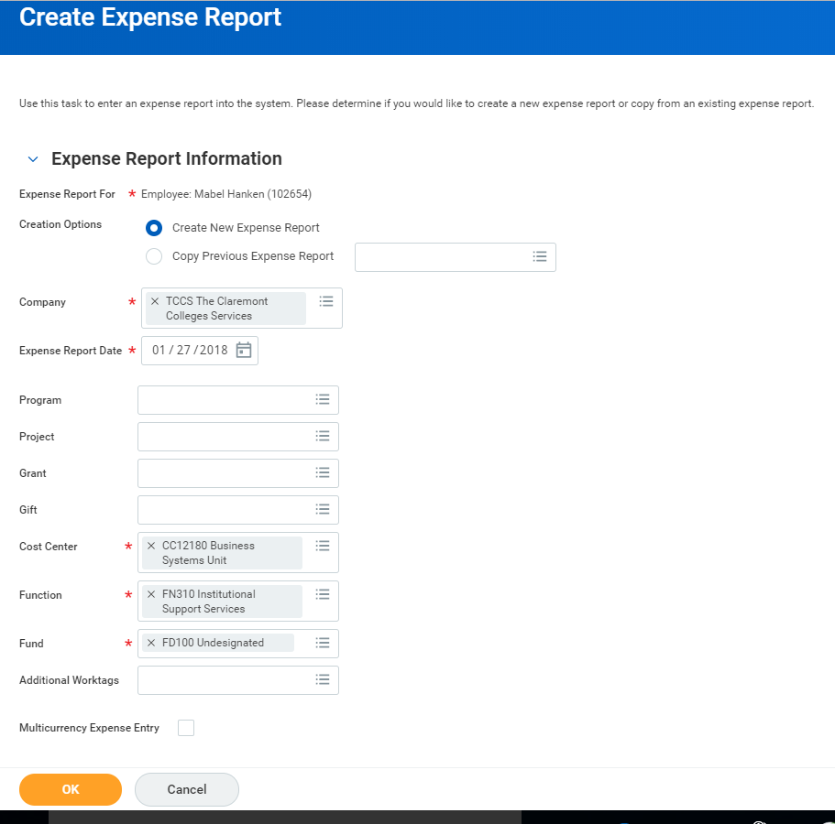
Travel policies for your institution may be viewed by clicking on the link provided on top right of page under Instructions.

- Scroll down to select your credit card transactions you want to expense.
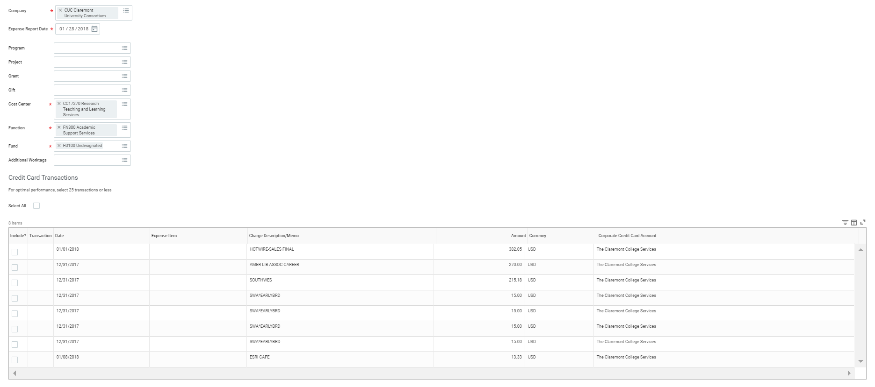
- Select All or click “include” box for each transaction you wish to include on the expense report.
- Click OK
Next Screen
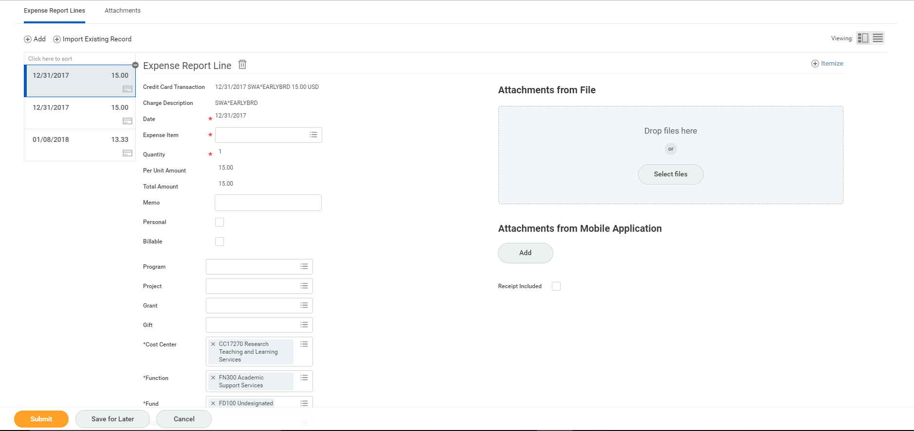
- Complete the required field, Expense Item for each credit card transaction you previously selected.
Note: Date, Quantity, Per Unit Amount and Total Amount for your credit card transactions may not be changed.

- A business purpose is required on the line memo for each expense item and header memo for the entire expense report.
- You have 3 options to add attachments
  - Click Attachments tab and upload a summary document
  - Drop files or Select File from your local computer for each expense report line
  - Click Add for attachments from mobile application to select receipts/images uploaded through your mobile device.
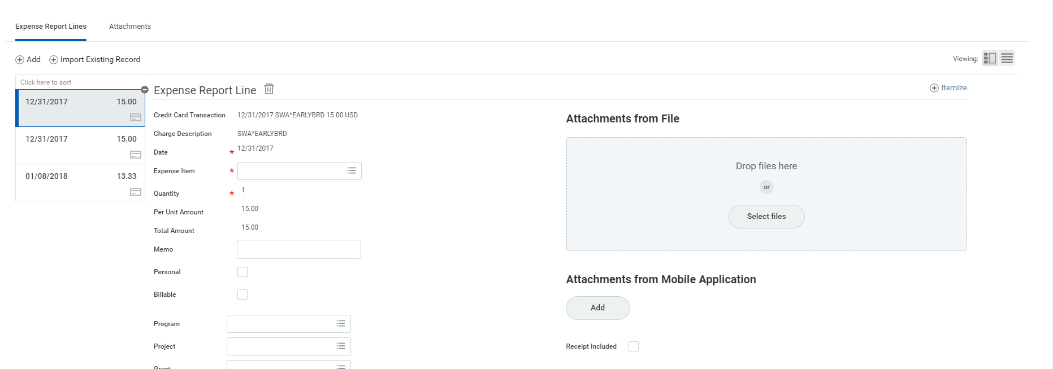

Add WorktagS AT THE LINE LEVEL
Worktags are keywords needed for the expense report to be routed correctly, and are used for reporting purposes. Based on your organization’s configuration and policies, you may need to add additional worktags on each expense report line.

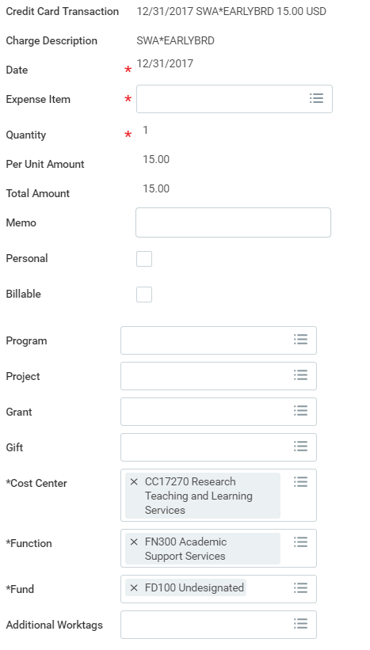
- Cost Center: Workday may auto-populate this field and should only be modified as needed.
- Location: Workday may auto-populate this field and should only be modified as needed.
- Additional Worktags: Reimbursements may be associate an expense report with a project, program, grant and/or gift worktag.
- Click Submit (if no itemization is needed)
Itemize Your Expenses
Your organization may require you to itemize your expenses. For example, your hotel bill may include your room rate, room service, internet fees, and more.
From the Expense Report Lines tab within an expense report:
- Before you submit, click Itemize. Itemization fields display based on the expense type.
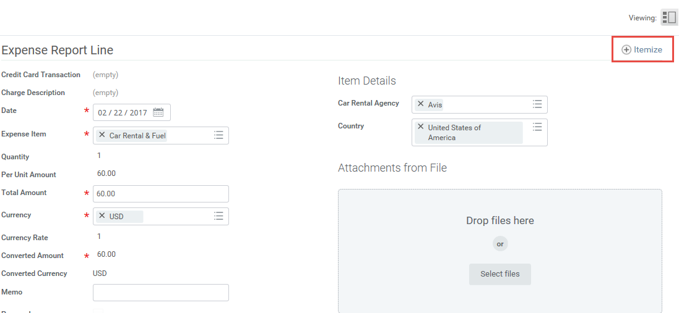
- Enter the necessary information based on the expense type you are itemizing. Your itemized expenses must equal the total of your Expense Report Line.
- Then click Done.

combined expense report with BOTH credit card transactions and reimbursements
1. After completing the required fields for your credit card transactions, you can add reimbursable expense report lines by clicking + Add for each additional line you want to include in your expense report.
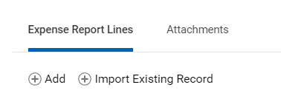
2. A new expense report line will populate at the top of your listed expense report lines to be completed as needed.
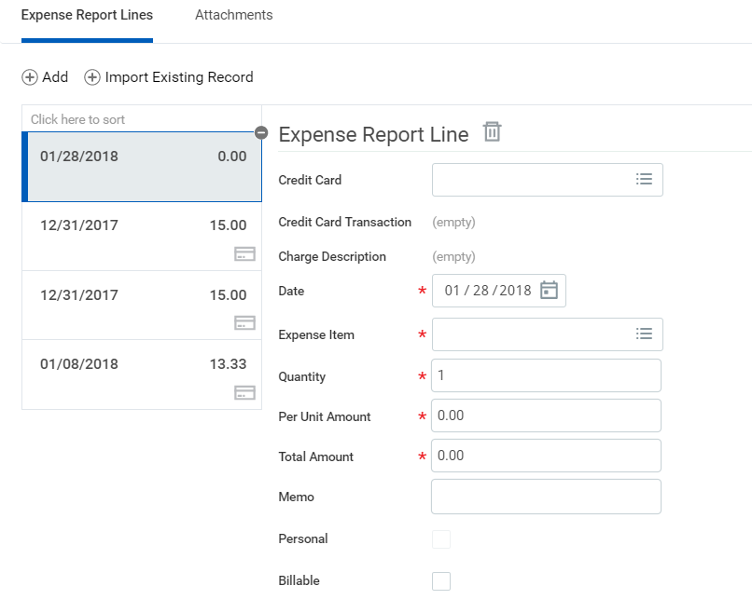

- Complete all required fields, including Date, Expense Item, Quantity, Per Unit Amount, and Total Amount for each reimbursable item.
- Review the summary of all items listed on your expense report by type of transactions.
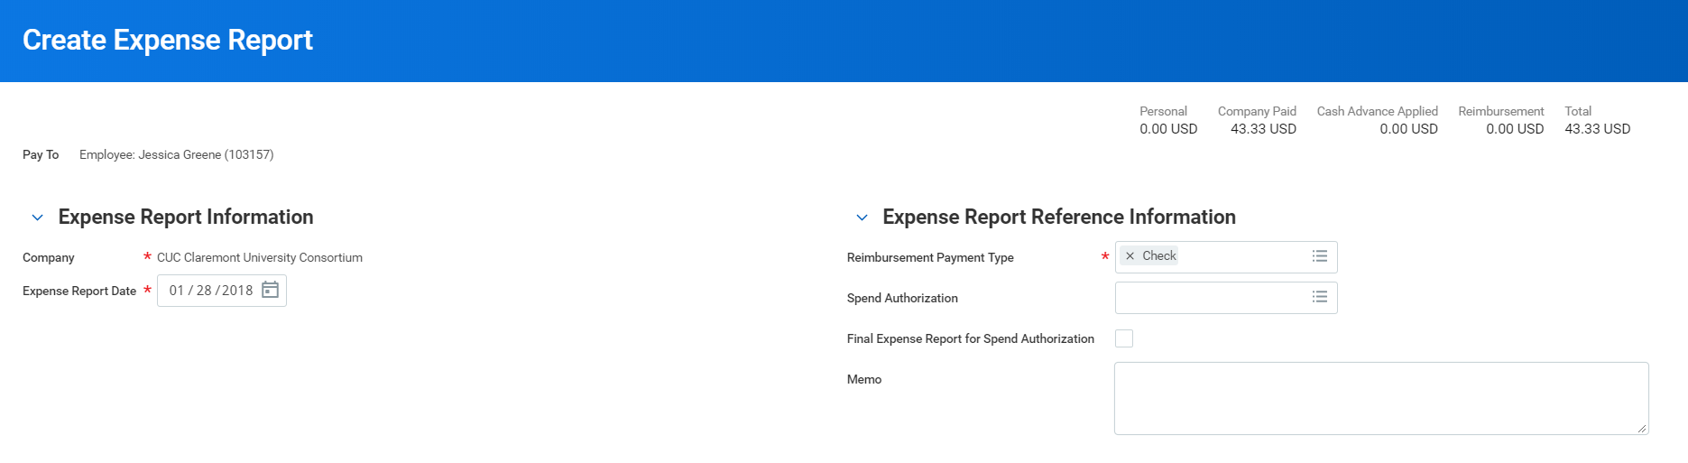
Total Expense Report
Total credit card transactions

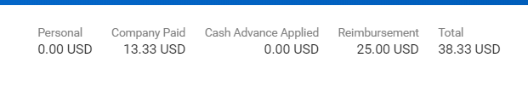
Total Reimbursement

- Once your review is complete, click Submit.
FIND Existing Expense Report
From the Search bar
- Type My Expense Reports, select the report
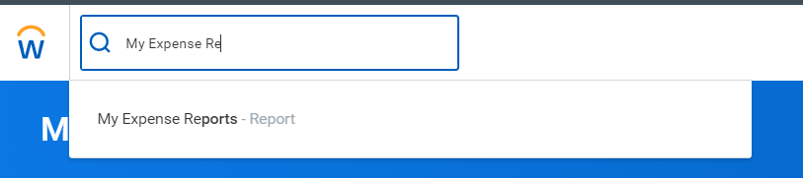

- Select Expense Report Status applicable
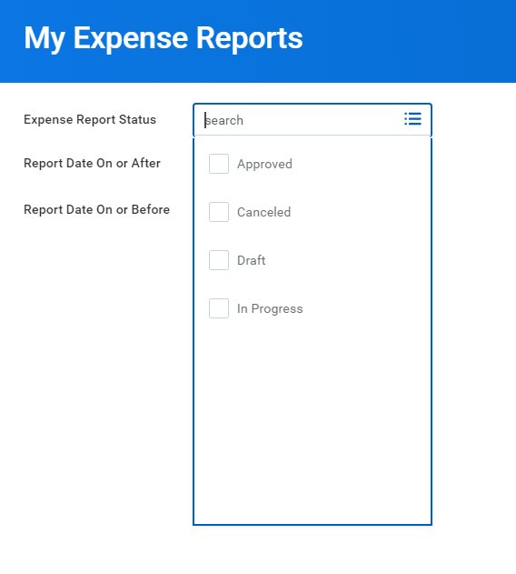
- Enter Report Date On or After AND/OR Report Data on or Before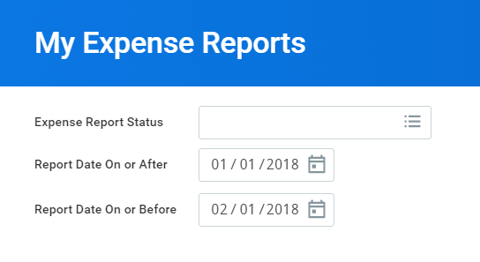
- Click OK

