Create an Expense Report
Expense reports are submitted so that you are reimbursed for business-related costs, such as airfare or hotel expenses.
From the Search Bar
- Type Create Expense Report
- Select either Create New Expense Report, Copy Previous Expense Report, or Create New Expense Report from Spend Authorization. Your selection determines what information displays on the new expense report.
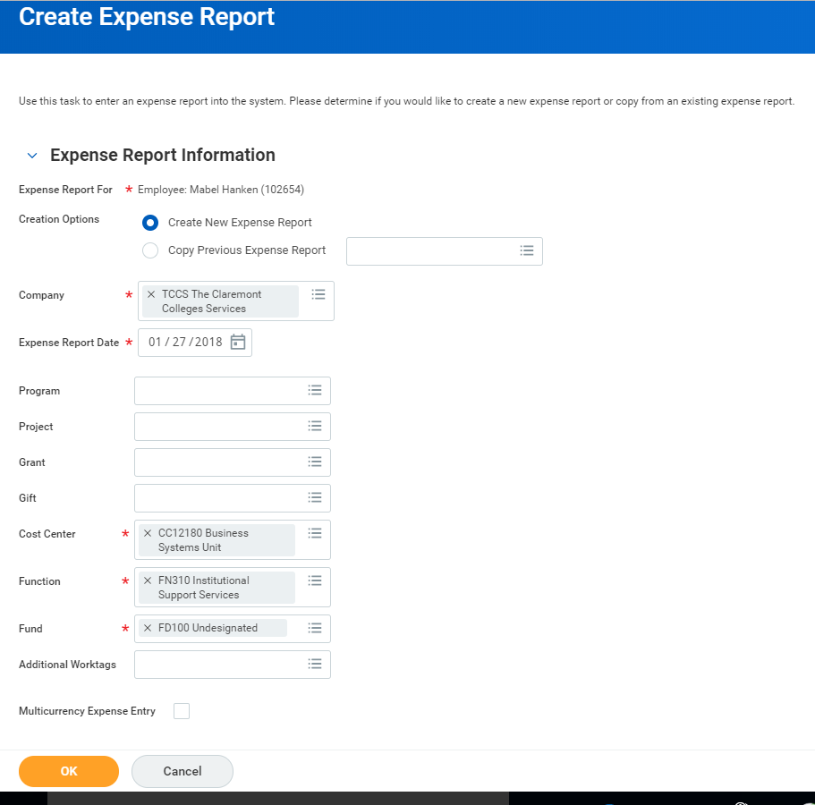
Note: Your employee worktags will default with each new expense report. These can be changed by clicking on the “x” to remove such worktags if needed.

Travel policies for your institution may be viewed by clicking on the link provided on top right of page under Instructions.
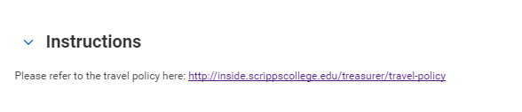
- Click OK.
- Complete all required fields, including Date, Expense Item, Quantity, Per Unit Amount, and Total Amount.
Next Screen
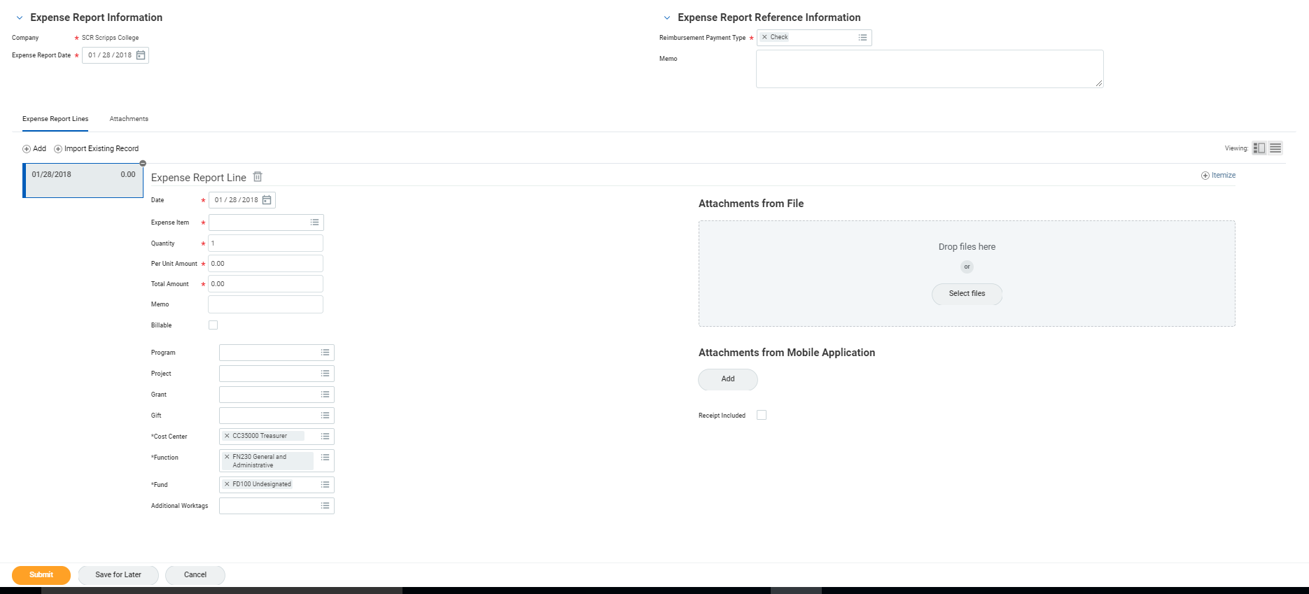
- A business purpose is required on the line memo and header memo.
- Add attachments as needed.

Add WorktagS AT THE LINE LEVEL
Worktags are keywords needed for the expense report to be routed correctly, and are used for reporting purposes. Based on your organization’s configuration and policies, you may need to add additional worktags on each expense report line.
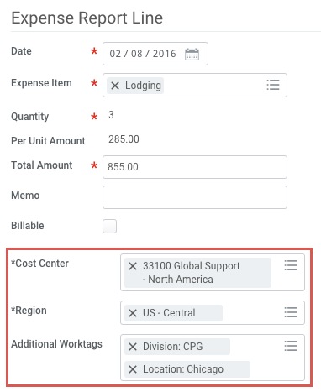
- Cost Center: Workday may auto-populate this field and should only be modified as needed.
- Location: Workday may auto-populate this field and should only be modified as needed.
- Additional Worktags: Reimbursements may be associated with an expense report with a project, program, grant and/or gift worktag.
- Click Submit (if no itemization is needed)
Itemize Your Expenses
Your organization may require you to itemize your expenses. For example, your hotel bill may include your room rate, room service, internet fees, and more.
From the Expense Report Lines tab within an expense report:
- Before you submit, click Itemize. Itemization fields display based on the expense type.
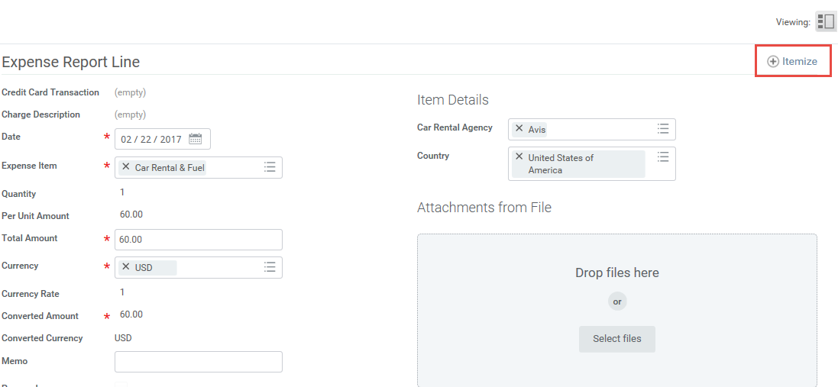
- Enter the necessary information based on the expense type you are itemizing. Your itemized expenses must equal the total of your Expense Report Line.
- Then click Done.

FIND Existing Expense Report
From the Search bar
- Type My Expense Reports, select the report
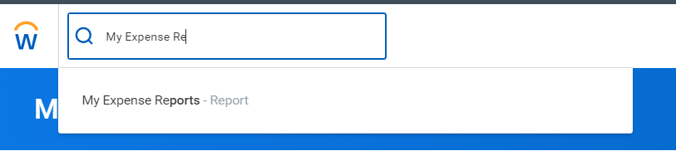
- Select Expense Report Status
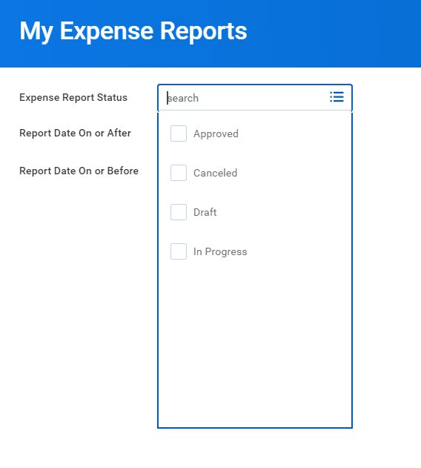
- Enter Report Date On or After AND/OR Report Data on or Before
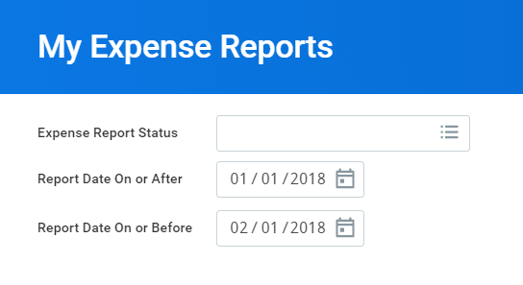
- Click OK

