Mobile
Enter Expense and Submit Expense Report
iPhone
Use the Expenses worklet (card) to track expenses, upload receipts, and submit expense reports.

Note: Ensure you have installed the Workday application. For instructions on how to install the Workday app, please see reference aid Getting Started: Using Your Mobile Device

Login to Workday application

From the Home Page, click Expenses worklet
- Tap New Expense.
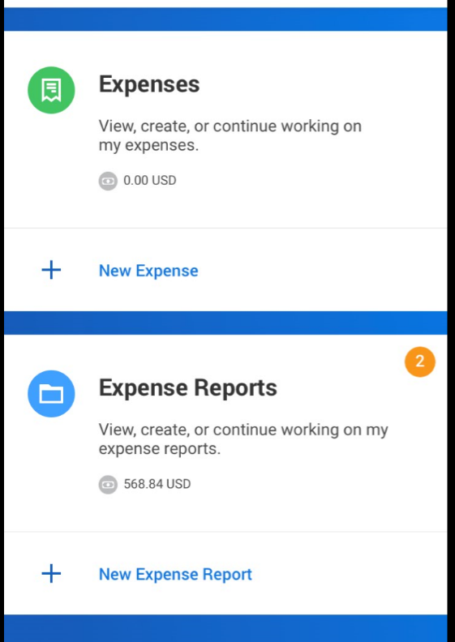
- Tap the Camera icon to take a photo of the receipt. For an iPhone, you can also choose an existing photo or import an attachment. For an Android, you can also select an existing photo from the gallery. If you took a photo, tap Use Photo.
- Date should default to today’s date, enter an Amount and Expense Item. Recommended: Include a memo to assist in completing your expense report at a later date.
Note: An icon of the image should appear indicating your photo was successfully added to your expense item.
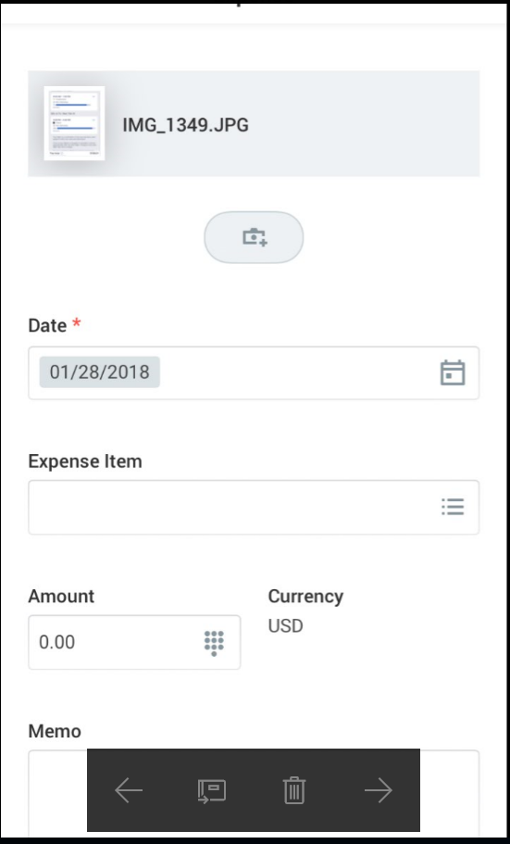
- Tap Done.
Repeat previous steps to add any other expense items you want to report.
When all expense items are added, you can add all expense items and submit an expense report using two options:

Option A

1. After adding your last expense, click Select All on the top of your mobile screen.

2. Total items will appear at the bottom, click Add to Report.

3. You can select to Create New Report or select Existing Report

4. Your items will be added and ready for review. Tap on # item – Review.
5. Click Submit

Option B

1. Back arrow to previous page
2. Tap New Expense Report.
3. Add Memo, Company, Expense Report Date and Cost Center should default.
4. Tap the Additional Worktags prompt. Add information your organization may require, like Program, Project, Grant or Gift.
- Once you’ve completed the expense report information, tap Done.
- Tap Add Expense to attach expenses to the report.
- Tap Existing Expenses. You can also choose to add more expenses in this step by tapping New Expense.
- Choose the pre-existing expenses you want to include in the report by tapping the checkmark next to each expense item you have saved.
- Tap Done.
- Tap Review.
- Review your expense items for accuracy and correct any errors, then tap Submit. A confirmation screen shows your expense report has been routed for approval.
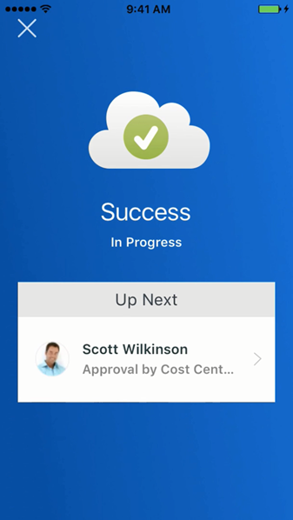
IOS iPad
Use the Expenses worklet (card) to track expenses, upload receipts, and submit expense reports.

From the Expenses card:
- Tap New Expense.
- Tap the Camera icon to take a photo or choose an existing photo of your receipt.
- Enter an Amount, Date, and any other supporting information for the expense.
- Tap Done.
Repeat previous steps to add any other expense items you want to report. When all expense items are added, you can submit an expense report from the Expense worklet or tap on Add to Report
- Using the worklet, tap New Expense Report.
- Include the Company and Cost Center (if not already defaulted)
- Tap the Additional Worktags prompt. Add information your organization may require like Project, Program, Grant or Gift.
- Tap Done.
- Swipe right to tap Add Expense.
- Tap Existing Expenses. You can also choose to add more expenses in this step by tapping New Expense.

- Choose the pre-existing expenses you want to include in the report by tapping the checkmark next to each expense item you have saved.
- Tap Done.
- Tap Review.
- Review your expense items for accuracy and correct any errors, then tap Submit. A confirmation screen shows your expense report has been routed for approval.

