Create a Spend Authorization Request
Spend authorizations are used to grant permission for future expenses. These authorizations are initiated by workers. Managers approve or take other actions on them.
From the Search Bar
- Search Create Spend Authorization, click on task
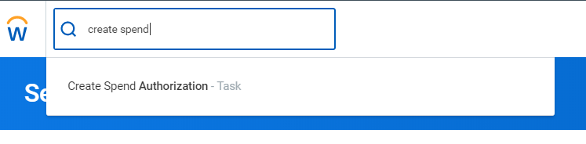
- Complete the required fields, including Company, Start Date, End Date, Description and Spend Authorization Total.
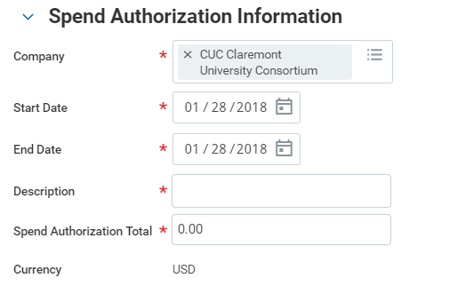
- Select your Reimbursement Payment Type and enter a justification.
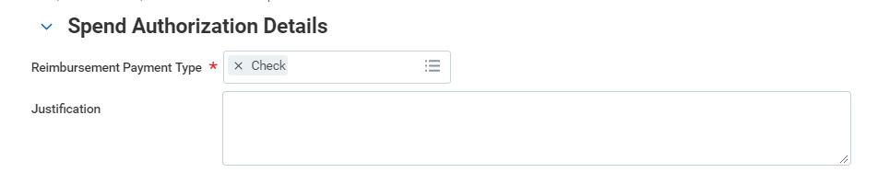

Note: In the Justification field, you can clarify the reason for the future expense
- Click the Add Row icon to add spend authorization line item details.
- Complete all required fields for each spend authorization line.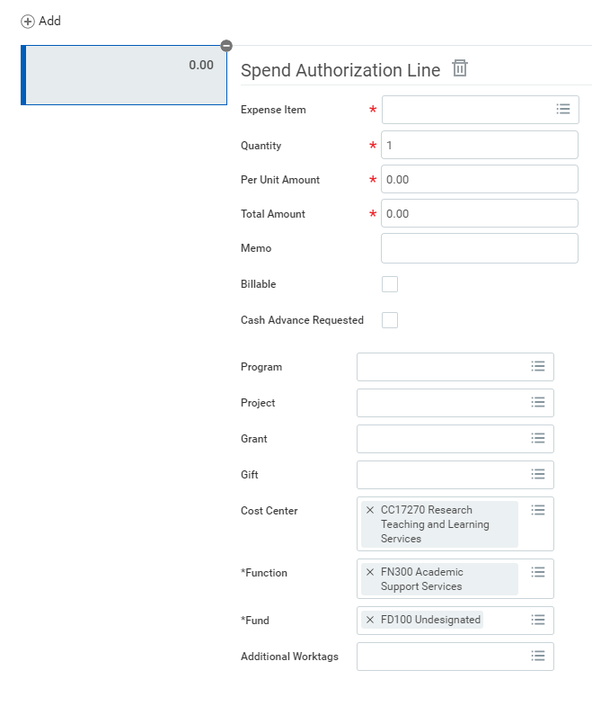
Note: Workday will default worktags associated with your worker profile.
- Add additional lines as needed.
- If required by your institution, add attachment then click Submit.

Create a (Spend Authorization) cash advance Request
To request a cash advance, use Create Spend Authorization task
- Complete the required fields, including Company, Start Date, End Date, Description and Spend Authorization Total.

- Select your Reimbursement Payment Type and enter a Justification
- Under Spend Authorization Lines, click the Add Row icon
- Complete the following fields, Expense Item, Quantity, Per Unit Amount and Total Amount.

- Check box Cash Advance Requested
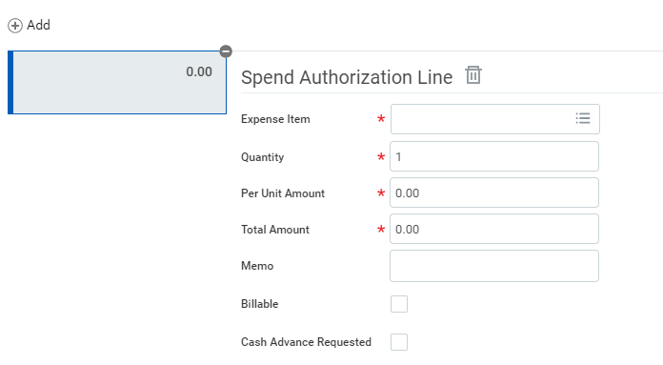
- Complete any additional worktags needed
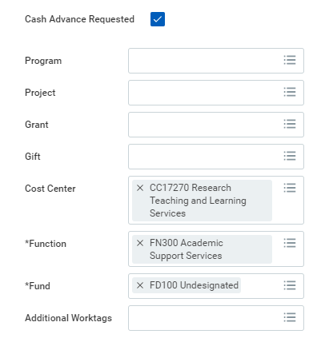
- Click Submit

View an Existing Spend Authorization
From the Search Bar
1. Search My Spend Authorizations and click on report.
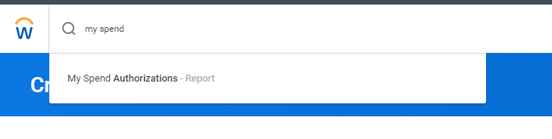
Note: You can click the Create Spend Authorization button to create a new spend authorization from this report if needed.
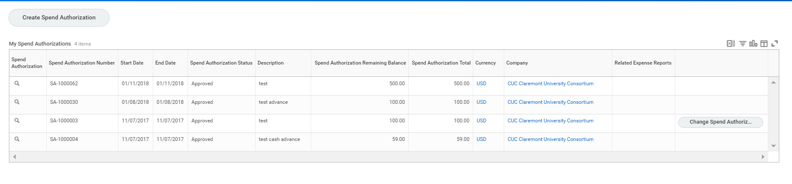
2. Click the Magnifying Glass icon to view spend authorization details
3. If your spend authorization report is “in progress”, click the Process History tab to check what process step your spend authorization is currently in.

