How To Feminist Zine
Zine
- DIY short publication with an emphasis on genre b(l)ending such as incorporation of artwork, poetry, cartoons, editorials, and short stories
- Combination of text, drawings, and found images such as recycled materials from ads, newspapers, magazines, etc.
- Most zines revolve around a specific theme such as FEMINIST ACTIVISM
- Self-published by their creator, zines are free of corporate interests and represent authentic thought, critical exploration, comic reflection, and individualized texts that emphasize the muse of the creator
Elaborate by adding your definition of Zines:

Feminism
- belief in and advocacy of the political, economic, and social equality of the sexes expressed especially through organized activity on behalf of women's rights and interests
Elaborate by adding your definition of feminism:

Get Inspired
Chapman University Feminist Zine Archive
Women’s Media Center
The Westport Library on Zine Activism
Get Started
Printable Version
Digital Version

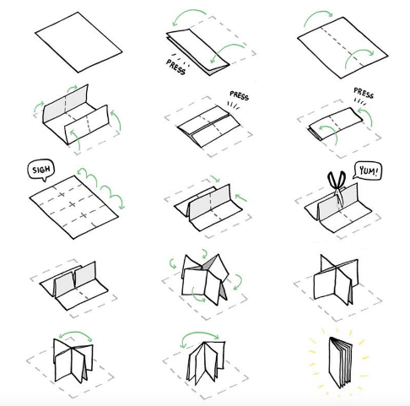

Brainstorm Sheet
Front Cover | Content P1
Content P2 | Content P3
Content P4 | Content P5
Content P6 | Back Cover

